CHAMPAIGN COUNTY MENTAL HEALTH BOARD

THREE-YEAR PLAN

FOR

FISCAL YEARS 2022-2024

(1/1/2022 – 12/31/2024)

WITH

ONE YEAR OBJECTIVES

FOR

FISCAL YEAR 2023

(1/1/2023 – 12/31/2023)

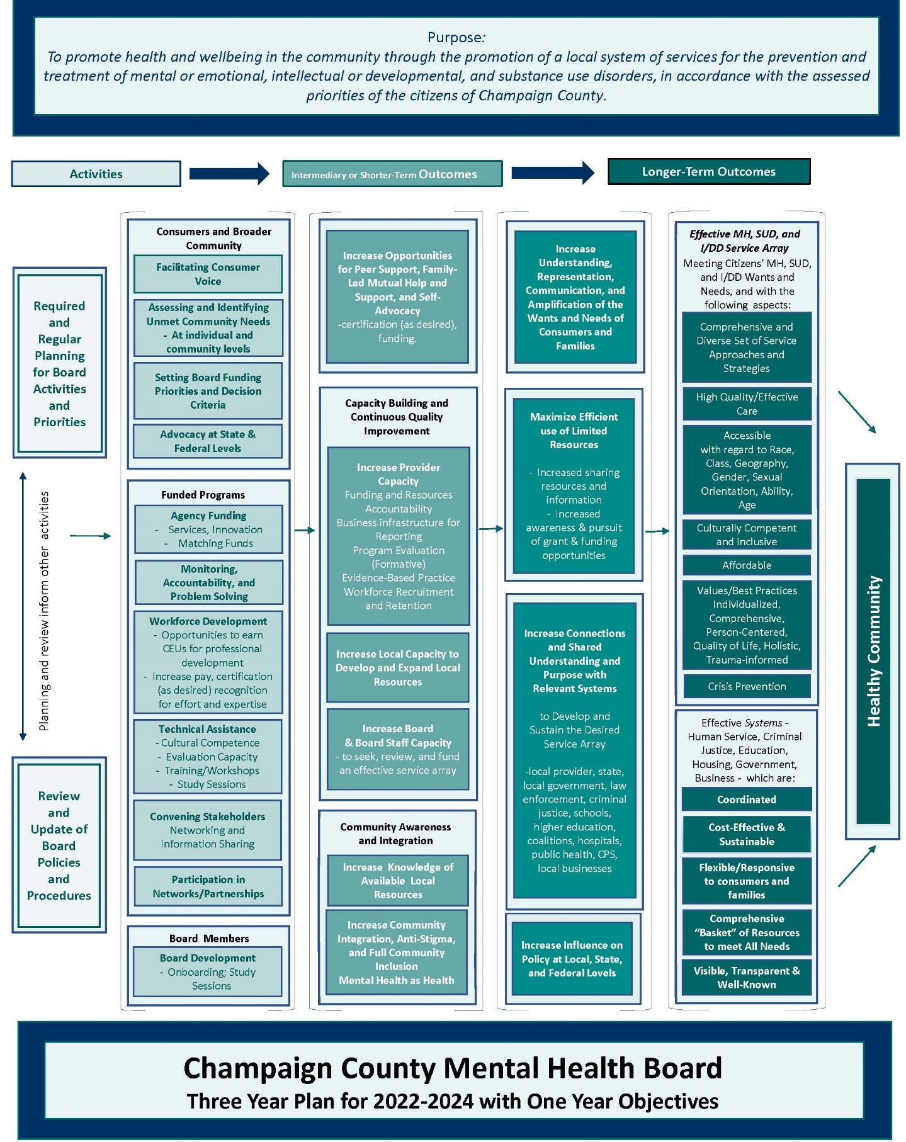

Logic Model Developed by Board and Staff with the UIUC Evaluation Capacity Building Project Team during Spring 2021
CHAMPAIGN COUNTY MENTAL HEALTH BOARD

WHEREAS, the Champaign County Mental Health Board has been established under Illinois Revised Statutes (405 ILCS – 20/Section 0.1 et. seq.) in order to "construct, repair, operate, maintain and regulate community mental health facilities to provide mental health services as defined by the local community mental health board, including services for, persons with a developmental disability or substance use disorder, for residents thereof and/or to contract therefor..."

WHEREAS, the Champaign County Mental Health Board is required by the Community Mental Health Act to prepare a one- and three-year plan for a program of community mental health services and facilities;

THEREFORE, the Champaign County Mental Health Board does hereby adopt the following Mission Statement and Statement of Purposes to guide the development of the mental health plan for Champaign County:

MISSION STATEMENT

The mission of the CCMHB is the promotion of a local system of services for the prevention and treatment of mental or emotional, intellectual or developmental, and substance use disorders, in accordance with the assessed priorities of the citizens of Champaign County.

STATEMENT OF PURPOSES

1. To plan, coordinate, evaluate, and allocate funds for the comprehensive local system of mental health, intellectual and developmental disabilities, and substance use disorder services for Champaign County.

2. To promote family-friendly community support networks for the at-risk, underserved, and general populations of Champaign County.

3. To increase public and private support for the local system of services.

4. To further develop systematic exchange of information about local services and needs between the public/private service systems and the CCMHB.

To accomplish these purposes, the Champaign County Mental Health Board must collaborate with the public and private sectors in providing the resources necessary for the effective functioning of the community mental health system.
COORDINATED SYSTEMS OF CARE

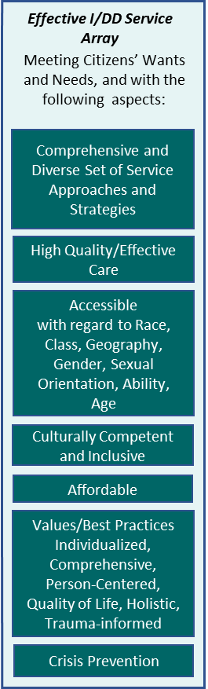

Goal #1:

Support a continuum of services to improve the quality of life experienced by individuals with mental or emotional disorders, substance use disorders, or intellectual and/or developmental disabilities and their families residing in Champaign County.

Objective 1.1: With clear connection between the model and best outcomes for people served, encourage use of appropriate evidence-based, evidence-informed, recommended, innovative, or promising practice models. (Allocation Priority/Criteria Objective)

Objective 1.2: Promote wellness for people with mental illnesses, substance use disorders, or intellectual and/or developmental disabilities to prevent and reduce early mortality, through support services including access to services addressing basic needs, enrollment in benefit plans and coordinated access to primary care. (Allocation Priority/Criteria Objective)

Objective 1.3: Support development or expansion of residential and employment supports for persons with behavioral health diagnoses and no other payor source. (Allocation Priority/Criteria Objective)

Objective 1.4: Encourage and participate in community efforts to prevent overdose deaths and expand substance use disorder prevention and treatment. (Allocation Priority/Criteria and Collaboration/Coordination Objective)

Objective 1.5: Build resiliency and support recovery e.g. peer supports, outside of a clinical setting. Peer-run/operated, mutual help groups support professional medical therapy for recovery, maintenance of recovery, and familial support. (Allocation Priority/Criteria Objective)

Objective 1.6: Utilizing expertise of consultant(s) selected through RFP2022-010, build evaluation capacity of contracted providers in order to improve positive outcomes for those engaging in funded services. (Policy Objective)

Objective 1.7: Engage with consultant(s) selected through RFP2022-010 to improve providers’ ability to set internal goals for advancing program performance outcome evaluation. (Policy Objective)

Objective 1.8: Support targeted efforts for workforce recruitment and retention initiatives, with level of assistance linked to length of service commitment. (Allocation Priority/Criteria Objective)

Objective 1.9: Enable providers to implement flexible service options, such as telehealth or other virtual means, to maintain access and engagement with clients and community. (Collaboration/Coordination Objective)

Goal #2:

Sustain commitment to addressing health disparities experienced by historically underinvested populations.

Objective 2.1: Support an inclusive network of culturally and linguistically responsive and family driven support groups. (Allocation Priority/Criteria Objective)

Objective 2.2: Provide technical assistance for continuous improvement of funded agency providers’ cultural and linguistic competence plans to meet the needs of all people served. (Collaboration/Coordination Objective)

Objective 2.3: Encourage providers and other community-based organizations to allocate resources to provide training, seek technical assistance, provide language access and communication assistance, and pursue other professional development activities for all staff and governing or advisory boards to advance cultural and linguistic competence. (Allocation Priority/Criteria Objective)

Objective 2.4: Where families and communities are disproportionately impacted by incarceration, encourage the development of social networks and improved access to resources. (Allocation Priority/Criteria and Policy Objective)

Objective 2.5: Assess and address the needs of residents of rural areas and farm communities, with assistance from the Regional Health Plan Collaboration. (Collaboration/Coordination and Policy Objective)

Objective 2.6: With assistance from the Regional Health Plan Collaboration, assess the impact of public health threats on racial, ethnic, gender and/or sexual minority groups or other at-risk populations in Champaign County. Encourage providers to improve health and behavioral health outcomes for all residents. (Collaboration/Coordination and Allocation Priority/Criteria Objective)

Maximize Efficient use of Limited Resources
Participation in Networks/Partnerships
Convening Stakeholders
Networking and Information Sharing

Goal #3:

On behalf of all eligible Champaign County residents, improve access to the supports, services, and resources currently available and beneficial to some.

Objective 3.1: Participate in and report on various coordinating councils whose missions align with the needs of the populations of interest to the Board with the intent of strengthening coordination between providers in the delivery of services. (Collaboration/Coordination Objective)

Objective 3.2: Communicate on issues of mutual interest with the C-U Public Health District and the Champaign County Board. (Collaboration/Coordination Objective)

Objective 3.3: Engage with CUPHD, United Way, Carle Foundation Hospital, and OSF in the Regional Health Plan Collaboration toward the next Community Health Improvement Plan. (Collaboration/Coordination Objective)

Objective 3.4: Increase awareness of community services and access to information on when, where, and how to apply for services, including through system navigators and expanded language access. (Collaboration/Coordination Objective)

Objective 3.5: Encourage providers to offer services in neighborhood community centers to reach all areas and people of Champaign County. (Collaboration/Coordination Objective)

Board Development
Onboarding; Study Sessions
Increase Board
& Board Staff Capacity
- to seek, review, and fund
an effective service array

Goal #4:

Continue the collaborative working relationship with the Champaign County Board for Care and Treatment of Persons with a Developmental Disability (CCDDB).

Objective 4.1: Coordinate integration, alignment, and allocation of resources with the CCDDB to ensure the efficacious use of resources for people with I/DD. (Allocation Priority/Criteria Objective)

Objective 4.2: Assess alternative service strategies that empower people with I/DD and increase access to integrated community settings. (Policy Objective)

Objective 4.3: Collaborate with the CCDDB on promoting inclusion and respect for people with I/DD. (Allocation Priority/Criteria and Collaboration/Coordination Objective)

Objective 4.4: Collaborate with the CCDDB for use of the funds from the sale of the CILA homes to meet the needs of Champaign County residents with I/DD with significant support needs. (Policy and Allocation Priority/Criteria Objective)

CHILDREN AND FAMILY FOCUSED PROGRAMS AND SERVICES

Increase Understanding, Representation, Communication, and Amplification of the Wants and Needs of Consumers and Families
Flexible/Responsive
to consumers and families

Goal #5:

Building on progress achieved through the six-year Cooperative Agreement between the Federal Substance Abuse and Mental Health Services Administration (SAMHSA), the Illinois Department of Human Services (IDHS), and the Champaign County Mental Health Board (CCMHB), sustain the SAMHSA/IDHS system of care model.

Objective 5.1: Participate in the Champaign County Community Coalition and other system of care initiatives. (Collaboration/Coordination Objective)

Objective 5.2: Sustain and build on the successes of Champaign County family-run organizations that incorporate family-driven and youth-guided principles in use of peer support specialists, and other peer-to-peer supports to assist multi-system involved youth and their families (Allocation Priority/Criteria Objective)

Objective 5.3: Support development of a coordinated response to community violence, including gun violence, that leverages existing investments by the Board in prevention and early intervention services for children, youth, and families, with funds from other funders to mitigate the public health crisis associated with community violence and in particular gun violence. (Collaborative/Coordination and Policy Objective)

Objective 5.4: Promote and support those targeted interventions that specifically address historical trauma experienced by African American and other minority youth. (Allocation Priority/Criteria Objective)

Objective 5.5: Sustain commitment to building systems that are trauma-informed, family-driven, youth-guided, and culturally responsive. (Policy Objective)

Objective 5.6: Acknowledging racial trauma as a mental health issue, develop or identify an appropriate response. (Policy Objective)

Objective 5.7: Identify or create opportunities to advocate at local, state, and national levels for full implementation and funding of safety net, screening, and crisis response for all children and families, including those with multi-system involvement or encountering multiple barriers to success and health. (Collaboration/Coordination Objective/Policy Objective)

CRIMINAL JUSTICE AND MENTAL HEALTH SYSTEM COLLABORATION

Crisis Prevention
Goal #6:

Divert persons with behavioral health needs or intellectual and/or developmental disabilities from the criminal justice system, as appropriate.

Objective 6.1: Continue involvement in the Crisis Intervention Team Steering Committee in support of increased collaboration between law enforcement and crisis service providers toward positive health and behavioral health outcomes for all Champaign County residents. (Collaboration/Coordination Objective)

Objective 6.2: Sustain efforts to engage persons with behavioral health diagnoses re-entering the community from jail or prison or with recent involvement with the criminal justice system, in treatment and other support services such as the Champaign County Problem Solving Court and reentry services. (Allocation Priority/Criteria Objective)

Objective 6.3: Support integrated planning and service coordination for adults involved in the criminal justice system through participation in the Champaign County Reentry Council or similar body to address identified needs. (Collaboration/Coordination Objective)

Objective 6.4: Through the National Association of County Behavioral Health and Developmental Disability Directors (NACBHDD), in its partnership with the National Association of Counties (NACo), use and promote technical assistance and support through collaborative and mentorship opportunities aimed at improving outcomes for those with behavioral health needs and justice system involvement. (Collaboration/Coordination Objective)

Increase Connections and Shared Understanding and Purpose with Relevant Systems
to Develop and Sustain the Desired Service Array

Comprehensive “Basket” of Resources to meet All Needs
Visible, Transparent & Well-Known

Goal #7:

In conjunction with the Champaign County Sheriff’s Office, other law enforcement, and community stakeholders, pursue a continuum of services as an alternative to incarceration and/or overutilization of local emergency departments for persons with behavioral health needs or developmental disabilities.

Objective 7.1: Support local collaborations to increase housing and employment supports for persons with a mental illness, substance use disorder, and/or intellectual and developmental disabilities. (Allocation Priority/Criteria and Collaboration/Coordination Objective)

Objective 7.2: Identify supports and services which reduce unnecessary incarceration and institutionalization, including behavioral health assessments, crisis stabilization, and treatment for addictions. (Collaboration/Coordination Objective)

Objective 7.3: Collaborate in the planning and implementation of 988, mobile crisis response, and other crisis supports. (Allocation Priority/Criteria Objective, Collaboration/Coordination Objective)

Comprehensive and Diverse Set of Service Approaches and Strategies
High Quality/Effective Care

Goal #8:

Support interventions for youth who have juvenile justice system involvement.

Objective 8.1: Through participation on the Youth Assessment Center Advisory Committee or other similar collaboratives, advocate for community and education-based interventions contributing to positive youth development and decision-making. (Collaboration/Coordination Objective)

Objective 8.2: Through participation in the Champaign County Community Coalition and other community focused initiatives, encourage multi-system collaborative approaches for improving outcomes for youth and families and communities. (Collaboration/Coordination Objective)

COMMUNITY ENGAGEMENT & ADVOCACY

Increase Knowledge of Available Local Resources
Community Awareness and Integration
Increase Community Integration, Anti-Stigma, and Full Community Inclusion
Mental Health as Health
Goal #9:

Address the need for acceptance, inclusion, and respect associated with a person’s or family members’ mental illness, substance use disorder, intellectual and/or developmental disability through broad based community education efforts to increase community acceptance and positive self-image.

Objective 9.1: Continue support for and involvement in efforts to promote inclusion and challenge stigma and discrimination, such as the disABILITY Resource Expo, Ebertfest, National Children’s Mental Health Awareness Day, and other related community education events. (Collaboration/Coordination Objective)

Objective 9.2: Promote substance use disorder prevention initiatives as a community education tool targeting youth and young adults. (Collaboration/Coordination Objective)

Objective 9.3: Promote behavioral health community education initiatives, such as National Depression Screening Day, to encourage individuals to be screened and seek further assistance where indicated. (Collaboration/Coordination Objective)

Objective 9.4: Encourage and support efforts to more fully integrate people with behavioral health disorders and/or intellectual and/or developmental disabilities into community life in Champaign County. (Allocation Priority/Criteria Objective)

Objective 9.5: Support Mental Health First Aid for Adults, Youth, and Teens, to encourage community members to provide first responder support for people that may be experiencing signs and symptoms of a crisis. (Collaboration/Coordination Objective)

Objective 9.6: Support development of web-based resources to make information on community services more accessible and user-friendly. (Collaboration/Coordination Objective)

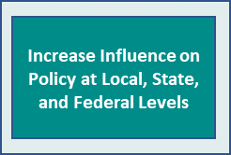

Goal #10:

Engage with other local, state, and national stakeholders on emerging issues.

Objective 10.1: Monitor the local impacts of changes in Medicaid and Managed Care and advocate through active participation in the Association of Community Mental Health Authorities of Illinois (ACMHAI) and other statewide associations and advocacy groups. (Collaboration/Coordination Objective)

Objective 10.2: Track state implementation of class action suit settlements involving persons with intellectual and/or developmental disabilities or mental illness, e.g. Ligas Consent Decree and Williams Consent Decree, and advocate for the allocation of state resources sufficient to meet needs of clients returning to home communities or seeking fuller integration in their communities. (Policy Objective)

Objective 10.3: Maintain active participation in the National Association of County Behavioral Health and Developmental Disability Directors (NACHBDD), National Association of Counties (NACo), and like-minded national organizations, to understand trends, best practices, and innovations and to advocate at the national level. (Collaboration/Coordination Objective)

Objective 10.4: Monitor State actions to implement terms of the NB vs Norwood Consent Decree (through the Pathways to Success program) to improve access and treatment to children and youth for community based mental health and behavioral health care under the Early and Periodic Screening, Diagnostic, and Treatment (EPSDT) provisions of the Medicaid Act. (Policy Objective)

Objective 10.5: Advocate at the state and national levels on the issue of behavioral health and intellectual and developmental disability workforce shortages. (Policy Objective)

Approved November 16, 2022

