CHAMPAIGN COUNTY BOARD FOR

CARE AND TREATMENT OF PERSONS WITH A DEVELOPMENTAL DISABILITY

THREE-YEAR PLAN

FOR

FISCAL YEARS 2022-2024

(1/1/22 – 12/31/24)

WITH

ONE YEAR OBJECTIVES

FOR

FISCAL YEAR 2022

(1/1/22 – 12/31/22)

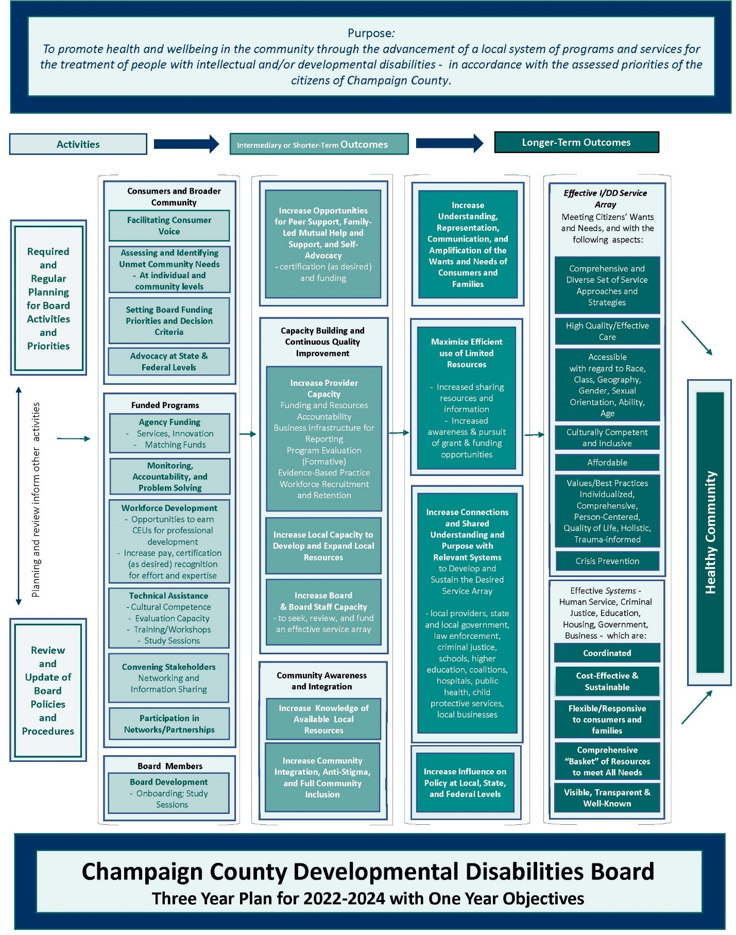

Logic Model Developed by Board and Staff with the UIUC Evaluation Capacity Building Project Team during Spring 2021

CHAMPAIGN COUNTY BOARD FOR CARE AND TREATMENT OF PERSONS WITH A DEVELOPMENTAL DISABILITY

(CHAMPAIGN COUNTY DEVELOPMENTAL DISABILITIES BOARD)

WHEREAS, the Champaign County Developmental Disabilities Board was established under the Illinois County Care for Persons with Developmental Disabilities Act, now revised as the Community Care for Persons with Developmental Disabilities Act (IL Compiled Statutes, Chapter 50, Sections 835/0.05 to 835/14 inclusive) in order to “provide facilities or services for the benefit of its residents who are persons with intellectual or developmental disabilities and who are not eligible to participate in any such program conducted under Article 14 of the School Code, or may contract therefore with any privately or publicly operated entity which provides facilities or services either in or out of such county.”
WHEREAS, while the Champaign County Developmental Disabilities Board is not required by state statute or other authority to prepare a one- and three-year plan for a program of supports and services for people with intellectual and developmental disabilities, open strategic planning with input from stakeholders and constituents is highly valued.

THEREFORE, the Champaign County Developmental Disabilities Board does hereby adopt the following Mission Statement and Statement of Purposes to guide the development of the intellectual and developmental disabilities supports and services plan for Champaign County:

MISSION STATEMENT

The mission of the Champaign County Board for Care and Treatment of Persons with a Developmental Disability (CCDDB) is the advancement of a local system of programs and services for the treatment of people with intellectual and/or developmental disabilities, in accordance with the assessed priorities of the citizens of Champaign County.

STATEMENT OF PURPOSES

1. Planning for the intellectual and developmental disability service and support system to assure accomplishment of the CCDDB goals.

2. Allocation of local funds to assure the provision of a comprehensive system of community based intellectual and developmental disability services and supports anchored in high-quality person-centered planning.

3. Coordination of affiliated providers of intellectual and developmental disability services and supports to assure an interrelated, accessible system of care.

4. Evaluation of the system of care to assure that services and supports are provided as planned and that services are aligned with the needs and values of the community.

To accomplish these purposes, the Champaign County Developmental Disabilities Board must collaborate with the public and private sectors in providing the resources necessary for the effective functioning of the intellectual and developmental disability service and support system. The CCDDB shall perform those duties and responsibilities as specified in Sections 835/0.05 to 835/14 inclusive of the Community Care for Persons with Developmental Disabilities Act.
A COORDINATED AND ACCESSIBLE CONTINUUM OF SERVICES AND SUPPORTS
Goal #1:

Support a continuum of services to meet the needs of people with intellectual and/or developmental disabilities (I/DD), along with their families, residing in Champaign County.

Objective #1: Under established policies and procedures, solicit proposals from community based providers in response to Board defined priorities and associated criteria using a competitive application process.

Objective #2: Explore the use of evidence-based, evidence-informed, promising, recommended, and innovative practices which align with federal and state requirements and are appropriate to each person’s needs and preferences, in an effort to improve outcomes for people with I/DD, along with their families, across the lifespan. Recommended practices are supported by an evidence base, cultural context, and sound clinical judgement.

Objective #3: Promote wellness for people with I/DD to prevent and reduce early mortality, through supports and services which may include enrollment in benefit plans, linkage and advocacy, and coordinated access to primary care. Support access to physical and behavioral health treatments for persons regardless of ability/disability.

Objective #4: Identify outcomes of value to those who use services and supports. Partner with key stakeholders toward improved outcomes for people.

Objective #5: Pursue, as feasible, development or expansion of residential and/or employment supports for persons with I/DD not supported with state/federal funding.

Objective #6: In response to changes in Medicaid and Medicaid-waiver services, realign CCDDB investments to fund services and supports outside the realm of Medicaid, including pilot projects and creative solutions to persistent problems, such as workforce recruitment and retention, including, but not limited to, Direct Support Professional (DSP) retention efforts and payments.

Objective # 7: Support initiatives providing housing and employment supports for persons with intellectual and developmental disabilities through the Champaign County Continuum of Care or other local collaboration.

Objective #8: Enable providers to implement flexible responses to operations and program delivery during the ongoing COVID-19 pandemic, such as continuing to support telehealth or other virtual service options, to maintain access and engagement with clients and community.
Goal #2:

Sustain the commitment to improving outcomes for members of underrepresented and underserved populations.

Objective #1: Support culturally and linguistically responsive and family driven support networks for underrepresented and underserved populations of Champaign County.

Objective #2: Provide technical assistance for continuous improvement of funded agency providers’ cultural and linguistic competence plans, to meet the needs of all people served.

Objective #3: Encourage providers and other community-based organizations to allocate resources for training, technical assistance, and professional development activities for direct support staff and governing and/or advisory boards, to advance cultural and linguistic competence.

Objective #4: Promote trauma-informed practices in program delivery, board and agency staff development, policies, and procedures.

Objective #5: Review data on the impact of COVID-19 on Champaign County residents with attention to underserved populations and promote provider response to mitigate the adverse impact, as resources allow.
Maximize Efficient use of Limited Resources
Goal #3:

Improve access to and engagement in services through increased coordination among providers, community stakeholders, people with I/DD, their families, and other key supporters.
Participation in Networks/Partnerships
Convening Stakeholders
Networking and Information Sharing

Objective #1: Sponsor or co-sponsor educational and networking opportunities for service providers and others supporting people with I/DD.

Objective #2: Engage other local funders and stakeholders and participate in coordinating bodies and intergovernmental councils as appropriate, to develop new initiatives, strengthen services, and maximize opportunities for people who have I/DD.

Objective #3: In collaboration with the CCMHB and other community partners, ensure that the needs of justice-involved persons with I/DD are considered in the development of an effective diversion/deflection system.

Objective #4: Use public, family, self-advocate, provider, and stakeholder input to guide advocacy for planning and policy changes at the state and federal levels, local system redesign and enhancement, and in the consideration of future funding priorities for the CCDDB.

Objective #5: Track Illinois Department of Human Services Division of Developmental Disabilities’ Prioritization for Urgency of Need for Services (PUNS) database for state and local trends and to ensure full representation of the service preferences of Champaign County residents. Maintain and increase communication with the Independent Service Coordination team, representatives of the IDHS Division of Developmental Disabilities, and stakeholders, regarding the use of PUNS, the service and support needs and preferences of Champaign County residents, and system changes.

Goal #4:

Encourage high-quality person-centered planning and follow-through for people served by funding from the CCDDB and, through the Intergovernmental Agreement, from the CCMHB.

Objective #1: Continue emphasis on self-determination and Person Centered Planning (PCP) training and implementation for all treatment plan clients. Support conflict free case management for all treatment plan clients.

Objective #2: Develop guidelines for connecting the person-centered plan to services and supports and people’s identified personal outcomes.

Objective #3: Collaborate with agency providers on the identification of performance measures consistent with valued outcomes such as connection to friends, community, meaningful work and non-work activities, etc.

Objective #4: Track the utilization of funded services, driven by self-directed service plans, through an integrated online data collection and tracking system.
Board Development
Onboarding; Study Sessions
Goal #5:

Continue the collaborative working
Increase Board
& Board Staff Capacity
- to seek, review, and fund
an effective service array
relationship with the Champaign County
Mental Health Board (CCMHB).

Objective #1: Coordinate integration, alignment, and allocation of resources with the CCMHB to ensure the efficacious use of resources within the service and support continuum for people with I/DD.

Objective #2: Assess alternative service strategies that empower people and increase access to integrated settings as exemplified by the local collaborative approach to the Employment First Act.

Objective #3: With the CCMHB, continue the financial commitment to community-based housing for people with I/DD from Champaign County.

Objective #4: Collaborate with the CCMHB on promoting inclusion and respect for people with I/DD.

Objective #5: Collaborate with the CCMHB for use of the funds from the sale of the CILA homes to meet the needs of Champaign County residents with I/DD with significant support needs.

CHILDREN AND FAMILY-FOCUSED PROGRAMS

Goal #6:

Identify children at-risk of developmental delay or disability, and support early intervention services and family supports.

Objective #1: Support the use of evidence-based/informed models by programs serving families with young children not eligible for Early Intervention or under the School Code, and require collaboration and coordination by providers to avoid duplication of effort.

Objective #2: Emphasize cultural and linguistic competence in services and supports for young children and early identification of disabilities among underserved and underrepresented children. Reduce disparities in the age of identification and intervention to remediate delays. Promote culturally responsive and family driven support networks for underrepresented, underserved, and general populations of Champaign County.

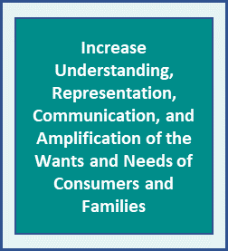
Goal #7:

Support access to services and programs for youth and adults with I/DD, with a preference for evidence-based practices to increase positive outcomes.

Objective #1: To improve the transition from school to adult services, foster collaborations among schools, adult service providers, young people with I/DD, and other stakeholders.

Objective #2: Emphasize flexible support for people with I/DD and their families to enhance their ability to live together, to transition to greater independence when and if they choose, and to be as connected to their communities as possible.

COMMUNITY ENGAGEMENT & ADVOCACY
Increase Knowledge of Available Local Resources
Community Awareness and Integration

Increase Community Integration, Anti-Stigma,
and Full Community
Inclusion
Goal #8:

Promote inclusion and respect of people with I/DD, through broad based community education efforts.

Objective #1: Continue efforts to challenge stigma and discrimination, such as the Alliance for Inclusion and Respect and disABILITY Resource Expo: Reaching Out for Answers. Continue to engage with student groups on related research projects and discussions.

Objective #2: Participate in and promote other community education initiatives, such as walks, forums, and presentations to raise awareness, improve cultural competence, and cultivate acceptance, inclusion, and respect.

Objective #3: Support the continued awareness and understanding of developmental disabilities through sustainable self-advocacy and family support organizations, especially those comprised of parents and persons with the most prevalent intellectual/developmental disabilities. Encourage groups’ community education efforts to reduce stigma/promote inclusion and collaboration with Cultural and Linguistic Competence Coordinator on outreach and engagement strategies.

Objective #4: Encourage and support efforts to integrate people with I/DD more fully into community life in Champaign County. Emphasize inclusion as a benefit to all members of the community, regardless of ability.

Objective #5: Encourage efforts to support people with I/DD in meaningful work and non-work experiences in their community, driven by their own interests. Investigate and develop strategies for engaging employers and other community partners.

Objective #6: Engage with the community college and university toward creating opportunities for people with I/DD and amplifying efforts to reduce stigma and increase inclusion, including through the School of Social Work Community Learning Lab and similar opportunities.

Objective #7: Support development of web-based resources to make information on community services more accessible and user-friendly.

Objective #8: Increase knowledge, of the broader community, of available local resources to broaden support and advocacy for local provider agencies by the community at large.

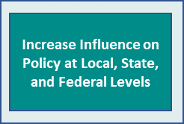
Goal #9:

Stay abreast of emerging issues affecting service and support systems and access to services and be proactive through concerted advocacy efforts.

Objective #1: Advocate for workforce development and stability, in coordination with people with I/DD.

Objective #2: Intensify advocacy efforts on behalf of people with I/DD. Advocate for positive change in state funding, including increased Medicaid reimbursement rates and policy decisions affecting the local system of care for persons with I/DD. Through participation in appropriate associations and organizations, support efforts to strengthen service and support systems.

Objective #3: Track implementation of relevant class action suit settlements, such as the Ligas Consent Decree. Advocate for the allocation of state resources sufficient to meet needs of people returning to home communities from state DD facilities. Encourage development of least restrictive residential options for people transitioning from large facilities or selected from PUNS. For people not yet selected, and for those who have chosen Home-Based Support rather than CILA, advocate for the state to create flexible options.

Objective #4: Follow state and federal Olmstead cases, implementation of the Workforce Innovation and Opportunity Act, Home and Community Based Services guidance, and the local impact of each.

Objective #5: Monitor changes in the Medicaid waivers and Medicaid/Managed Care, and advocate for increased service capacity sufficient to meet demand in Champaign County.

Objective #6: Continue broad based advocacy efforts to respond to reductions in state funding or changes in service delivery, reimbursement rates below actual cost, including transportation rates, and delayed payments for local community-based intellectual and developmental disability services and supports and to the broader human services network under contract with the State of Illinois. As opportunities arise, participate in planning and policy development with state agencies such as IDHS, and use these opportunities to advocate for the needs of Champaign County residents.

Objective #7: In addition to the monitoring and evaluation of funded programs, encourage organizational change strategies which not only align with new and anticipated federal and state requirements but also result in the highest quality personal outcomes for people with I/DD, their families, and those most closely involved in their lives.

Approved December 15, 2021

