Champaign County Mental Health Board (CCMHB),

Champaign County Board for Care & Treatment of Persons with a Developmental Disability (CCDDB), and

I/DD Special Initiatives Funds
___________________________________________________________________

Application Instructions for PY2024
___________________________________________________________________

Getting Started Registration, Agency and Board Details, Applications pages 1 - 3
Tips We Hope You Find Helpful pages 4 - 5
Step 1: Name Each Program for which Funding is Sought pages 5 - 6
Step 2: Agency Forms (one of each, per agency, per fund) pages 7 - 11
Step 3: Program Plan Narrative (one form per program) pages 11 - 15
Step 3 continued: Financial Forms (one of each per program) pages 16 - 25
Appendix A: Cultural and Linguistic Competence Glossary pages 26 - 28
Appendix B: Program Plan Narrative Glossary pages 28 - 30
Appendix C: Identifying Measurable Consumer Outcomes pages 30 - 31
Appendix D: Program Financial Forms Glossary pages 32 - 37
___________________________________________________________________

Getting Started
___________________________________________________________________

Registration:
Organizations seeking funding from any of the three funds complete an Eligibility Questionnaire and registration process at http://ccmhddbrds.org and receive email notification of successful registration. This process is required once per organization, through CCDDB, I/DD Special Initiatives, or CCMHB, and establishes an “Agency Home Page” through which the Agency Director and assigned Agency Users create and complete the forms required for an application for funding. Requests for technical assistance may be directed to Board staff, as early as possible during the application period.

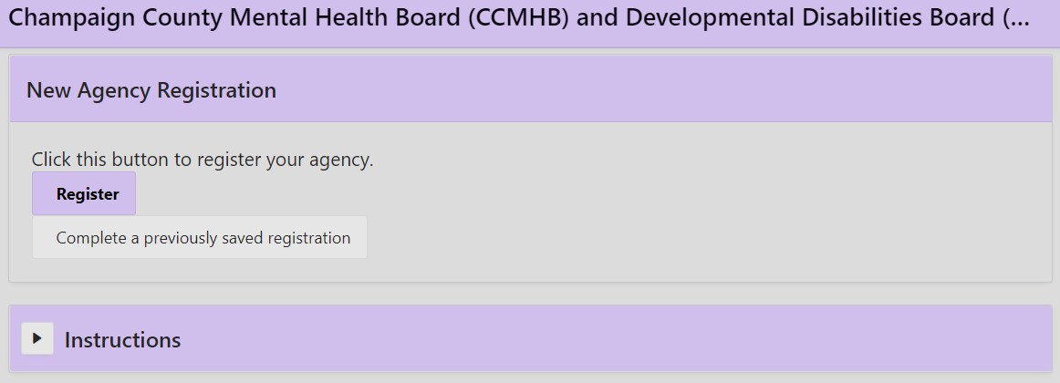
Clicking on “Register” will take you to this section:

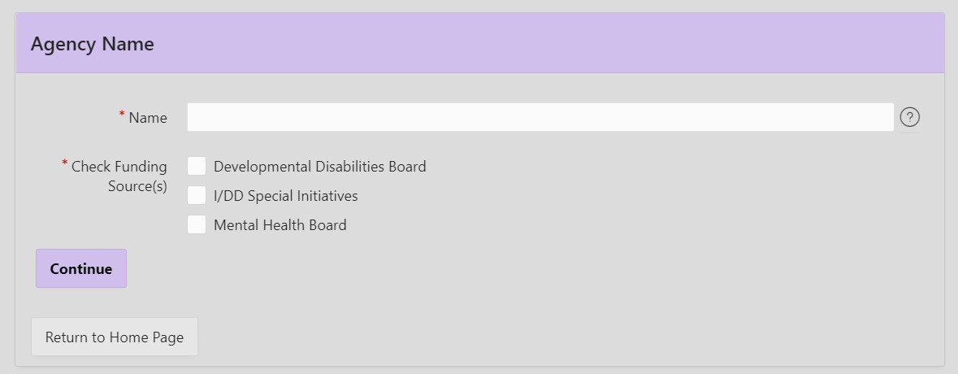

After entering an agency name, selecting a fund source, and clicking “Continue,” you will be asked to read and acknowledge the Funding Requirements and Guidelines for either the CCMHB or the CCDDB, to enter basic agency details, and to complete the Eligibility Questionnaire for that board.

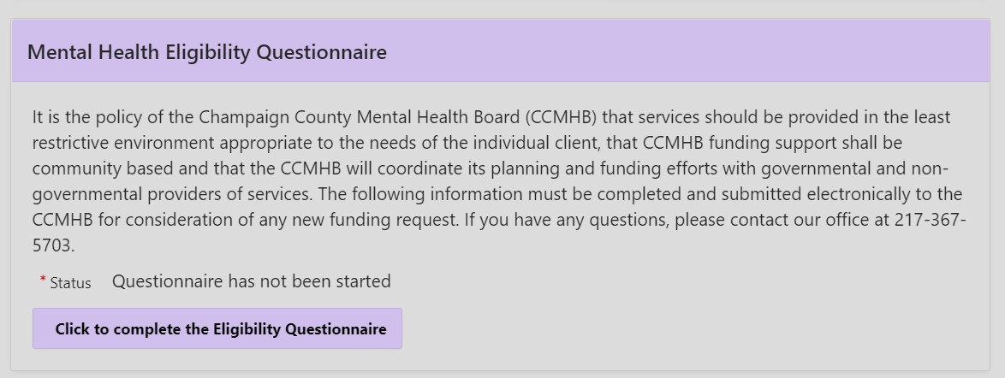

The Eligibility Questionnaire also serves as a self-assessment of alignment with Board policies and readiness to meet contract requirements. Misrepresentation may disqualify an applicant or invalidate a subsequent contract. A Financial Accountability Checklist, posted on http://ccmhddbrds.org, also supports agency self-assessment but is not completed as part of an application.

If you would like to review the CCDDB or CCMHB Funding Requirements and Guidelines for Allocation of Funds prior to beginning the registration process, these documents can be found at https://www.co.champaign.il.us/mhbddb/PDFS/DDB_Funding_Guidelines_122021_FINAL.pdf and https://www.co.champaign.il.us/mhbddb/PDFS/MHB_Funding_Guidelines_122021_FINAL.pdf)

Provide identifying details about the Agency, such as contact information for the director and another staff person. Emails assigning a temporary registration ID and later confirming successful registration will be sent to the email address entered for Agency Director. Once registered, you will have an Agency Home Page, with a welcome statement followed by downloadable files, Agency Details, and Board Members list. A sidebar to the left allows navigation to Application forms and other sections.

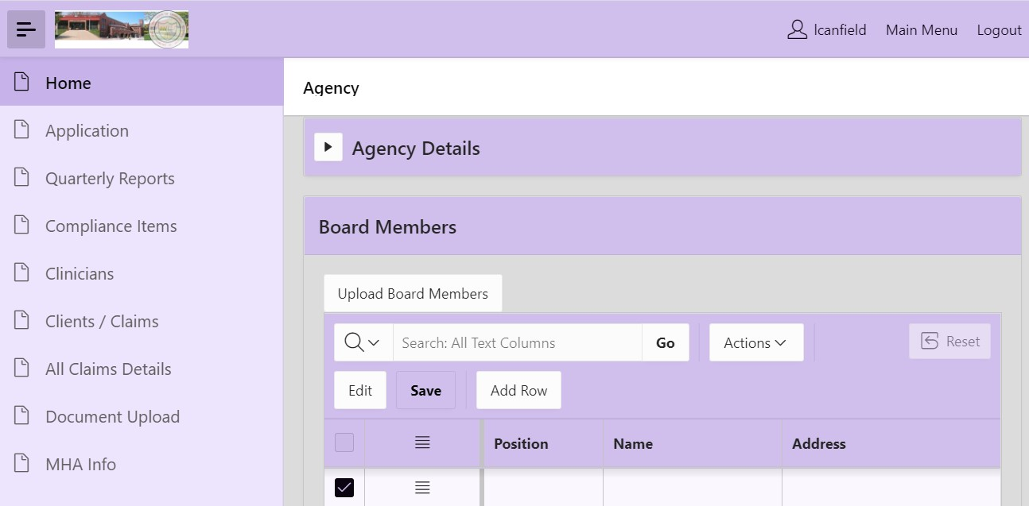

Agency Details: These should be updated whenever there are relevant changes.

Board Member List: The required Board Member List has been relocated to the Agency Home page, directly following the Agency Details section, where it may be revised at any time. Include current information on the agency’s governing board using the online format. Previously registered and currently funded organizations should update this list at the time of application and as needed throughout the program year. New agencies will fill in the blank form. At the top of the Board Member list, select “Add Row” to create an entry for each member; the information can also be uploaded from an excel document. Employees or their relatives cannot serve on an Agency Board, and at least one member must reside in Champaign County.

Application Components: Agency Directors and Users should coordinate to complete all components of the application, including program and financial forms for each separate request for funding. Inaccurate, incomplete, or misleading information may be justification for rejecting an application, voiding a contract, or revising forms during contract negotiation. Attachments should not be included unless requested. The deadline for submitting all forms for CCDDB, I/DD Special Initiatives, or CCMHB funding requests is 4:30 PM CST Friday, February 10, 2023. Applications will not be accepted after the deadline.

A complete application will include the following forms, listed in the order they appear on the system:

Agreement for Interagency Cooperation (one per agency per fund)
Cultural and Linguistic Competence Plan (one per agency per fund)
Program Plan Narrative (one per program)
Personnel Form (one per program)
Revenue Form (one per program)
Expense Form (one per program)
Budget Narrative (one per program)
Authorization and Cover Form (one per agency per fund)
__________________________________________________________________

Tips we Hope you Find Helpful
___________________________________________________________________

- Start early. Even though the application period is nearly five weeks, the content required for some forms is complex.

- Reflect on the Eligibility Questionnaire. If this self-assessment revealed that your organization is not fully qualified or prepared, consider how all requirements will be met.

- Read these application instructions in their entirety. They address expectations and relationships between forms. If something is not working as expected, the cause might be a system error, a user error, or poorly written instructions. In any of these cases…

- Contact CCDDB-CCMHB staff early during the registration/application period for any technical assistance. Staff are not able to advise on the content of an application during this period but will explain how the forms work and trouble-shoot with the developer as needed.

- Save Often with “Save My Responses (Do not submit yet).” Logout occurs after a time when there is no movement between sections. If the system logs out, you will be unable to retrieve unsaved information. Selecting “Save” allows you to return later for editing or review.

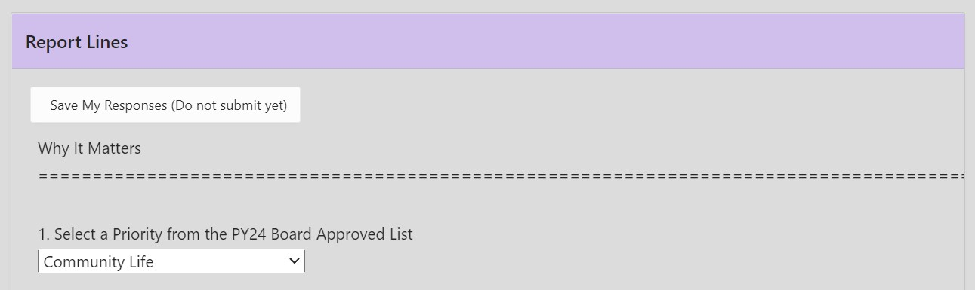

- “Submit my Responses” has a double prompt and will prohibit further edits once the form is submitted. If further edits are needed, the form can only be opened by CCDDB/CCMHB staff, who are only available during business hours.

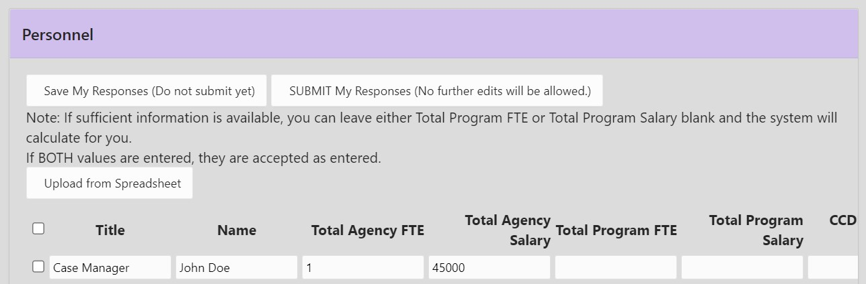

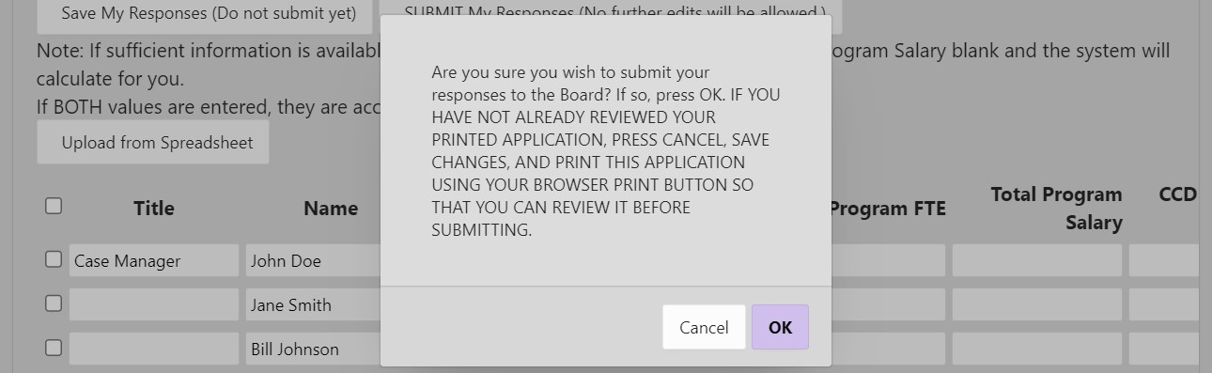

- The “Submit” button may not appear on some forms, e.g., Program Plan Narrative, until all required (yellow) boxes have an entry.

- Exceeding a word or character limit may generate an error message when attempting to “Save” or “Submit.” If this occurs, the section should be edited so as not to exceed limits. Be advised that copying and pasting from Word documents to the online forms can add characters, which skews the character count and exceeds space limits. Please observe character limits, as future processes are hindered by excessive content, even if the initial application allows it.

- Print and download options are available for each form. You may use these for your records or to share with agency staff and board members. No printed documents need to be submitted to the CCDDB-CCMHB office, as all are submitted online.

___________________________________________________________________

Step 1:

Name Each Program for which Funding is Sought
___________________________________________________________________

On the left side of the Agency Home page is a collapsible column with tabs for: Home; Application; Quarterly Reports; Compliance Items; Clinicians; Clients/Claims; All Claims Details; Document Upload; and MHA (for ‘mental health authority’) Info. Applicants will focus on the first two options.
- Click on “Application”.
- Select the Board (i.e., fund) to which an application will be submitted, preferably the fund with the most closely aligned priorities and criteria. Each of the three funds’ PY2024 Allocation Priorities document can be downloaded from http://ccmhddbrds.org or https://www.co.champaign.il.us/mhbddb/PublicDocuments.php. If requesting funding from more than one of the CCDDB, I/DD Special Initiatives, or CCMHB funds, a new registration is not required, but a full set of application forms is.
- If the Fiscal Year has not defaulted to 2024, please select it from the dropdown.
- Just below these two dropdown selections is a graphic titled “Percent Complete” which will turn green when all forms have been submitted. If the bar is green but not labeled 100%, an extra form may be present, which you may delete if in Pending status or notify CCDDB-CCMHB staff if Submitted (e.g., if there is a reason to keep it or if they should delete it).

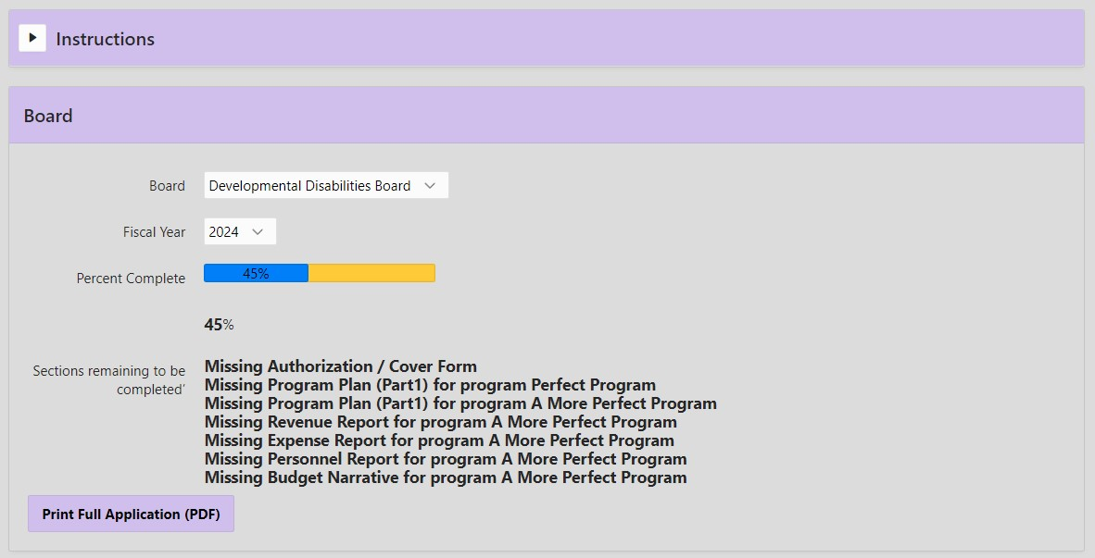

PROGRAMS

To create a new application, go “Step 1: Please enter the programs for which funding is desired.” Under the subhead “Programs,” click “Create.” Fill in the name of the program for which funding will be requested and again click “Create.” The amount of funding being requested will be added when the associated program’s Revenue Form is submitted.

Repeat the naming process for each program for which funding is to be requested from the CCDDB, I/DD Special Initiatives, or CCMHB fund. You may add a new program to the list at any time. Each program established in this list requires a Program Plan Narrative, Personnel Form, Revenue Form, Expense Form, and Budget Narrative to be prepared and submitted.

If later you choose not to complete a request to fund a particular program, delete that program name.

If you submitted an application in the prior year, all forms have been cloned and can be edited for the new application cycle. These may be accessed by selecting the appropriate Board and Fiscal Year and viewing forms which are in “Pending” status.

Review and edit cloned forms, updating dates, targets, and other relevant details, and selecting a PY2024 priority category. To change the name of a cloned program, go to “Step 1,” select “Edit” next to the name, enter the new program name, and “Save.” It will appear on each associated form.

To delete a cloned application, you have chosen not to submit, first delete each of the program-specific forms under “Step 3” by selecting “Edit” and then “Delete All Responses (start over),” after which the “OK” prompt will appear. Before clicking OK, be sure you have selected the form you mean to delete. Once all corresponding forms are removed, the program name may be deleted as well. Return to “Step 1,” select “Edit,” then “Delete” (and “OK” when prompted.) Cloning is intended as a convenience, but this is not always the case.

If you have a two-year contract for PY23-PY24, do not delete cloned forms. They should be revised and submitted prior to June 2023. Consult with CCDDB-CCMHB staff on the details of this process.

__________________________________________________________________

Step 2:

Agency Forms (one of each, per agency, per fund)
___________________________________________________________________

To start working on a required form, select “Create” next to that form’s name. Select the relevant program name from the dropdown menu (which will include all of the program names you created), and then select “Create.” The Agreement for Interagency Cooperation, Cultural and Linguistic Competency Plan, and Authorization & Cover Form are part of the overall Agency Plan and need only be completed once for the full application to be complete, per fund (CCDDB, I/DD Special Initiatives, or CCMHB). Print options are available for each.

AGREEMENT FOR INTERAGENCY COOPERATION

This form must be agreed to by the Agency Executive Director. The Agency Plan is considered incomplete if this form is not in the application packet submitted online.

CULTURAL AND LINGUISTIC COMPETENCE PLAN

The Cultural and Linguistic Competence Plan (CLCP) is designed to ensure that policies and practices support the needs of diverse populations currently receiving or seeking services as well as those who are employed by the applicant organization or serving on its board of directors. The agency CLCP should provide examples of specific tasks and responsibilities associated with the National Culturally and Linguistically Appropriate Services (CLAS) Standards: Principal Standard; Governance Leadership and Workforce; Communication and Language Assistance; and Engagement, Continuous Improvement, and Accountability. See Appendix A below for CLC definitions and full descriptions of each CLAS Standard.

The CLCP is structured such that specific action steps are created for all levels of an agency, including policy and governance, administrative, practice, and individuals served. This format also reflects the importance of a team approach and shared responsibilities in the development of a culturally and linguistically responsive organization. Everyone, including the members of the board of directors or formal decision-making body, is responsible for prioritizing cultural and linguistic competence throughout an organization. Remember, this is a journey not a destination.

The CCDDB and CCMHB will review the CLCPs submitted with PY24 funding applications, with attention to action steps for each of the following:
- Annual Cultural and Linguistic Competence training
- Recruitment of people with diverse backgrounds and skills for the Board of Directors as well as the workforce
- Cultural Competence Organizational or Individual Assessment/Evaluation
- Implementation of Cultural Competence Values and Trauma Informed Practices
- Outreach and engagement of underrepresented and marginalized communities defined in the criteria in the program application
- Interagency collaboration
- Language and communication assistance

Agencies currently receiving CCDDB or CCMHB funding should review and update their current plan, using the online form now available. Organizations not currently funded will complete this online form as part of the application. All CLC Plans must be submitted using the online form. The following sections describe accountability and participation required at various levels of the service system: individuals and families, providers of services, policymakers, family organizations, community stakeholders, and collaborating agencies. A Glossary of terms is at the end of this section.

To generate the CLCP form online, select “Create.” You will submit only one completed CLCP form, though it is possible to create several. Please delete any duplicates or partially completed forms prior to finalizing your full application. You only have to submit one CLCP per organization, per fund, even if applying for more than one program. Remember to save often using “Save My Responses.”

Area: Select one from the dropdown of “All Areas.” Each will be used, with different applicable standards and individualized actions, timeframes, responsible people, and benchmarks.

Applicable Standards: For each Area, check the box next to the relevant CLAS Standard (see Glossary below for full details). The Standard provides direction for the development of all action steps within the CLCP table, capturing measures/benchmarks which reflect the organization’s journey toward cultural and linguistic competence. Click on “Save” to develop the content.

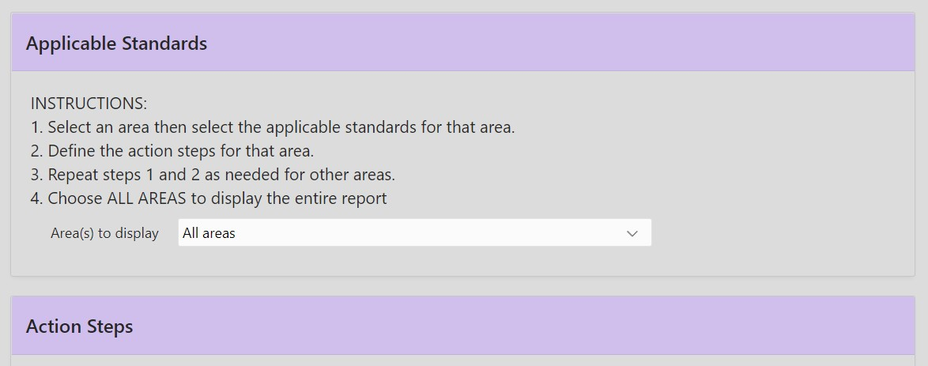

Action Steps: Select “Add Row” and fill in each of the following sections. Protect your progress by saving periodically. Sections may be edited using the “Edit” button.
Action Steps: Explicitly state the measurable and time-sensitive tasks to be completed within a year by those responsible at each level of accountability.
Time Frame: Provide task completion dates and the frequency of tasks conducted more than once. Time frames for task completion should fall within the same period as the funding request.
Responsibility: Indicate specific individuals within the organization who will be responsible for the implementation of culturally and linguistically responsive practices.
Benchmarks: Offer observable indicators of progress in reaching or measuring the goal. A benchmark for training on cultural and linguistic competence might be: 100% of the board/staff have received Cultural Diversity training by January or within 6 months of hiring.
Applicable Standard: Provide a CLAS Standard that would match the action step that is outlined in the CLC Plan. You may use a CLAS Standard more than once.

Once all fields are completed, save and select the next Area, repeating these steps until each Area is addressed.

- Governance, Leadership, and Workforce
Standard 4 - Educate and train governance, leadership, and workforce in culturally and linguistically appropriate policies and practices on an ongoing basis.
Action Steps | Time Frame | Responsibility | Benchmarks
1.1 Allocate funding/resources for annual cultural and linguistic competence training. | Quarter 1 PY24 | Governing Board | Staff will be allowed 8 hours per year for cultural and linguistic competence training.
Annual Training will be provided to Board, Leadership, and Staff | Quarter 2&4 | Management  Leadership Teams
- Communication and Language Assistance
(All actions in this section should be based on Standards 5-8)
5. Offer language assistance to individuals who have limited English proficiency and/or other communication needs, at no cost to them, to facilitate timely access to all health care and services.
6. Inform all individuals of the availability of language assistance services clearly and in their preferred language, verbally and in writing.
7. Ensure the competence of individuals providing language assistance, recognizing that the use of untrained individuals and/or minors as interpreters should be avoided.
8. Provide easy-to-understand print and multimedia materials and signage in the languages commonly used by the populations in the service area.
Action Steps | Time Frame | Responsibility | Benchmarks
2.1. Develop a directory of local providers, organizations, and other community supports.
2.2 A list of qualified interpreters will be provided for the staff and clients to ensure quality care.

Action Steps | Time Frame | Responsibility | Benchmarks
3.1. Read and sign agreement that CLCP has been read and practices will be implemented within the designated time period.
Organize a Cultural and Linguistic Competence Committee with authority to monitor goals of CLCP and create action steps.
Assess and modify the physical facility to reflect the population of focus, to be welcoming, clean, and attractive by providing cultural art, magazines, refreshments, etc.

- Engagement, Continuous Quality Improvement, and Accountability
9. Establish culturally and linguistically appropriate goals, policies, and management accountability, and infuse them throughout the organization’s planning and operations.
10. Conduct ongoing assessments of the organization’s CLAS-related activities and integrate CLAS-related measures into measurement and continuous quality improvement activities.

- Consumer and Individual Level
Principal Standard:

Provide effective, equitable, understandable, and respectful quality care and services that are responsive to diverse cultural health beliefs and practices, preferred languages, health literacy, and other communication needs.

Action Steps | Time Frame | Responsibility | Benchmarks
Conduct regular satisfaction surveys/feedback for clients to discuss services that were delivered.

AUTHORIZATION & COVER FORM

The system will track the status of funding requests at the top of the application page, with a color-coded bar and a list of forms to be completed. The application deadline appears there, as well as within subsections. The tracking function will not show the application to be 100% complete until you have submitted all forms and the Authorization & Cover Form, which is created in “Step 4” on the Application page.

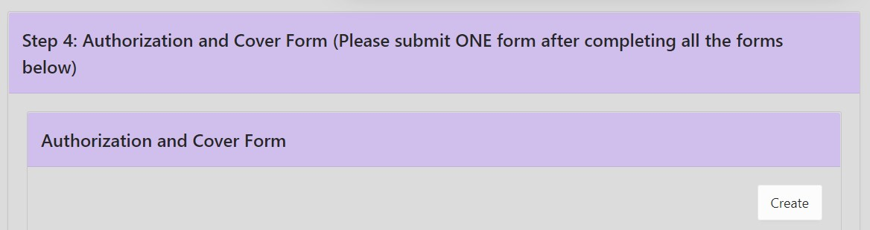

The Authorization & Cover Form is the third of the three forms required per agency, per fund. It also summarizes tasks completed and remaining. Submission of this form is the final step of the funding application process. You will not be able to submit this form until all others have been submitted. An application is not complete until this final form has been submitted.
_________________________________________________________________

Step 3:

Program Plan Narrative (one form per program)
__________________________________________________________________

The Program Plan Narrative should be a clear and succinct description of the program for which funding is requested. If an applicant seeks funding for multiple programs, a Program Plan Narrative is required for each. Include essential details in response to the prompts. Protect your work by selecting “Save My Responses” often. Remember that copying and pasting from other documents into sections with space limitations may result in loss of content due to additional characters inserted by the originating word processing software.

“Create” a new Program Plan Narrative or “Edit” one which was cloned or previously saved. Agency Name is automatically added. To the right of “Program” will be a dropbox with Program Names entered in “Step 1.” Select the appropriate program name and then “Create.” In the created or saved form, any area highlighted in yellow requires a response. Note that the Status is Pending.

Why It Matters
- Select a priority from the dropdown list of PY2024 Board Approved Priority Categories. For programs serving persons with I/DD, apply to the CCDDB and select the priority best aligned. If I/DD and targeting one of the specific project/priority areas, apply to the I/DD Special Initiatives fund and select the project/priority. If I/DD services for Very Young Children and their Families, apply to the CCMHB. For CCMHB funding, select the priority most closely aligned with the proposed program.
- In 100 words or fewer, describe how this proposal aligns with the selected priority. If more than one PY2024 priority is relevant but not to be captured in a separate funding proposal, you may include a comment to that effect.

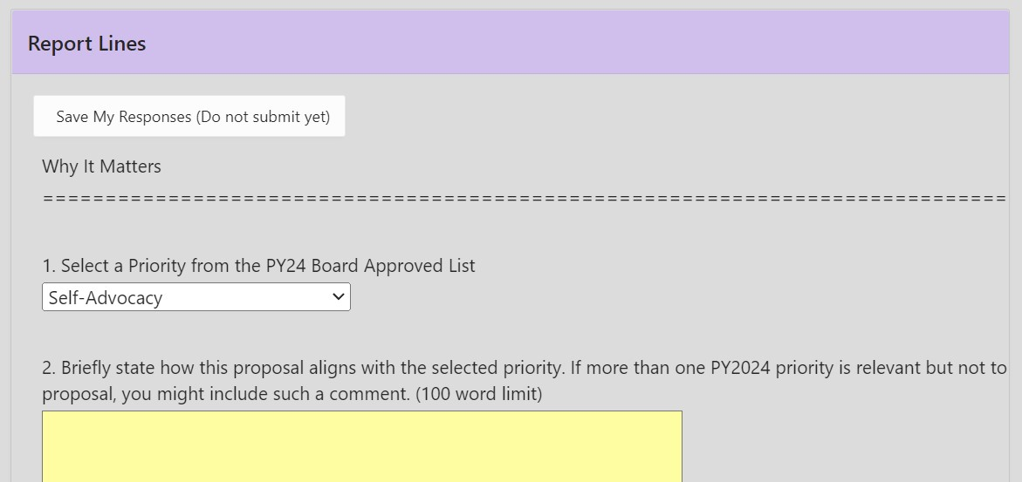

Who Will Benefit
- In 100 or fewer words (not including the “Required Eligibility Criteria for Funded Services” statement in the form), identify the target population your program will serve and your rationale for this focus. Rationale may be based on empirical research, local needs assessment, or other cited source.

Scope of Services
- In 300 or fewer words, describe all program services or link to agency website describing these; then identify the specific activities or supports to be funded by the CCDDB, I/DD Special Initiatives, or CCMHB and how these will allow the program to achieve its goals or outcomes. Include details on how the person being served contributes to the plan for their services.

- Are similar or related services/supports available to this target population through another organization in Champaign County? YES/NO

- List similar/related services and the organizations offering them. (250 word limit)

- How will your organization’s proposed program coordinate or partner with these providers on behalf of the target population? (200 word limit)

- List all organizations with which you have written working agreements. (200 words)

- Cite the evidence-based, evidence-informed, recommended, promising, or innovative practice featured in the proposed service(s) or support(s), including a link. (250 words)

- List staff qualifications, credentials, and/or specialized training. (200 word limit)

- Identify where the proposed service activity or support will occur. Describe virtual options and any training available for staff and clients using them. (200 word limit)

Eliminating Disparities and Promoting Inclusion
- How will this program engage and serve residents of rural areas of Champaign County, especially medically underserved townships? Does the program place a priority on serving rural residents? Statements such as “the program serves all residents of Champaign County,” without an explanation of how people are to be engaged, are not sufficient. (200 words)

- Where will rural residents be served? Include any virtual options. (100 word limit)

- How will this program engage and serve people who are members of historically underinvested (e.g., racial, ethnic, and gender minority) populations? Statements such as “the program serves all people regardless of race or ethnicity,” without an explanation of how people are to be engaged, are not sufficient. (200 word limit)

- Where will people from underinvested groups be served? Include any virtual options. (100 word limit)

- On behalf of the target population, how will the program promote inclusion, reduce stigma or discrimination, or improve access to the community? (200 word limit)

PROGRAM PERFORMANCE MEASURES
Describe specific performance outcomes that your program, if funded, will later report on (some quarterly and others at end of year). CCMHB/CCDDB required outcomes focus on three areas: consumer access, consumer outcomes, and utilization data. Applicants must project estimated outcomes. Incumbent applicants must report actual performance in relation to what was projected. The most effective outcomes are directly impacted by program activities, are quantifiable, and can be measured in some way. For more information, definitions, and resources on this topic, please see Appendix B and Appendix C, below. Remember to save often using “Save My Responses.”

Consumer Access
Your responses in this section will detail the ways your program will determine how people find and engage with your services. All questions require an answer - text, numeric, or YES/NO.

- List the eligibility criteria for this program. E.g, “People from the ages of 16-65 years old with depression are eligible for our program.” (100 word limit)

- How do you determine if a person meets criteria? E.g., confirmation of PUNS enrollment, self-report from potential participants, proof of income, specific score on an assessment, “We use a cut-off score of 5 on the PHQ-9, which is a short depression screener.” (100 word limit)

- How do eligible people learn about this program? E.g., through outreach events, from referral. If through online media, explain how the audience is reached. (100 word limit)

- Estimate the number of days from the date a person is referred or seeks assistance to the date of completion of assessment of eligibility and need. (numeric)

- Estimate the percentage of people referred or seeking assistance for whom an assessment will be completed within the identified time frame. (numeric)

- Estimate the number of days from the date of completed assessment to the date of first engagement in services. (numeric)

- Estimate the percentage of eligible persons who will engage in services within the identified time frame. (numeric)

- Estimate the average length of time of participant engagement in services or supports. Identify and use the unit most appropriate to this program. (20 word limit)

- Beyond the required race, ethnicity, age, gender, and zip code information, what demographic data will you collect? (100 word limit) Note: Demographic information on program participants’ race, ethnicity, age, gender, and zip code are required to be reported quarterly. Your program may find that it is important to collect other demographic information as well. While not required, there is space in the comment section of the quarterly reports for you to provide this information.

Client/Participant Outcomes

Your responses in this section will detail the ways your program will impact people who engage with your services. The impacts you want your program activities to have on participants are referred to as ‘outcomes’. If you currently report outcomes to other funders or organizations, you may use those here if they are appropriate (i.e., if they are quantifiable, measurable, and directly impacted by program activities).

- What impact will this program have on the people it serves? Number each outcome and identify a numeric target and time frame for each. (300 word limit)

- For each of these outcomes, list the specific survey or assessment tool to be used to collect information on the outcome and indicate who will provide the data. Associate each with a Numbered Outcome. (300 word limit) What process will you use to measure outcomes? You may want to use pre/post tests, or quarterly assessments, or information from some yearly record. Do you plan to measure this outcome using data from a survey, or assessment tool, or interview, or another method? The tool used should be evidence-based or empirically validated. For more information on what that means and potential tools, see the Glossary at the end of this section.

- Will outcome information be gathered from (or on behalf of) every person who receives the service/support? YES/NO

- If NO, how will you choose the people whose outcome information will be collected and reported? (100 word limit)

- How often will outcome information be collected? (20 word limit)

Utilization
Here, you will explain service categories your program will report. Programs do not need to collect and report on every category. Instead, pick only the ones that are most useful for understanding program impact. You may be counting multiple activities or only reporting one activity within a particular category, but an explanation should be provided of what types of activities are being counted in the respective category. Incumbent programs may use service categories from the previous year’s plan, projecting targets for the new program year based on past performance. For more information on the categories, see definitions in the Glossary.

Give a short description for each category you plan to collect and report on, as well as the projected (numeric) target for that category. Indicate “n/a” if you will not report on a given category.

- Treatment Plan Clients (TPC), people whose services are guided by a written, individualized treatment plan. (100 word limit, include a numeric target)
- Non-Treatment Plan Clients (NTPC), people who receive a service or support not related to such a plan. (100 word limit, include a numeric target)
- Community Service Events (CSE), available to the public to raise awareness of the program or issues it addresses. (100 word limit, include a numeric target)
- Service or Screening Contacts (SC), episodes of contact with people served or screened. (100 word limit, include a numeric target)
- Other, may be hours of direct service or other target relevant to program. (200 words, include a numeric target and sufficient description)

Service Fees and Other Sources of Funding
- What other payment sources are available for this service/support? (100 word limit) This includes private and public insurance, other grant or FFS funding, and private pay/self-pay. It is important because the CCMHB and CCDDB should always be treated as the payor of last resort, using other available pay sources to support program activities whenever possible.
- Do the people served pay a fee? YES/NO
- Does the program use a sliding fee scale? YES/NO
- Sliding Fee Scale, if applicable (200 word limit) If some or all clients are asked to pay fees, enter the fee scale here.
- Is program eligible and willing to participate in DD Waiver programs (e.g., CILA, HBS)? (CCDDB and I/DD Special Initiatives application question) Is program eligible and willing to participate in Medicaid programs? (CCMHB application question)

__________________________________________________________________

Step 3, continued:

Financial Forms (one of each, per program)
__________________________________________________________________

The system will identify any errors when saving or submitting a Personnel, Revenue, or Expense form. Each error must be corrected before the form can be submitted on the system. Do not enter a blank space, letter, or special character in a box in which a number is to be entered in the Personnel, Revenue, and Expense forms. These actions will generate an error message. When saved, the system will insert the $ and comma characters as necessary.

Protect your work by clicking “Save My Responses” often. CCDDB-CCMHB Revenue and Expenses must balance. If the total program projects a surplus or deficit, provide a rationale in the Budget Narrative.

There are specific interactions across some forms. The Personnel form auto-populates a row of the Expense form. The Expense form compares totals with the Revenue form. The Revenue form auto-populates the Program name itself. Save the Personnel form before the Expense form, and save each form before submitting, in case further edits are needed.

Do not neglect a column. The Personnel, Revenue, and Expense forms require agency-level, program-level, and contract-level details, such that each column will include amounts less than or equal to those in the column to its left.

PERSONNEL FORM

“Create” one Personnel Form per proposed program, and provide all information requested. The template has been revised and includes start and end dates for each staff person identified in the matrix. There are three options for entering data: filling in one item at a time; downloading, completing, and uploading an excel spreadsheet; or copying a form from another program.

- If entering one item at a time or adding to an uploaded or copied personnel form, click on “Add Person” to create a row for each staff member/position. Fill in all items as instructed below and select Direct or Indirect as appropriate to each position. Personnel will be categorized, and the subtotal and total costs calculated automatically.

- A downloadable excel spreadsheet is available at the top of the Application page. This may be most useful for large agencies or programs. Use capital letters to identify whether a position is Indirect or Direct and the person Active or Termed (Terminated).

- Copy a personnel form which was submitted for a different program or different fiscal year into the current form and then edited for accuracy. After you “Create” a blank form for the particular program and click on the dropdown selection titled “Form to copy,” you will see a list of submitted personnel forms. Make your selection and click on “Copy Personnel Form.” This will auto-populate many cells for you to use or edit, and it may leave some cells for you to complete.

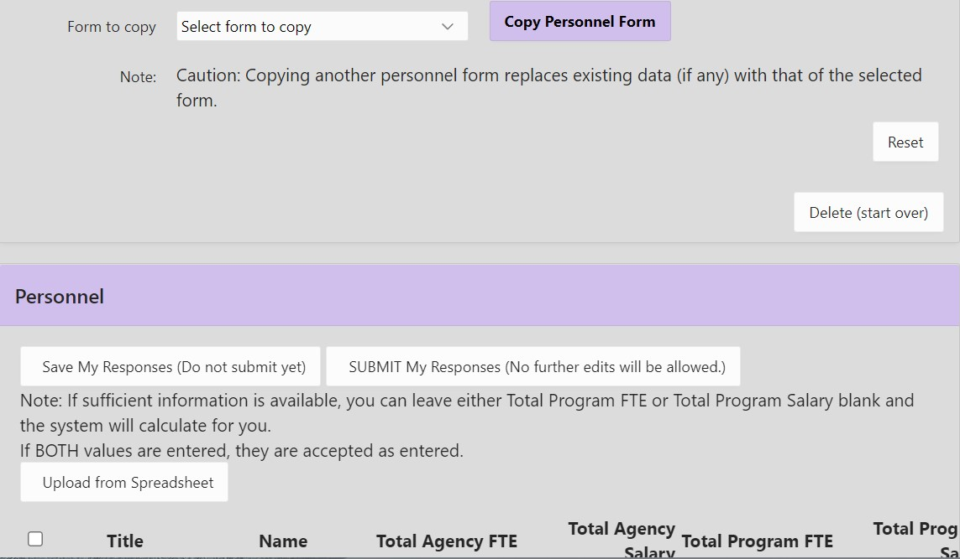

With any of these three options, review and edit entries per the following guidelines. The form projects the number of Full-Time Equivalent staff and salary/wage costs for Total Agency, Total Program, and (CCDDB-CCMHB) Contract for the program year. It also calculates subtotals of Indirect and Direct FTE and costs for Total Agency, Total Program, and proposed Contract.

Select “Save My Responses” often.

Do not enter a blank space, letter, or special character in a box in which a number is to be entered. This action will generate an error message. When saved, the system will insert the $ and comma as necessary.

Individual FTE entries can include decimal points to the hundredth. Entering to the 1,000th (e.g., 0.025) or further will generate an error message. You may “Delete Checked Rows” to correct a mistake without losing other, correct entries.

Salary entries must be whole numbers.

Direct and Indirect personnel not associated with the program seeking funding no longer need to be listed individually in the Total Agency column. They can all be grouped on one line with the Title “Other” to indicate this aggregation. Total FTE can exceed 1.0 and is to represent total number of agency employees whose salary/wage is not allocated to the program. Enter separate lines for Direct and Indirect personnel. A single person may have responsibilities appropriate to both categories, which can be indicated by splitting their time and salary into two entries.

Any staff position with time and cost allocated to the program, whether Direct or Indirect, must be listed individually in the Total Agency column. If an agency is submitting multiple applications, all of the applicant’s personnel forms should individually list all staff assigned to any program for which funding is being sought and account for their time in the Total Agency columns. Then, for those who are assigned to each specific program, account for their time and cost in the Total Program columns. When the position is to be supported in whole or in part by the CCDDB or CCMHB contract, complete the CCDDB-CCMHB contract columns (the rightmost columns).

Personnel listed in the Total Program column and the CCDDB/CCMHB-Contract column are derived from the Total Agency Column. Be sure the information in the Total Agency Column is correct and up to date for program-specific positions.

When you have entered a salary amount or percentage of FTE for Total Program and CCDDB/CCMHB-Contract, the system can calculate the unfilled item for each position, by selecting “Save My Responses.” Or you may enter the salary amount and FTE percentage in each of the spaces for the Total Program and CCDDB/CCMHB-Contract columns.

Title: Enter the title of each position in the agency (e.g., Chief Financial Officer, Receptionist). When more than one employee has the same position title (e.g., Clinician, Program Coordinator), each employee must be listed on a separate line.

Name: Enter the name of the person currently employed in the position. If the position is currently vacant but to be filled, please indicate as such.

Total Agency FTE and Total Agency Salary: For each individual position/person listed, enter the FTE equivalent, not greater than 1.0. Include projected costs for all staff of the Total Agency. If the word “Other” is the position title, indicating aggregated positions, FTE may exceed 1.0; this should ONLY be used if no portion of the staff time or salary is to be attributed to the Total Program or Contract Funding. Annual salary information corresponds to each individual position and employee reported (or the aggregate) and includes the cost of regular hours worked, as well as overtime, vacation, holiday, personal, sick, and other paid leave time.

Total Program FTE and Total Program Salary: Enter the FTE (not to exceed 1.0) and/or the total annual salary attributed to each staff person, including salary for regular hours worked, as well as overtime, vacation, holiday, personal, sick, and other paid leave time. Include projected number of personnel and the costs for all staff involved with the total program.

CCDDB/CCMHB-Contract Funded FTE and CCDDB/CCMHB-Contract Funded Salary: Enter the FTE (not to exceed 1.0) and/or the total annual salary attributed to each position to be funded by the proposed CCDDB or CCMHB contract. Include amounts for regular hours worked, as well as overtime, vacation, holiday, personal, sick, and other paid leave time. Include projected number of personnel and the costs for program staff funded with CCMHB or CCDDB funding.

Type: Select “Indirect” or “Direct” as appropriate. A person may be attributed to both indirect and direct, as long as the totals do not exceed 1.0 and the split is justified in Budget Narrative.

Status: Select “Active” or “Termed” (for Terminated) as appropriate. Because you are proposing a budget, Active will be most appropriate, including for positions currently vacant, to be hired.

Hire Date/End Date: Complete these as appropriate (nearly always “Hire Date” only) for each person currently filling a listed position.

Automatic calculations:
Indirect Totals, FTEs and Salaries: The form completes these calculations using the data you have entered. Indirect Service is defined as administration and support (such as management, fiscal, maintenance) functions. All indirect positions should be listed, regardless of funding source.
Direct Totals, FTEs and Salaries: The form also completes these calculations of your data. Direct Service is defined as activity of direct benefit to the individual, family, or community being served. Examples may include “hands on” care, training, case finding and/or coordination, instruction, counseling, etc. Here also, all direct positions should be listed, regardless of funding source.
Total Salaries and Total FTEs: These calculations are also completed automatically.

Clicking on “SAVE” will update these totals. Once completed, the Personnel Form automatically populates the Salaries/Wages row (all three columns) of the associated program’s Expense Form.

REVENUE FORM

Select “Create.” Then from the dropdown selection, choose a proposed program, and “Create” again. The form you create for each program is a grid, with three columns and fourteen rows or lines. All boxes in yellow must be completed. For each numbered, budgeted source of revenue, enter a whole dollar amount based on the best possible estimate. For the total contract budget, revenues unrestricted by the source must be allocated on a reasonable basis to all contracts, whether or not they are CCMHB or CCDDB funded. An individual revenue form is to be completed for each proposed program. Do not enter a blank space, letter, or special character in any field in the Revenue Form. This action will generate an error message.

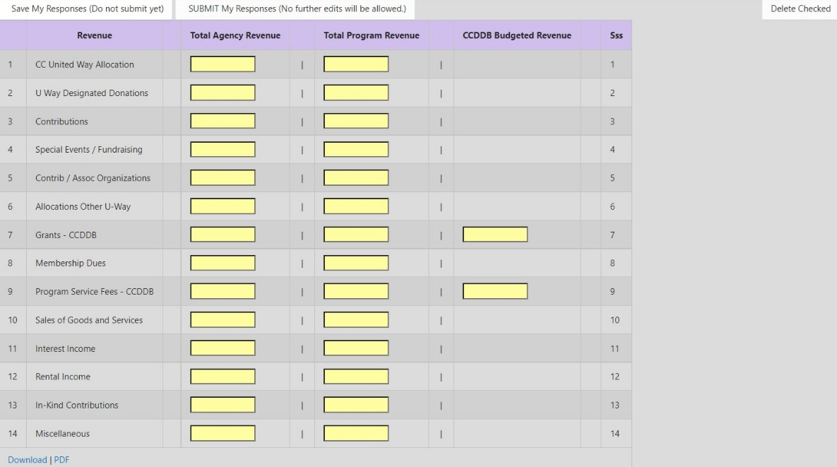
A completed form may be copied from one program to another (and then appropriately edited to the new program), using the “Form to Copy,” dropdown selection, and “Copy Form” function near the top of the form.

An incumbent program requesting increased revenue from the CCMHB or CCDDB should provide an explanation for the increase in the Budget Narrative Form (below).

Instructions per column:
Total Agency Revenue: List all revenue sources for the total agency.
Total Program Revenue: List all revenue sources supporting the program, including the CCMHB/CCDDB request.
CCMHB/CCDDB Budgeted Revenue: List only the CCMHB or CCDDB revenue for this particular program. For a Grant contract, enter the requested amount in Line 7 and zero (0) in Line 9; if a Fee for Service contract, enter zero (0) in Line 7 and requested amount in Line 9.

Instructions per row:
1. CC United Way Allocation: Total Champaign County allocation for the agency fiscal year.
2. United Way Designated Donations: United Way campaign designations.
3. Contributions: Include both contributions specifically earmarked for a particular program which are separate from general contributions and contributions that are not specific to a particular program but are allocated on a reasonable basis to all programs. Revenues unrestricted by the donor must be allocated on a reasonable basis to all contracts including CCMHB or CCDDB funded programs.
4. Special Events/Fundraising: Includes total sales of goods (e.g., T-shirts) directly connected with the event.
5. Contributions by Associated Organizations: Amounts from national, state, and local organizations and/or payments from collaborative operations with other agencies.
6. Allocations from any other United Way: Any and all contributions received from any United Way outside Champaign County.
7. Grants: All grant funds from anticipated funding sources. All revenue listed should be specified as to the source. Sources must be listed individually; DO NOT combine amounts from different sources.
Line 7 is reserved for the CCMHB/CCDDB contract amount for the agency plan fiscal year. Add rows to the report by selecting “Grants” from the drop-down menu (toward the bottom of the form) and then clicking “Create new row for.”
For Line 7, the “Total Agency Revenue” column space is to include all grant revenue requested for all CCMHB or CCDDB programs combined. Line 7 “Total Program Revenue” and “CCMHB/CCDDB Budgeted Revenue” column amounts will be the same.
Adding more lines, 7.1, 7.2, etc. allows you to include grants from other funders. The source and amount from each additional grant must be listed in the Total Agency Column on the form. If funds from other sources will be used in the program, the amount to be used for the program from each additional source must be listed in the Total Program Revenue Column.
8. Membership Dues: Amounts received from organizations for dues.
9. Program Service Fees: Reimbursement fees received for services provided. Sources must be listed individually; DO NOT combine amounts.
Line 9 is reserved for the CCMHB/CCDDB Fee for Service contract amounts for the agency plan fiscal year. Add rows to the report by selecting “Program Service Fees” from the drop-down menu (toward the bottom of the form) and then clicking “Create new row for.”
For Line 9, the “Total Agency Revenue” space is to include all Fee for Service revenue requested for all CCMHB or CCDDB programs combined. Line 9 “Total Program Revenue” and “CCMHB/CCDDB Budgeted Revenue” amounts will be the same.
Add more lines, 9.1, 9.2, etc. to include fee for service revenue from other funders. The source and amount from each additional FFS contract must be listed in the Total Agency Column on the form. If funds from other FFS sources will be used in the program, the amount to be used for the program from each additional FFS source must be listed in the Total Program Revenue Column.
10. Sales of Goods and Services: Sales of any goods where the sale is not directly connected with a special event or fundraising activity. Revenue from sales of goods and services, including workshop or activity products, should be reported here.
11. Interest Income: Investment income.
- Rental Income: Revenue received from other organizations/agencies for facility rental.
13. In-Kind Contributions: Please refer to Appendix D, below, for detail on allowable In-Kind Contributions.
14. Miscellaneous: Include bequests.

EXPENSE FORM

Select “Create.” Then from the dropdown selection, choose a proposed program, and “Create” again. The form you create for each program is a grid, with three columns and nineteen rows or lines. All boxes in yellow must be completed. The Salaries/Wages line (with no yellow boxes) will be auto-populated by the saved or submitted Personnel Form. For each of the rest of numbered, budgeted expense types, enter a whole dollar amount based on the best possible estimate. An individual expense form is to be completed for each proposed program. Do not enter a blank space, letter, or special character in any field in the Expense Form. This action will generate an error message. When saved, the system will insert the $ and comma as necessary.

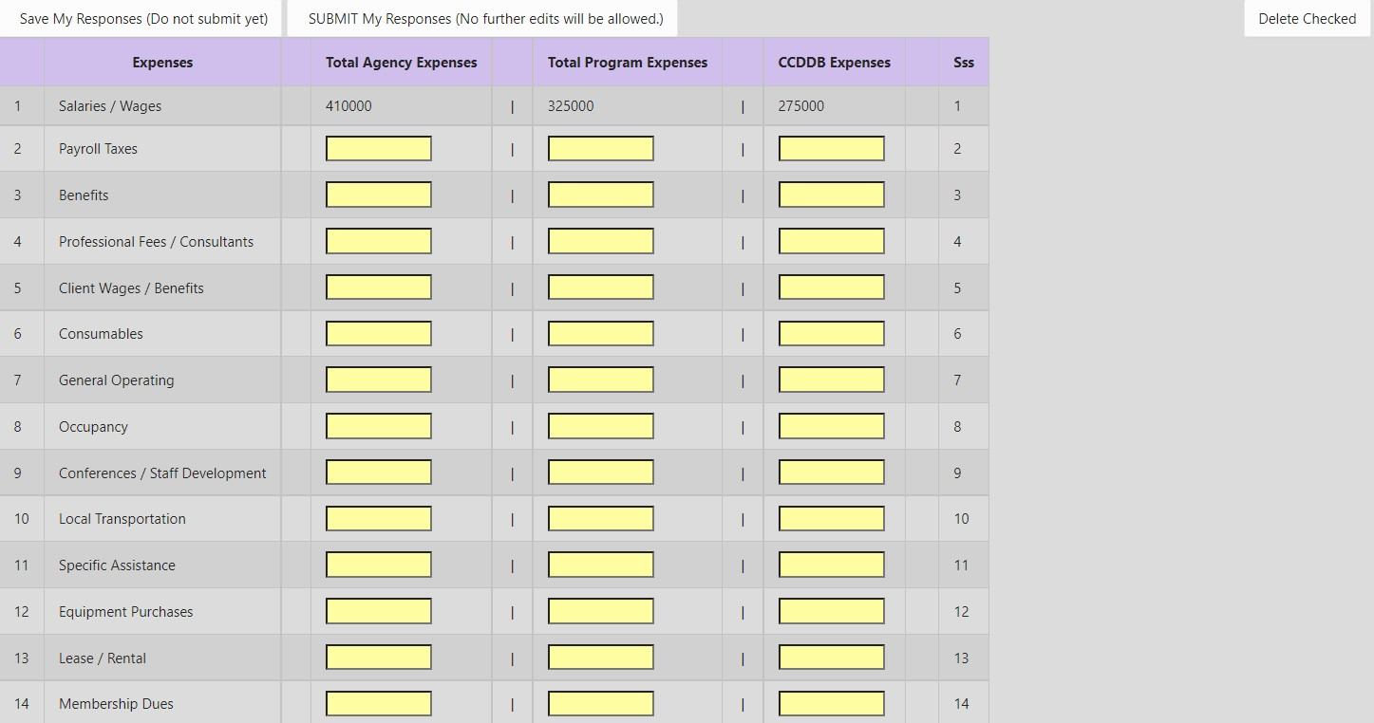

A completed form may be copied from one program to another (and then appropriately edited to the new program), using the “Form to Copy,” dropdown selection, and “Copy Form” function near the top of the form.

Instructions per column:
Total Agency Expenses: Projected expenditures for the total agency.
Total Program Expenses: Projected expenditures for the total program contract with CCMHB or CCDDB. All expenses for the program need to be listed in this column.
CCMHB/CCDDB Expenses: Projected expenditures being paid for by CCMHB or CCDDB budgeted revenue.

Instructions per row:
1. Salaries/Wages: THIS ROW WILL SELF-POPULATE FROM THE PERSONNEL FORM ONCE THE PERSONNEL FORM HAS BEEN SAVED OR SUBMITTED AND THE EXPENSE FORM HAS BEEN SAVED. The figures on this line are the amounts to be paid to regular full-time and part-time agency employees, not including consultants or other professionals engaged on a contract basis. Do include: Salaries and wages, including overtime; Payout for accrued leave time.
2. Payroll Taxes: Examples: employer FICA; employer share of federal income tax and Unemployment/Workman's Compensation.
3. Benefits: Examples: employee health and retirement benefits; accident insurance premiums; life insurance premiums; medical and hospital plan premiums; pension or retirement plan premiums; supplemental payments to pensioned employees; employment termination expenses; and other employee benefits including disability insurance.
- Professional Fees/Consultants: Fees for accounting and payroll services, independent auditors (see Funding Guidelines, Audit Accountability section, or Appendix D, below, for allowable amounts); vocational or academic instruction; psychiatric, psychological, social services, medical care, recreation, rehabilitation or personal care, speech, language, occupational and physical therapy; housekeeping and laundry services; and anyone paid on a contractual basis.
5. Client Wages and Benefits: Total wages and fringe benefits for individual clients paid through agency programs, i.e., clients participating in an agency-administered employment program or paid internship in a community employment setting.
6. Consumables: Office supplies; medicines and drugs; recreation and crafts; educational supplies; food and beverages; kitchen supplies; housekeeping supplies; laundry supplies and linens; workshop supplies; and program support supplies.
7. General Operating Expenses: Include all of the following that apply: telephone/web-based and/or internet services; subscriptions/reference material - cost of purchased publications, technical books, magazines & pamphlets, online subscriptions; postage/shipping - postage, Fed Ex, UPS, trucking, and other delivery expenses along with shipping materials; outside printing - cost of printing, commercial artists and supplies for plates, art work, proofs, photographs and other costs of leaflets, films and other informational or promotional materials; liability/malpractice insurance – cost of all other liability, malpractice, personal injury, and other insurance not reported as property insurance or as employee benefits; and bonding expense.
8. Occupancy Expense: Costs arising from an agency's occupancy and use of land, buildings and offices. The cost of permanent improvements and items of equipment with a unit cost of more than $500 each and having a useful life of more than one year cannot be included. Includes: property insurance - all comprehensive hazard insurance including property liability insurance; electricity, heat & other utilities; janitorial & other maintenance services; building & grounds maintenance supplies; equipment maintenance; and property taxes.
9. Conferences, Staff Development, Conventions, and Meetings: Cost of conducting and/or the attendance of conferences, staff development events, conventions & meetings relating to the agency's activities.
10. Local Transportation: Vehicle Operating Cost - vehicle insurance, license plates, gasoline, repairs and maintenance (do not include depreciation or lease payments); Other Staff Transportation - cost for staff travel, including mileage paid for use of personal vehicles.
- Specific Assistance: Cost of providing individual clients with special necessary needs where the items purchased became the property of the individual rather than the agency. Examples: clothing; allowance; foster parent board payments; client legal expense; necessary appliances; client transportation (e.g., public transportation)
- Equipment Purchases: Equipment items with a unit cost of less than $500 (or greater if specified and approved) or a lower maximum based on established policies of the agency. Do not include capital equipment purchases.
- Lease/Rental: Equipment; vehicles; building rent/lease.
14. Membership Dues: Cost for membership dues paid or payable to organizations that provide services, publications, and materials for the agency’s use.
15. Interest Expense: Interest expense cannot be charged to funding from CCMHB/CCDDB. Interest expense paid from non-CCDDB/CCMHB sources can be included in amounts posted to the total agency column or total program column. The CCMHB/CCDDB column is blocked from use, including: current operating interest; construction period interest; mortgage interest; and equipment interest.
16. Fund Raising Activities: Expenses directly connected with the event.
17. Cost of Production: Expenses directly involved with production costs.
18. Miscellaneous: Awards and Grants - amounts paid or committed to individuals or organizations for the support of research, fellowships, scholarships and other health or welfare programs; Moving/Recruiting - cost of interviewing prospective employees and moving and expense allowance provided to new employees; Amortization of organization and pre-operative costs - (e.g., operation expenses incurred in making preparations for rendering client care before the first client is admitted); Capital Improvements; Equipment with a cost of $500 and above (purpose should be specified and approved).
19. Depreciation: Total allocation of the cost of physical assets over their estimated useful lives. Depreciation expense cannot be charged to funding from CCMHB/CCDDB. Depreciation expense paid from non-CCDDB/CCMHB sources can be included in amounts posted to the total agency column or total program column. The CCMHB/CCDDB column is blocked from use.

For clarification or additional information on allowable expenditures, refer to the CCMHB or CCDDB Funding Guidelines or to Appendix D, below.

At the bottom of the Expense form are comparisons of the Expense and Revenue columns which are updated as the forms are saved.

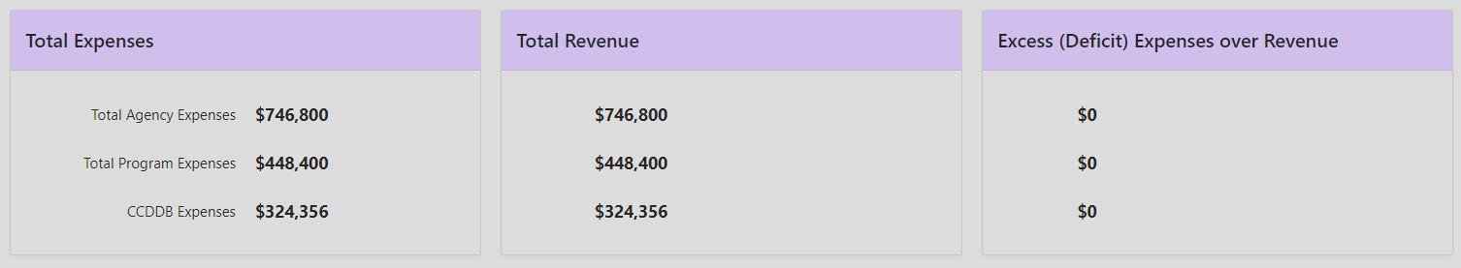

BUDGET NARRATIVE FORM

Applicants must provide a budget narrative that explains each item listed in the budget for CCMHB or CCDDB funds and how the amount was calculated. Agency Executive Directors, Program Directors, and Financial Officers should participate in the development of the budget narrative. Format of the narrative is to include the line item, cost, and one or two sentences to describe use of the funds in relation to the program and how the cost was determined. See below for more details. Line items not thoroughly justified in relation to the program may be deleted from the approved budget. Numbers listed in the budget narrative must match those presented on the Financial Forms (Personnel, Revenue, Expense).

If an increase in funding is requested for an incumbent program, provide a justification for the increase. Include detail on attempts to secure funding from other sources and explanation of why other funding has not been/will not be secured.

Reminder: Exceeding space limits on certain sections of forms may generate an error message when attempting to SAVE or SUBMIT the form. If that is the case, the section needs to be edited. Space remaining in one section (Personnel, Revenue, or Expense) may be used to provide additional space from another section as needed but should be clearly identified.

Remember to save often using “Save My Responses.”

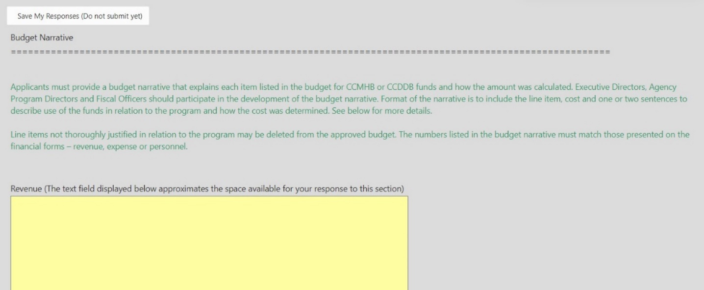
Revenue: Identify other sources of funding for the program by amount and whether funds have been awarded or the status of the request. Clearly state the source of revenue: state, federal, private. Indicate if funds from other sources are renewal of existing contracts, one or multi-year commitments, or initial requests for new or expanded program funding. For CCMHB or CCDDB funds, indicate if they are used as a match and cite the source of the match requirement.

Expenses: Identify the line item, cost for total program, and amount to be paid by CCMHB or CCDDB. Then describe how each line item, particularly the use of the requested funds listed in Column 3 of the Expense Form, supports the program and projected outcomes, and how the cost was calculated. Note: If you wish to submit a GATA approved indirect cost allocation plan with approval letter, clearly indicate in this section that these will be made available to the CCMHB/CCDDB, especially if the plan varies from any of the above requested representations.

Guidance for particular expense line items:
- Professional Fees/Contractual: Explain services to be provided, name of contractor if known or how the contractor will be selected, and how the cost was determined. Audit expense and name of auditor or firm should be listed here. The audit is to be performed by an independent, licensed certified public accountant registered with the State of Illinois. Please note that, for incumbent agencies, the amount budgeted will be for the expense associated with independent audit of the most recent completed contract year. (See Funding Guidelines for more details.)
- Occupancy Expense: Break out the total cost charged to the program by type of expense and then to CCMHB or CCDDB and list the amount. Also describe how the respective amounts to be charged to the contract were determined.
- Specific Assistance: The type(s) and amount(s) of assistance must be described and how client eligibility for these funds will be determined. The applicant must also indicate if the program has a policy or guidelines in place for how these funds are accessed and for what purpose/use.
- Equipment: In those cases where purchase of equipment is requested, justification must be provided linking each described piece of equipment solely to the program and how the cost was determined. If items are the same as purchased within two prior program years, the applicant must explain why the additional items are being purchased. Reminder – equipment items must have a unit cost lower than $500 unless specified for such purpose and approved.
- Miscellaneous: A description is required for each expense included in this line item.

Personnel: Identify key personnel by position and cost for total program and amount to be paid by CCMHB or CCDDB. Describe the activities to be completed in support of the program with the requested funds and explain how the cost was calculated. Describe the relationship between the program services and each staff position to be charged (in whole or in part) to the program contract. Explain how indirect and direct staff positions duties determine how the position is classified. You may reference back to the position and wages/salary on the “Personnel Form – CCMHB/CCDDB Funded” column as a supplement to the narrative statement(s) included here. Items listed here should match amounts included on the Personnel Form.

Additional Comments: Provides optional extra space for explanations of the above. Please indicate clearly which section is continued here.

__________________________________________________________________

Appendix A:

Cultural and Linguistic Competence Plan Glossary
__________________________________________________________________

Definitions specific to CLC are adapted from Cross, Bazron, Dennis & Isaac’s (1989) Towards a Culturally Competent System of Care: A Monograph on Effective Services for Minority Children Who Are Severely Emotionally Disturbed: Volume I and Goode & Jones (modified 2004), National Center for Cultural Competence, Georgetown University Center for Child & Human Development:

Cultural Competence: a defined set of values and principles which are reflected within the behaviors, attitudes, policies, and structures of agencies, family/youth/consumer organizations, providers, and community stakeholders to result in appropriate and effective services for all; the capacity to value diversity, conduct self-assessment, manage the dynamics of difference, acquire and institutionalize cultural knowledge, and adapt to diversity and the cultural contexts of the communities served; and Integration of the above in all aspects of policy making, administration, practice, service delivery, and systematic involvement of families and individuals, key stakeholders, and communities.
Linguistic Competence: the capacity of an organization to communicate effectively and convey information in a manner easily understood by diverse audiences. Linguistic competence involves the development of interagency and internal capacity to respond effectively to the behavioral health/disability literacy and communication needs of the populations served and to possess the policy, structures, practices, procedures, and dedicated resources to support this capacity.
Culture: the integrated pattern of thoughts, communications, actions, customs, beliefs, values, and institutions associated, wholly or partially, with racial, ethnic, or linguistic groups, as well as with religious, spiritual, biological, geographical, or sociological characteristics. Culture is dynamic in nature, and individuals may identify with multiple cultures over the course of their lifetimes.
Competence: the capacity to function effectively as an individual and an organization within the context of the cultural beliefs, behaviors, and needs presented by individuals and families and their communities.

Additional Definitions:
Underserved Populations: primarily members of minority groups or those with low-income or limited access, whose health may be compromised by a lack of care that is responsive to their particular needs, concerns, and cultural background.
Marginalized Population: a group of people who are excluded from full participation in society.
Disparity: lack of similarity or equality; inequality; difference.
Health: understood to encompass many aspects, including physical, mental, social, and spiritual well-being. (HHS Indian Health Services [IHS], n.d.; HHS Office of the Surgeon General [OSG] & National Action Alliance for Suicide Prevention, 2012; WHO, 1946).

National Standards for Culturally and Linguistically Appropriate Services:
“2013 National Standards for CLAS in Health and Health Care: A Blueprint for Advancing and Sustaining CLAS Policy and Practice” https://www.thinkculturalhealth.hhs.gov/clas

Principal Standard:
- Provide effective, equitable, understandable, and respectful quality care and services that are responsive to diverse cultural health beliefs and practices, preferred languages, health literacy, and other communication needs.

Governance, Leadership, and Workforce:
- Advance and sustain organizational governance and leadership that promotes CLAS and health equity through policy, practices, and allocated resources.
- Recruit, promote, and support a culturally and linguistically diverse governance, leadership, and workforce that are responsive to the population in the service area.
- Educate and train governance, leadership, and workforce in culturally and linguistically appropriate policies and practices on an ongoing basis.

Communication and Language Assistance:
- Offer language assistance to individuals who have limited English proficiency and/or other communication needs, at no cost to them, to facilitate timely access to all health care and services.
- Inform all individuals of the availability of language assistance services clearly and in their preferred language, verbally and in writing.
- Ensure the competence of individuals providing language assistance, recognizing that the use of untrained individuals and/or minors as interpreters should be avoided.
- Provide easy-to-understand print and multimedia materials and signage in the languages commonly used by the populations in the service area.

Engagement, Continuous Improvement, and Accountability:
- Establish culturally and linguistically appropriate goals, policies, and management accountability, and infuse them throughout the organization’s planning and operations.
- Conduct ongoing assessments of the organization’s CLAS-related activities and integrate CLAS-related measures into measurement and continuous quality improvement activities.
- Collect and maintain accurate and reliable demographic data to monitor and evaluate the impact of CLAS on health equity and outcomes and to inform service delivery.
- Conduct regular assessments of community health assets and needs and use the results to plan and implement services that respond to the cultural and linguistic diversity of populations in the service area.
- Partner with the community to design, implement, and evaluate policies, practices, and services to ensure cultural and linguistic appropriateness.
- Create conflict and grievance resolution processes that are culturally and linguistically appropriate to identify, prevent, and resolve conflicts or complaints.
- Communicate the organization’s progress in implementing and sustaining CLAS to all stakeholders, constituents, and the general public.

__________________________________________________________________

Appendix B:

Program Plan Narrative Glossary
__________________________________________________________________

Outcome and Access Terms:
Evidence Based Model (and Evidence Informed, Best Practice, Innovative, and Promising Practice Model): When a program uses an evidence-based model, the services it provides are based on a combination of the best available research, clinical expertise, and patient values. Examples of evidence-based tools and assessments for collecting data on consumer outcomes can be found in Appendix C of these instructions (below) and in the online resource bank at https://drive.google.com/drive/u/0/folders/0B6cs5gZd3CK1Q2RBcFZpaHFKWmM?resourcekey=0-LTlk4A6etptY5mCGDnw5JQ

Performance Measures: Measures of your program’s performance as reported through consumer access, outcomes, and utilization. The year-end Performance Outcome Report no longer includes utilization measures, as these are reported through quarterly Program/Service Activity Reports.

Consumer/Participant/Client Access: includes the eligibility criteria used to determine if an interested person qualifies for the program’s service activities, how these criteria are determined for each person, the process a person should expect when seeking the service, and how the program conducts its outreach, in search of the target population/people who might benefit.

Consumer/Participant/Client Outcomes: The impacts on a person which result from your service. For example, a person may experience increased quality of life or decreased substance use following engagement with the program. Consumer outcomes can be measured using evidence-based tools and assessments provided in the Application Instructions Appendix or online tool.

Comparative Target/Benchmark: If the service you are providing has been utilized and evaluated by another program, using the data collected by that program on the service and comparing it to the data you collect on your own program’s service provides you with a comparative benchmark.

Estimate: What you expect or anticipate based on your informed best guess. The original application for funding includes a Program Plan Narrative, in which you identify estimates for several measures.

Utilization/Service Category Definitions:
Community Service Events (CSE): Number of events used to promote the program, including public presentations, consultations with community groups and/or caregivers, school class presentations, and small group workshops. DO NOT count individual participants who attended an event, or number of pamphlets passed out, as a count of CSEs. The focus is on activities that promote the program or educate a targeted audience about the program.

Service Contacts/Screening Contacts (SC): Number of phone and face-to-face contacts with consumers who may or may not have open cases in this program - includes information and referral contacts, initial screenings/assessments, or crisis services. This may also include contacts for non-case specific consultations. To be counted, the contact requires engagement; it is not an unanswered telephone call/correspondence. Screening contacts wherein initial assessments are completed is the preferred usage of this category. The number of contacts (quantify) is to be counted here; hours of service fall in the “Other” category. Hours of service should not be used in the “Other” category without a quantification of the volume of individual client service encounters expressed as Service Contacts.

For example, the Service/Screening Contact target number may be a total of persons receiving an assessment plus total of screening or non-case specific contacts plus total of service encounters with treatment plan clients. Or you may be reporting only the number of service encounters as a service contact. Whether the former, latter, or some combination, each subcategory included in the target number must be defined in the narrative.

Treatment Plan Clients: Service recipients with case records and treatment (or service) plans. Each client should be counted only once each year - either as continuing client or as a new case. A continuing treatment plan client is one whose case was opened in the previous agency operating year, who continues to receive services during the current year. New treatment plan clients are those whose cases were opened during the current year.

New TPCs should represent the number of new unduplicated clients for whom an assessment has been completed and a treatment plan prepared to treat the diagnosed condition. For example, “Q” number of clients will complete an assessment and engage in services and will be counted as a TPC (note that each individual session is a service encounter and can be counted as a service contact – see above).

Non-Treatment Plan Clients: Service recipients with case records but no treatment (or service) plans, to which substantial services are provided. Operational definitions are negotiated with each program, based on the nature of its services. Examples may include: recipients of material assistance, cases in which considerable outreach is done but the individual never commits to treatment/service, cases closed before a treatment/service plan was written because the person did not want further service, cases in which a client is seen as a service to another agency but does not receive program services beyond assessment, (e.g. a court-requested evaluation), and youth enrolled in and participating in an after school program.

A new NTPC may be a person who has enrolled in a program or service that does not treat a diagnosed condition, i.e., no treatment plan required, such as a prevention-oriented service. It may also be a parent, child, or sibling of the primary client, who is participating in a program but does not have a treatment plan. For example, “X” number of parents will participate in a parent education class (note that the class can be counted as a CSE) or “X” could represent someone who had an assessment completed (assessment is counted as a service contact) but then did not engage in treatment and so will be counted as an NTPC.

Other: Programs, when applying for funding, may choose an indicator of their own invention such as contact hours, discharges, intakes, etc. Contact Board staff for further information. Other must have been defined in the Utilization Section of the Program Plan Narrative as part of the submitted application.
__________________________________________________________________

Appendix C:

Identifying Measurable Consumer Outcomes
__________________________________________________________________

These sections are meant to walk you through the stages of crafting a strong, measurable consumer outcome. This document refers to ‘consumer outcomes’ as indicators of the impact of your program on a client. Virtually all programs strive for consumer outcomes to be positive impacts on clients, even when they aren’t explicitly named. Programs should logically link their activities (the things they do with and for clients) to the consumer outcomes they hope to see. For a reminder of the Theory of Change logic modeling process, visit our Box resource here or at https://uofi.app.box.com/s/jidv3wz8s5k8k0t9yh2puqvsrfit85ka.

One example of a goal common to social and behavioral health services is something akin to ‘better quality of life’. This is a good starting place for developing a measurable consumer outcome but requires a bit more work to be able to demonstrate program impact.

First, we need to get more specific and identify how we would know if this goal is achieved (or not). We need to think about the ways that our program impacts quality of life so that we can point to indicators we might see of our ideal outcome. ‘Indicator’ refers to the ways we would know if an outcome is met. Let’s say Program X is a treatment-focused program, which might conceptualize ‘better quality of life’ as, for example, a decrease in depression, lower stress levels, or better sleep, among many other possibilities. Notice that while the descriptive language is still general (‘more’, ‘better’), the outcomes are getting more specific. Be careful to not overwhelm yourself with outcomes to measure. We recommend starting with two or three solid consumer outcomes. For our purposes, let’s use ‘lower stress levels’ as a more specific consumer outcome for Program X.

From here, we need to identify an assessment tool that will help us measure the outcome we have identified. ‘Assessment tool’ refers to the specific way an outcome is being measured. Common approaches are survey questionnaires or interview protocols, but they may also be things like attendance records or teacher reports. What matters is that the assessment tool is an appropriate measure of the outcome you have identified. This means relying on evidence-based tools whenever possible: the GoogleDrive Measure Bank is a resource for finding evidence-based tools. In keeping with our example, Program X might choose to utilize the Patient Stress Questionnaire (found in ‘Broad Mental Health Assessments’ in the GoogleDrive) as an assessment tool for the consumer outcome ‘lower stress levels’.

To provide evidence of your program’s impact, it is often important to show change in the consumer outcome you are measuring. Many programs achieve this by doing pre- and post-test measures, which means participants are assessed at the beginning and near the end of their program engagement. Other programs might use established benchmarks or past years’ data as a comparison. The ‘best’ method to use depends on the outcome being measured, program activities, and logistical concerns. Program X may specify that they want to see clients who score above a certain threshold on the Patient Stress Questionnaire (e.g. 53 points) at intake score below that threshold at discharge. Alternatively, they may choose to average all client scores at intake and discharge, and use an average decrease of some number of points (e.g. 6) as the consumer outcome goal.

Remember, a strong consumer outcome is specific, measurable, and meaningful, and this can be achieved in a variety of different ways. There is no one-size-fits-all. Use the GoogleDrive as a resource for evidence-based assessment tools. If you can’t find a relevant assessment tool, the section ‘General/Global Outcomes’ has information on free, customizable assessment tools for a variety of consumer outcomes.

You can access the GoogleDrive Measure Bank here:
https://drive.google.com/drive/folders/0B6cs5gZd3CK1Q2RBcFZpaHFKWmM?usp=sharing

Other examples of consumer outcomes and appropriate assessment tools:

Consumer Outcome | Assessment Tool | Specific Outcome Goal
Decrease in Client Stress | Patient Stress Questionnaire (in Broad Mental Health Assessments) | Average decrease of 6 points between Intake and Discharge among all clients
Decrease in Risky Behaviors | Risk Behavior Survey  (in Substance Use and Risky Behaviors) | Any decrease in frequency of risky behaviors endorsed at Intake; no new risky behaviors engaged in during program engagement
Improvement in Social Skills | Social Competence Scale for Teenagers (in Child/Adolescent Measures) | Average increase of 5 points between intake and discharge
Client Needs Met | Adult Needs and Strengths Assessment (in Need/Stability Measures) | Decrease of at least 1 point on all items in which clients endorse a 2 or 3 (indicating a high-level of need) between intake and discharge

__________________________________________________________________

Appendix D:

Program Financial Forms Glossary
__________________________________________________________________

In-Kind Contributions represent the value of non-cash contributions provided by the grantee, other public agencies and institutions, or private organizations and individuals. In-kind contributions may consist of real property and equipment, and goods and services directly benefiting and specifically identifiable to the grant program. All In-Kind Contributions shall be accepted as part of the grantee's revenue when such contributions:
1) are identifiable from the grantee's accounting records, including the general ledger;
2) are necessary and reasonable for proper and efficient accomplishment of program objectives; and
3) conform to the following Provisions on Valuation:
- Volunteer Services may be furnished by professional and technical personnel, consultants, and other skilled and unskilled labor. Each hour of volunteered services may be counted as local share if the service is an integral and necessary part of an approved program.
- Rates for Volunteer Services should be consistent with those regular rates paid for similar work in other activities of the agency. In cases where the kinds of skills required for the grant-assisted activities are not found in other activities of the grantee, rates used should be consistent with those paid for similar work in the labor market in which the grantee competes for the kind of services involved.
- Volunteers Employed by Other Organizations: When an employer other than the grantee furnished the services of an employee, these services shall be valued at the employee's regular rate of pay (exclusive of fringe benefits, and overhead costs) provided these services are in the same skill for which the employee is normally paid.
- Valuation of Donated Materials: Contributed materials could include office, maintenance, workshop or classroom supplies and food etc. Prices assessed to donated materials should be reasonable and should not exceed the cost of the materials to the donor or current market prices, whichever is less, at the time they are charged to the project.
- Valuation of Donated Equipment, Buildings and Land: The method used for claiming revenue for donated equipment, buildings and land may differ depending upon whether there is a transfer of ownership to the grantee:
- If there is a transfer of ownership to the grantee, the total value of the donated property may be claimed as revenue in the year in which ownership is transferred.
- If there is not a transfer of ownership to the grantee, the fair rental or use value may be claimed for the periods for which the property is in use. The fair rental or use value must be established by an independent appraiser, i.e., private Realtor, equipment dealer or certified appraiser.
- Valuation of Other Charges: Other necessary charges incurred specifically for an indirect benefit to the grantee may be accepted as revenue, provided they are adequately supported and permissible under law. Such charges must be reasonable and properly justifiable.

Supporting Documentation: The following requirements pertain to the grantee's supporting records for in-kind contributions from private organizations and individuals:
- The number of hours of volunteer services must be supported by the same method used by the grantee for its employees.
- The basis for determining the charges for personal services, material, equipment, buildings and land must be documented.

Independent Audit, Review, or Compilation, and Allowable Charges for Each (from CCMHB and CCDDB Funding Guidelines):
- Independent Audit (for agencies with $300,000 total revenue or greater)
- An independent CPA firm performs an audit to provide a high level of assurance regarding the accuracy of financial statements, resulting in a formal report expressing an opinion on the presentation of the financial statements, identifying any significant or material weaknesses in internal control.
- The resultant audit report is to be prepared in accordance auditing standards generally accepted in the United States of America and the standards applicable to financial audits contained in “Government Auditing Standards,” issued by the Comptroller General of the United States. The report shall contain the basic financial statements presenting the financial position of the agency, the results of its operations, and changes in fund balances. The report shall also contain the auditor’s opinion regarding the financial statements, taken as a whole, or an assertion to the effect that an opinion cannot be expressed. If the auditor expressed a qualified opinion, a disclaimer of opinion, or an adverse opinion, the reason therefore must be stated. Supplementary Information (see below) will also be required with the audit.
- A funded agency with total revenue of $300,000 or greater will be required to have an audit performed by an independent audit firm. An agency with total revenue of less than $300,000 and greater than $30,000 may choose or be required by the CCDDB/CCMHB to have an independent audit performed.
- If a funded agency provider is not required by another funding organization (e.g., state government, federal government, a foundation, etc.) to have an audit completed, and if one is to be completed for the CCMHB/CCDDB contract, the funded agency may budget for and charge up to $8,500 (total) to CCMHB/CCDDB for costs associated with this requirement.

- Independent Financial Review (for agencies with total revenue over $30,000 and below $300,000)
- An independent CPA firm performs a review to provide a basic level of assurance on the accuracy of financial statements, based on inquiries and analytic and other procedures, and narrower in scope than an audit.
- The resultant report is to be prepared in accordance with standards generally accepted in the United States of America. The report shall contain the basic financial statements presenting the financial position of the agency, the results of its operations, and changes in fund balances. Some of the supplementary information required for an audit will also be required in a review (see below).
- A funded agency with total revenue of less than $300,000 and greater than $30,000 will be required to have a financial review performed by an independent audit firm. If the agency chooses or is required to have an independent audit rather than a financial review, this should be made clear prior to contract execution.
- If a funded provider is not required by another funding organization (e.g., state government, federal government, a foundation, etc.) to have a financial review, and if one is to be completed for the CCMHB/CCDDB contract, the funded agency may budget for and charge up to $5,000 (total) to CCMHB/CCDDB for costs associated with this requirement.

- Compilation (for agencies with total revenue below $30,000)
- An independent audit firm prepares a compilation report on financial statements, not providing a level of assurance but rather considering whether the financial statements appear appropriate in form and are free from obvious material misstatements.
- The resultant report is prepared in accordance with standards generally accepted in the United States of America. Some of the supplementary information required for an audit will also be required in a compilation (see below).
- A funded agency with total revenue of $30,000 or less will be required to have a compilation performed by an independent audit firm.
- If a funded agency provider is not required by another funding organization to have a compilation, and if one is required for the CCMHB/CCDDB contract, the funded agency may budget for and charge up to $2,500 (total) to CCMHB/CCDDB for costs associated with this requirement.

- Shared Cost
In the event that the funded provider is required by another funding organization to have an independent audit, financial review, or compilation, the cost is to be pro-rated across revenue sources. Audit, Financial Review, and Compilation cost limits still apply.

- Supplementary Information (required from all agencies, regardless of total revenue)
The following supplementary financial information shall be completed by an independent CPA firm and included in the audit or review or compilation report (and failure to do so will make the report unacceptable):
- Schedule of Operating Income by CCMHB/CCDDB-Funded Program: This schedule is to be developed using CCMHB/CCDDB approved source classification and format modeled after the CCMHB/CCDDB Revenue Report form. Detail shall include separate columns listing total program as well as CCMHB/CCDDB-Funded only revenue. Individual sources of income should not be combined. Example: Funds received from several state or federal agencies should not be combined into one classification, such as “State of Illinois” or “Federal Government.”
- Schedule of Operating Expenses by CCMHB/CCDDB-Funded Program: This schedule is to be developed using CCMHB/CCDDB approved operating expenses categories and format modeled after the CCMHB/CCDDB Expense Report form. Detail shall include separate columns listing total program as well as CCMHB/CCDDB-Funded only expenses. The statement is to reflect program expenses in accordance with CCMHB/CCDDB reporting requirements including the reasonable allocation of administrative expenses to the various programs. The schedule shall exclude any expense charged to the Board from the list of non-allowable expenses (above).
- CCMHB/CCDDB Payment Confirmation: CCMHB/CCDDB payment confirmation made to an agency required by the independent auditor during the course of the audit or review or compilation is to be secured from the CCMHB/CCDDB office.
- For Audit Only, Auditor Opinion on Supplementary Information: The independent auditor should clearly establish his/her position regarding the supplementary financial information presented in the Schedule of Operating Income by CCMHB/CCDDB-Funded Program and Operating Expenses by CCMHB/CCDDB-Funded Program. This can be done either by extending the overall opinion on the basic financial statements or by a supplementary opinion. If the independent auditor determines that the additional procedures necessary to permit a supplementary opinion on the schedules of operating income and expenses would materially increase the audit time, he/she may alternatively state the source of the information and the extent of his/her examination and responsibility assumed, if any.
- Capital Improvement Funds: If the agency has received CCMHB/CCDDB capital improvement funds during the last year, the audit or review or compilation shall include an accounting of the receipt and use of those funds.
- For Audit Only, Internal Controls: The independent auditor should communicate, in written form, material weaknesses in the agency’s internal controls when it impacts on the CCMHB/CCDDB’s funding. Copies of these communications are to be forwarded to the CCMHB/CCDDB with the audit report.
- The independent CPA report must include, at a minimum, these items described in the “Financial Accountability Checklist”:
- Agency board-approved financial procedures in place that include separation of duties for preparation of payment authorization, approval of authorization and check signatories;
- Agency board review of financial statements at Agency Board meetings and Source Document - Agency Board meeting minutes (dated);
- Agency board Minutes with motion approving CCMHB/CCDDB grant applications for current year;
- Agency board minutes with motion approving the budget of the fiscal year under review;
- Verification that the agency has fulfilled its response to any findings or issues cited in the most recent Auditor’s issuing of a Management Letter, if applicable;
- Demonstration of tracking of staff time (e.g. time sheets);
- Proof of payroll tax payments for one quarter, with payment Dates;
- Form 941 or IL-941 or UC3, comparison of payroll tax amounts and alignment to period;
- W-2s and W-3, comparison to the gross on 941;
- Verification of 501-C-3 status (IRS Letter), if applicable;
- IRS 990 Form or AG990-IL, confirmation that 501-C-3 status is maintained;
- IRS 990 Form or AG990-IL for associated foundation, if applicable;
- Secretary of State Annual Report; and
- Accrual Accounting Method is in use.

- Filing: The audit or review or compilation report is to be filed with the CCMHB/CCDDB within 6 months of the end of the agency’s fiscal year. In order to facilitate meeting filing requirements, agencies are encouraged to contract with certified public accountants before the end of the fiscal year. A letter of engagement is required prior to contracting (as above).

- Late Audit, Review, or Compilation: in the event that an independently performed audit, review, or compilation report is not submitted to the CCMHB/CCDDB office prior to the aforesaid, six-month deadline, payments on the agency’s contract(s) will be suspended for three months or until the required report is received. If the report is not received within three months, the contract(s) will be automatically terminated and no further payments made to the agency. The payments for services delivered according to the contract(s) and withheld during that three month period will be released upon submission of the required report and resolution of any negative findings. If a satisfactory report is NOT received within 12 months after the close of the agency’s fiscal year, the parties agree that the CCDDB or CCMHB has no obligation to the agency to issue the suspended payments. An agency will not be eligible for subsequent CCMHB/CCDDB funding until the required report is filed and any negative findings (including the return of excess revenue) are resolved.

- Penalty: Failure to meet these requirements shall be cause for termination or suspension of CCMHB/CCDDB funding.

- If the provider organization does not comply with the requirement to produce an audit or financial review or compilation as specified, the organization shall repay all Board CCMHB/CCDDB funds allocated for such purpose.

- Records: All fiscal and service records must be maintained for five years after the end of each budget period, and if need still remains, such as unresolved issues arising from an audit or review or compilation, related records must be retained until the matter is completely resolved.

- At the discretion of the CCDDB or CCMHB, independent audit or financial review or compilation requirements may be waived for special circumstances. The waiver provision shall be specified in the contract.

NOTE: Each new grant year will include the audit/review/compilation costs to complete your requirement for the preceeding grant year. First-year funded agencies may not use CCMHB/CCDDB funds to pay for audit/review/compilation for activities prior to contracting with CCMHB/CCDDB. Example: the cost of an audit/review/compilation covering the PY23 grant year will be paid during PY24 using PY24 funds and recorded as a PY24 expense.

NOTE: the thresholds for what can be charged to the CCDDB or CCMHB for an independent CPA audit, financial review, or compilation are negotiable (per contract) due to rising costs.

Non-Allowable Expenses (from Funding Guidelines):
- Bad debts;
- Contingency reserve fund contributions;
- Contributions and donations;
- Entertainment;
- Compensation for board members;
- Fines and penalties;
- Interest expense;
- Sales tax;
- Purchase of alcohol;
- Employee travel expenses in excess of IRS guidelines;
- Lobbying costs;
- Depreciation costs;
- Rental income received must be used to reduce the reimbursable expense by CCMHB or CCDDB funds for the item rented;
- Capital expenditures greater than $500, unless funds are specified for such purpose;
- Supplanting funding from another revenue stream. The CCMHB or CCDDB may delay allocation decisions when anticipated funds from other sources may be influenced by their decisions;
- Supplementation of state or federal funds and/or payments subject to the coordination of benefits;
- Expenses or items not otherwise approved through the budget or budget amendment process;
- Expenses incurred outside the term of the contract;
- Contributions to any political candidate or party or to another charitable purpose;
- Excessive administrative costs including:
- Any indirect administrative cost rate in excess of 20% (subject to review by the CCMHB or CCDDB) of the non-administrative portion of the budget, unless approved by the CCMHB or CCDDB;
- Any indirect administrative costs that exceed those approved in the program/service budget; and
- Any indirect administrative costs for which an organization’s cost allocation plan has not been submitted and deemed acceptable to the CCMHB or CCDDB.

