9/22/2021
2021 CCDDB-CCMHB Community Needs Assessment Report with Appendices ENGLISH

CHAMPAIGN COUNTY
DEVELOPMENTAL DISABILITIES BOARD
and
CHAMPAIGN COUNTY
MENTAL HEALTH BOARD

CCMHB/CCDDB
Brookens Administrative Building
1776 East Washington Street
Urbana, Illinois 61802
(217) 367-5703
Executive Director Lynn Canfield
ccmhddbrds.org

Table of Contents
ACKNOWLEDGEMENTS 2
INTRODUCTION 3
EXECUTIVE SUMMARY 4
OPERATING ENVIRONMENT 6
COVID-19 Impacts and Recovery: 6
Vulnerabilities: 8
Strengths: 10
SURVEYS, PROCESS, AND FINDINGS 11
Community Survey: 11
Focus Group: 16
Community Survey Distribution: 19
Service Provider Survey: 23
MENTAL HEALTH DATA 24
Mental Health Crisis Meets Public Health Crisis: 25
Disproportionate Impacts: 26
SUBSTANCE ABUSE DATA 29
Coping with Stress and Isolation: 30
Priorities of Those in Recovery: 31
INTELLECTUAL/DEVELOPMENTAL DISABILITIES DATA 32
Service Needs and Preferences: 32
Observations: 35
REFERENCES 40
APPENDIX I: FULL COMMUNITY NEEDS ASSESSMENT SURVEY QUESTIONS AND RESPONSES 44
APPENDIX II: SERVICE PROVIDER SURVEY QUESTIONS AND RESPONSES 83
APPENDIX III: PROGRAM REPORTS ON THE IMPACTS OF COVID-19 93

CHAMPAIGN COUNTY DEVELOPMENTAL DISABILITIES BOARD
AND CHAMPAIGN COUNTY MENTAL HEALTH BOARD
COMMUNITY NEEDS ASSESSMENT REPORT 2021


This report was compiled and authored for the Champaign County Developmental Disabilities Board and the Champaign County Mental Health Board by CCDDB/CCMHB Associate Director for Mental Health and Substance Use Disorders Leon Bryson, Associate Director for Intellectual and Developmental Disabilities Kim Bowdry, and Executive Director Lynn Canfield, with substantial input from Cultural and Linguistic Competence Coordinator Shandra Summerville.

ACKNOWLEDGEMENTS
Thanks to all who contributed to the report, directly and indirectly.

Beverley Baker, Chief Impact Officer, United Way of Champaign County
Daycar Baretto, Program Manager, Don Moyer Boys and Girls Club
Lisa Benson, Director of Community Services, Champaign County Regional Planning Commission
Chaundra Bishop, Regional Health Plan Coordinator, Champaign-Urbana Public Health District
Allison Boot, Boot Books, Public Relations Consultant
Barbara Bressner, Special Projects Consultant
Charles Burton, Director, Don Moyer Boys and Girls Club
Alex Campbell, EMK Consulting
Victoria Cisneros, Data Consultant
Stephanie Howard-Gallo, Operations and Compliance Coordinator, CCMHB/CCDDB
Sang Lee, Researcher, New American Welcome Center
Becca Obuchowski, Executive Director, Community Choices
Sarah Perry, Director of Community Living, DSC
Brittany Sanders, Program Manager, Don Moyer Boys and Girls Club
Ashlee Salinetro, Project Manager, Champaign County Regional Planning Commission
Dr. Anita Say-Chan, Director of UIUC Community Data Clinic
Dr. Awais Vaid, Deputy Administrator & Epidemiologist, C-U Public Health District
Rick Williams, Ministry Development Assistant, CU at Home
Champaign County Community Coalition
Community Focus Group Members
Local Funders Group
Human Services Council
Mental Health and Developmental Disabilities Agencies Council
Vermillion-Champaign Regional Health Plan Executive Committee

INTRODUCTION
Established under the “Community Mental Health Act,” Illinois Revised Statutes (405 ILCS – 20/Section 0.1 et. seq.), the Champaign County Mental Health Board is required to prepare a one- and three-year plan for a program of community mental health services and facilities. To guide the development of this plan for Champaign County, statements of mission and purposes are identified in the Three Year Plan for 2019-2021.

The mission of the CCMHB is the promotion of a local system of services for the prevention and treatment of mental or emotional, intellectual or developmental, and substance use disorders, in accordance with the assessed priorities of the citizens of Champaign County.

The Champaign County Board for Treatment of Persons with a Developmental Disability operates under Illinois Compiled Statutes, Chapter 50, Sections 835/0.05 to 835.14 inclusive, referred to as the “Community Care for Persons with Developmental Disabilities Act.” While not required to do so by the statute or other authority, the CCDDB also prepares one- and three-year plans for a program of supports and services.

The mission of the Champaign County Board for Care and Treatment of Persons with a Developmental Disability (CCDDB) is the advancement of a local system of programs and services for the treatment of people with intellectual and/or developmental disabilities, in accordance with the assessed priorities of the citizens of Champaign County.

The Boards’ strategic planning and priority setting processes are coordinated by staff who report to both. A variety of approaches are necessary for assessing these community needs and preferences, as the issues are not easy to talk about and have different impacts across the community. To develop three-year plans, annual objectives, and allocation priorities, we benefit from investigating the issues and sharing information as often as possible. Board and staff members participate in local collaborations, state and national trade associations, and national learning communities.

To assess the priorities of Champaign County’s citizens regarding supports and services related to mental health conditions (MH), substance use disorders (SUD), or intellectual/developmental disabilities (I/DD), our primary data are from surveys of those who have a qualifying diagnosis in any of the three areas; care about someone with a qualifying diagnosis; provide the relevant services or supports; or otherwise have an interest. While surveys allow us to ask direct questions, those with the most at stake can be hard to reach, over-surveyed, or hesitant to share personal information. Based on our experience seeking feedback about these issues, we were prepared to learn from the focus group discussions and survey processes as well.

A variety of secondary sources offer context for issues identified by participants in the survey processes and contribute to our understanding of the operating environment and needs and strengths of those who seek or use MH, SUD, or I/DD services. Secondary data form a community profile, including health, housing and financial stability, and characteristics of the population and service systems. Multiple sources are cited in References. Some informed the survey questions. Other useful information was contributed by partner organizations also engaged in assessment processes:
- United Way of Champaign County
- Champaign County Regional Planning Commission – Community Services
- Champaign County Regional Planning Commission – Independent Service Coordination
- Illinois Department of Human Services – Division of Developmental Disabilities
- New American Welcome Center
- Champaign-Urbana Public Health District and others’ Champaign County Community Health Plan 2021-2023 (the “IPlan”)

EXECUTIVE SUMMARY
Our approach to completing a community needs assessment is different each time. With three years between each, the differences are sometimes in reaction to changes in Champaign County or the larger context and also to our own capacities and what we learned from the last community needs assessment process.

This time around, while some persistent challenges remain, a lot has changed. Even with the shortcomings of our primary data collection, major themes emerged which echo other findings.

Persistent Challenges, to name just a few:
- State and federal funding and regulatory issues of behavioral health and I/DD service systems do not change very quickly, to the dismay of advocates, providers, planners, and even policy-makers. Availability and flexibility of services are limited.
- The stigma associated with these conditions, and possibly with addiction more than the others, is tied to deep shared values and attitudes which are also slow to move.
- The healthcare and human services systems can be very hard to navigate, especially for those who are in crisis or have limited access, even to resource information.
- Disparities in health and behavioral health outcomes, which are not as positive for members of racial or ethnic minorities, young people, those with disabilities or serious mental illness, rural residents, and other groups.
These threats – and possible solutions - are prominent among survey results and other sources.

A Driver of Change:
While COVID-19 was not an explicit theme in direct survey results, it has exaggerated the existing vulnerabilities, and maybe also the strengths, of our systems and communities. Much of this report is built on evidence of health and support needs prior to the pandemic, as not all data are available at this time. Without knowing whether we are near the end, middle, or beginning of the global pandemic, we already know that its impacts are profound. Understanding the service needs and relative strengths of Champaign County may support recovery from its long-term consequences.

Some of the impacts of the pandemic are strongly identified in surveys and other sources, including escalating violence, increased mental health concerns, threats to housing and financial stability, the worsening human services workforce shortage, and concern for the community’s youth.

Clues for the Future:
Respondents also commented on positive qualities of our community, hinting at strengths which could grow and be mobilized. Natural resources such as the parks and rural settings were important to some and not mentioned by others, suggesting they are not universally experienced as assets. Champaign County is ranked as a relatively healthy community, again a strength for some but not true for all.

Although our approach to this process is different each time, during this cycle we benefited from many collaborators who also hope to understand what is needed to make Champaign County the healthiest in the state.

Early lessons about the process include:
- Low responses regarding SUD, possibly due to stigma or seeing SUD as an MI;
- Low awareness of I/DD services and issues by outsiders;
- Value of in-person outreach;
- Balance between what we want to know and what people are willing to share - one in-person respondent asked what changes would happen as a result;
- Value of the annual preferences assessment of people with I/DD, though respondents appear to prefer what they already have;
- Potential for annual preferences assessments of people with SUD or MI, though we would still be seeking that balance;
- More time is needed, regardless of outreach, distribution, and survey design; and
- Compassion is a value here…
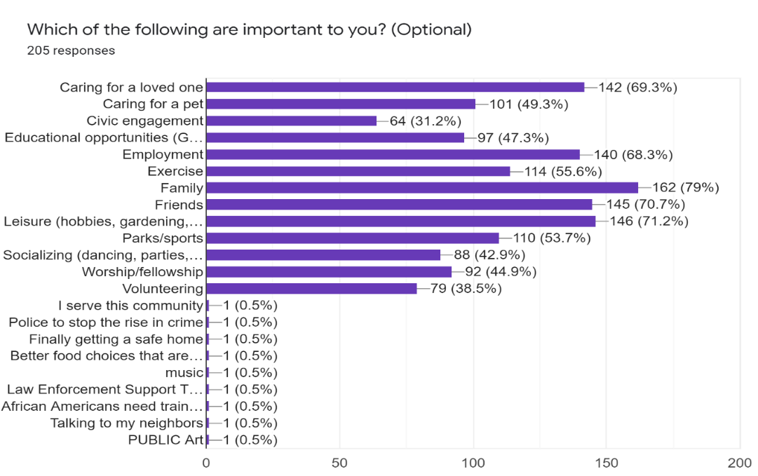
Because we are curious about everything, and respondents gave us so many clues to follow, but not in quantities sufficient for confidence, we have not completed all analysis of interest. We will continue to refer to these results to guide future efforts.

OPERATING ENVIRONMENT
From the US Census Bureau Population Estimates Program, Champaign County’s 2019 total population estimate was 209,689, a change of 4.3% for 2010 to 2019, with expected increases in both Cities and a small decrease in the Village of Rantoul. Although few results of the 2020 US Census have been released, they show lower growth. With total population 205,865 and 206.7 people per square mile, Champaign County experienced 2.4% growth since 2010, highest in immigrant and racial minority groups. Fuller demographic details are not yet published. Champaign County is the 10th most populous in Illinois.

COVID-19 Impacts and Recovery:
Conditions prior to the global pandemic and early indications suggest that our healthcare and human service systems in their current state are not adequate to manage its long-term impacts. Trends of concern:
- Increased death rates, regardless of cause, require us to consider the grief of others, as a secondary impact of the health crisis. Researchers estimate that every death from COVID-19 will leave nine bereaved loved ones. (Verdery et al.).
- People receiving and providing care have been especially impacted, as have children. In addition to the social and academic impacts of remote school and other stressors, “more than 1.5 million children around the world are estimated to have lost at least one parent, custodial grandparent, or grandparent who lived with them due to death related to COVID-19 during the first 14 months of the pandemic.” (Hillis et al.).
- By 2018, US life expectancy had fallen further below that of peer countries, from 1.88 years less to 3.05 years less. Then between 2018 and 2020, it declined further, and disproportionately for racial and ethnic minority groups - by another 3.88 years for Hispanic, 3.25 years for non-Hispanic Black, and 1.36 years for White populations. These changes wiped out recent progress in reducing the gap between life expectancies of Black and White US citizens. (Woolf et al.).
- Even excluding COVID-19 deaths, significant increases in death risk during 2020 were found for all US age groups, other than those 4 or younger. Hardest hit were men aged 15 through 64. (Jacobson and Jokela).
- During this era, some have become more skeptical of information, regardless the source, more hesitant to follow 'expert' advice, and more divided along these lines. COVID misinformation is associated with lower education and news consumption, higher internet use and trust in social media, and being male. (Filkukova et al.).
- Political unrest, wars, gun violence, natural disasters, and climate catastrophes simultaneous to the global pandemic are compounding the human costs.
- While the increase started before the pandemic and is still below historical high rates, violence continues to escalate in 2021, with a 7% increase in aggravated assault, 22% increase in gun assaults, and 24% increase in homicides across the US by March. First quarter burglary, larceny, robbery, and drug offense rates were lower than 2020, due to stay-at-home orders and business closures. An increase in motor vehicle theft may also relate to vehicles less secure at home. (Rosenfeld and Lopez).

To recover from the crisis, in which one third of people in the US show signs of anxiety and depression, and with what we understand of the different impacts on various groups, the Well Being Trust report “Supporting a Nation in Crisis…” (p 5) recommends a focus on mental health and addiction needs and especially on:
- Health professionals and first responders
- Youth and families
- Formerly incarcerated individuals reentering the community
- People with SUD
- Older adults
- Victims of partner violence, child abuse, and elder abuse
- People of color
- Undocumented immigrants
Given the threats related to state/federal funding and regulation of safety net and social service systems, and the risk of missing opportunities offered at that level, special attention to these populations is consistent with our findings.

Among the states, Illinois has some of the strongest privacy and Mental Health and Substance Use Parity laws, a Section 1115 demonstration waiver with behavioral health focus, and expanded Medicaid eligibility. However, the implementation of Managed Care has not been smooth, Integrated Health Home innovation has been on hold since 2019, Medicaid rates are low, and progress toward compliance with a variety of rules and consent decrees is very slow.

The lack of adequate local service capacity, largely due to the deepening workforce shortage, was another shared concern of our survey respondents and other informants. The workforce shortage and low provider capacity will be another threat to recovery across the country. According to the report, “Trends in Behavioral Health…” (Otsuka, p 27 and p 88, 2021):
- The US behavioral health workforce (all occupations combined) is 13% below that needed to provide adequate care;
- The 2018 turnover rate of I/DD staff was near 50%;
- In 2020 26% of I/DD agencies were more short-staffed than before, and many had left their positions due to COVID;
- This, along with decreased revenue related to stay-at-home orders, caused 68% of I/DD providers to close one or more service options; and
- Approximately 66% of addiction treatment providers also reported revenue loss in 2020.

While the pandemic has forced some deep issues to the surface and exacerbated others, positive change may result if appropriate action is taken.
- Flaws and inequities in the safety net and health systems are on full display.
- Expansion of telehealth and other remote supports should continue, and efforts made to lower the variability in access, usefulness, and positive health outcomes.
- Integrated care coordination was also accelerated and should continue.
- Collective trauma shines a light on mental health and may help reduce stigma.
- Acknowledgement of the ‘essential’ roles of the behavioral health and I/DD direct support workforce should lift advocacy efforts to improve pay and conditions.
- Increased community employment of persons with I/DD may lead to other community integration opportunities.
- The relationship between social connection and well-being is much clearer.

Vulnerabilities:
Among survey results, concerns about housing and financial stability accurately reflect some local vulnerabilities. People with limited resources are likely to encounter barriers to health care access, including for mental health supports. Financial insecurity itself is an indicator of mental distress. To make matters worse, pay has not remained competitive for much of the human services workforce associated with safety net and long-term supports and services, creating financial hardship for those providing care and treatment for people who have behavioral health conditions or intellectual/developmental disabilities. As a result, the workforce crisis deepens while the need for services grows.

The National Low Income Housing Coalition estimates an hourly wage of $22.11 is necessary to afford a two-bedroom apartment in Illinois and $18.58 for a one-bedroom. The average renter wage is $18.23, and the median wage for all occupations is $21.55. There is a shortage of affordable rental homes across the state.
- 44% of Champaign-Urbana and 47% of County households are renters.
- The estimated mean renter wage here is $12.11, far below the state.
- The hourly wage needed for a two-bedroom apartment in Champaign County (at fair market rent of $868) is $16.69.
- If earning minimum wage, the renter would have to work 61 hours/week; if the mean renter wage, 55 hours/week.
- With minimum wage of $11, the affordable rental amount is $572/month.
- With monthly SSI payments of $794, the affordable amount is $238/month.

In 2020, United Way reported that 36% of Illinois households lack financial resources for basic survival. The U.S. Census Bureau (2019) estimated 11.9% of Illinoisans were living at or below poverty and that Champaign County’s poverty rate was even higher: of 84,290 households, 19.9% met federal poverty guidelines, and another 24% were at or below the threshold for ALICE “Asset Limited, Income Constrained, Employed.”
- Younger families were among the poorest. Where the head of household was aged
- 25 or younger, 8,192 were in poverty and 2,441 ALICE;
- 25-44, 4,829 in poverty and 6,896 ALICE;
- 45 to 64, 2,782 in poverty and 5,431 ALICE; and
- 65 and over, 887 in poverty and 5,385 ALICE.
- Champaign County’s highest rates of poverty were among American Indian/Native Alaskan (though few in number) and Asian families, and highest rates of ALICE were among Black, Asian, and multiracial families.

From the US News & World Report “Healthiest Communities” County rankings:
- Lowest rankings are in Equity (28), Housing (28), and Community Vitality (25)
- Highest rankings are in Infrastructure (80), Population Health (70), Education (66), Environment (60), and Public Safety (59)
- Population Health is strong due to: fewer people with no health insurance (6.2% compared to 10.6% national); lower smoking rate (17.5% compared to 21.1% national); and higher life expectancy (80.5 years compared to 77.5 national)
- Mental Health score of 73 is based on:
- 12.9% of adults with frequent mental distress (12.6% state and 15.1% national)
- Deaths of despair (34.6 in 100,000) comparable to state, lower than national
- Medicare beneficiaries with depression (17%) similar to state, lower than national
- The low Equity ranking is based on educational, health, income, and social equity:
- Neighborhood disparity and racial disparity in educational achievement are higher than national rates, and neighborhood disparity is higher than state
- Air toxics exposure and premature death disparity index scores are higher than national, and premature death rate is higher than state
- Neighborhood disparity in poverty is higher than national and state rates
- Racial disparity in poverty is higher than national, lower than state
- Poverty rate of 20% is higher than national (14.2%) and state (12.5%)
- Households receiving public assistance income (2.4%) are higher than national (1.9%) and close to state (2.3%)
- The low Housing ranking is based on very low rankings in Housing Affordability and Housing Capacity. The greatest threats are in work hours needed to pay for affordable housing, affordable housing shortfall (-90.4 compared to national -62.3 and state -66.8), and overcrowded households (5% compared to national 1.9% and state 2.5%).

Children and Families
From Voices for Illinois Children interactive maps, using data from 2015-2019:
- 15.8% of Champaign County’s children lived below poverty level, vs 17.1% statewide.
- This rate varied with race and ethnicity, with 31.9% of Black children and 19% of Latina/o children below poverty level in Champaign County, slightly below state rates.
- Champaign County’s median household income ($52,797) was lower than the state’s ($65,886), and much lower for Black households ($31,395 County, $38,573 State) and Latina/o households ($42,578 County, $55,836 State).
- Rates of children ages 3 and 4 not enrolled in school were lower for Champaign County, at 39.6%, than for the state, at 44%.
- 82.1% of Champaign County mothers received adequate prenatal care, compared with 78.8% statewide.
- Champaign County’s infant mortality rate of 9% was higher than the state rate of 5.6%. Statewide, the Black infant mortality rate was 11.4%.
- The percentage of Champaign County children (25.8%) living in households receiving Supplemental Security Income, cash public assistance, or Supplemental Nutrition Assistance Program benefits, was close to the state rate (25.5%).

The Illinois Early Childhood Asset Map offers data per county drawn from many sources (American Community Survey, state agencies, US Census Bureau, etc). For Champaign County, in the most recent year reported:
- In 2012, 381 children were in foster care.
- In 2019, 1.87% of kindergarten students were homeless. The state rate was 1.97%.
- In 2019, 24.82% of children birth to 5 were indicated victims of abuse or neglect. The state rate was 19.37%.
- In 2016, 19,083 children were enrolled in Medical Assistance Programs.
- In 2017, 700 children in preschool through 2nd grade had IEPs.
- In 2019, there were 389 enrollment slots for early childhood home visiting programs, and 234 children were enrolled in Early Intervention.
- In 2019, children birth to 5 in homes speaking English numbered 10,134, Chinese 682, Arabic 315, Spanish 296, Korean 195, Hindi 183, Urdu 89, German 75, and Unknown 49.
- In 2018, of limited English-speaking households, 0.81% spoke Spanish, and 3.53% spoke other languages.

Strengths:
Prior to 2020, Champaign County had been fortunate, with numerous social service organizations and resources.
- When the State of Illinois had no budget for two years, some regions lost critical provider capacities such as psychiatry and community-based long-term care, which are hard to reestablish when resources are again available. We suffered fewer losses.
- The 2021 County Health Rankings show Champaign among the healthiest counties in Illinois, with a better mental health provider rate than the state, though far less than top performing counties of the US. (University of Wisconsin Population Health Institute).
- Early Childhood partnerships, such as the Home Visiting Consortium, result in a system more prepared to meet the needs of very young children across the County.
- System of Care values are sustained by collaborations of providers focused on positive youth development. Pouring energy and resources into young people and their families may be the best way to ensure Champaign County’s future health and wealth.
- With a culturally and linguistically diverse population, training and planning for appropriate and responsive healthcare and human services grows in relevance.
- Trauma-informed care and system training has been widely available in Champaign County, including for service providers, educators, neighborhood and faith-based groups, and law enforcement. This may give our community an advantage in collective recovery from collective trauma.
- Many peer support, family advocacy, and self-help groups exist, creating a foundation for more responsive care and reduction of the impact of stigma.

SURVEYS, PROCESS, AND FINDINGS
Primary data were collected through two surveys, one of service providers and the other of community members, and through quarterly report comments by representatives of funded agencies on how the pandemic has impacted their services, clients, and staff. Full results of each survey and funded agency comments are presented in Appendices I, II, and III.

Community Survey:
Overview
During the spring of 2021, CCDDB and CCMHB staff designed a community needs assessment survey. Collection of community survey data began on June 8 and extended through August 20, 2021. With 24 questions, some optional and some long answer, this was a questionnaire style, self-administered survey available on the internet, in Spanish and English, and with paper copies distributed to interested groups. The process followed a cross-sectional research design, taking a snapshot of Champaign County residents at a single moment in time. 210 completed surveys, 12 of them in Spanish, were analyzed.

Characteristics of Survey Respondents
- 97% of respondents live in Champaign County.
- Of those, 69% live in Champaign, 28% in Urbana, and 3% Other.
- 34% have a mental health concern, 9% an I/DD, 8% a substance use disorder, and 6% don’t know or prefer not to say. 48% report having none of these.
- 49.5% of respondents care for a family member or friend.
- 68% have tried services.
- 95% have access to the internet.
- 71% live ‘on my own in my own place’, 17% with others, 12% miscellaneous/no answer.

GENDER | # | %
Female | 151 | 72%
Male | 48 | 23%
Non-binary | 3 | 1%
Prefer not to say | 3 | 1%

RACE/ETHNICITY | # | %
White | 131 | 62%
Black/African American | 39 | 19%
Latino/a/Hispanic | 17 | 8%
Biracial/Multiracial | 4 | 2%
Miscellaneous or no response | 19 | 9%

AGE, BY RANGE | # | %
18 and younger | 2 | 1%
19-24 | 8 | 4%
25-34 | 36 | 17%
35-44 | 67 | 32%
45-54 | 33 | 16%
55-64 | 37 | 18%
65-74 | 16 | 8%
75 and older | 6 | 3%

EDUCATION COMPLETED | # | %
Grade School | 4 | 2%
Junior high/middle school | 3 | 1%
Some high school, no diploma | 3 | 1%
High school diploma or equivalent | 31 | 15%
Some college courses | 42 | 20%
Certificate/technical degree | 6 | 3%
Associate degree | 15 | 7%
Bachelor’s degree | 41 | 20%
Master’s degree | 46 | 22%
Doctoral degree | 7 | 3%
Professional certification or licensure | 5 | 2%

Reminiscent of survey results informing the current IPlan, the most representative respondent would be a white woman who has a Master’s degree, lives alone in the City of Champaign, is aged 35 to 44, does not have an MI, SUD, or I/DD, has tried services (possibly on behalf of someone else), and has access to the Internet. As shown below, she does not rely on or need public benefits or housing support and receives information primarily through email.

Findings
The following tables collect themes and responses to the survey, listing in order of frequency all which were identified in greater than 5% of responses. Full results, including narrative answers to open-ended questions, are presented in Appendix I of this report.

What do you like about life in Champaign County?
No Answer: 59 (28%)
Opportunities: 39 (19%)
Rural Setting: 32 (15%)
Diversity: 19 (9%)
Community: 19 (9%)
Quiet/Tranquility: 16 (8%
College: 14 (7%)

What do you NOT like about life in Champaign County?
Gun Violence/Unsafe: 95 (45%)
Misc Dislikes: 33 (16%)
No Response: 22 (10%
Nothing: 16 (8%)
Lack of MH Resources: 14 (7%)

Mental Health Services, Supports, or Resources Known to Respondents
Rosecrance: 44 (21%)
Pavilion: 37 (18%)
Carle: 28 (13%)
Don’t Know: 27 (13%)
Private Therapists: 16 (8%)
DSC: 12 (6%)
OSF: 12 (6%)

Substance Abuse Services, Supports, or Resources Known to Respondents
Rosecrance: 54 (26%)
Pavilion: 32 (15%)
Carle: 18 (9%)
NA: 16 (8%)
AA: 13 (6%)
Don’t Know 12 (6%)

Intellectual/Developmental Disabilities Services, Supports, or Resources Known to Respondents
DSC 59 (28%)
Don’t Know: 30 (14%)
Community Choices: 19 (9%)

Services, Supports, or Resources which Should be Added, to Help More People
Mental Health Services:
- Walk-in clinics
- Shorter or no wait times
- More psychiatrists
- Free, or more affordable, services
- More in-patient options and case management
- More emphasis on youth and young adults
Substance Use Disorder:
- Free or more affordable services
- More in-patient options and case management
- More emphasis on youth and young adults
Intellectual/Developmental Disabilities
- More options including for those with Autism
- More options for adults and their families
- Mentoring by those with I/DD for those with I/DD
- More vocational opportunities
Housing/Homelessness:
- More shelters
- More affordable housing options
- More transportation
- Better support system and available mental health services
- Supportive housing
Miscellaneous:
- More bi-lingual service options
- Increase community outreach

Preferred Methods for Receiving Information
Email: 139 (66%)
Cell: 99 (47%)
Social Media: 67 (32%)
Postal Mail: 41 (20%)
Radio/TV: 39 (19%)
Friends/WOM: 36 (17%)
In-Person: 34 (16%)
Newspaper: 29 (14%)

Benefits or Services in USE, not Related to MI, SUD, or I/DD
None of the listed: 80 (38%)
Medicaid: 70 (33%)
Medicare: 55 (26%)
SNAP: 52 (25%)
SSI/SSDI: 35 (17%)
Food Pantries: 28 (13%)
Legal Services: 11 (5%)
Planned Parenthood:10 (5%)
Not Sure: 7 (3%)

Benefits or Services NEEDED, not Related to MI, SUD, or I/DD
None of the listed: 99 (47%)
Legal Services: 24 (11%)
SNAP: 23 (11%)
Medicaid: 22 (10%)
Section 8: 21 (10%)
Not Sure: 21 (10%)
SSI/SSDI: 17 (8%)
Food Pantries: 16 (8%)
Medicare: 13 (6%)

Which of the following are important to you?
Family: 162 (77%)
Friends: 146 (70%)
Leisure: 146 (70%)
Loved One: 142 (68%)
Employment: 137 (65%)
Parks: 113 (54%)
Pet: 101 (48%)
Exercise: 100 (48%)
Education: 97 (46%)
Worship: 92 (44%)
Socializing: 89 (42%)
Volunteering: 59 (28%)
Civic: 55 (26%)

Housing Related Needs, not Specific to MI, SUD, or I/DD
None: 84 (40%)
Safe Neighborhood: 50 (24%)
Repairs: 47 (22%)
Affordable Housing: 28 (13%)
Rent/Mtg Assistance: 24 (11%)
Utilities Assistance: 21 (10%)
Accessible Housing: 19 (9%)
Safe Home: 18 (9%)
Help: 9 (4%)

Relational Analysis
Due to low total responses, this approach was not likely to yield insights, but it was attempted anyway and may offer clues for future surveys. Because 76% of respondents were from the Cities of Urbana and Champaign, certain responses are sorted by City, with very similar results:

 | City of Champaign | City of Urbana
# Respondents | 105 | 50
Likes | No Answer/Don’t Like/Cited the Past – 24%  Opportunities – 19%  Rural Setting – 14%  Community – 13%  Diversity – 11%  University – 10% | No Answer/Don’t Like/Cited the Past – 33%  Diversity – 16%  Community – 13%  Opportunities – 13%  Rural Setting – 9%
Dislikes | Gun Violence/Unsafe – 45%  No Response – 24%  Lack of Services (MH/SA/DD) – 7% | Gun Violence/Unsafe – 44%  No Response – 18%  Lack of Services (MH/SA/DD) – 7%
Concerns | No Concerns – 52%  MH – 30%  I/DD – 10%  SUD – 9% | No Concerns – 49%  MH – 40%  I/DD – 9%  SUD – 5%
Tried Services | Yes – 61%, No – 39% | Yes – 75%, No – 25%
Internet | Yes – 94%, No – 6% | Yes – 98%, No – 2%
Gender | Female – 71%, Male – 26%,  No Answer – 3% | Female – 75%, Male 20%, Non-binary – 4%, No Answer – 2%
Race | Black – 21%, White – 59%, Hispanic – 10%, Other – 9% | Black – 20%, White – 65%, Hispanic – 7%, Other – 7%
Age | <18 – 1%  19-24 – 5%  25-34 – 20%  35-44 – 28%  45-54 – 14%  55-64 – 21%  65-74 – 9%  75 and older – 1%  No Answer – 2% | <18 – 0  19-24 – 4%  25-34 – 20%  35-44 – 31%  45-54 – 16%  55-64 – 15%  65-74 – 7%  75 and older – 5%  No Answer – 2%

Sorting Gender by Age Groups and Race by Age Groups showed few differences per City.

The largest groups of respondents by Race were White (60%) and Black/African American (18%), and with secondary sources pointing to important racial disparities in our community, sorting responses regarding the community’s strengths and vulnerabilities may be of interest:

 | Black/African American | White
# Respondents | 37 | 127
Likes | Opportunities – 27%  Don’t Like/Cited the Past – 19%  No Answer – 16%  Family Nearby – 11%  Community – 11% | No Answer – 25%  Opportunities – 20%  Rural Setting – 13%  Community – 11%  Parks – 9%
Dislikes | Gun Violence/Unsafe – 41%  No Response – 14%  Lack of Opportunities – 14% | Gun Violence/Unsafe – 49%  No Response – 19%  Lack of Resources – 9%
What Should be Added to Help More People? | Youth programs/opportunities – 27%  Don’t know/none – 22%  Homeless Shelters – 11%  Mental Health Services – 11% | Mental Health Services – 35%  (10 noted Psychiatric Services)  Youth programs/opportunities – 9%  I/DD Services (incl for Autism) – 9%  SUD Services – 8%  (4 noted Detox)

Focus Group:
Planning
Prior to assembling the focus group, CCMHB/CCDDB staff met with each of Dr. Anita Say-Chan, UIUC Community Data Clinic, Chaundra Bishop, Regional Health Plan Coordinator, CUPHD, and Victoria Cisneros, Consultant, to discuss the process and expectations for listening sessions, focus groups, and surveys. The Associate Directors began recruiting community members for a focus group by reaching out to agencies with self-advocates or peer supporters. We received several responses from individuals interested in participating in the development of our Community Needs Assessment survey. The group consisted of 7 members with various backgrounds; diversity in age, gender, race/ethnicity, physical ability, and other background factors was favored in the recruitment. Once the group was assembled, they held two two-hour sessions on Zoom, due to COVID restrictions. During the sessions, there were key areas which helped shape the survey. These centered around: Quality of Life, Community Assets, and Community Concerns and Needs.

Participants
Representatives from DSC (3), Community Choices (2), CU Trauma & Resiliency Initiative (1), FirstFollowers (1), and a Champaign County resident/parent of children attending Unit 4 Schools. Also present were Chaundra Bishop, Victoria Cisneros, Leon Bryson, and Kim Bowdry.

Quality of Life
Factors most consistently highlighted as important to participants’ quality of life included:
- Access to healthcare
- Access to quality and affordable housing
- Social interaction (how to make friends/communicate)
- Safety/Security in neighborhoods
- Financial security
- Education/opportunities for children’s success
- Dignity, respect, and acceptance

Participants’ own words:

Lower income rentals are usually in slum condition and not being addressed correctly – it’s not an excuse to keep the rent low. If the rent is in the $500 range, you are in a dangerous part of town. Things are broken down and not fixed. People should have access to decent housing.
- Participant is an Outreach Specialist

A lot of slumlords. Moving to a place across from a high school, constantly contacting the landlord to get him to do the things that she’s already asked him to take care of… I had to help a neighbor to advocate for herself because she didn’t know how to do it.
- Participant is the parent of an Autistic teenager
Community Assets
Focus group members recognized that specific people and organizations, or types of people and organizations, were community assets as well, such as advocates who help people navigate systems and those agencies that provide some sort of necessary social support. Specific agencies mentioned included the YMCA Swimming group, Cunningham Township, Healthcare Consumers & Courage Connection. Participants identified a few strengths and resources that they valued in their communities.
- Recreational Centers
- Social Service Grant Programs
- Disability Services

Participant’s own words:

DSC has resources that can help with supporting people with Autism and disabilities, and other community places have resources.
- Participant works at DSC

Community Concerns
There were common concerns noted across the group. Factors most consistently highlighted as important to participants’ community concerns included:
- Crime and violence
- Transportation and direct service line routes
- Access to the Internet and Technology in rural community
- Lack of Black and Brown businesses
- Inadequate employment opportunities

Participants’ own words:

Approximately only 100 minority-owned businesses, most of those are owned by white women. You should have about 7% African American owned businesses when the population is 14% African American; you should see these types of businesses in the community – this has a lot to do with the youth now, food desserts, not taking care of the North End.
- Participant is an Outreach Specialist

Understanding what resources are available, having business plans available, understanding how to start and maintain businesses, how to get loans, what banks are the best to get loans. Need for support system in Champaign to help them do what they are trying to do.
- Participant is the parent of an Autistic teenager

Dangerous crime areas – lost two police officers. There needs to be a community discussion with law enforcement. If they could step up the patrols in those areas that would help. Whole BLM movement puts a different spin on things. We need to put our trust in law enforcement.
- Participant works at DSC

The crime is all over Champaign County. The gun violence is in limited areas. Champaign County is still a pretty safe community to live in, but we hope the violence calms down.
- Participant is a retired Teacher’s Aide

We need activities, but we know that more patrol doesn’t work. These issues have to be looked at from the community; we need wraparound services. We need preventive measures. We can’t wait until after the shooting happened. We need mentorship.
- Participant is an Outreach Specialist

I live with parents on a farm. I like it, and it works for now. I am concerned that other people might not have as good of a situation as other people, and they may have been forgotten about. Transportation – not as easy for others living in the country, the weather is also an issue. Do those people have enough food, heating? Technology concerns – iPhones or laptops to facilitate communication purposes – training on Zoom, email, etc. Home living supports – training for daily living or in need of an aide. Having access to technology and internet in rural areas is a problem.
- Participant has Autism, lives in rural Champaign County, and is a Community Choices and DSC participant
Community Needs
- DARE for people with and without disabilities, starting in elementary schools
- Peer support-to prevent bullying situations, misunderstandings, or preventing being taken advantage of
- More plain clothed police officers
- Access to medical health care
- Healthier grocery stores
- Crime Prevention services

Participant’s own words:

Social interaction missing, beyond skill streaming, I never had a mentor growing up in school. I now mentor a student in high school. I’ve always struggled with social interactions with teachers and friends who don’t understand how I understand things. I still struggle with interactions with people, being able to recruit people for important things, like encouraging people to get involved with leadership and advocacy.
- Participant is a CC Leadership & Advocacy Co-facilitator

Community Survey Distribution:
With the focus group’s input, and after comparison with the upcoming Community Health Needs Assessment which will support future health plans, a final version of questions was created in a Google survey and the link shared broadly. A Spanish language version of the google survey was also available.
- Mental Health and DD Agencies Council and Human Services Council
- CU Trauma & Resiliency Initiative working group; Senior Task Force; Champaign County Community Coalition; Birth to 6 Council and Local Interagency Council; Crisis Intervention Team Steering Committee; Reentry Council; Continuum of Service Providers to the Homeless; School of Social Work Community Learning Lab; and Disability Resource Expo Steering Committee
- I/DD providers: Al Ryle Company, LifeLinks, CU Able, CC Down Syndrome Network; CU Autism Network; The Autism Program at UIUC; Individual Advocacy Group; Piatt County Mental Health Center; RPC Independent Service Coordination Unit; DSC CILA and Employment programs
- MH support groups: NAMI; Depression & Bipolar Support Alliance; GROW in Illinois
- Representatives of other systems: Juvenile Detention Center; Sheriff’s Office and Jail; New American Welcome Center Health & Well-being Working Group; Cunningham Township Supervisor’s Office; Champaign Township Supervisor’s Office; United Way of Champaign County; Champaign County Farm Bureau; Housing Authority of Champaign County; Carle Behavioral Health; Carle Pediatric Department (Windsor in Urbana); the Pavilion; OSF Community Resource Center; Board of Health; CU Public Health Department; Youth Assessment Center; Division of Rehabilitation Services; Workforce Innovation and Opportunity Act office; and local school district representatives
- Focus group participants and members of the CCMHB and CCDDB
- Faith community: First Baptist Church of Savoy; Windsor Road Church; Fellowship Baptist District Association; Interfaith Alliance-CU Vicinity; Angel’s Youth Center; CU at Home; Church of the Brethren; Community United Church of Christ; First Mennonite Church; Unitarian Universalist Church; Channing-Murray; Salvation Army; Faith United Methodist Champaign; Mount Olive Baptist Church; St. Luke CME Church; CU Church; The Hope Center at Vineyard; First United Methodist Urbana; Berean Covenant Church; Bethel AME Church
- Garden Hills Neighborhood Group; Rita Conerly; HitNHomeboy; Hayes HV&T
- Earned Media: The CCMHB/CCDDB Executive Director did brief interviews with WCIA and WAND television; links to the online survey (English and Spanish) were included in the web versions of each interview.
- Social Media: Allison Boot, Consultant, promoted the survey through Alliance for Inclusion and Respect and Disability Resource Expo Facebook, Instagram, and Twitter pages. CCMHB/CCDDB staff shared it through personal social media networks.

Of those contacted by email, one recipient strongly suggested this may not be the ideal way to learn about the opinions and concerns of all community members. This reinforced our commitment to efforts described below, to reach people more directly. Some who spoke to our team had similar reservations about surveys.

Paper copies of both the Spanish and English questionnaires were delivered to nine food pantries, five libraries, and a drop-in center for people without permanent housing.
- Broadlands Food Pantry; Community Services Center of Northern Champaign County; Jubilee Café; Newman Shares on UIUC campus; Restoration Urban Ministries; Salvation Army Pantry; St. Patrick’s Food Pantry in Tolono; UniPlace Christian Church Food Pantry & Hot Dinner on UIUC campus; Windsor Road Christian Church
- Four food pantries did not return our calls; two declined to receive surveys; four other food pantries were not open often enough to allow for completion and return of surveys; one more was not open when surveys were delivered
- Public libraries in Champaign, Urbana, Mahomet, St. Joe, and Ogden
- DSC for Community Living participants and CILA residents
- CU at Home for Phoenix Center visitors to discuss and complete
- Pediatric office patients and families

Partners’ own words:

The people coming to our food pantry are struggling financially, they don’t have the types of needs that you are trying to reach with your survey. They can all drive.
- Partner runs a food pantry at a church

As you know, there’s a huge Spanish-speaking population. And I know individuals and families don’t often reach out for services, because it’s not part of their culture and because of the digital divide, as well as the language barrier. I think, in the future, if the survey could be put in another language or two (I’m thinking French), that would be really helpful… Another thought, maybe for the future, would be to put a flier or something in Spanish, at the Latino grocery stores. I think there are about four in town...

I don’t know if anyone in the deaf community would be interested in the survey. I don‘t think I can really get it out to appropriate people with the time that’s left, but you might put it on the list for next time. PACE has connections with an active deaf community...
- Partner is a disability rights advocate

Country Brook Apartments Complex
The Associate Director for Mental Health and Substance Use Disorders traveled with two Program Managers of the Don Moyer Boys & Girls Club to the Country Brook Apartment Complex (CBA) to administer the Community Needs Assessment survey to residents. The CBA is a 150-unit Section 8 Family/Section 42 property located in west Champaign. The targeted area was a lower income neighborhood that continues to experience the effects of violence, trauma, and mental health and substance abuse challenges. An important goal of the canvassing effort was to empower residents to take a stronger role in speaking out about the strengths and needed services in their community. Since the desire was for a high participation rate and validity of results, the team chose to conduct door-to-door interviews. The surveys were administered during the daytime. The team randomly knocked on doors to generate participation. Approximately twenty residents filled out the survey. All were African American, and 95% were African American females. The other 5% identified as African American male. Once the residents completed the surveys, some decided to talk more about their environment and what is going on in Champaign County.

Respondents’ own words:

This place is always bad around here with the violence and shootings going on. But these past few days have been good.
- Respondent is a single mother of three

I don’t like Champaign because there is nothing to do for kids.
- Respondent is a single mother of two

I’m glad I have Section 8. I don’t know about any mental health services. I only know you can go to the hospital or Rosecrance if you need help with alcohol and drugs.
- Respondent is married with three children

The Police need to do a better job with driving around and getting these guns off the streets. I know a lot of people who have been murdered for stupid reasons. That’s why I got to get out of here. Nobody is safe here.
- Respondent is a single male

After the survey, what’s changes gonna happened?
- Respondent is a mother of one

There were many residents who declined the survey for various reasons:
- Don’t have the time
- Too many surveys administered in the area
- Not interested
- Too long and asking too much
- Unsure of the person knocking on their door

Shadow Wood Mobile Home Park
The Associate Director for MH/SUD and a Spanish-speaking Program Manager for Don Moyer Boys & Girls Club traveled to the Shadow Wood Mobile Home Park (SMHP) to administer surveys to the residents. Shadow Wood Mobile Home Park is located on the North end of Champaign, just south of Interstate 74. The team set up a survey table at the entrance of the park for the greatest results of respondents. Approximately 10 respondents, all Spanish-speaking between the ages of 25-64, filled out the Spanish version of the survey with assistance from the Spanish-speaking Program Manager.

Once the surveys were completed, the team debriefed the event. The Program Manager reported that all the respondents live below the poverty line, and many worked odd jobs to support themselves. All respondents relocated from other parts of the US and from Latin countries found living in the mobile park/Champaign peaceful and stress-free. When asked about supports or resources that should be added to our community to help more people, nearly all the residents said there need to be more religious services available. Only one respondent was familiar with substance abuse services in Champaign County. None of the respondents were familiar with intellectual/development disabilities services. When asked about using food pantries, only three reported taking advantage of free food when it is brought to the mobile park.

Service Provider Survey:
Overview
Champaign County’s service providers have steadily shared insights with the CCDDB and CCMHB and their staff, which became even more critical during the global pandemic. A brief survey was designed to seek their perspective on the service systems and the community generally. Questionnaire-style and self-administered, the survey included eleven optional and long-answer questions and was developed as a result of discussions during meetings of the CCMHB and CCDDB. The purpose was to understand community assets and threats from the perspective of those within the system. The link to this online questionnaire was available through August and distributed through email groups:
- Mental Health and Developmental Disabilities Agencies Council
- Human Services Council
- CU Trauma and Resiliency Initiative Working Group
- United Way of Champaign County
- Champaign County Special Education Staff
- Unit 4 and Unit 116 staff
- Individual Advocacy Group (CILA provider)
- CU Public Health District

Findings
Of 27 online surveys completed, many with questions left blank, the most frequently mentioned threats and barriers to care were:
- Mental health needs not met due to lack of: insurance/affordability, providers, school-based services, in-home services, senior services, or bilingual services (20)
- Loss of employment and not enough services for gaining employment (10)
- Overlapping with the above were lack of providers who bill Medicaid/Medicare, long waiting lists to see them, and related stigma (9)
- Homelessness, housing instability, housing for people with substance use disorders (8) and for those with I/DD (4)
- Lack of resources and information was a barrier to care for MH (7), I/DD (6), and SUD (8)
- High cost of services was a barrier to care for MH (7) and SUD (4)
- Other barriers: long waiting lists for MH (6), stigma about MH (5), and not enough staff in both the MH and I/DD systems (5)
- Of other concerns about life in Champaign County, gun violence topped the list (4)

There were fewer responses and less agreement regarding community strengths. The following were identified as assets or as adequately addressed:
- Enough mental health counselors, therapists, clinicians, providers (9), support for acquiring insurance (3), peer support groups (2), inpatient and employment services (1 each), and treatment options for schizophrenia, depression, and anxiety (1 each)
- (4) respondents felt I/DD care was adequate, (2) specified employment supports, and (1 each) mentioned adequate integration, leisure/recreation, access to services, and support for depression among those with I/DD.
- Few responses relate to adequate care for SUD: enough sober living homes/housing; enough rehab/counseling for those who have insurance; adequate treatment; adequate prevention; adequate inpatient; and needle exchange (1 each)

Full responses are found in Appendix II, and while some providers may be less aware of other types of service, these qualitative data tend to reinforce results from the full survey. In addition, throughout 2020 and 2021, funded agencies have shared observations about the impacts of the global pandemic on their services, people served, and staff (e.g., provider burnout). The most recent of these observations are available as Appendix III.

MENTAL HEALTH DATA
Community survey respondents had more to say about mental health needs than the other categories and would most like to see the following supports added:
- walk-in clinics
- shorter or no wait times
- more psychiatrists
- free, or more affordable, services
- more in-patient options and case management
- more emphasis on youth and young adults

Service provider survey respondents also noted unmet mental health needs related to:
- insurance and affordability, lack of providers, or the need for specialty (school based, in home, senior, or bilingual) services
- lack of Medicaid/Medicare providers, long wait lists, and stigma
- lack of resources and information about MH resources

Consistent with Champaign County’s Health Rankings (see Operating Environment above), some noted that we have enough of certain types of mental health providers. Still the dominant theme of unmet mental health needs in this community is appropriate given national and state evidence before and during the pandemic. Recent corroborating local findings follow.

The Champaign County Regional Planning Commission conducted a community needs assessment survey during Summer 2021 to assist in Social Services planning.
- Over 60% of “client” respondents indicated needing assistance with dealing with stress, depression, or anxiety.
- 66.67% indicated they wanted to learn how to help their children cope with stress, depression, or emotional issues.
- Of “Community” respondents, almost 70% believe that mental health services are among the top needs of low-income households.
- A majority of “Agency” respondents believed there are a sufficient amount of childcare programs for families. One mentioned that there was not enough AFFORDABLE childcare in Champaign County.

The United Way of Champaign County conducted a community needs assessment survey early in 2021 to support Community Impact strategic planning and funding decisions.
- The top 3 issues from ALL respondents were: child abuse and neglect; basic needs; and behavioral healthcare/mental healthcare.
- When sorted by demographics, the non-white respondents also indicated behavioral healthcare/mental healthcare in a tie for third.
- When presented with 4 choices related to Health - healthy lifestyles, community safety/violence prevention, access to behavioral/mental health treatment and innovation in healthy food accessibility - community safety/violence prevention ranked highest at 55.53%, access to behavioral/mental health treatments second at 27.58%.
Champaign County’s New American Welcome Center (NAWC) engaged in a community needs process which also included surveys and focus groups:
- 42% of respondents selected healthcare services as a source of stress
- 25% of respondents noted “feeling depressed or down at times”
- 10% preferred not to say
- In listening sessions with community members from Central West Africa and Latin America, depression and mental health were identified as issues.
While the full report is not yet available, results of our surveys echo that these mental health needs are not being met, with language access an identified issue. 2020 Census data indicate growth in Champaign County’s immigrant population, so the NAWC’s findings will be useful in our own planning, highlighting the need for Cultural and Linguistic Competence training and for healthcare system navigators and service providers who use languages other than English.

Mental Health Crisis Meets Public Health Crisis:
Prior to COVID, increased rates of diseases of despair and related deaths, including from suicide and drug overdose, were found even among groups of people who had not been so deeply affected previously. With what is known from prior global pandemics, many predicted increases in mental health concerns, whether the direct long-term consequence of physical illness or as a consequence of prolonged stress, financial instability, overwhelming grief, or collective trauma.

Pre-COVID data of interest for Champaign County from the 2021-2023 Community Health Plan:
- The 2018 suicide rate of 12.9 per 100,000 people was higher than the state rate (10.3) and lower than national (13.4) (CUPHD et al., p. 24)
- Of gun-related deaths in 2019, 13 were suicide and 6 homicide. (p. 28)

From The State of Mental Health in America 2021 report, rankings, and prevalence data:
- Prior to COVID:
- There had already been increases in the prevalence of MI (to 19%) and suicidal ideation among US adults.
- Unmet mental health treatment needs were very high across the country, with 60% of youth with major depression receiving no treatment, and 23.6% of adults with a mental illness reporting an unmet need.
- By September 2020:
- There had been a 93% increase over 2019 totals of people completing the anxiety screen, and a 62% increase in depression screens;
- 80% of those screened scored moderate to severe anxiety or depression, and 70% of them cited loneliness in the top three causes;
- By age, the group most likely to score moderate to severe were youth 11-17;
- By race, the highest average rates of change for anxiety and depression were among Black/African American screeners.
- Reports of thoughts of suicide and self-harm reached record levels, with 37% suicidal, higher rates among youth, even higher among LGBTQ+ youth; and
- By race, the highest average rates of change for suicidal ideation were among Native American/American Indian screeners.
- By 2021:
- Severe depression had reached 9.7% among US Youth, with the highest rate (12.4%) among those youth identifying as more than one race.
- The US rate of uninsured adults with mental illness had increased (to 10.8%) for the first time since the Affordable Care Act.
- Illinois ranks 11th of all states for adult mental health and 36th of all states for youth mental health. Each ranking is based on seven measures.
- For prevalence of MI, Illinois ranks 19th, for access to care, 28th, and overall, 22nd.
- The prevalence rate for any MI in adults is 18.06% in IL and 19% in the US.
- Rate of serious suicidal thoughts among adults is 3.87% in IL and 4.34% in the US.
- Rates of youth with a Major Depressive Episode are 14.86% in IL and 13.84% US, and for Severe Depressive Episode, 11% in IL and 9.7% US.
- The prevalence rate for any SUD in adults is 8.16% in IL and 7.67% in the US.
- The prevalence rate for any SUD in youth is 4.04% in IL and 3.83% in the US.
- Rate of students with Emotional Disturbance on an IEP is 10.19% in IL and 0.757% in the US. (In this case, high rates are associated with better outcomes.)

As noted in the Operating Environment section above, Champaign County is fortunate to have a relatively high ratio of mental health providers and a low uninsured rate, but the difficulties people have in securing benefits, navigating the healthcare system, and finding providers who accept Medicaid are among key findings of our primary data collection.

The increased national focus on trauma, anxiety, depression, and deaths of despair creates an unprecedented opportunity to challenge the stigma associated with mental illness and addiction and to eliminate the disparities in behavioral healthcare. Reliable information about causes, symptoms, prevention, and treatments may be more welcomed than ever and may result in better understanding and compassionate care.

Disproportionate Impacts:
Life Expectancy
In addition to the unfavorable changes in life expectancy noted in 2018 and during the pandemic, with disproportionate ethnic and racial impacts, people with serious mental Illinois had already an average life expectancy 25 years lower than that of the general population and largely due to preventable conditions, including access to healthcare. (NASMHPD, p 5).

Behavioral Health Workforce
People performing ‘essential work’ during the pandemic reported higher rates of mental distress as a result. Providers of behavioral health and other social services are included in this category. During monthly meetings and in quarterly service reports from funded programs, local service providers noted many negative impacts of the new stressors.

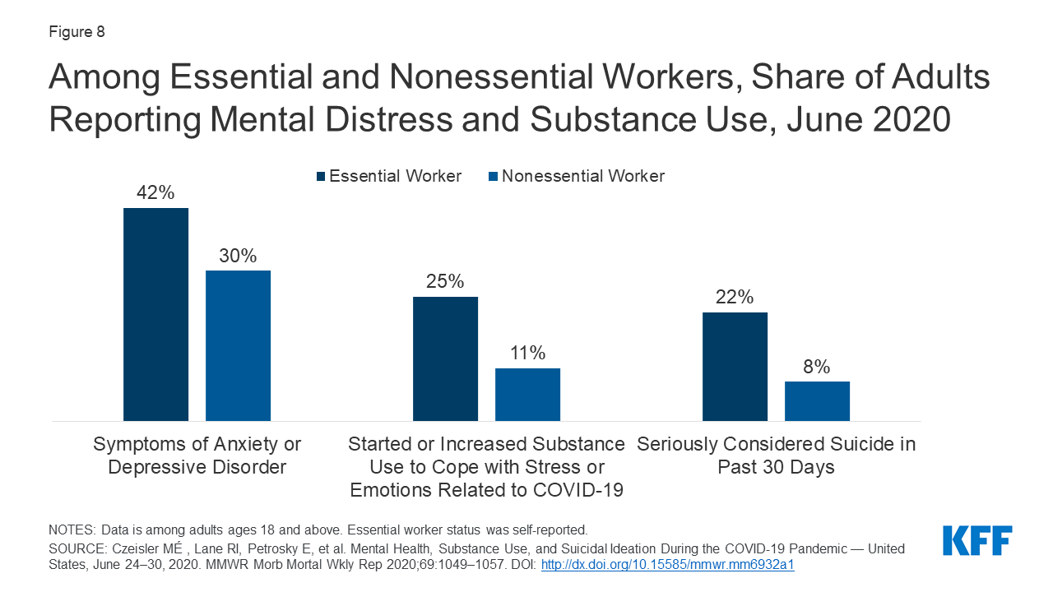
(Panchal et al.).

Residents of Rural Areas with Limited Services
People living in rural communities have had decreasing access to mental health services for some time, though the expansion of telehealth during the pandemic may have provided some relief, as long as those communities were ‘connected’ and residents were ready with devices.

Approximately 7.3 million nonmetropolitan adults reported having any mental illness (AMI) in 2018, accounting for 21.2% of nonmetro adults. In addition, nearly 1.6 million, or 4.8%, of adults in nonmetropolitan areas reported having serious thoughts of suicide during the year. While the prevalence of mental illness is similar between rural and urban residents, the services available are very different. Mental healthcare needs are not met in many rural communities across the country because adequate services are not present.
(Rural Health Information Hub)

Rural Health Clinics may be reluctant to start providing mental health services when reimbursement rates are low. In addition, high no-show rates among mental health clients and high numbers of uninsured patients further exacerbate the issue.
(Gale et al.).

Racial and Ethnic Minority Groups
There is evidence of other deeply uneven impacts of COVID-19, especially felt by members of racial and ethnic minority and immigrant groups. Black, Indigenous, and Hispanic/Latino people, reported higher levels of anxiety, depression, and suicidal ideation, as noted above. Making matters worse, prior to COVID, these groups had already been less likely to be able to access or benefit from appropriate care.
From The Center for American Progress report on “Health Disparities by Race and Ethnicity”
- In 2017:
- Black/African Americans had lower rates of health care coverage than whites (89.4% versus 93.7%, 44.1% had government health insurance, and 12.1% under the age of 65 had no coverage.
- 83.9% of Latino/a/Hispanic US residents had health care coverage, 39.5% had government health insurance, and 20.1% had no health insurance.
- Asian Americans had a higher rate of coverage at 92.7% and lower rate of government insurance (29.6%).
- 66.9% of Native Hawaiian/Pacific Islanders had private and 33.5% government health insurance.
- 14.9% of American Indians/Alaska Natives were uninsured.
- In 2018:
- 8.7% of Black/African Americans received mental health services, compared to 8.8% Latino/a/Hispanic, 6.3% Asian Americans, 10.9% Native Hawaiians/Pacific Islanders, 14.1% of American Indian/Native Alaskans, and 18.6% White.

Disparities are deepened by the economic disruption:

The economic downturn and staggering job losses due to the pandemic have resulted in lost health insurance, financial instability, food insecurity, and loss of housing among those lacking the safety net of savings and family resources. The median net worth of white families (more than $170,000) is nearly 10 times higher than black families (less than $20,000), and black households have been hit harder by downturns, whether in 2008 or currently. These stresses and losses increase the risks of depression, anxiety, substance use, and suicide, as well as poor physical health.
(Gibbs et al.).

Disproportionate COVID death rates among Black/African Americans cannot be attributed entirely to high prevalence of risk factors such as diabetes and hypertension. Factors such as higher presence in ‘essential’ front line jobs, disproportionate environmental risk factors, and discriminatory institutional practices have contributed. (Sawani and Malcom).

Young People
The 2020 Illinois Youth Survey includes responses from students of nine schools, all grades, across Champaign County, though the majority of respondents reside in the City of Champaign. 48% were eligible for free or reduced lunch.
- Of 12th graders, 45% had experienced depression, and 20% had considered suicide.
- 25% experienced any type of bullying, 21% bullied due to disability or appearance and 17% due to race, religion, or sexual orientation, and 5% experienced every type.
- Of 10th graders, 48% had experienced depression, and 20% had considered suicide.
- 35% experienced any type of bullying, 23% due to disability or appearance and 22% due to race, religion, or sexual orientation, and 5% experienced every type.
- Of 8th graders, 40% had experienced depression. The suicide question is not asked.
- 47% experienced any type of bullying, 48% experienced bullying due to disability or appearance, and 6% experienced every type. Race question is not asked.
- For all three grade levels, the most prevalent type of bullying was name-calling, then cyber-bullying, then threats of violence, then violence (hitting, kicking, pushing).
- For all three grade levels, 5% reported an experience of violence in a dating relationship.

All of these 2020 findings, other than cyber-bullying of 8th graders and dating violence among 12th graders, were higher rates than statewide in 2018. They reflect the increased negative impacts on youth mental health described above for the US and Illinois.

SUBSTANCE ABUSE DATA
Community Survey respondents indicated adding these would help people with SUDs:
- free or more affordable services
- more in-patient options and case management
- more emphasis on youth and young adults

Service Provider Survey respondents noted these barriers related to SUD:
- homelessness, housing instability, not enough housing for people with SUD
- lack of resources and information about SUD resources
- high cost of services
Respondents mentioned the following once each, as adequate for the local need:
- sober living homes/housing
- rehab/counseling for those who have insurance
- treatment, adequate prevention, and inpatient services
- needle exchange

Although fewer comments in either survey related to SUD, there is evidence that Champaign County’s unmet SUD treatment needs have increased in recent years, as has related loss of life.

According to the Illinois County Behavioral Risk Factor Survey, Round 6 (2015-2019), 20.6% of County residents were at risk for binge drinking and 6.8% for heavy drinking. For the previous five-year period, fewer were at risk for binge/acute drinking (13.9%) and for chronic drinking (2.3%). (IBRFSS).

The Champaign County Community Health Plan 2021-2023 data on local SUD-related deaths prior to 2020, greatly increased for alcohol-related:
- Alcohol-impaired driving deaths more than doubled since 2015, to 32%, higher than state and national rates. (CUPHD, p 24).
- From 2015 to 2019, there were 198 drug-related deaths of Champaign County residents; 71% were white, 27% Black; >71% were male, 29% female; and ages ranged from 11 days and 73 years. (p 27).
- Opiates were the leading cause of these deaths. (p 57).

The 2020 Illinois Youth Survey includes data on substance use by Champaign County youth. While the following do not point to alarming changes over time, 2020 survey responses were lower than hoped, and comparisons here are limited to previous statewide rates:
- Among 12th graders, 46% had used alcohol, 2% inhalants, 30% marijuana, and 5% other illicit (lower rates than for Illinois students during 2018), and 8% had used a prescription drug not for them (higher than the rate for Illinois students during 2018).
- Sources of alcohol for 12th graders: any social source (68%), parent supply (43%), stolen/taken without permission (32%), and retail (19%). Sources of marijuana and prescription drugs were mainly “someone gave it to me” and “bought from someone”.
- 17% drove under the influence when using marijuana and 8% when drinking, slightly lower than statewide 2018 rates.
- Among 10th graders, 37% had used alcohol and 2% inhalants (lower than for statewide 2018), 23% marijuana and 3% other illicit drug (higher than statewide 2018), and 4% a prescription drug not for them (lower).
- 6% drove under the influence when using marijuana (equal to 2018 statewide rate) and 6% when drinking (slightly higher than statewide 2018 rate).
- Among 8th graders, 20% had used alcohol, 4% inhalants, 4% marijuana, no other illicit, and 1% a prescription drug not for them. All were lower than state rates from 2018.
- For all three grade levels, the rates for first use (new users) for all substances were lower than state rates from 2018, with the exception of 10th graders trying marijuana.

Coping with Stress and Isolation:
By June of 2020, substance use was rising (13% of US adults) as a coping mechanism for stress. Deaths from drug overdose reached a record high in 2020, with 93,331 across the country, an estimated 250 people losing their lives each day. The Centers for Disease Control and Prevention National Center for Health Statistics’ 12-month provisional data, January 2015 to January 2021, show a 30.9% increase across the US.

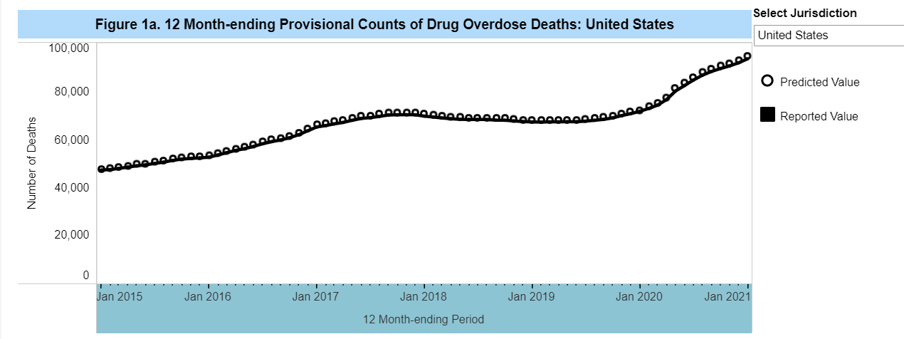

For Illinois, complete data are not yet available, but an increase of 24.3% is estimated. The national increase is attributed largely to synthetic opioids, e.g., Fentanyl. (CDC NCHS, 2021).

Shifts in drug availability may also be to blame for increased illicit opioid use deaths; if heroin isn’t easy to access, someone might take fentanyl… pandemic-related strains, from economic stress and loneliness to general anxiety about the virus, are a major driver for the increase.
(Abramson).

In 2010, a range of conditions classified as Alcoholic Liver Disease was a leading cause of US deaths. The prevalence of alcoholic fatty liver disease (AFLD) was stable from 2001 to 2016, but those with AFLD and stage 2 or greater fibrosis increased significantly by 2016. This is of concern because fibrosis is the strongest predictor of cirrhosis, liver cancer, and death. (Wong).

During the pandemic, with psychosocial stressors such as social isolation, loss of structured activity, and loss of employment, the consumption of alcohol increased, and a rise in severe ALD followed in several states. (Chen et al.).

Co-occurring disorders are very common, affecting 9 million people in the US; over half receive no treatment for either condition, only 7% receive services for both. (Gordon and Gans). Prior to the pandemic, over 25% of adults who had depression, anxiety, schizophrenia, or personality disorders also had a substance use disorder. (MentalHealth.gov). In addition to barriers to treatment of co-occurring disorders created by privacy rules and licensing and billing codes, stigma complicates access to addiction treatment and other necessary care. People with SUD are underserved in the healthcare system, increasing their risk for other illnesses and possibly keeping them from treatment for COVID-19. (NIDA).

Priorities of Those in Recovery:
Community Catalyst’s national study of people with substance use disorders identified the outcomes they seek from treatment:
- staying alive
- better quality of life and mental health
- reduction of substance use
- basic needs met
- increased self-confidence
- connection to ongoing supports.

During COVID, only 20% of respondents changed priorities, with quality of life less important and connection to services and basic needs more important. Their recommendations include:
- a full continuum of services, including crisis and long-term peer recovery supports
- harm reduction programs that focus on keeping people alive, including overdose prevention
- educating providers on harm reduction
- integration of mental health supports into SUD services, even for people who do not have an MI diagnosis
- adjusting services to meet individuals’ desired recovery goals.

While this is a national survey and the first of its kind, it breaks a silence and should serve as a model for improving the needs assessment process.

INTELLECTUAL/DEVELOPMENTAL DISABILITIES DATA

Service Needs and Preferences:
According to the Illinois Department of Human Services – Division of Developmental Disabilities “Prioritization of Urgency or Needs for Services (PUNS) Summary by County and Selection Detail” for July 14, 2021:
- Of 356 Supports Needed, the most frequently identified are:
  - Personal Support - habilitation, personal care, intermittent respite (306)
  - Behavioral Supports - behavioral intervention, therapy, counseling (147)
  - Speech Therapy (90)
  - Other Individual Supports (82)
  - Occupational Therapy (72)
  - Followed by Assistive Technology, Physical Therapy, 24-hour Respite, Adaptations to Home or Vehicle, Intermittent Nursing Services in the Home
- 321 people identified the need for Transportation Support
- 243 people identified the need for Vocational or Other Structured Activities:
  - Support to work in the community (217)
  - Support to engage in work/activities in a disability setting (98)
  - Support to work at home (6), and
  - Attendance at activity center for seniors (2)
- 65 people are waiting for Out-of-home residential services with less than 24-hour supports, and 45 are seeking 24-hour residential.

Through a CCDDB-funded contract, the CCRPC Independent Service Coordination Unit completes an annual preferences interview with each person enrolling in or completing an update for the State’s PUNS system. This assessment adds questions to those required by the State, in order to understand service gaps and opportunities. The full report will be available with other year-end reports as a downloadable document on http://ccmhddbrds.org. From 147 respondents, 25 new and 122 updating, selections are ranked from most to least popular.
- Living arrangements:
- With family – 76%
- Alone - 27%
- With roommates – 3%
- 24-hour CILA with bedroom of their own – 6%
- 24-hour CILA with shared bedroom – 4%
- Intermediate care facility – 1%
- Prefer to live in:
- Champaign - 51%
- Urbana – 16%
- Outside of Champaign County – 7%
- Mahomet or Rantoul – 6% each
- Champaign County – 3%
- Outside of Illinois – 3%
- St. Joseph – 2%
- Philo or Tolono – 1% each
- Homer, Fisher, and Sidney – less than 1% each
- Employment/volunteering:
- Other – 42%
- Retail – 21%
- Restaurant/food services – 16%
- With animals – 14%
- Service industry, outdoors, or education/childcare – 10%
- Public services – 7%
- The arts – 6%
- Office – 5%
- Technology services, factory, construction, recreation, or health services – 3%
- Writer, trade work, agriculture, or automotive – 1%
- Community opportunities:
- CU Special Recreation – 68%
- Health & wellness – 57%
- Special Olympics – 56%
- Groups and clubs – 53%
- Church – 48%
- YMCA – 35%
- Gardening – 33%
- Best Buddies – 24%
- Continuing education – 15%
- Other – 10%
- Leisure activities:
- Recreation/sports – 90%
- Eating out – 88%
- Zoo/aquariums – 86%
- Parks – 85%
- Movies – 83%
- Swimming – 71%
- Theatre/arts/museums – 70%
- Festivals – 67%
- Shopping – 62%
- Sporting events – 55%
- Concerts – 51%
- Other – 4%
- 98% seek support for Transportation, 98% for Financial, 96% Independent/daily living, 91% Medical, 81% Vocational, 80% Socialization, 47% PT/OT/Speech, 45% Behavioral therapy/counseling, 31% Respite, and 23% Assistive Technology
- 71% are not receiving case management services; 12% have case management support from DSC, 12% Community Choices, 3% CCRPC ISC, 2% Other, 1% Rosecrance, 1% PACE
- 49% were aged 19-59, 31% were 13-18, 12% were 7-12, 7% were 0-6, and 2% over 60
- 58% were male and 42% female
- 75% were white, 16% Black/African American, 6% Other/2 or more races, and 3% Asian
- 5% were of Hispanic or Latino/a origin
- 54% currently live in Champaign, 18% Urbana, 10% Rantoul, 7% Mahomet, 3% St. Joseph, 2% Tolono, 1% in each of Fisher, Philo, Rantoul, Savoy, and less than 1% in each of Bondville, Foosland, Homer, and Sidney.

Most representative of respondents would be a white, non-Hispanic, non-Latino adult man, living in Champaign with family, not receiving case management, seeking support for transportation, financial, independent living, and medical, and most interested in recreation/sport, CU Special Recreation activities, and a job doing “Other.”

Supports Sought by or on behalf of Residents with I/DD,
Using data from IDHS-DDD July 14, 2021 PUNS Report Sorted by County and Selection Detail
and CCRPC-ISC Decision Support program year-end report for PY2021:
Category of Support/Service | PUNS Result | ISC Result
Transportation | 90% | 98%
Financial management |  | 98%
Independent living support |  | 96%
Medical support |  | 91%
Personal support | 86%
Vocational support | 68% | 81%
Socialization |  | 80%
Support for work in the community | 61%
Speech/OT/PT | 59% | 47%
Behavioral supports | 41% | 45%
Work in disability setting | 28%
Other individual supports | 23%
Less than 24-hr residential | 18%
Assistive technology | 14% | 23%
24-hour respite | 5% | 31%
24-hour residential | 13% | 10%
Adaptation to Home/Vehicle | 4%
Intermittent in-home Nursing | 2%
Support to work at home | 2%
Attendance at senior center | Less than 1%
Reporting on unmet needs of Champaign County residents with I/DD may be easier than for residents with behavioral health concerns, thanks to: annually updated PUNS data; the CCRPC-ISC preference interviews; and strict eligibility criteria resulting in a smaller number of eligible persons whose needs and preferences should be clearly understood. Unfortunately, knowing that many people are waiting for long-term supports and services does not lead to immediate solutions to the system-wide insufficiencies which were worsened by COVID-19.

Community Survey respondents indicated they would like to see the following added:
- more options, including for those with Autism
- more options for adults and their families
- mentoring by those with I/DD for those with I/DD
- more vocational opportunities

Service Provider Survey respondents identified related barriers:
- lack of providers who bill insurance and long wait lists for those services
- insufficient housing options for people with I/DD
- lack of resources and information about them
- not enough staff

These are echoed in testimonials below.

Observations:
People with I/DD have been especially impacted by COVID-19, in part due to high-risk congregate living and difficulty accessing supportive services, including for health care:

A cross-sectional study of 64,858,460 patients across 547 health care organizations reveals that having an intellectual disability was the strongest independent risk factor for presenting with a Covid-19 diagnosis and the strongest independent risk factor other than age for Covid-19 mortality… Beyond the direct risk of Covid-19, the pandemic has had negative effects on the ability of individuals with intellectual disabilities to receive the health care and daily support that they typically receive. Providers who are not cognizant of this medical limitation may incorrectly turn them away… A lack of typical supportive services may lead to increased behavioral issues and treatment with psychotropic medication with negative side effects, including weight gain.
(Gleason et al.).

Providers of services for people with I/DD have also been and continue to be deeply impacted by the COVID-19 pandemic, which has demanded even more from an already endangered and underpaid direct support workforce:

Not a single time have I posted encouraging/begging people to get the vaccine. Today is different. Despite the controversy, I want to make a plea to those working in the human service agencies. I am watching unvaccinated people quarantine over and over, while others work significant OT to make up for that loss all over the state of Illinois. There are so many unvaccinated that are doing that, too, but if exposed, guidance dictates safety measures that send them home for an extended time. (I don't disagree with the safety measure).

If ELIGIBLE and you work with a vulnerable population, please, please get the vaccine. People are depending on us for their health and safety. We've chosen a profession because we are passionate about a Mission that includes being responsible for the health, safety and welfare of others.

If you're on the fence about it, one of my favorite quotes I was accused of saying many years ago is (I didn't): Indecision is a decision in and of itself. I know there will be support and criticism to my plea, I just ask that you are kind in your responses. #TheyDeserveMore #getvaccinated #itsnotover #deltaVariant #tired
- From the personal facebook page of a local I/DD agency executive, August 11, 2021

Self-advocates continue to identify the state/federal funding imbalance, a pre-pandemic condition with no solution in sight, as a barrier to independence for many:

I am a person with autism who lives in Champaign.

Advocating for my rights and the rights of others is important to me. I want Illinois legislators to know that people with intellectual and developmental disabilities deserve to live full lives in their communities. I am fortunate to have choices about where I work, where I live, the activities I participate in and what my day looks like.

Because I receive state funding, I work with community service providers to move into my own apartment, secure a job with the University of Illinois, and facilitate advocacy and leadership classes and projects for myself and others with these types of disabilities.

A lot of nondisabled people in Illinois don’t understand that some people with these disabilities are not able to choose these things. Why? People with intellectual and developmental disabilities are part of their communities, contribute to their communities and are the experts in their own lives. They should have the right make decisions about their own lives. The state does not properly fund services for people with disabilities. Some people are on a waiting list for services and funding. I was on the wait list for 12 years.

Some people with disabilities live in state-run institutions and have to wait for services because the state doesn’t have the funding available to help them leave. If Illinois legislators agree to fully fund community living services for people with these types of disabilities, then we can all choose the lives we want to live.
- Sarah Demissie, “From Our Readers: Disabled need greater support,”
The News-Gazette Opinions Page, July 21, 2021

Family members continue to be the drivers of system advocacy, against growing obstacles:

I write today on behalf of my 32-year-old son, Daniel, and thousands of Illinois citizens with developmental disabilities who continue to face a housing and staffing crisis.

Dan has autism, is non-verbal and requires 24/7 supports. He is loving, funny and helpful. He’s a terrific son who “keeps us on our toes” and is an essential part of our family. Dan is fortunate to live for just over six years in a small group home near us in Champaign — one that could be forced to close because of inadequate state funding. We are very grateful to the agency that committed to opening a home for Dan here in Champaign.

Over the years that Dan has been “home,” his emotional and behavioral stability have improved dramatically. We’ve never seen him happier. But, the threat that the agency will not be able to hang on is with us every day. Dan and others like him deserve the opportunity to live near their families, to build friendships and develop interests, to volunteer, work and play in their communities, just like “regular” people do. Illinois agencies provide the homes and care that make this life possible for people with disabilities, but they are severely underfunded and chronically understaffed.

In fact, our state ranks 47th for its funding commitment to people with intellectual and developmental disabilities. Direct Support Professionals — the caregivers who really support my son — are systemically undervalued and undercompensated by the state.

I say that Dan is fortunate because far too many Illinois residents with developmental disabilities are forced to live far from their home communities. And that’s if they receive any support or placement at all. More than 18,000 people with disabilities are languishing on the state’s waiting list, and the lack of services is especially acute for people with complex medical or behavioral needs.

Even before COVID blindsided us all, we were aware that the cost to Dan’s agency of operating the three Champaign homes was becoming too burdensome. They closed one home in January. The possibility that they could close Dan’s home is frightening.

No system of care is perfect, but we can and absolutely must do better. Many other states do. Why can’t Illinois?

The good news is that everyone now knows exactly how to solve this crisis. In December 2020, the Illinois Department of Human Services released a state-commissioned, independent study that lays out a clear list of priorities and the funding required to implement them. When the General Assembly passes its annual budget in the next few days, I urge them to follow the funding recommendations in the study.

Now is the time to finally make humane treatment of our citizens with developmental disabilities a priority.
- Debra Ruesch, “My Turn: Debra Ruesch
Town Hall | 'Now is the time to finally make humane treatment of our citizens with developmental disabilities a priority',”
The News-Gazette Opinions Page, May 25, 2021

COVID inadvertently brough some good news for job seekers with I/DD:
While COVID has put incredible strain on all areas of our communities, particularly direct service professionals working group homes and community day programs, there have also been some unexpected positive outcomes. After the initial period of hard lock-downs, business closures, and mass layoffs, people with I/DD have had an unexpectedly large presence in the economy re-opening. Since the spring of 2021, our participants with disabilities are finding community jobs at far greater rates than they were before the pandemic. In the last week alone, we have supported three people to find meaningful community-based, competitively paid employment. Two years ago this would have been unprecedented for the size of our organization.

Early in the pandemic we had a glimmer of hope that this extremely difficult period would spark the creativity of businesses to be flexible, carve positions, and think about different ways to do things. Some of the hiring we're seeing reflects this shift. Businesses have absolutely become more agile. They are, of course, also experiencing a significant shortage of workers. In response to this, hiring departments have become much more open and collaborative when approached by our employment staff.

Many of our participants are also coming to the employment process with renewed motivation and in some cases new skills. The pull of re-engagement in the community is high and lots of people are excited to find work. Many, like all of us, are also coming to our services with new computer and communication skills picked up from months of searching through emails for zoom links and messages from friends.

It has been an extremely heartening pattern to witness when so many people and organizations are struggling. COVID has stretched our community in many ways, but we hope that this trend toward flexibility and inclusion continues in our workforce.
- Becca Obuchowski, Executive Director, Community Choices, Inc.

REFERENCES

Abramson, A. (2021, March 1). Substance use during the pandemic. Monitor on Psychology. www.apa.org/monitor/2021/03/substance-use-pandemic

Behavioral Health Workforce Education Center Task Force Report to the Illinois General Assembly.
(2019, December). A Report on the Illinois Behavioral Health Workforce Crisis and Recommended Solutions to Grow, Recruit, & Retain a Qualified, Modern, Diverse, and Evolving Behavioral Health Workforce: Response to House Bill 5111 (PA 100-0767). www.ilga.gov/reports/ReportsSubmitted/693RSGAEmail1488RSGAAttachBH%20Workforce%20Task%20Force%20Report%2027DEC2019%20FINAL.pdf

Carratala, S. and Maxwell, C. (2020). Health Disparities by Race and Ethnicity. Center for American
Progress. www.americanprogress.org/issues/race/reports/2020/05/07/484742/health-disparities-race-ethnicity/

Centers for Disease Control and Prevention. National Center for Health Statistics. (2021). Vital Statistics
Rapid Release: Provisional Drug Overdose Death Counts. www.cdc.gov/nchs/nvss/vsrr/drug-overdose-data.htm

Centers for Medicare & Medicaid Services. (2021). Press release CMS Data Shows Vulnerable Americans
Forgoing Mental Health Care During COVID-19 Pandemic. CMS. www.cms.gov/newsroom/press-releases/cms-data-shows-vulnerable-americans-forgoing-mental-health-care-during-covid-19-pandemic.

Champaign-Urbana Public Health District et al. (2021). Champaign County Community Health Plan 2021-
2023. www.c-uphd.org/documents/admin/Community-Health-Plan-2021-2023.pdf

Chen PH, Ting PS, Almazan E, Chander G, Cameron AM, Gurakar A. (2021). Inter-Hospital Escalation-of-Care Referrals for Severe Alcohol-Related Liver Disease with Recent Drinking During the COVID-19 Pandemic, Alcohol and Alcoholism. doi.org/10.1093/alcalc/agab047

Cohn, R. (2020). Stanley Ligas, et al. V. Theresa Eagleson, et al. Seventh Annual Report of the Monitor.
www.dhs.state.il.us/OneNetLibrary/27897/documents/DD%20Reports/Ligas/SeventhAnnualReportoftheMonito_in_Ligas3.120.pdf

Community Catalyst, et al. (2021, April). Peers Speak Out: Priority Outcomes for Substance Use Treatment and Services. www.communitycatalyst.org/resources/tools/peers-speak-out

Filkukova, P, Ayton P, Rand K, and Langguth J. (2021). What Should I Trust? Individual Differences in Attitude to Conflicting Information and Misinformation on COVID-19. Front. Psychol., 21 June 2021. doi.org/10.3389/fpsyg.2021.588478

Gale, J., Loux, S., Shaw, B., & Hartley, D. (2010). Encouraging rural health clinics to provide mental health services: What are the options? (Research & Policy Brief). Portland, ME: University of Southern Maine, Muskie School of Public Service, Maine Rural Health Research Center.

Gomez, S. (2021, July). Drug Overdose Deaths Hit 93,331 Record High During Pandemic. Addiction Center. www.addictioncenter.com/news/2021/07/drug-overdose-deaths-hit-93-331-record-high-during-pandemic/

Gordon, S, and Gans, S. (2021, July 16). Co-Occurring Disorders: Mental Health Issues & Addiction. Verywell Mind. www.verywellmind.com/co-occurring-disorders-mental-health-and-addiction-4158280

Gibbs T, Pauselli L, Vieux U, Solan M, and Rosenfield P. (n.d.). Mental Health Disparities Among Black Americans During the COVID-19 Pandemic. Psychiatric Times. www.psychiatrictimes.com/view/mental-health-disparities-among-black-americans-during-covid-19-pandemic

Gleason, J, Ross, W, Fossi, A, Blonsky, H, Tobias, J, and Stephens, M. (2021, March 5). The Devastating
Impact of Covid-19 on Individuals with Intellectual Disabilities in the United States. NEJM Catalyst Innovations in Care Delivery. catalyst.nejm.org/doi/full/10.1056/CAT.21.0051

Heath, S. (2018, June 28). Top Challenges Impacting Patient Access to Healthcare. Patient Engagement HIT. patientengagementhit.com/news/top-challenges-impacting-patient-access-to-healthcare

Hillis, S. et al. (2021). Global Minimum Estimates of Children Affected by COVID-19-associated
Orphanhood and Death of Caregivers. The Lancet. DOI: 10.1016/S0140-6736(21)01253-8 www.sciencedirect.com/science/article/pii/S0140673621012538

Illinois Behavioral Risk Factor Surveillance System. Illinois County Behavioral Risk Factor Survey, Round 6 (2015-2019). Illinois Department of Public Health (IDPH). http://www.idph.state.il.us/brfss/countydata.asp?selTopicCounty=ALCOHOL&areaCounty=Champaign_10&show=freq&yrCounty=6&form=county&yr=&area=&selTopic=

Illinois Youth Survey. (2020). County Report: County Name: Champaign. University of Illinois Center for Prevention Research & Development, School of Social Work. IDHS. iys.cprd.illinois.edu/UserFiles/Servers/Server_178052/File/2020/Cnty20_Champaign.pdf

Jacobson, Sheldon H. and Jokela, Janet A. (2021, June 10). Beyond COVID-19 deaths during the COVID-19 pandemic in the United States. Health Care Management Science (2021). doi.org/10.1007/s10729-021-09570-4

Massachusetts: Institute for Healthcare Improvement. (2020). A Guide for Health Systems to Save Lives from “Deaths of Despair” and Improve Community Well-Being. www.ihi.org/resources/Pages/Publications/guide-for-health-systems-to-save-lives-from-deaths-of-despair-improve-community-well-being.aspx

Mental Health America. (2021). The State of Mental Health in America. Support by Alkermes, Otsuka America Pharmaceutical Companes, and Takeda Lundbeck Alliance. mhanational.org/issues/state-mental-health-america

MentalHealth.gov. (2019, March 22). Mental Health and Substance Use Disorders. MentalHealth.gov. www.mentalhealth.gov/what-to-look-for/mental-health-substance-use-disorders

National Association of State Mental Health Program Directors Medical Directors Council. (2006). Morbidity and Mortality in People with Serious Mental Illness. NASMHPD. www.nasmhpd.org/sites/default/files/Mortality%20and%20Morbidity%20Final%20Report%208.18.08_0.pdf

National Center for Health Statistics. (2017, February). Health Insurance and Access to Care. www.cdc.gov/nchs/data/factsheets/factsheet_hiac.pdf

National Institute for Health Care Management (NIHCM). (2021, July). Long COVID, the Delta Variant, & Violence. nihcm.org/newsletter/long-covid-the-delta-variant-violence?utm_source=NIHCM%2BFoundation&utm_campaign=6e631acadb-July_2021_Newsletter&utm_medium=email&utm_term=0_6f88de9846-6e631acadb-167736168

National Institute of Mental Health. (2021, January). Mental Illness. NIMH. www.nimh.nih.gov/health/statistics/mental-illness

National Institute on Drug Abuse, N. I. on D. A. (2020, November 20). COVID-19: Potential Implications for Individuals with Substance Use Disorders. www.drugabuse.gov/about-nida/noras-blog/2020/04/covid-19-potential-implications-individuals-substance-use-disorders

National Low Income Housing Coalition. Out of Reach 2021: Illinois. reports.nlihc.org/oor/illinois

Otsuka America Pharmaceutical. (2021, July). Trends in Behavioral Health: A Reference Guide on the US Behavioral Health Financing and Delivery System. Third Edition. psychu.org/guide-third-edition/

Panchal N, Kamal R, Cox C, and Garfield R. (2021, Feb 10). The Implications of COVID-19 for Mental Health and Substance Use. KFF. www.kff.org/coronavirus-covid-19/issue-brief/the-implications-of-covid-19-for-mental-health-and-substance-use/

Rosenfeld, R, and Lopez, E. (May 2021). Pandemic, Social Unrest, and Crime in U.S. Cities: March 2021 Update. National Commission on COVID-19 and Criminal Justice, Council on Criminal Justice. covid19.counciloncj.org/2021/05/21/impact-report-covid-19-and-crime-4/

Ross, W. (2021, April 20). The terrible toll of COVID-19 on people with intellectual disabilities. AAMC. www.aamc.org/news-insights/terrible-toll-covid-19-people-intellectual-disabilities

Rural Health Information Hub. (2018, November 11). Rural Health Information Hub. Rural Mental Health Overview. www.ruralhealthinfo.org/topics/mental-health

Sawani, J, and Malcom, K. (2020, May 4). Racial Disparities in the Time of COVID-19. MHealth Lab, University of Michigan, Michigan Medicine. www.labblog.uofmhealth.org/rounds/racial-disparities-time-of-covid-19

Shore, J. H. H., Larson, S., Rinehart, L. R., Gordon, S., Yellowlees, P., Sison, A., & Arnold, J. (2021, February 24). Advancing Telepsychiatry in the Era of COVID-19: Considerations for the Management of Major Depressive Disorder. clinical.med-iq.com/psychiatry/free-cme-course/advancing-telepsychiatry-in-the-era-of-covid-19-considerations-for-the-management-of-major-depressive-disorder.html

Syed, S. T., Gerber, B. S., & Sharp, L. K. (2014, December 14). Traveling towards disease: transportation barriers to health care access. Journal of community health. www.ncbi.nlm.nih.gov/pmc/articles/PMC4265215/

United Way of New Jersey. (2021). ALICE Report: Asset Limited, Income Constrained, Employed. unitedforalice.org/illinois

University of Illinois at Urbana-Champaign, College of Education, Early Childhood Collective. Illinois Early Childhood Asset Map. Funded by the Illinois State Board of Education (ISBE) and Illinois Department of Human Services (IDHS). iecam.illinois.edu

University of Wisconsin Population Health Institute. (2021). County Health Rankings & Roadmaps: Building a Culture of Health, County by County. Support provided by Robert Wood Johnson Foundation. www.countyhealthrankings.org/

US Census Bureau, Population Estimates and 2020 Population and Housing State Data. www.census.gov

US News Healthiest Communities. How Healthy is Champaign County, Illinois? www.usnews.com/news/healthiest-communities/illinois/champaign-county

Verdery A, Smith-Greenaway E, Margolis R, Daw J. (2020). Tracking the Reach of COVID-19 Kin Loss with a Bereavement Multiplier Applied to the United States. Edited by Douglas S. Massey. Proceedings of the National Academic of Sciences of the United States of America. PNAS July 28, 2020 117 (30) 17695-17701 doi.org/10.1073/pnas.2007476117 www.pnas.org/content/117/30/17695

Voices for Illinois Children. 2021 Illinois Kids Count Report: Addressing Child Poverty Before and After COVID-19. www.voices4kids.org/wp-content/uploads/2021/07/2021-Illinois-KIDS-COUNT-Report.pdf and Exploring Illinois Children’s Well-Being: Interactive Maps. www.voices4kids.org/__interactivemaps/

Well Being Trust. (2021). Supporting a Nation in Crisis: Solutions for Local Leaders to Improve Mental Health and Well-Being During and Post-COVID-19. debeaumont.org/wp-content/uploads/2020/08/mental-health-action-guide.pdf

Woolf S, Masters R, Aron L. (2021, May 24). Effect of the covid-19 pandemic in 2020 on life expectancy
across populations in the USA and other high income countries: simulations of provisional mortality data. BMJ 2021; 373:n1343, Published 24 June 2021. doi.org/10.1136/bmj.n1343

Wong T, Dang K, Ladhani S, Singal AK, Wong RJ. (2019). Prevalence of alcoholic fatty liver disease among adults in the United States, 2001-2016. JAMA. 2019;321(17):1723-1725. DOI:10.1001/jama.2019.2276. jamanetwork.com/journals/jama/fullarticle/2732559?guestAccessKey=644408df-7a63-40c2-8e61-3d0988921a38&utm_source=For_The_Media&utm_medium=referral&utm_campaign=ftm_links&utm_content=tfl&utm_term=050719

APPENDIX I: FULL COMMUNITY NEEDS ASSESSMENT SURVEY QUESTIONS AND RESPONSES
This survey was available online and on paper, in English and Spanish, during August 2021. Some questions were required, but many were optional and long-answer, to collect rich data. Of 210 total returned, 40 were on paper in English, 11 on paper in Spanish, 158 were online in English and 1 online in Spanish. Full responses are aggregated below, per question. The lead-in read: “Please treat our brief survey as a thought experiment. We want to make Champaign County a place where people can achieve their best life, with the health and wellness and success they aspire to and deserve. This includes people who live with mental illnesses, mental injury (such as from trauma), who choose recovery from substance use disorders (such as addiction or alcoholism), and who have intellectual/developmental disabilities which may make some aspects of community life harder to access. Your Opinion Matters!”

Do you live in Champaign County? (Required)
Yes – 203 (97%)
No – 7 (3%)

What is your zip code? (Short answer, Optional)
61821 – 42 (21%)
61820 – 33 (17%)
61802 – 32 (16%)
61822 – 25 (13%)
61801 – 23 (12%)
61853 – 7 (4%)
61866 – 7 (4%)
61874 – 6 (3%)
61849 – 3 (2%)
61843 and 61880– 2 each
51834, 61820-2935, 61821-3419, 61822-6111, 61823, 61844, 61847, 61854, 61856, 61862, 61872, 61873, 61877, 61920-2410, 61953 – 1 each

What do you like about life in Champaign County? (Long answer, Optional)
Compassion, diversity,
Very diverse in races. Enough for me to do
I live a quiet life.
the people and the size (easy to get everywhere...even though there is no trader joes)
The university keeps things young and gives us many cultural and academic resources, good mass transit in Champaign and Urbana, and the park district provides good special needs and other programming. Plus it is more affordable than places like the Chicago area.
Semi-rural with great amenities.
The cultural diversity, the university, the variety of restaurants
I work in Champaign
The diversity!
the variety and access to different events at various venues; access to shopping and restaurants; has something for everyone
lots of things to do for kids and seniors
It's diversity of cultures.
All of the opportunities that Champaign has to offer. Moving to Champaign County has changed my life.
I love the diversity of the people of Champaign County and the many wonderful opportunities that a college town provides for the community.
Advantages associated with the University.
yes
we have bigger city options with a smaller town feel
Wide variety of restaurants, lots of parks, lots of trees, good library, mix of white collar, blue collar, students, academics.
Connections
For the size of the community it is relatively resource-rich
Good options, resources for autism
The size - not too big, not too small
University, restaurants, not too much traffic
My mom and brother live here.
Accessibility to great resources/supports/services, especially with the UIUC community. Centrally located close to bigger cities - Indy, Chicago, etc. Local airport. Great restaurants & business scene.
Good programs for people in need
right size of community for me
Diverse, many activities and the ability to access U of I resources
Closeness to family and lifelong friends in the community I grew up in, arts and cultural activities in Champaign Urbana, access to nature preserves and biking trails
I enjoy the atmosphere
The amount of highly successful, thriving small businesses
The university presence and what USED to be a calm and crime free environment
And the parks are exceptional
Generally quiet, polite people
Quality of Life
Its home. A lot of interesting educated people here.
I like it. I came here to be with and live with my husband. I’m physically disabled and wish there were more mental health groups and more groups for people that are disabled as our mental health needs seems to be pretty low as anyone’s priority.
Lots to do, good restaurants, close to university
Less hectic
Cost of living, things to do
I love downtown and the restaurant options. Enjoy sitting on patios in the summer dining out with family. Love all of champaigns amazing parks and library
Slower pace of life. Small town feel but still convenient.
Sadly, not much. It’s a very unhealthy community.
It’s my hometown, it’s small
Unique blend of “rural small town” and “hip college town” that somehow just works
Many things to do for people with varying interestd
no crime to speak of outside of bad areas
I stayed here after finishing school because of how friendly, warm, & welcoming the people were.
Excitement of campus
The diversity (in people, restaurants, activities)
There are more diverse stores in Champaign and Urbana than in the surrounding areas. Other than that, nothing much.
Variety of cultures
That even though it is a big town, we still have a small town feel.
My family is here. I've lived here almost all of my life, so this is what's comfortable.
The Champaign library is AWESOME!!!
Libraries, Cultural events, Choices for shopping
Small town feel where I live.
The many things to do here.
A lot to do
The culture
The diversity, arts and the downtown social life.
Friendly people, great community, good restaurants and libraries, great health department, lots of nature and wonderful parks.
We have great parks. The cost of living is relatively low. It's easy to get around town by car, bus, bike, or walking. The MTD is fantastic and one of the best bus systems we've encountered (out of many states and several countries). We have lots of entertainment options from live music (Friday Night Live, free concerts in the park, etc), theatrical productions (Krannert), movie theaters, etc.
My village is quiet, safe, and works hard to benefit the children
My family
My small town living
not much
I love the mix of rural and city life and it’s opportunities
It’s easy living
The food
I like the proximity of businesses to where I live.
Love the area...tons of options and opportunities for both students and adults
Beautiful parks and great local restaurants.
High taxes
It’s a smaller city than most
Medical, culture and education (university)
There's a lot of food options
Not too big (like Chicago), and not too small (like Hoopeston).
The Mini-metropolitan feel
It is a nice community to walk in.
Well, it use to be quiet, family, friendly community.
jobs
Community & people
I like the people and the community
Nothing
a wonderful place to raise your kids! and working a good job
Size. Family is here.
The parks and schools
Access to quality health care providers and relationships
Small community, was a good place to raise family
they help you do different things
My family is here
My family lives here.
Nothing special
Nothing
A lot of opportunity & good connects
Liberal diverse community
The opportunites to do things you can't do in other communities this size
The MTD bus system
The music scene
Nothing
diversity
The past how we use to work together to make things better
I DO NOT LIKE LIVING HERE!
- Community has the ability to pull together to be something bigger than our issues.
- We have many different options for "safety nets" for our community members (lots of social service/non profit organizations that are willing to work together to create a better life for a client)
- Outreach from the county specifically is great, lots of clients trust in their outreach.
- We have beautiful scenery and lots of fun things to do
Something different from Chicago
Used to be safe
Family
variety of food, cultural and racial diversity, community events, shopping
Diversity
I have a good job.
Most all of my family and friends live in Champaign County. So I'm close to them.
That I live in a small town and not close to all the violence and chaos.
Things to do
Its ok
There is plenty of stuff to do with little children
I've lived here for most of my life. It used to have great services for those in need. I like the city and the country aspect of it.
So much - university, music, restaurants, out door activities, farmers markets, good healthcare, services for homeless, strong non- profits, DSC
good park districts, diversity, U of I
Variety of opportunities available for persons with a disability. Covid response has been very good.
Bible study groups and Cultural/theatre activities
In general, the people here seem to really try. Regardless of class or creed, most people really are trying to do good.
The serenity of the pastoral and peaceful rural environment.
Old parts of town/ festivals/ some of the old houses
It's small town with large city ammenties
Easy commute, lots of community opportunities for music, dining, art
The diversity and arts brought to town (primarily by the university and the college, presumably).
tranquility, job.
Tranquility
Tranquility
Quiet and small population
Calm and less dangerous
Quiet and peaceful.
My neighbor that I know--who watch me make sure that I am alright-that I can call on.
Family lives nearby-we'll be here until we die, most likely.
I like teaching at a Christian school. I like the variety of churches. I like the fact that groceries, gas, and other types of stores and restaurants are nearby, as well as healthcare.
Nothing anymore
Quiet
Weather, people, quiet
Quiet place, hospitality, very safe, and kind.
Quiet
Multicultural
being able to get access to important supports and resources about important issues
services, people, education opportunities, entertainment opportunities
I love the variety of neighborhoods and how welcoming and connected they feel, while still being part of a larger city that provides access to services and experiences that are not always available in smaller communities.
I have a strong community of family and friends here. I love the University bringing great things to the region
People are nice. It's easy to get around places and not hard to find anything.
Clean, friendly, quiet
small country living
When I moved here in 1991, I did like it right away! Everyone liked each other and my Carle Hospital and the kindness of people that care.
The work places.
It's OK
opportunities
The City of Champaign County is a place where you can come too and raise your kids, it is a city/county of family.
No response
The community
Variety of community events/activities (fair, farmer's market, sweetcorn festival, etc.); beautiful nature opportunities (Meadowbrook, Middle Fork, Lake of the Woods, etc.); great arts & park district programs for families/individuals; the university! brings jobs, activities, etc.
Diversity, Recreational options, Public Art
The people
The convenience of riding the bus to work and shopping.
convenience, doctors/shopping
The balance of the open country and the beautiful neighborhoods, the amount of things available to do and all the loving people
no se
What do you NOT like about life in Champaign County? (Long answer, Optional)
Currently…. The crime!!!!
Lack of affordable housing, mental health and addiction services. Inaction.
Need new restaurants
Not enough activities for autistic adults. Also not enough psychiatrists.
the MAGA people
I have been shocked by the bias against disabilities in my involvement in the family court system. Officers of the court did nothing to help me as a victim of domestic abuse. I know courts often don't care, but then my disability was used to further make assumptions and restrict my rights.
Lack of access to health(all types) care for all county residents
Increasing community violence and lousy streets
Levels of violence increasing
NA
The racism
right now the gun violence and fear for general citizens just going about their day
gun violence
All of the gun violence that is now happening on a daily/weekly basis.
The increase in youth violence and not being able to let my 12 year old daughter go out alone.
Crime
Gun violence.
crime going up
good people, good weather, good schools esp the University, good community spirit
Gun violence.
Family
There are some very conservative areas where people promote viewpoints, perspectives, and ideologies that are harmful to others.
Lack of psychiatrists
Shortage of mental health resources
Lack of support, lack of resources, lack of research, lack of knowledge, intolerance and ignorance of others, judgment of medical professionals
Not as much for kids/families to do; racially segregated neighborhoods
Not a lot of options for things to do for people who don't drink.
Recent increase in violence & crime.
Crime rate
mean people
Barriers to access u of I services to community people
This is not my first choice for a retirement home. I have had to move here to care for my adult brother with ID/DD because services for him do not meet his needs or our family needs.
The violence
The violence, and crime, which all stem from poverty and lack of resources, needs to be addressed. Mental health issues need to become a primary standard of care for doctors, mental health screenings should occur more frequently than what's standard.
Too Republican, gerrymandered county
The crime - the shootings - the mall being an unsafe place now . I can’t believe that the police Are maligned when so many people are Angry, carrying guns and disallowing and mocking law enforcement
Crime targeting children and provoked my teenagers
Rising violence, no grocery downtown Champaign
Crime/Gun Violence/Cost of Living
Racism, violence. So tired of hearing about the police officer that got shot.
See above
Gun violence
Crime rate
Some of the neighborhoods/areas that don't seem safe at night anymore due to recent violence in champaign and urbana
Not sure!
Highly narcissistic, creates the illusion that they care for others, yet sadly this community is very selfish.
Nothing to do for families or individuals
The county caters to criminals and ignors the needs if tax paying citizens.
Gun violence, increased homelessness
Rising crime
Violence. Lots of violence
Crime, don’t feel safe
crime in bad area
Rising violence
Rising crime, lack of support for police from city council.
Getting dangerous to be here.
Lake of the Woods
Expensive, crime, lack of decent jobs, did I mention crime?, inadequate mass transit, lack of safe and affordable housing
The increased violent crimes rate over the last 3 years
Jtge justice system. We are letting criminals go too easy. Domestic battery charges roll over 10 months to have ppl forget the situation. I feel it's ok to loot, steal, and shoot ppl, they all seem to get a slap on the hand. Our community is no longer safe.
Violence, racism, the lack of compassion.
Not enough choices for kids to do in a bugdet. Not neccesarily free, but not so expensive.
There is nothing to do, and it is boring.
Crime
Increased violence and racial divide
Violence, lack of available mental health help, especially for kids who are legally adults, but can't function as one because of mental health issues
The gun violence
Too much violent crime
Recent increase in gun violence, resource disparity, lack of affordable mental health treatment, lack of psychiatry providers, monopolization of healthcare, education disparity, lack of resources for people who are homeless, disparity in resources for BIPOC, lack of things to do for kids (that they are interested in and can afford)
Gun violence
Lack of access to good mental health care, especially for youth. I spent time at Pavilion several times in the youth unit when I was a teenager and it was more damaging than helpful. Even as an adult, I have a hard time getting adequate mental health care in champaign county. I ended up having to drive to see a psychiatrist in Chicago because the psychiatrists at Carle are overworked and have too many patients and couldn't see me as often as I needed.
Another problem is there needs to be more support for the homeless community. Either larger or better shelters, or housing programs so that people get their own apartment or home.
The increase in gun violence is absolutely terrifying.
Extremely disgusted by Crime Rates, Lack of Community Resources
The increased crime levels.
The uptick of violence in town is terrifying (we’ve lived here 14+ years) and our tax rate seems absurdly high with little benefit
Shootings not feeling safe
Gun violence
Champaign Urbana violence
taxes are way to high
Currently the amount of crime especially gun violence is extremely concerning.
Taxes and gun violence
Everything else. The crime, the intolerance, the rudeness of the locals, the difficulty getting a good job
Crime
Gun violence, litter, drag racing
The gun violence
the gun violence has gotten out of control
Increasing crime rates and unclean streets/sidewalks (too much litter).
the loneliness
That some loud mouthed people consider Native imagery to be “racist” when it obviously is NOT
CRIME CRIME BAD PEOPLE
There are NOT enough kid-friendly activities. ESPECIALLY in the winter!!!!!
There is way too much crime - especially shootings.
The rampant crime
There are pockets of violence that seem to be spreading.
There is no community centers for Seniors or school-age children in Urbana. The Snow Removal service throw snow at the bottom of your drive way.
gun violence
too much shootings school sucks, college kids get too much
The school the shootings
Too much violence
lack of activities for kids & young Adults. Lack of Job program for teens-Summer. Lack of strong mentoring for at risk youth. Crime. Lack of Homeownership programs for minorities.
The only major psychiatry is carle, the wait is 6 months just to be talked to & another 3 months to see a doctor.
Lack of options and providers for private therapies and recreational services
Crime/shooting. Job market. Nothing to do.
All the shootings.
The violence right now
All of the shootings. Police profile. There's nothing to do here.
Conservative. Racism
The violence and no opportunities.
Over expensive
Flat, no bodies of water
The growing level of violence
Lately the rash of violence
Feeling unsafe, especially as a woman
The environment
racism
the violence
The shootings, the constant deaths, lack of things to do in Champaign for kids, nothing for the black community to do.
- recent gun violence
- lack of affordable and sustainable housing
- lack of living wage in most areas, if not all
- Not feeling safe in a public place like a park, when alone
These bad kids in this area they pick on my nieces & nephews
Killings
Violence. Not enough community support
Gun Violence
Poor road conditions. City planning for roads was done poorly.
All the gun violence
Champaign County has become too dangerous.
All the violence, shootings and hate for officers that show up to their jobs daily.
Violence
They seem to not care about the mobility of the disabled individuals in neighborhoods. There are no sidewalks and they are forced to use the street which is not safe.
the price of a house or apartment is ridiculous and most places are only for collage students when it should be for everyone because the people who live here and dont go to collage cant find affordable housing. I live in a homeless shelter with 2 kids and only my sons ssi
Lack of addiction and mental health services. ALso the way our ( Urbana) Goverment treats our law enforcment officers. NO Backing for our people in blue . I'm suprised they have not all walk away for other jobs. They support the community more than our local officials.
Divide between urban and rural communities- have and have nots - gun violence, lack of inpatient substance abuse beds - long term services for dual diagnosis - need more help for previously incarceratef
Increasing level of crime with almost daily shootings.
The shooting and harm
It somehow manages to feel less like a destination than something you should just visit or pass through. Everything feels far away; there are very few areas aside from UIUC campus that actually feel like a community or neighborhood, to me.
Violence, feeling unsafe
The urban chaos.
Everything is getting replaced by student housing/ high rise “luxury” apartments
Even with all of the amenties, it often feels like it is missing things
far from recreational places
Honestly, I really can't think of anything.
Nothing
Nothing
Nothing
The cold and the winter
The cold weather
The snow
No support from County officials--they told us they would do things (remove appliances, trash, etc...) not done. Children not having places to go to for play. Not having support for school. Kids sleeping in bathrooms.-people sleeping in cars. Selling drugs from car to car--shootings
Way too much emphasis on College sports.
1. People drop trash at the intersections and as they drive by. 2. Loud music (Rap) played so loudly my windows rattle. 3. Cars racing down my street and through the stop sign.
all the useless shootings, not enough activities for children (for free, or cost efficient) to do so they stay out of trouble.
Nothing
Nothing
Some people don't care about the city and throw trash on the streets.
Winter
Nothing
being unable to get access to important supports and resources about important issues
harsh weather in winter
The increase in violent crimes has been of concern.
Living in Tolono can be isolating as I am much more liberal than my neighbors.
Here recently in the last couple years too much crime
Crime rate
Nothing
small country living
I do not like life in my truck in Champaign-Urbana.
The living situation.
No response
N/A
No response
Adults with Intellectual Disabilities do not have true day training opportunities.
No response
No response
How poorly supported our PUBLIC SCHOOLS are. The town/gown divide.
Nothing
The violence and panhandling
crime/shootings
Knowing I am indeed the curmudgeonly townie I was worried I'd be; campus lol. I dislike very little besides the hateful, uninformed people who decide their voice is the only one needed to be heard. But that's an everywhere problem
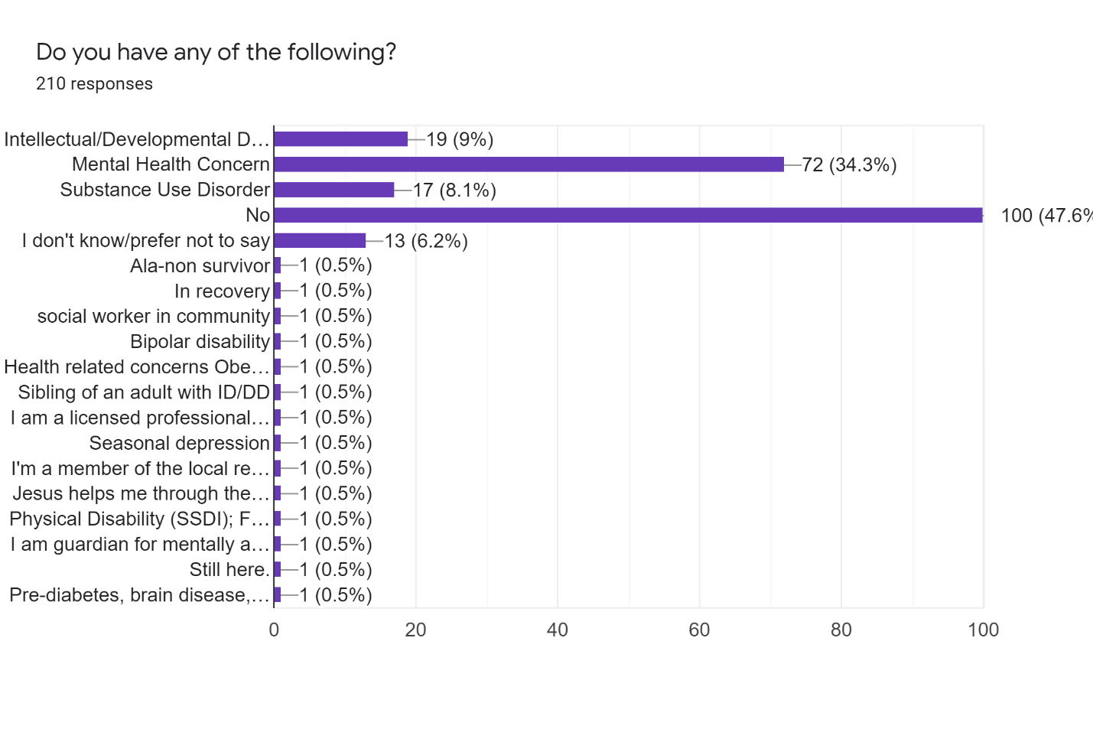

Are you a family member or friend involved in the care of a person who has one or more of the above conditions? (Required)
Yes – 50.5%
No – 49.5%

Have you ever tried to get services, supports, or resources related to mental health, substance use, or intellectual/developmental disability, in Champaign County? (For yourself or another person.) (Required)
Yes – 68.1%
No – 31.9%

List any mental health services, supports, or resources for people who live in Champaign County. (Long answer, Required)
NAMI, Crisis Nursery, Carle, Rosecrance, Pavilion
Rosecrance, community choices , Dsc carle private therapists
Pavillion- terrible
Rosecrance- very hard to get in
Therapy- expensive
Psychiatric- too long of a wait time
Na
Not enough here. Really is sad.
Speech language therapy, occupational therapy, CBT
I would reach out to Cunningham Township office, CU at Home (I think thats the homeless resource) and hope those two places could direct, There is a suicide survivor support group we have used.
Rosencranz
Psychiatrist/therapist
Rosecrance, wide range of private therapists, crisis intervention team
I don't know any mental health services that are adequate for Spanish speaking individuals
Therapists and testing facilities
Rosecrance, Counseling Center, many private practitioners, Carle, Pavilion, OSF, Christie, Promise Healthcare
Community Service Center Of Northern Champaign County
Rosecrance/Carle/OSF/Pavilion related services
Rosecrance, psychiatist
Carle, pavilion, Cunningham,
Rosecrance
Pavilion Substance abuse, WIN Recovery and HACC, BBBS
Carle, Rosecrance, Frances Nelson
Rosecrance, DSC, CCARTS
Rosecrance. Frances Nelson. Carle. OSF. Pavilion. Many private counseling services.
CCMHB, Courage Connection, RACES, CU Trauma and Resiliency Initiative
Rosecrance, Pavilion, Crosspoint, OSF/Carle ER, OSF 5th floor, Promise Health
PUNS, service coordination for DD population
none
Dr. Su, Dr. Yang for those with medicare medicaid. Many private counselors.
Church, Hospital
Pavilion, Behavorial Health,
Housing for individual with chronic mental health & substance abuse issues.
CCMHB, RACES, Rosecrance? and I check Psychology Today for finding therapists
Behavioral Perspective, Pavilion, OSF, Carle, Jessica McClellan at Keri Powell Therapy, Emily Beck at Champaign Counseling Group, TAP, Dr. Gait
Do you you want me to list the services?
Do you want me to list the services we have, Or list the services we lack?
Counseling
Private therapy practices
Therapy is the only resource I have found to be effective here.
Rosecrance, Carle, Christie Clinic, Pavilion, NAMI.
Regional Planning, DSC, DHS
DSC
not enough
Rosecrance, Health Care
I assume there is a public mental health clinic but I am not sure.
Rosecrance
Mental Health Center Champaign
Too numerous to list. Struggling for consistent help for MI son since 2005
DSCC. crisis nursery urgent care facilities
Unknown
Rosecrance, Carle, OSF
Dont know
Sources of help for substance abuse are nonexistent in Champaign County I’ve had 2 family members who tried to find help …one had to go to Danville and the other went to Springfield
Rosecrance, Hope Springs, Elliott, Keri Powell, OSF, Promise,
Grief counseling needed
Rosecrance
Rosecrance
None
Don’t really know. Moved here 1 year ago.
As a licensed professional- I can list services- yet so many needs are unmet. This town is loaded with services- but limited quality Medicaid services. For those with disabilities- visually impaired or in wheelchairs- we have accessible sidewalks but no mandates for winter maintenance. I have personally helped visually impaired individuals get to the bus on icy sidewalks. Come on people!
Rosecrance mental health center
None that are free
Behavioral therapists, courage connection, CU at home
idk
Rosecrance, promise healthcare, Carle
Pavilion, not sure of others
too numerous to mention
OSF
Carle Psychiatry, Hope Springs Counseling
Police
Carle, Rosecranz, Pavilion
doctor referrals
None
Champaign county
Only one place for people to go for head injuries in central Illinois. Usually end up in jail.
Francis Nelson
Researched local mental health facilities for therapists, group therapy, and PHP/IOP services.
Therapy
Keri Powell is who I go to
DSC for my youngest kids. It took forever to get services.
The Pavillion
If you are a veteran in Champaign county the VA in Danville.
This question is confusing. There are too many for me to list here.
Have to look on the internet, and then start calling places
Rosecrans ( wait list), provenance ( only hold them until stable then release and they go back to the same thing), Pavillion (same)
Pavilion
Rosecrance
Outpatient counseling (mostly private practice), acute psych treatment (TERRIBLE), psychiatry/med management (terribly lacking), substance abuse treatment
The Pavilion
The pavilion, carle, christie, urbana rehab, rosecrance, cu@home
The Pavilion
Public Health Department, Dental, Vision - re: Foster Care Services
I believe they are there, you just need to do a little research and find them.
Elliot Counseling and OSF are the only ones that ever returned my calls. I’ve given up on private practices.
Na
Carle psychology
Can’t name them
not aware of any
We have used Carle Psychology, Rock Counseling Group, the local NAMI group, Better Tomorrows Counseling and Kendrick Therapy.
I had to take my dad to Macon county to get assiy
You can try and get a psychiatrist or therapist but you’ll be on a multi month wait list just for an assessment
Crisis management, mental health evaluation support services
I don't know
Elliott Counselling Group
Pavilion, Rosecrance, counseling/therapy services at various locations
RACES, The Pavillion
Unknown
Don't know of any
Carle clinic
psychologist,therapist
The Pavilion, The VA
None
Pavilion is the only one I know of for mental health services and they are awful.
Carle Psychology/Psychiatry
Rosecrance
Rosecrance, C-U Public health
Therapy, psychiatry, inpatient mental health care
Rosecrance
Rosecrance
can't remember
None
I don't know
I'm not sure
After not being able to get timely appointments at Carle, I sought out a private practice therapist. I don't feel there are enough mental health services available in Champaign County.
Counseling, housing, medical care
Crisis nursery
Carle.
DSC, Pavilion
na
12 step programs, therapists, personal coaches, faith based
N/A
None
Rosecrance
Don't know any
Health district. Pavilion rosecranes Carle Christie hospitals independent drs and therapists
None
By campus. Rehab Center
Carle, Francis Nelson, rosecrance, pavilion, OSF
Rosecrance, Frances Nelson, The Pavilion
rosecrance and they aren't accepting new patients
The Rock Counseling group is amazing
I don't know any
elliott counseling, races, courage connection, carle, rosecrance
Pavilion
Roscrance
Rosecrance, Regional Planning Commission, Variety of therapy providers (private, does not accept Medicaid), both major hospitals, LifeLinks, Courage Connections, CU at Home, The Pavilion
Don't know of any
N/A
Don't know any
Rosecrance, Independent counseling
Rosecrance, YAC, Champaign Regional Planning, Cunningham, private MH practices, doctors, summer camps, boys and girls club,
U of I counseling. Carle mental health facility
Homeless shelters, family services treatment centers.
Homeless shelters, counseling centers, family services treatment centers.
I don't know
Prairie Center, Pavilion Hospital, suicide hotline, psychiatry.
I dont know
None
Have no idea.
Ssi
I would not call what we currnetly have here mental health services. The mentally ill wander our streets with little or NO SUPPORT.
The Pavilion, Rosencrance, CU at Home, Courage Connection, Township,
Rosecrance
Rosecrance, private therapists, etc.
DSC
Pavilion, Rosecrance, Champaign County Christian Health Center
Pavilion
The Pavilion
Elliot Counseling, The Pavilion, Rosecrance, OSF Heart of Mary
Talk therapy
Promise, Rosecrance, Carle, OSF, counselors, Pavilion, Family Service, UP Center, Courage Connections, RACES, GROW, NAMI
I only know of a few by name. The question is a bit unclear to me. There are various counseling services in town. I presume there are also (supervised) student counselors at the university. I also presume that there are staff counselors at the various schools available to K-12/Parkland/UofI students.
Rosecrance, Community Choices
I don't know
I don't know
I don't know
I don't know
I don't know
Psychologist
? Health care for those who can't afford insurance but make too much for Medicaid-they need to know who to go to or call.
Do not know-beyond my frame of reference
I don't know-Not needed
Pace
No
I don't know
I don't know
I don't know
I don't know
Carle individual and group cognitive behavioral therapies and prescription medications
Ryles corporation, services in schools, DSC
Outpatient Counseling through multiple private practices both individual, small, and large group practices, In patient services (the Pavilion), Carle out-patient counseling, community mental health services.
Rosecrance for severe, Pavilion, several private therapists, RACES for crisis
The Pavilion
University of Illinois Counseling Center, Hope Springs Counseling, Consolidated Care Inc, Mental Health Drug & Alcohol
Mental Health Center
N/A
No response
Don't know
Mental Health in Champaign
N/A
On Walnut
Mental Health services
I'm not from here
No response
?
Pavilion, Private Counseling
Private therapists, Pavilion, Rosecrance. And, the university PD now has 2 social workers on staff
Unaware of services in Champaign County.
DSC
Francis Nelson, DSC
DSC, Prairie Center, Rosecrance
Critical need for affordable, educated psychiatric care. The options available for those nearing crisis are enough to keep some from seeking the help they need.
no se

List any substance abuse services, supports, or resources for people who live in Champaign County. (Long answer, Required)
Rosecrance, Restoration Urban Ministries, WIN Recovery
Rosecrance
Above.
Na
Dont know.
N/A
AA meetings have to be around somewhere
I am not sure
Rosecrance does not follow up on calls
same as above
PATS at Lincoln Square
na
Rosecrance, pavilion, Carle, OSF, suboxone and methadone clinics/providers (CUPHD (harm reduction servcies)
Community Service Center Of Northern Champaign County
mostly Rosecrance; CU@Home
na
AA
Rosecrance and various Therapy Groups
Pavilion, Rosecrance, WIN Recovery
CARC, Rosecrance
Rosecrance
Rosecrance. Carle Addiction Recovery. Pavilion. AA NA. other support groups.
Rosecranes
Rosecrance, Pavilion, Drug Court
Case management, detox, counseling
none
Rosecrans.
Church, hospitals
Behavorial Health
Rosecrance
Same as above
New Choice, Rosecrance, AA, Celebrate Recovery
Rosecrance is a substance abuse recovery resource.
Counseling
?
Therapy is the only resource I have found to be effective here.
Rosecrance, Carle, Christie Clinic
Champaign Treatment Center
DSC
not enough; difficult to access
Safe House, Rosecrance
Not aware.
Rosecrance
AA, and drug courts
Phoenix
Pavilion. 5th floor of OSF hospital.
Rosecrans
Unknown
Rosecrance, Carle, OSF
Dont know
Rosecrance (if you qualify) and Pavillion and private practice psychologists if you have the right insurance
PATS, Rosecrance, Carle, Accent
None
AA/NA
Have only had experience with rosecrance and services stopped due to lack of insurance . Which was unfortunate because it was helping my family member with alcoholism and he was going voluntarily for help. It wasn't court ordered. The people that were court ordered get to continue the classes, and he doesn't and really wants the help.
None
Unsure
Prairie Center has lost many services and Pavilion has insurance limits. 12 step programs are accessible but many people need more than this. Wealthy afflicts who maintain insurance are set- screw the rest of them- huge service gap.
Unknown
None that are free
I don’t know of any
idk
Rosecrance
Pavilion, not sure of others
Carle, OSF
Don’t know
None utilized
Police
Carle, CEAD, Prairie Center
Prairie center
Jail
Champaign county
Unknown
Francis Nelson
There are a few that I've listed elsewhere and hope that others will provide information on the substance abuse component. I am aware that substance abuse is a problem in our community, but am focusing on mental health for our youth.
AA, NA, and Celebrate Recovery
Not really sure
Do not know
Rosecran
I don't know.
This question is also confusing. There are too many for me to list here.
Same as above-not readily available information
Pavillion, kind of
Pavilion
Rosecrance
Rosecrance and the Pavilion
The Pavilion
rosecrance, the pavilion, urbana rehab
The Pavilion is the only one I'm aware of.
None
Rosecrance
Unknown, I haven’t needed to search that out
Na
Need mental health care in rantoul
AA
carle and presence hospitals
We have not used any but know great things about Rosecrance .
Don’t know any
I don’t know
Don't know
I don't know
Rosecrance
Pavilion, Rosecrance
RACES
Unknown
Don't know of any
Carle clinic
NA
The Pavilion, The VA
None
Pavilion but it is not up to par. I've been there personally for substance use and it is a mess. We also have rosecrance. I havent been there but have heard it also needs work. We NEED a detox-only clinic.
Carle, The Pavillion
Rosecrance
AA, NA
The pavilion, rosencrance
As above
Rosecrance
One by methadone clinic by tracks
None
I don't know
I'm not sure
Rosecrance -- we used their services once, I was not impressed.
Prairie Center. Canaan's Safe House
Pavilion
Na
Pavilion
na
12 step programs, therapists, personal coaches, faith based
N/A
None
Rosecrance
Don't know any
Pavilion. Hospitals
None
None
Rosecrance, Carle, Pavilion
Rosecrance, Frances Nelson, The Pavilion
not sure
There’s a drug therapist named Tonya something but I can’t remember :(
I don't know any
rosecrance
Drug Court
Rosecrance
Rosecrance, Community Concepts, both major hospitals (somewhat...), CU at Home
One by Walmart
N/A
Don't know any
Rosecrance
Rosecrance
M/A
Carle Recovery Center. The Pavilion
Carle Recovery Center, PATS, Rosecrance, Drug Court. The Pavilion
I don't know
Prairie Center, Pavilion, Hospital
I dont know
Not aware of names
No idea
None
ONly 1
The Pavilion, AA groups, Rosencrance
Carle Pavilion, Rosecrance
Rosecrance
https://www.heritagenet.org/
Champaign County Christian Health Center, various hotlines
AA
idk other than The Pavilion
Elliot Counseling, The Pavilion, Rosecrance, OSF Heart of Mary
AA
Rosecrance, OSF, Carle, Pavilion,
I only know of Prairie Center.
Rosecrance
I don't know
I don't know
I don't know
I don't know
I don't know
I don't know
Places where kids can go-drop in-sleep-food. Need to find a way for kids to go where they need to be--protect people who try to help kids taking them to school activities and other activities which are available to them--provide then away to go to things these kids have mental problems and don't know what is is normal.
Same as above
I don't know
Prairie Center
Pavilion
I don't know
I don't know
I don't know
I don't know
Carle and Pavilion Hospitals for substance abuse individual and group therapies
don't know as not needed
I am unsure of these resources
Rosecrance, Pavilion, Maybe Carle?
Prairie Center
Mental Health Drug & Alcohol Services
Prairie Center
N/A
No response
Rosecrance
Don't know
N/A
N/A
N/A
I'm not from here
No response
?
Rosecrance
AA, NA, etc. Rosecrance
Unaware of services in Champaign County.
N/A
Police Dept. Fire Dept.
Same as above
The only one I know is Rosecrans
no se

List any services, supports, or resources available to people who have intellectual/developmental disabilities and live in Champaign County. (Long answer, Required)
PACE, Eden Supportive Living, DSC
Community choices dsc
DSC
TAPS, Champaign-Urbana Autism Network, Prarie Winds Speech
The Able Center.
SLP, OP,
CU Able, CUSR with the park dept, Unit 4 SpEd, the place that makes soap, Trinity Horsemanship foundation
Developmental Services Center, cu able, cusr, TAP
Community Choices, DSC
DSC, RPC programs
Don't know
na
DSC, CU Special Rec, Larkin's Place
Community Service Center Of Northern Champaign County
Salt & Light, DSC
DSC
Developmental service center, the place that does the Christmas tree fundraiser event each year. Circle of Friends for Alzheimer's people.
DSC, Rosecrance, Family Services of Champaign County, Psychology Dept at the U of I
Cunningham Children's Home,
DSC
DSC
Developmental Services Center. Community Choices. PACE. Regional Planning Commission.
The Pavillion, DSC, Cummingham Children's Home
Regional Planning, DSC
service coordination, day programming (very limited)
none
Usually a yearly fair that helps people find options. Park district offers programs that such folks can attend.
Church, hospitals
DHS
DORS and RPC and many more private organizations
Community Choices, Developmental Services Center?
Unknown
DSC, Community Choices, C-U Autism Network, CU Able, Camp New Hope, PACE
Occupational therapy, speech therapy, physical therapy
DSC
Therapy is the only resource I have found to be effective here.
DSC, Community Choices, Residential Developers, IAG, CUSR, The Challenger Baseball League, The Autism Program, Best Buddies, MTD Paratransit, PACE
Regional Planning, DSC, PACE, DHS, Community Choices
DSC
not familiar
NA
Community Choices is a human services cooperative. DSC is a major provider and provides residential services. Both Community Choices and DSC also provide Self Directed Assistance for people with the Home Based Services waiver. There is also PACE which serves people who qualify for the Department of Rehab waiver and employment support. There are other residential providers in the county but clients must live in their properties in order to get services and supports. There are also day programs, there used to be one on Rantoul but I am not sure if it is still there. CCarts provides transportation but it is limited in scope and accomodationn to those with IDD/DD. Community Choices is doing a lot with employment development in CU. The problem is rural areas have almost nothing available.
Dsc
Carle, DSC
Don't know
Note above
Unknown
Carle, OSF
Don't know
Champaign County Board of Developmental Disabilities, Development Services Center, Independent Service Coordination
DSC
My daughter needs help she’s 34 with learning disability
Unknown
I have no idea
None
Unsure
Developmental Service Center and yeah — not much else. Employees get such poor wages that care suffers - which is why abuse happens so frequently to developmentally disabled population. Taking hiring short cuts- unfair wages- and limited services creates the illusion we care but really - nope we don’t.
Unknown
None that I know of
I don’t know of any
idk
DSC
DSC
none
Don’t know
DSCC, PUNS, Early Intervention, DSC
Police
I’m not certain
DSC
Homelessness
Any public school, perhaps local library, hospital
Unknown
N/a
Community Choices, TAPS, CU Autism Network, U of I, CU Able, and Dr. Jennifer Huffman.
I'm certain there are more, but these are familiar to me so far.
None good...
Dsc
Do not know
Dsc and Edens
I don't know.
This question is also confusing. There are too many for me to list here.
a place on Bradley Avenue but the Kraft plant
Cusr
DSC
I don’t know
DSC and Choices
DCS
DRC
Developmental Services Center
None
DCFS
Unknown
Na
Help in rantoul
DCS
ymca and ywca
I proudly support DSC when I can
Don’t know any
I don’t know
Don't know any
I don't know
DSC
DSC, PUNS, Larkins Place, Behavioral Perspectives, Community Choices, TAP, CU Autism Network, The Place
I am unaware of any but continue to look
Unknown
Don't know of any
I don't know
NA
DCFS
None
No idea
There's one in Urbana.
DSC
DSC
Not sure
Pace, DSC
DSC
No
None
Speech Therapist-brother goes to in Champaign
I'm not sure
I am unaware of these.
DSC
Dsc
Na
DSC
Community Choices, DSC, Stephens Family YMCA/Larkin's Place, Carle, Behavioral Perspectives
PACE, RPC
N/A
None
Community choices
Don't know any
Dsc swan school. School districts local clinics and hospitals
None
Carle
DSC
Developmental Disabilities Board
DSC
There are many NA groups that have proven to be successful with a few people I know
I don't know any
DSC
Don't know
I'm not sure
DSC, Community Choices
None
N/A
Don't know any
PACE
unaware, other than UIUC DRES
M/A
CU Special Rec. Family Connections
Down Syndrome Network, C U Special Rec, children-Family Connections, CU Able
I don't know
I don't know.
I don't know
MDAA
No idea
Dshs
Not sure about this 1
DSC
DSC, State of IL DRS
DSC, Community Choices, Early Childhood programs
DSC
Pavilion, Rosecrance.
Dsc
idk
?
Not familiar
DSC, Community Choices, PACE
I've driven by it (and applied for a job there), but I can't recall the name of it. It's in east Champaign, on an east-west road (University?), on the north side of the road. Yeah, that one! :)
Rosecrance, Community Choices
I don't know
I don't know
I don't know
I don't know
I don't know
I don't know
? Help them (who want to work) find jobs which they will fill in.
Same as above
My granddaughter receives speech services because she was born deaf.
DSC
No
I don't know
I don't know
I don't know
I don't know
Carle individual cognitive behavioral therapies and prescription medications
Ryles corporation, public education, library, medical community, DSC
I believe The Circle and Cunningham provide services for this population.
Don't know due to lack of exposure to this population
NA
I don't know
Mental Health Center
N/A
No response
Don't know
Work at Goodwill.
N/A
Don't know
Not knowing of
I'm not from here
DSC tends to cater to those with high need or little support - not those in the middle. Community Choices, CUSR. Need a day program that addresses improvement of living skills & job training!!
?
Swan Center, Private daycare for adults
I can't name any
DSC, Carle Hospital
DSC
DSC, Community Choices
DSC, Community Choices
Unsure
no se

What are some services, supports, or resources that should be added to our community to help more people? (Long answer, Required)
Better availability of affordable counseling
More transportation support, more cila more supportive housing
Long term addiction living resources
Detox centers without crazy rules
Na
More psychiatry. More housing support for autistic adults
More therapy and support for those on the Autism spectrum with EF disorders
Mentoring from adults with disabilities to kids/young adults with disabilities. Seeing/interacting/knowing adults who have a frame of refernce for what things might be like for youth is invaluable for anyone - moreso for a marginalized community
No one is advocating for parents with disabilities.
Coordinated wrap around services, increase # of therapists
more affordable housing
Bilingual, bicultural services, supports, and resources
na
All of the above IN SPANISH
I can't think of anything at this time.
walk-in services that have time/resources for people in need. Seems there's a wait for everything.
more psychiatrists
More rent and utilities assistance, more homeless shelters, counseling, assisted living group houses for people with mental disability ...there used to be a place called First Call for Help or something like that. Churches would contribute fixed amount each month to this org and it handled distribution and kept track of the callers so that they could distribute the money equitably.
One-Stop-Shop concept
More affordable Mental Health counseling for adults, children and families, Affordable After school programs for Children
Psychiatry
More options for I/DD community, increased transportation options, and more peer-supported activities for people in the sober community
Community supported Detox Center.
Not sure
More of the existing services especially access to counseling and psychiatry. Long wait lists. It would be good to also increase options for access in the community. I work with seniors now and many of them would prefer in home services due to transportation and other issues
personal support work, community living arrangements, alternative day programs.
none
Free detox center. More psychiatrists that treat those with medicare, medicaid, no insurance, indigent. Carle didn't last I checked.
Not sure
Faith Communities
Affordable housing.
We need more therapists who have specific training in trauma and related therapeutic approaches (CPT, EMDR) as well as therapists who are trained to work with LGBTQ people. Too many therapists say they work with LGBTQ people or on trauma because it's popular to say that, but demonstrate they are not affirming or experienced in these areas.
More psychiatrists!!!
Crisis Intervention Teams, more psychiatrists, psychologists, Residential treatment centers, Case Managers
School advocacy, community advocacy, children advocacy, dietary needs, parenting groups that only provide positive parenting, groups that teach executive functioning skills and coping skills to parents and families and those with the diagnoses
Peer mental health support; there should be a whole team of people out there supporting folks who are not traditional “professionals”
More services for people who are choosing to be sober, not who are forced to be sober. There is a big difference.
Intensive at-home support for people living alone; transportation; low-cost dental/medical/counseling/vision/hearing care; caregiver support groups; intensive case management; homeless (or transient home) services
Better vocational opportunities people with intellectual disabilities
more residential facilities
more; particularly housing and associated support
Childcare and Dental Resources
We need providers for CILA services to individuals who live in their own apartment or house they or their families own, especially in rural areas. Also overall there is a LOT of segregation people with disabilities in our communities in housing, access to employment and socialization, by well-meaning organizations such as Community Choices and DSC. And there are barriers to access programs and services for people with ID/DD with physical disabilities. For example, Community Choices has social events in family members homes or places which are not always accessible for wheelchair users. Transportation is a major issue. We have had a lot of problems with CCARTS, which were brought to the attention of various levels but there was never a response to our concerns. CCARTS should have funding to expand hours and days of services, or there should be funding for using other services such as Lyft and Uber in rural areas. I would also like to see more supports for caregivers, such as a caregiver support group. Community Choices has put one together but it is facilitated by a staff member, and limited to members; also it meets in a bar for a short meeting time.
We do need more mental health services
Community outreach, promoting at local events, advertising on local radio, being creative with your actions
More housing support, more consistent services for the MI.
Parents who care and get involved with their children and teens - and give law enforcement information to help investigative work t
Unknown
Community Outreach
Affordable mental health services
Honestly I don’t know
More options for low income, Medicaid
More availability to grief counseling
Larger mental health ward
Resources and help on knowing where to go to get evaluated for autism and or to know how to connect to other people who have autism. A support group or group activities for that diagnosis
Do not know
Christian counseling
Services that address insurance gaps, screening for those who are employed in social services that fall in the personality disorder spectrum. These people should not be in this field. Mandated to allow freedom of mobility in all seasons for those who are visually or mobility impaired.
More places for families to do things, more places people can get together and have fun.
Free substance abuse treatment and mental health treatment.
Better support system for those dealing with homelessness, more information about current programs, universal healthcare
More police
Access to GOOD psychiatrists, not yang or su. Low cost daycare
Not sure
none...we are well covere
More police, and separately someone to help the homeless downtown
ADA contractors, especially those willing to work with funding from DCFS, DSCC, etc
Police
WE NEED MORE READILY AVAILABLE THERAPY!
Vagrancy and mentallly ill people need to be hospitalized
Anything would be good. Maybe something like an asylum, but without the abuse.
Support our law enforcement, 1st responders, and fire departments, . Invest in our schools.
Better food choices, less government, more community.
Have more buses run on the routes to where the resources are
Mental health needs to combine services for both autism AND and anxiety/depression. This doesn't get acknowledged.
There is little to no recognition for our young adults who are struggling with co-morbid diagnoses and need supports to transition into becoming more independent. And this needs to start when they are juniors/seniors in high school. Not after.
We need a cohesive plan to help them and recognize their neurological parts, all of them combined, in order to best serve them.
Help for middle class. They make money on paper, but we have ALot taken out. Many who would be considered low income if we subtract insurances, dues, and taxes. They need a nice safe place for teens to be, to meet ppl, and to learn social activities. To go as a group and do things.
We need more resources for youth and young adults
Do not know
More help with going to college. My son left high-school tried to go to parkland, but he had to be the one to look and get help from them. That's not fair because in high-school the help is there and he didn't have to be the one searching and asking for help. Needless to say he failed at parkland. He had an iep plan throughout his entire public school time.
Resources for individuals on how to do every day living.
I don't know.
Mandatory Anger Management for those who are arrested.
Mental health inpatient
Legal advice for parents who are dealing with adult children dealing with schizophrenia, bipolar, psychosis, etc who want to help but aren't able to.
More outpatient offices. I could not get a psych appointment to adjust my medications for SIX months. I was forced to admit myself to the Pavillion, just because my meds needed adjusting, and had to stay 5 days. There needs to be better options.
I don’t know
Psych - med mgmt and inpatient, both acute and long-term
Better access to mental health support that is financially attainable for everyone.
more mental health assistance for youth, especially lgbt youth. the pavilion is a good place to start but it needs to be better, there need to be more empathetic and better trained staff.
I think we need programs for children and teenagers to keep them off the streets and engaged in positive, social activities.
Social Workers, Crime Intervention, Police Action
I believe we have plenty.
I used PyschologyToday.com to try to find therapists in my area upon the recommendation of my psychiatrist but couldn’t get a call back. I would like to see an updated local website guide for people that finally work up the nerve to ask for help and not get so deeply discouraged that they give up
Na
Mental health clinic in rantoul
Rural area support. Do not limit services to the larger towns!!
Weatherization and energy assistance, better ways to recycle
We need more on the ground resources for those who need services but don’t know where to look, how to pay and such.
More for mental health to support homeless
More mental health support like therapy or psychiatry or inpatient or outpatient hospitalization programs that ISNT only linked to the school. I’m not a student and I had a very hard time finding support that had availabilities
Help for younger people on their own for the first time that have these disabilities
Find a way to disincentivise people getting a gun and killing people
More accessibility to homeless shelters and services
There are many supports for children with IDD (E.g., Larkin's Place, ABA clinics), but not many adult services for both individuals with IDDs and their families. The community would benefit from more resources for adults. There are also limited supports for individuals with mental health disorders, children and adults. It is important for the community to support those with mental illness so they can reduce the likelihood of further incarceration (data indicate that children who are identified with emotional disturbances and other health impairments [specifically ADHD] in school have a significantly higher rate of incarceration later in life). Instead of incarcerating those with mental health needs we should be providing them with the medical attention they need.
there are a lack of available counselors at RACES...2 counselors left and my daughter and I have been wait listed until they are replaces and we can resume counseling...its been over a year now. My son also has several disabilities and I wish there were more options for youth that have ASD, developmental delays, etc to better prepare them for independent living and learning every day tasks to help them become more independent.
Unknown
Should be way more affordable or free services. These things must be a top priority to the community. I see valuable money just wasted on the university and ridiculous city projects that benefit nobody.
Someplace that supports the elderly & disabled who have nobody to help them!
quick appointments to mental health services
Native support
None
DETOX. Better in patient services.
Wellness checks. A solution for the homeless.
Sober living homes; Veterans resources; supported housing
Weekly Mental health screenings and treatments for school aged kids
More intensive outpatient care options for mental illness management. So care providers can work together holistically with patients
A free Community Center, jobs for teenagers to prepare them to go to work.
More mental health support
After school programs for 9 and 7 for low income families
None
More safe houses
I'm not sure
Better access to mental health services for EVERYONE
Programs for school age kids/Parents families who have loss loved ones to violence better access to medical care
Senior supports
More psychiatry options & affordable psychiatry.
Funding is cut across the board. I know that DSC is planning on cutting my brother out of their program because he is more adept than others in his program, but he still needs assistance.
Employment opportunities for persons with intellectual disabilities NOT SHELTERED WORKSHOPS SUPPORTED EMPLOYMENT
Confidential affordable therapy not conducted through the medical system
Community outreach
More things for children to do.
Community choices
Counselors for the black community
More programs for drug abuse victims. More services for abused women. Single parents. Affordable decent housing. Financial help for mental health and addiction people
None
Recreation places for kids to allow them to be kids, which will help with the shooting.
More mental health services, competent psychiatric services
Inpatient mental health and substance abuse treatment, especially for teens and young adults
Additional places for mental health counseling and support
Helping the homeless. Majority of homeless people suffer from some form of disability and/or mental health issues.
Don't know
more cost friendly mental health services, and groups
Violence prevention for teens
homeless shelters. more help w/ DFCS Services
Crisis Response team in coordination with the cities & fire departments, More public accessible (Medicaid accepting) mental health and substance use services, inpatient treatment for MH and SUD clients that is not the Pavilion (different way of treating and serving community members), Additional place for clients to go and have proper crisis/mental health assessment when it's an emergency (currently, Carle does not have an inpatient psych unit and I do not believe that just OSF has enough to house all that truly need assistance), Additional shelter for those without addresses in Urbana, Outreach beyond the twin cities to destigmatize homelessness, mental health, substance use, developmental disabilities.
Get people out more , more schooling, neighborhood events, block parties, things for kids & families
Placement for mental health people who are homeless
More kid activities. More place for teens
More low cost everything I think would help. Most people can't afford the cost for a lot of these things or are left with bills because of the changes that happen to their insurance from year to year.
we need more services for people with medicaid and/or limited income
Programs. Fix the poor roads.
Something for teens
I don't know
I don't know
Shorter wait times to get in to get help for those in need.
More Medicaid doctors, mental health services and providers.Reliable and convenient public Transportation
More mental health treatment. Dual diagnosis treatment facilities, 28 day rehab facility, homeless facilites that provide mental health treatment
No idea
I dont know
Full Time Mental Health workers who really care not clock punchers looking for a paycheck
Inpatient services for dual diagnosis- long term residential services for chronically homeless due to mental health and substance issues - need help for those with prior convictions -
More free Mental Health counselors
Additional education and transitional support for teens and young adults
We need more Art Therapy. There are few to no art therapy mental health care services offered in the county by credentialed art therapists. Yet, many can benefit from art therapy in other cities. Art Therapy can be made available in hospitals, veterans facilities, schools, nursing homes, centers that service those with disabilities, hospice, juvenile detention centers, and other centers. It can help with those impacted by COVID-19 and those who are grieving.
I don't know. Mass mental health efforts always seem to chase away the people they're trying to help because they're too big. Most of us have just fallen through cracks at some point, and the larger the support structure, the larger the cracks.
More choices, more help for the poor.
Outreach to schools to normalize that everyone needs to maintain their mental health as much as their physical health especially with personal anecdotes.
NA groups
don't know
N/A
I'm not really sure. I only started needing services like this back in pre-pandemic 2020, so I'm not used to navigating the system, but it seems generally simple enough. I can't imagine how difficult it would be for someone with no internet, though. I'm not really sure what's out there, and what the need is, but my thought is that perhaps it's less the need for more services than it is to add staff members to the existing service centers, so that they can better serve their clients (more time to learn skills/train, and therefore more knowledgeable and skillful when directing clients to services, able to spend more time with each client due to not being rushed to finish a heavy workload, etc., etc.). This would (probably) also save on creating an entirely new department, and all the overhead that creates.
Housing and mental help for the mentally disabled or physically disabled.
Recreational, education, religious
Recreational services
I cannot think of anything now.
Recreation and religious services
Religious services
Education
(see 23)
No idea
-Garbage receptacles at bus stops that are also emptied regularly.
-Street lights at more than just intersections.
-Street cleaned
-People ticketed for speeding.
More services for children
Help for people with drugs and substance abuse. More social help to people who doesn't have SSN, they don't receive help.
Education
More social help for the elderly people.
Religious, sports, education and health services
Social services
physical therapies, occupational therapies, and speech therapies for all people to access
legal
I had a difficult time finding any licensed Art Therapists in the area, which would be incredibly beneficial to trauma treatment and mental health treatment in the community.
More funding for and awareness of existing resources
I don't know
I don't know
Help for the homeless
N/A
No response
No response
I am 70 years old, there is not enough Senior Housing.
More shelters
I really don't know
out going jobs from restaurants, factory, box offices, rental place of events
Not from here
C-U needs a day program that focuses on moving participants forward!! Need job skill training & life skills training!! Just housing people isn't helpful!!!
?
Teen mental health supports - peer group, community center. Anything - FOR KIDS. Child mental health services.
High profile, easily accessible, low cost/no cost mental health & addiction support. More support for low-no income & homeless. More support for LGBTQAIT individuals, esp. low-no income.
Unknown
More jobs
Info for other programs
No response
Affordable therapy for those with or without health insurance, assistance for those who have pets but cannot currently afford to give them proper or consistent veterinarian care
no se

Do you have access to the Internet? (Optional)
Yes – 96.1%
No – 3.9%
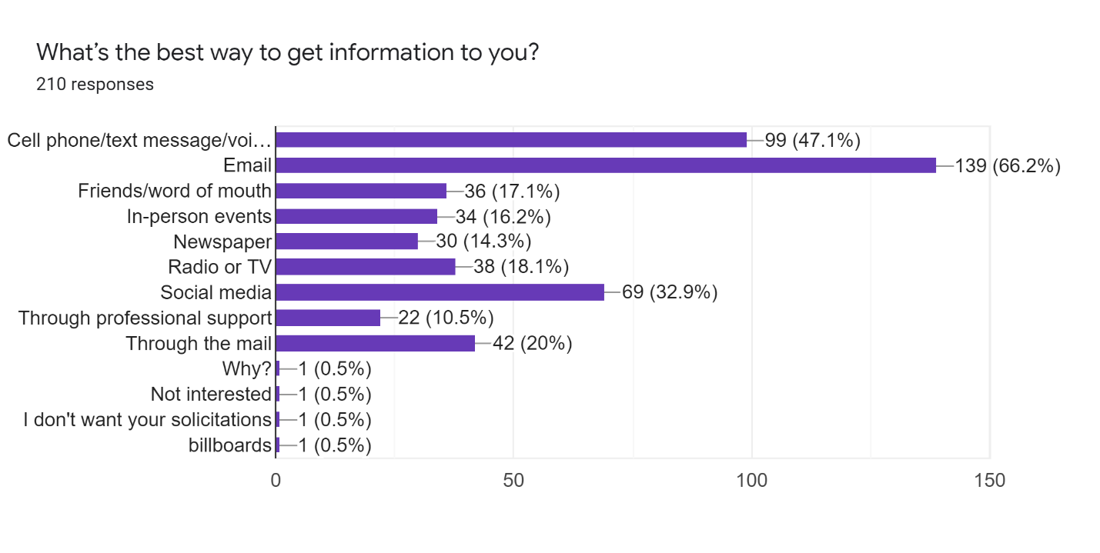
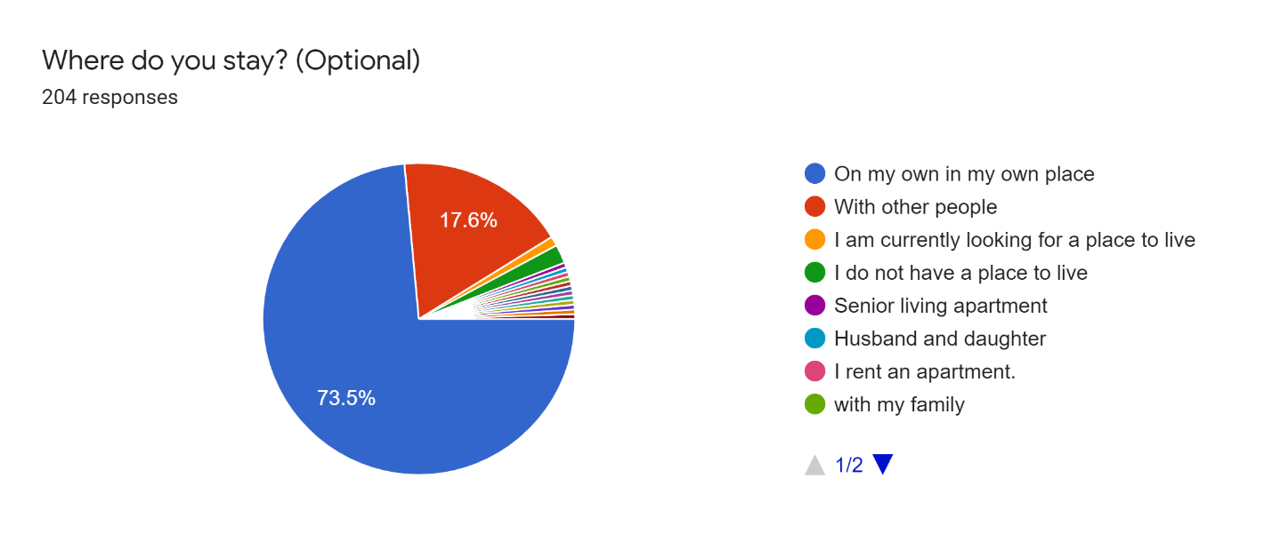
On my own in my own place – 150 (73.5%)
With other people – 36 (17.6%)
I do not have a place to live – 4 (2%)
I am currently looking for a place to live – 2 (1%)
Senior living apartment, husband and daughter, I rent an apartment, with my family, (address), “I’m an ex-homeless who currently has a bought home. Thanks to services that this area no longer provides. If I tried to turn my life around with the services we have today I would probably have just killed myself. Todays services are very SAD,” Parents, I live with my husband in a home we own, My husband and I own our home, I live in my truck, Shelter, Renta – 1 each (0.5%)
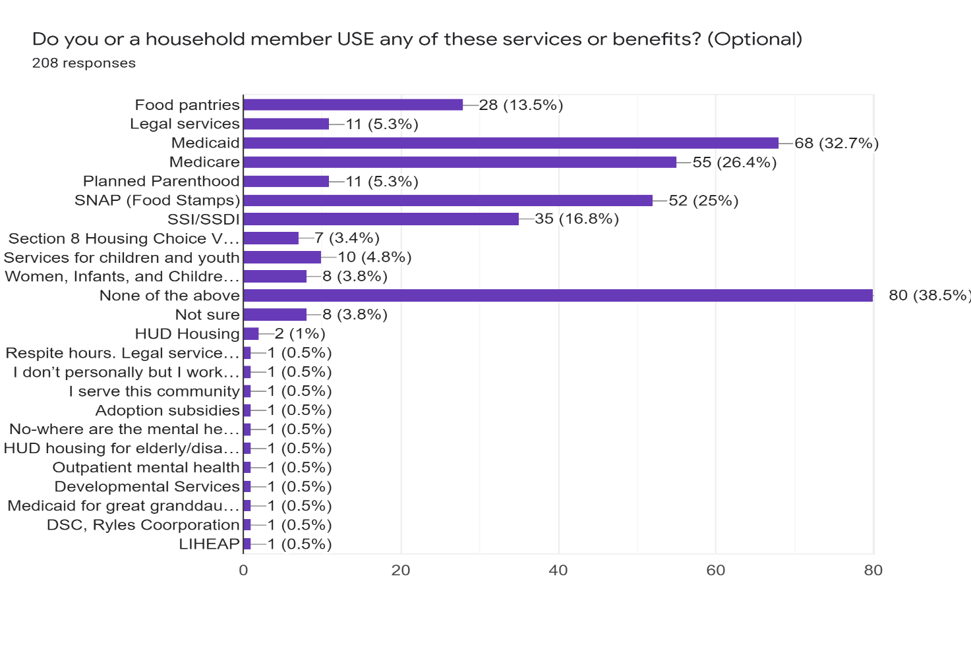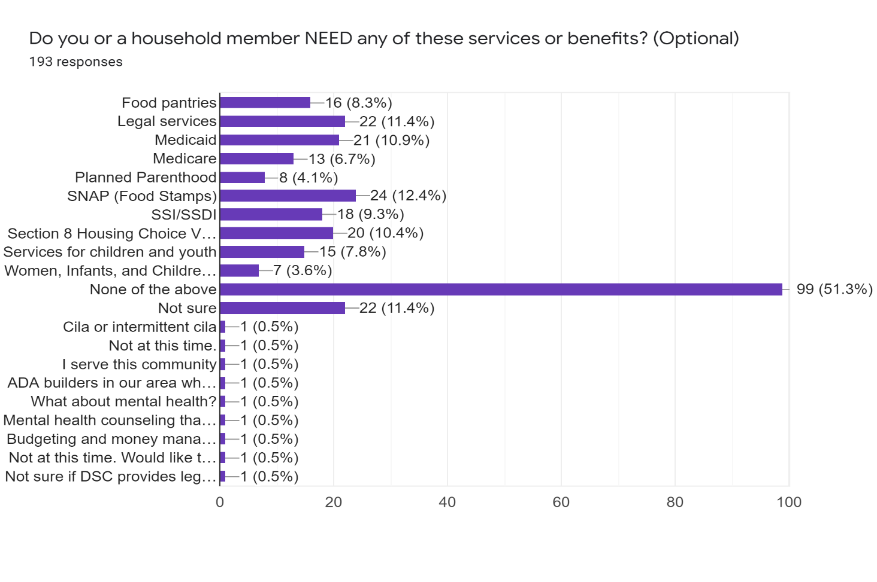
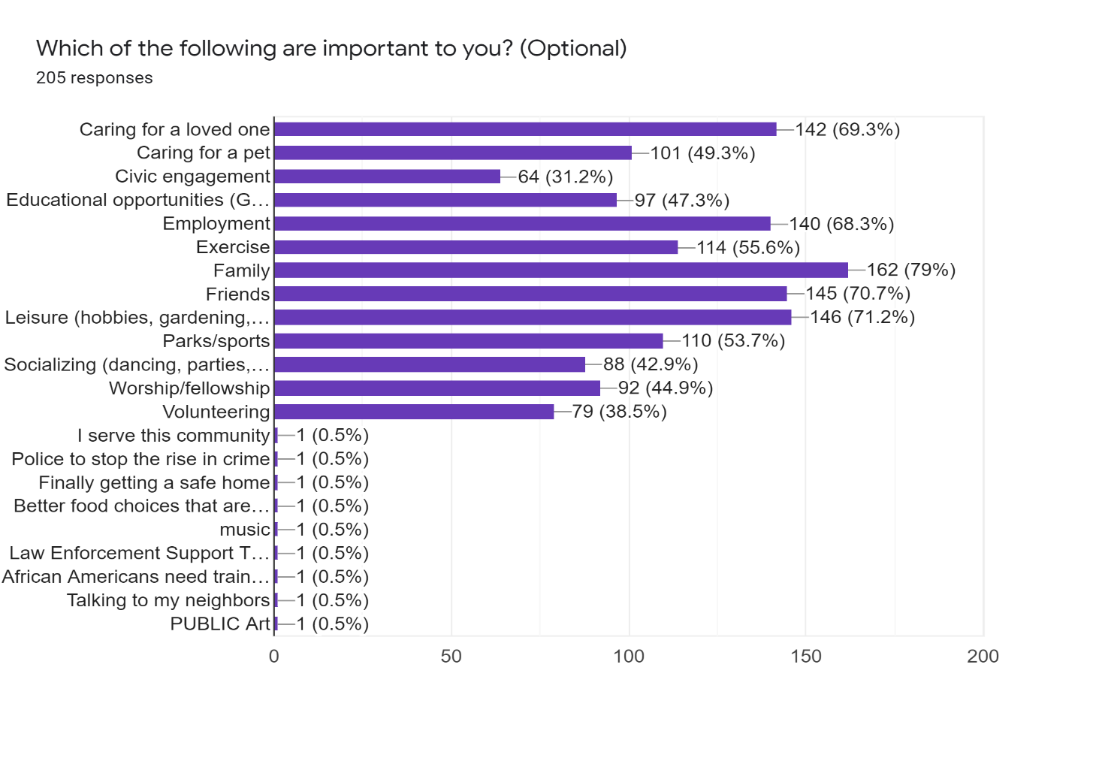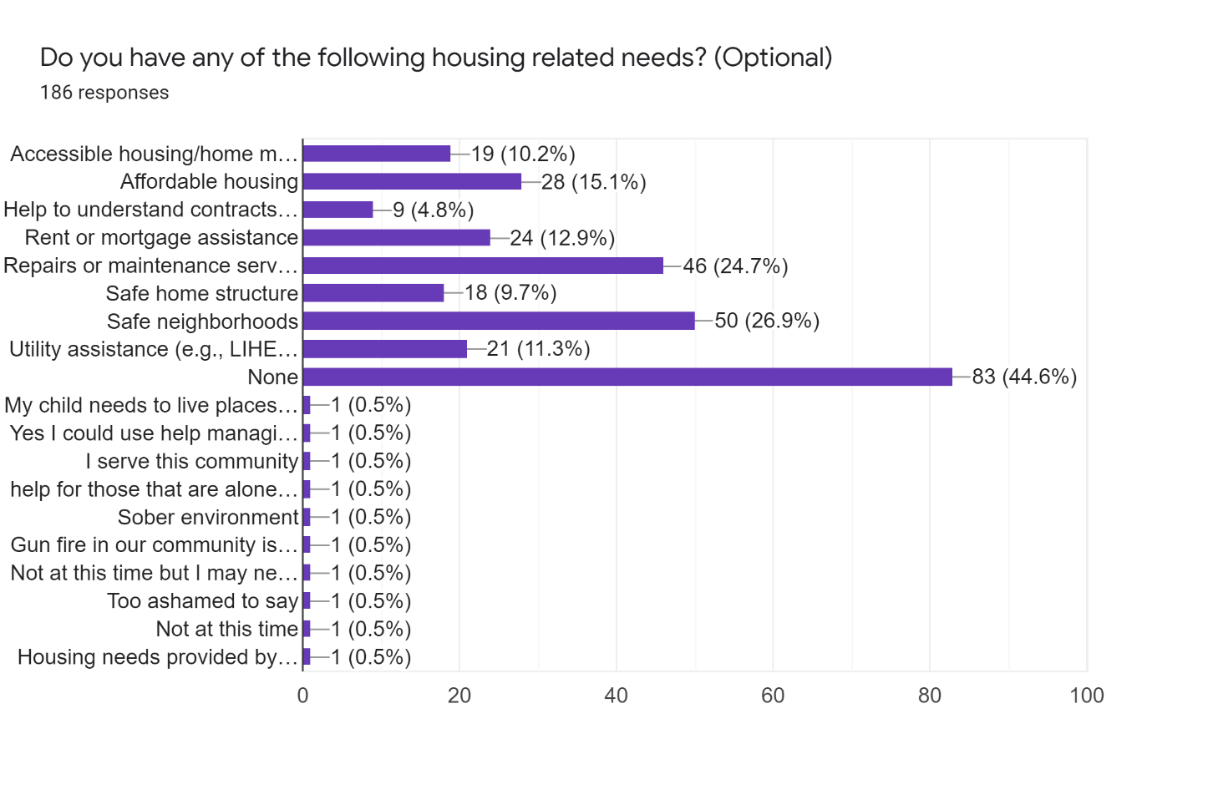
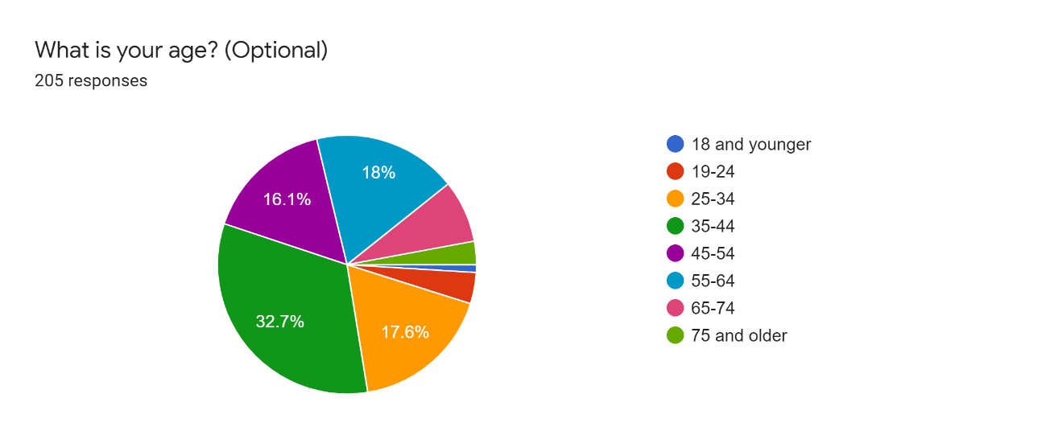
18 and younger – 2 (1%), 19-24 – 8 (3.9%), 25-34 – 30 (17.6%), 35-44 – 67 (32.7%), 45-54 – 33 (16.1%), 55-64 – 37 (18%), 65-74 – 16 (7.8%), 75 and older – 6 (2.9%)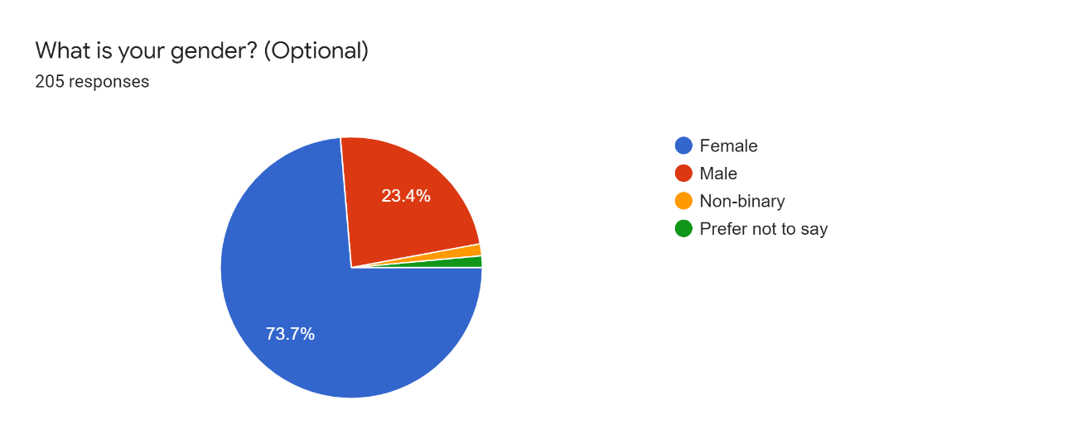
Female – 151 (73.7%), Male – 48 (23.4%), Non-binary – 3 (1.5%), Prefer not to say – 3 (1.5%)
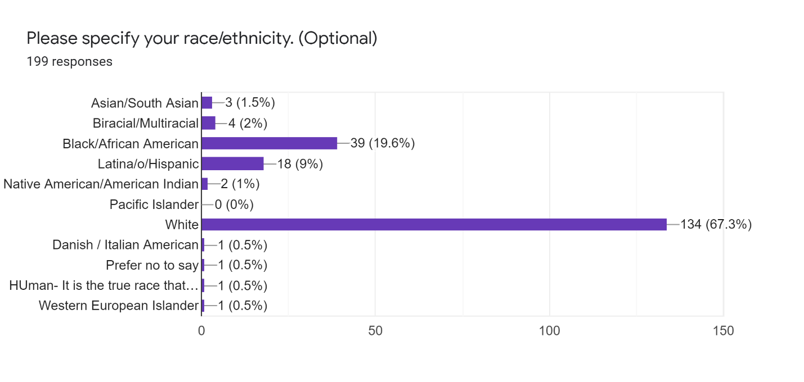
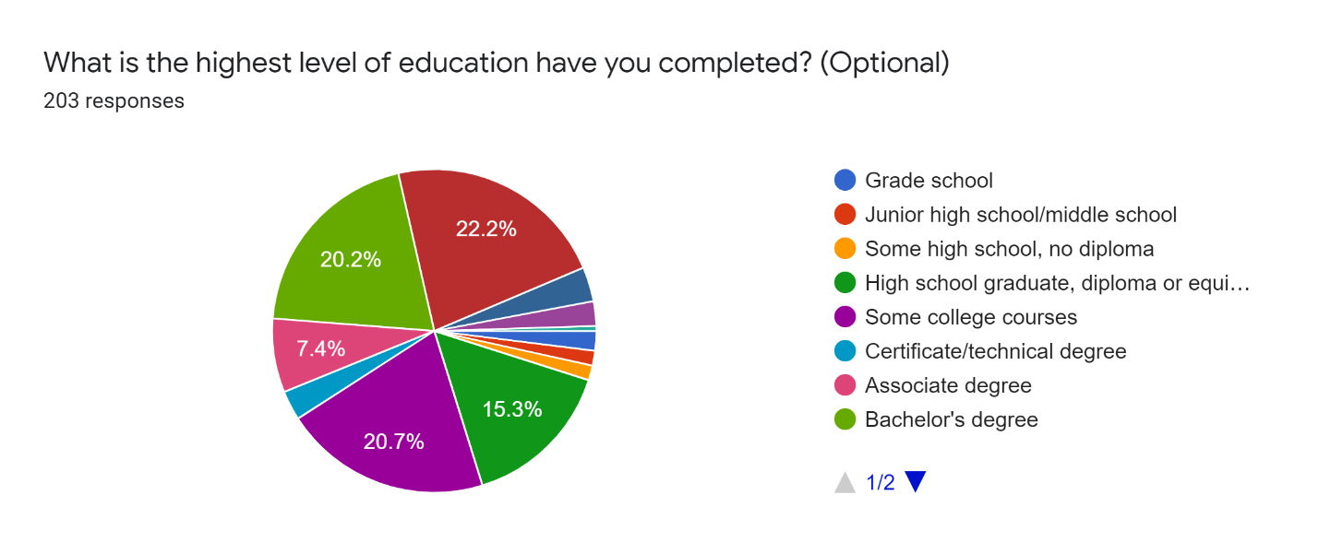
Grade school – 4 (2%), Junior high school/middle school – 3 (1.5%), Some high school, no diploma – 3 (1.5%), High school graduate, diploma or equivalent – 31 (15.3%), Some college courses – 40 (20.7%), Certificate/technical degree – (%), Associate degree – 15 (7.4%), Bachelor’s degree – 41 (20.2%), Master’s degree – 45 (22.2%), Doctoral degree – 7 (3.4%), Professional certification or licensure – 5 (2.5%), The School of Hard Knocks – 1 (0.5%)

What else would you like to tell us about services, supports, resources, or benefits available in Champaign County or about life in Champaign County? (Long answer, Optional)
Nothing
?
Just rebuild & re-do the entire Champaign.
The lack of professional behavior from an employee at Cunningham Township on social media and with Unit 4 school district has caused me to avoid working at all with that office
Safe Affordable housing for low-income persons.
I've completed this survey related to needs my daughter currently has. Affordable tutoring and money management training are needs currently.
Mental health service accessibility is my biggest concern right now because I can’t do anything else until I can get some affordable help
I believe Champaign County is doing better than most of Illinois in general; however, a recent study showed Illinois is rated 47th in the country for the care of adults with IDD. This is a challenging need because funding is a huge concern as it relates to supporting individuals with such conditions. I will be interested to see how the Champaign County can work around these funding issues to better support individuals with IDD and mental health needs.
NA
We are really not safe out here in Scottswood. Need support of our County officials to clean up our neighborhood--help our Urbana Township to clean roads (borrow street cleaner from Urbana or Champaign) Mail the services that are available to houses out here where they can call or go to for food--bus passes--health care. reduce driver's license plate due to income.
I just love everything about Champaign b/c they help everyone.
The goose “charity” slaughter in Crystal Lake Park was inhumane and wrong as we as unnecessary
WOUld love to talk in person if you like Call me 217-xxx-xxxx
Seems like people take advantage of low income services. I believe ppl should be drug tested for services, regularly
SUPPORT THE POLICE
I have been physically, socially and emotionally attacked for my cultural beliefs in this town because they don’t align with what is considered “politically correct” by the current cancel culture. My car has been vandalized, I have been cursed at in front of my children, screamed at in public and degraded where I live and work. No one gives a flying fuck. They would rather rip down Native images and call it “offensive” and “political” than care about those of us who feel we are being completely and viciously erased from existence.
right now, there are very little resources for people like myself who know nobody personally in the area, are disabled & need a helping hand occassionally. it leaves me in a very stressful & desperate situation looking online for individuals whom I don't know or trust who usually either disappoint or take advantage.
My partner is transgender, it would be great to have more mental health services informed of trans health/ that are safe for trans people.
The Pavilion was garbage. I did what I had to do to get our of there. Although I meet some new friends.
Birth control abs domestic violence and anger prevention services. Please get parents or guardians to their kids schools for evaluations and meetings
The issues I see most commonly amongst the individuals I work with are: need for more intensive supports/case management for independent living to be successful; assistance with applying for and understanding federal benefits like SSI, SNAP, etc.; assistance with transportation (especially in rural areas).
I like Champaign. I am employed full time in a difficult job where I do well, but my accomplishments never seem to overcome the biases I keep encountering. I don't know if it is because I am female, because I have disabilities, or both. But Champaign county needs to be better.
It would be nice to have more truly community based services and funding for organizations that are homegrown. Rosecrance and OSF, for example, are corporations based elsewhere. Carle is getting to be that way.
We are far better than other counties but for us being such an educated and semi affluent county we really have dropped the ball for those who are not as blessed.
I lived in Champaign two years and it was so bad I broke my lease to try and move out. All I got was harassment and transphobia living in Champaign
I really don't know too much.
We need to do better.
Hoping the community gets better due to all these shootings
We need more family friendly attractions that are AFFORDABLE. We have plenty of parks but can only use them for half the year, if we're lucky.
In March 2020, my best friend committed suicide right in front of me. It took me a few months to reach out for help, probably 4-5 months later... so around July-August 2020. It is now mid August 2021 and I have STILL YET TO SEE A THERAPIST. It’s either unaffordable, the wait-list is months long (I was on one for 6 months, Carle made a mistake in scheduling, now I again have to be on a waitlist), insurance doesn’t cover costs, or there’s simply a shortage of therapists. It truly sickens me that mental health seems to be put on the back burner. I have been through not 1, but 3 traumatizing events in the last 18 months and have yet to receive the care I need.
They don't want to help if you have state insurance
N/A
Have research and interviews done with patients of the resources to gauge how well they are doing
Like the summer downtown Champaign concerts, would be nice to have an amphitheater, would be good to have more interaction with the community and the U of I.
There aren’t enough for our need. They aren’t well known. There aren’t enough services. Mental Health demand cannot be met-our current “supply” is busting at the seams
Champaign County is significantly behind in their support for the neurodiverse community, like the rest of the Midwest and has more than a decade of advances to make to be current.
Pathetic- illusion - selfish
When our son experienced a mental break in high school, we ended up spending thousands of dollars on worthless treatment recommended by the Pavillion and got no assistance from the school system in terms of IEP. Our son was written off from day one. We have ZERO confidence in any so called "help" offered in this backward county.
need door to door transportation help
that there really aren't enough services
Supports and programs for LGBTQIA youth and adults are much needed
I was born here, and will probably die here.
We need lawn and snow removal for elderly. Let’s get an outdoor movie theatre for these COVID-19 days. We need more Art Therapy. There are few to no art therapy mental health care services offered in the county by credentialed art therapists. Yet, many can benefit from art therapy in other cities. Art Therapy can be made available in hospitals, veterans facilities, schools, nursing homes, centers that service those with disabilities, hospice, juvenile detention centers, and other centers. It can help with those impacted by COVID-19 and those who are grieving. Thank you.
I am required to get 3 quotes for an ADA bathroom and doorway widening. I can only find one out of Decatur approved by DCFS. I therefore cannot obtain funding to convert my son’s bathroom into a roll on shower or widen his doors for his wheelchair.
More services are needed and they need to be coordinated.
it is challenging to get access to service, but even more so if you are underinsured or on Medicaid
Life here could be amazing but for our youth we need a lot more, next generation, "they need this."
We need more services & support
need more services for middle class, those who make too much to be low income, but are still struggling
No response
Not enough for autistic adults.
It is terribly hard to hire good home based support workers in a rural community.
Services needs to be advertised where the people who need them are.
The preschools in CU are not inclusive. The only option is the public school program and its good but its frustrating that its the only option.
Mental health services not affordable even if you have insurance
Burnout of what workers are left in mental health, too many hours, spend more time in charting then taking care of patients d/t all these government regulations.
Discretion when interacting with the Police Department (Officers) people would report more if they felt safe. Yet the Police Officers knock right on your door leaving the offenders knowledge of who reported them.
I've had friends search for services in town and been given the run around. I'd like to see those organizations be held accountable if they're receiving funds to help people but aren't really doing what they say they do.
I used to work in a church office. I fielded lots of calls and walk-ins of people who needed financial assistance for rent, utilities, food, medical bills, a bus ticket. When I mentioned the resources in the county, they would say they had tried them all already. I wish there was an organization that updated Church offices every year as to all the services because I always felt that I was missing some.
If help is available, it one wants it. It's up to the individual.
If you have a family move to a small town to avoid the negative/bad experiences.
Need to get everyone vaccinized
I don't want pets and kids to get abused.
Just need more options that can actually provide services for low income people
Unknown
I miss at 410 University Ave Dept of Aging and Abuse - Linda
opportunities for new providers
We need more police to stop the rise in crime and our children shooting each other
I am filling this out as if the person for whom I am the guardian would answer
I have 3 kids. My 12 yr & my 15 yr are in desperate need of better mental health services in Champ. Cnty. Our private counselor referred us to the Pavilion & I am scared to death of taking them there. I have friends who have taken their suicidal teenagers there and it it HORRIBLE. Not helpful and in fact teaches kids more bad things to do!
the UP center helped me a lot as a teenager. Life is still pretty difficult for lgbt youth in champaign county. I was the only out student in my class and was bullied for it. The UP center helped me to meet other lgbt youth and to be proud of who I am.
Aone stop shop for services; services available in the most impacted neighborhoods
We need more interpreters to help the Latina community.
Most of the services are not extended outside of Champaign/Urbana or not accessible to people in need outside Champaign/Urbana. I’ve been told many times we do not service the rural areas.

Please provide your email address. (Short answer, Optional)
For privacy, not shared here, but 89 respondents did provide a contact email.

Thank you for your time!

APPENDIX II: SERVICE PROVIDER SURVEY QUESTIONS AND RESPONSES
A link to a brief provider-specific survey was emailed to the various groups of social service providers, with encouragement to share within their organizations and other interested parties. All 11 open-ended questions were optional. 27 surveys were submitted, and the full responses, including blanks, are presented below.

What mental health needs are not addressed or not adequately addressed in our community?
1 – anxiety/trauma due to Covid and its associated community impact
2 – No place for individuals who are in need of semi supervised housing with exception of Eden Supportive Living. Need Living Room model!
3 – behavioral health for those impoverished, in particular who have experienced trauma, employment services
4 – [left blank]
5 – There are not enough providers who take Medicaid. In addition, there is a serious lack of psychiatry services in the community. There is often a long waiting list to get into psychology/psychiatry services at Carle. There is also not an adequate mental health crisis response team.
6 – Pediatric psychiatry, bilingual counseling
7 – mental health wait lists are long for individuals on Medicaid. Those who have low incomes and do not qualify for Medicaid insurance are basically denied altogether. There are not enough therapists accepting Medicaid and sliding scale to meet the need. The times that counseling services are offered are usually always during normal working hours of 8am - 5pm and do not accommodate the schedules of those who may truly need the services the most. Some places do offer evening times, but a couple of evening slots does not even begin to scratch the surface of what is needed.
8 – ?
9 – Access to therapy/psychologists that accept Medicaid
Therapists with experience/training working with people with I/DD
Support for people with I/DD who have experienced sexual assault/violence (RACES has done a great job with this for 1:1 counseling, but Support groups for people in this situation would be great.)
10 – Dual diagnosis supports for people with I/DD and mental health concerns. Quality intensive outpatient programs for folks with eating disorders, anxiety disorders, PTSD (non-vets), honestly any intensive outpatient programs that are not substance abuse-related.
11 – Mental health assistance of all kinds should be easily available through a centralized location and office or clearinghouse to make access easy and comprehensive for all people needing services or information.
12 – I'm not as connected as before covid, but I believe any need not able to be addressed by a PCP involves too much time waiting for an appointment.
13 – There aren't enough psychiatrists. Wait for Carle to see one is 6+ months
14 – The primary thing I have came across is a lack of properly addressed members of the community with acute psychosis or people in prodome/ early stages of psychosis with no idea that they are experiencing serious psychological changes that are extremely difficult to talk about. There are an endless amount of larger issues regarding pharmaceuticals and the soft science and logic behind many Psychoatrists and prescription drugs/ the healthcare industry as a whole, but to keep things specific to CC, psychosis.
15 – lots of unmet trauma needs, children in DCFS care wait weeks to months to receive approved mental health services
16 – Anger management, crisis intervention, housing
17 – The needs of the families of persons with mental health needs - Information and support, also it seems that the working families who do not have good insurance that covers mental health care have to do without it
18 – group therapy classes, grief support classes, secular support not associated with religion, accessible therapists who take Medicaid (very few available at all, those who are available have very long wait lists and inconsistent openings)
19 – housing (for folks too ill to maintain independence) and associated support
20 – PTSD, Conflict Resolution,
21 – Mental health access for older adults is extremely hard to come by- especially low income older adults that are mostly home-bound or have a hard time getting out of the house. In-home services are needed. Oftentimes we have a hard time getting folks access to a wrap-around mental health caseworker, even when it is very much needed.
22 – There is not enough information about mental health issues and needs so when people have these issues they don’t know it, and they don’t know how to go about go about getting the help they need.
23 – Bilingual mental health clinicians & clinicians able to use sign language
24 – impacts of oppression, homelessness and poverty and how they contribute to one's mental health needs
25 – Chronically homeless
26 – More services are needed for people with dual diagnosis of DD/MI beyond the small case management effort at Rosecrance. I've seen a sharp decline in opportunities for different programs previously offered by Rosecrance to address therapeutic issues in small group formats and to provide outlets (drumming, art, dialectic counseling). I'm not sure we are doing enough for citizens who have criminal records related to MI issues and who with such records have great difficulty finding employment and housing. Waiting time for psychiatry is far too long --6 mo
27 – supportive housing, psychiatry

What intellectual/developmental disability needs are not addressed or not adequately addressed in our community?
1 – we do not have a robust program that enables people with significant disabilities to engage in social settings.
2 – N/A
3 – community living, employment services
4 – Activities for adults with disabilities
5 – There are not enough providers in the community. We need more CILA, Community Day Services, Supported Employment, and alternative housing options for people with ID/DD.
6 – Not sure
7 – Parents who care for their children with disabilities don't receive enough respite care. This is extremely important and can impact every aspect of life when a parent doesn't receive it.
8 – ?
9 – Additional supports for people with dual I/DD - MI diagnoses
Supportive living (not CILA, not 100% independent community living) - lots of people and families are interested in arrangements with some level of support, generally overnight, but the freedom for the person to come and go as they please and otherwise direct their own life.
-Transportation is a barrier for many people with I/DD
-Staffing Crisis: Many more services and supports could be offered if agencies were not so short staffed. It makes it difficult to implement new programs and provide the best and most community-integrated support when working with a bare-bones staff.
10 – Support for people with I/DD who have experienced sexual trauma and abuse. Transportation and supportive housing services for folks with I/DD. Honestly the every day basic supports are getting harder and harder to access for folks with I/DD.
11 – From birth on, we should be providing appropriate housing, employment, and educational needs for people with disabilities for the good of individuals and the community. Hoarding and OCD are serious problems for individuals and families. People with those disorders and their caregivers and family members need help dealing with these disorders.
12 – I feel there are more community services available for these needs. I do wish the public schools were better able to help with assessments and follow through.
13 – [left blank]
14 – Personally I have not seen a lack of support for the mentally disabled.
15 – more housing options
16 – more independent living resources and supports
17 – Access to training for employment and better integration also more group homes needed
18 – Unknown because I have never investigated
19 – [left blank]
20 – More services
21 – unsure
22 – Lack of information and resources.
23 – not sure
24 – How to support those with these disabilities in crisis situations
25 – [left blank]
26 – I see limited services for individuals with mild DD, who may pass as typical but who need supports to be successful in employment, community activities and independent living. Services available often require PUNS funding. I also see no structured access to continuing education through Parkland College for individuals with ID/DD adn the continued requirements of basic algebra prevent accessing certification programs. Other CC have provided practical math as an alternative. We lack sufficient housing -both CILA based- and housing voucher based or HUD
27 – supportive housing

What substance use disorder needs are not addressed or not adequately addressed in our community?
1 – marijuana is not illegal anymore yet is still treated with prejudice.
2 – N/A
3 – opioids
4 – sex addiction
5 – [left blank]
6 – detox
7 – [left blank]
8 – ?
9 – I'm not sure, this is not an area that I have much experience.
10 – [left blank]
11 – I don’t know.
12 - Expecting regular floor nurses to take care of these patients is unreasonable. More hospital beds with specialized units.
13 – [left blank]
14 - Intravenous drug use, crack, heroin, more housing for addicts is needed with as much variety as possible as every addict is different and comes out of rehab in different stages of addiction mentally. More compassionate care. A type of rehab that is not so firmly 12 step based. Ideally there should be a wing at u of I devoted to the many, many other ways we can treat addiction. Non secretive needle exchange, free and readily available harm reduction information to students starting in 6th grade as an effective form of death prevention and drug use as a whole. Minimally any addict should easily know where to get this info in the community. Readily available fentanyl test strips, needles, narcan...etc A safe injection site would be great.
15 – still no detox
16 – detox services
17 – The needs of families of those with substance use disorders - information and support
18 – group therapy classes, grief support classes, secular support not associated with religion, accessible therapists who take Medicaid (very few available at all, those who are available have very long wait lists and inconsistent openings)
19 - marijuana is not seen as an addictive and/or problematic drug
20 – Various addictions, some drug addiction programs.
21 – unsure
22 - Proper information, warnings, and reminders about the dangers of substances. Programs to help recovering addicts reintegrate back into society. Transparency about substance disorders to eliminate the stigma associated with the disorders.
23 – not sure
24 – [left blank]
25 – Heroin, and Alcoholism
26 – [left blank]
27 – [left blank]

What mental health needs ARE adequately addressed in our community?
1 – depression/anxiety leading to loss of employment
2 – NAMI has good free education programs and some family support groups that are needed.
3 – N/A
4 – [left blank]
5 – None.
6 – psych care and counseling for those with commercial insurance
7 – There are plenty of options for individuals that have insurance or can afford to pay out of pocket. I think we try to address stigma, but I think I have a biased view possibly of how well we are doing with that.
8 – I believe that we have a lot of counseling options and options for mutual support groups
9 – Compared to many other communities it seems that we have decent access to psychiatry.
10 – There are many peer support groups that meet on a weekly, or semi-regular basis.
11 – [left blank]
12 – It would seem counseling is widely available.
13 – Multiple types of mental health providers
14 – Inpatient/ outlatient Psych unit, multiple dual diagnosis treatment centers readily available counseling. Churches, temples...etc.
15 – lots of counselors but not accessible, don't take some insurance, sliding scale fees still high
16 – therapy and supportive services
17 – Some of the people needing mental health care can get it
18 – None.
19 – [left blank]
20 – Not certain!
21 – [left blank]
22 – N/A
23 – qualified clinicians
24 – social services for survivors of assault or dv
25 – schizophrenia
26 - If you already have a psychiatrist and health insurance, then you have access to services. NAMI is a useful resource for families
27 – [left blank]

What intellectual/developmental disability needs ARE adequately addressed in our community?
1 – [left blank]
2 – DSC is good.
3 – N/A
4 – [left blank]
5 – None.
6 – Not sure
7 – Organizations like DSC and Community Choices do a wonderful job in the community.
8 – ?
9 – It seems that there are multiple options for families to connect and share resources here compared to some other places.
10 – Segregated leisure/recreation programs and opportunities.
11 – [left blank]
12 – Once a child is diagnosed there seems to be support services.
13 – [left blank]
14 – All I can say for sure is that integration into the work place is great here and all of the services for students with developmental disabilities at u of i.
15 – [left blank]
16 – employment and training
17 – There appears to be some support systems in place to help those in need
18 – Unk
19 – [left blank]
20 – Developmental services!
21 – [left blank]
22 – Accommodations for physical disability symptoms like wheel chair ramps.
23 – access to services
24 – [left blank]
25 – Major Depressive Disorder
26 – DSC provides day programs and services for individuals with ID but does not seem to engage in services for other disabilities if IQ is above 70. Criterion should be life skills related not the outdated notion of IQ
27 – [left blank]

What substance use disorder needs ARE adequately addressed in our community?
1 – [left blank]
2 – N/A
3 – DNK
4 – [left blank]
5 – [left blank]
6 – rehab and counseling for those with commercial insurance
7 – IV drug users can get clean needle supplies and dispose of used needles for free at the local health department.
8 – ?
9 – Unknown
10 – [left blank]
11 – [left blank]
12 – [left blank]
13 – No enough support groups
14 – There are many adequately ran parts of the recovery industry in Champaign county, we just need more of them with more variety in order to truly be adequate. We do have proper number of mtd and Suboxone clinics which is endlessly important atm. There should also be a few new sober homes opening up which may then make the housing for addicts adequate.
15 – [left blank]
16 – treatment
17 – Some of the people needing this are able to get help
18 – Little to none.
19 – [left blank]
20 – Opium addiction
21 – [left blank]
22 – Prevention for our kids & early intervention in some cases for young adults.
23 – inpatient/outpatient services
24 – [left blank]
25 – Meth
26 – [left blank]
27 – [left blank]

What barriers keep people from accessing mental health resources within our community?
1 –[left blank]
2 – Need trained individuals to accompany police/navigator to provide initial crisis support and then adequate follow up care; med reminders, appointment reminders, talking to individuals about how they might want a different life journey. Listen and support.
3 – workforce to address service capacity
4 – [left blank]
5 – Providers who take Medicaid, waiting list for services at Carle, stigma.
6 – transportation, time off from work, affordability, access to childcare
7 – Stigma, Money, Time, Transportation
8 – money and knowledge of available resources
9 – Financial - limited resources that accept medicaid or are unaffordable out of pocket. Many other who would like or would benefit from mental health resources may not have the flexibility with work to get to appointments during the day.
Stigma - while this is getting better, it is still a barrier for many people
10 – The cost and limited availability of quality, specialized services. The waitlists for specialized and basic services (like psychiatry) are too long.
11 – Without a central clearinghouse of come kind, people do not have the time, the energy, and often the capability to track down different types ad sources of assistance. It should be easy, not hard, to get help that is available.
12 – Insurance, out of pocket costs, unavailability of providers/appts
13 – [left blank]
14 – Social stigma, the pretention of doctors and staff, no care about what you know, doctors always have to be the smartest person in the room, especially when they're wrong. None of them ever (literally) take a dose of their own medicine and think all unscheduled pharmaceuticals are safe when they are some of the worst drugs for you. Generally power hungry people/ people who do not treat the mentally ill or addicted with the respect of say, anyone else. One bad doctors visit, no one wants to go back. Lack of actual care is the true primary barrier.
15 – lack of culturally competent providers
16 – waiting lists, cost, transportation, stigma
17 – Lack of information and resources
18 – Lack of providers who take Medicaid, out of pocket incredibly costly
19 – waiting lists (provider capacity), poor public understanding of mental illness and the accompanying stigma such ignorance generates
20 – The process and information on availability!
21 – transportation, mobility issues, difficult access points, stigma, resistance to services
22 – Stigma behind mental health issues, lack of information, and access to information.
23 – currently COVID
24 – Cost/finances, accessibility, ability for the resources to address the underlying needs, options to address a myriad of needs, qualified, competent and well-trained professionals
25 – Lack of resources
26 – Lack of Insurance, waiting lists
27 – transportation

What barriers keep people from accessing intellectual/developmental disability resources within our community?
1 – [left blank]
2 – N/A
3 – workforce to address service capacity
4 – [left blank]
5 – Lack of understanding of state funded services, not enough providers, no private pay options.
6 – not sure
7 – [left blank]
8 - knowledge of available resources
9 - Lack of Funding/Lack of understanding of services that are available without funding - Many services are available for those waiting on the PUNS list
I/DD Diagnosis that does not quite make one eligible for PUNS - there are many people who don't officially qualify but need support in some way. services for people in this situation would likely not put a heavy strain on providers, but would make a significant impact in people's lives.
-One missing piece... while many services and supports are available, there is often one or two missing elements for any person's given situation. It might be transportation, or lack of housing with overnight support, or lack of access to consistent PSWs. The system as it stands now is either fully and sometimes oppressively full-service (as in a CILA) or too fragmented to make community-based life sustainable for many with a mid-level support need... So maybe the barrier is that support is all or nothing?
10 - They aren't "disabled enough" to qualify, but still need creative supports or more intensive supports than are available to the general community.
11 – Transportation problems, time problems, the ability to negotiate getting the help needed.
12 – possibly needing an advocate to help navigate the system
13 – [left blank]
14 – No idea. Probably socio-economic. I know rich parents (for whatever reason) think that there's no way their perfect child could be different, drastically reducing early intellectual progress as they refuse to allow their kids to be in special education or just feed them pills. Acceptance from society is a major barrier.
15 – [left blank]
16 – access to information, help with reaching resources
17 – Lack of information and resources
18 – unk
19 – [left blank]
20 – Availability of information
21 – [left blank]
22 – Lack of information and access to information.
23 – currently COVID & caregivers
24 – Cost/finances, accessibility, ability for the resources to address the underlying needs, options to address a myriad of needs, qualified, competent and well-trained professionals
25 – Lack of resources
26 – Not enough providers, waiting lists, lack of coordination across agencies and with highschools
27 – transportation

What barriers keep people from accessing substance use disorder resources within our community?
1 – [left blank]
2 – N/A
3 – Workforce to address service capacity
4 – [left blank]
5 – [left blank]
6 – transportation, time off from work, affordability, access to childcare
7 – Stigma, Readiness to Quit, Peers, Money, Transportation
8 – knowledge of available resources
9 – Unknown, though I would bet that limited capacity, financial barriers, and consistent staffing are affecting this field as well.
10 – [left blank]
11 – I don't know.
12 – money, insurance, lack of detox facilities
13 – Pavilion's reputation
14 – Part of it depends on cost of treatment, mostly that there is only 1 type of treatment with a 5%-10% chance of working for 1 year before relapsing. Not interested in aa/na or religion and keep getting told it's the only way. With nothing it's very easy to not want anything (homelessness). Housing for addicts post rehab, plenty of people selling drugs. All in all not the right type of support or care that is primarily caused by what we believe to be true based off tradition and order.
15 – [left blank]
16 – same as mental health
17 – Lack of information and resources
18 – Lack of providers who take Medicaid, out of pocket incredibly costly, regulations surrounding detox/treatment (cant go into treatment needing detox or vice versa so some sober patients use simply to get accepted into treatment or left to detox alone to get into a program that doesn't offer it)
19 – the legality and cultural comfort with alcohol and marijuana as "acceptable"
20 – Information!
21 – [left blank]
22 – Access to information.
23 – COVID
24 – Cost/finances, accessibility, ability for the resources to address the underlying needs, options to address a myriad of needs, qualified, competent and well-trained professionals
25 – Lack of resources
26 – stigma, insurance
27 – transportation

What services, supports, or resources should be added, on behalf of any of the populations above?
1 – [left blank]
2 – Well Paid Staff to include peer support specialists.
3 – after school programs for youth, employment matching and support (there are jobs and need services to help workers connect with jobs), a longer term plan to address workforce issues in human services
4 – [left blank]
5 – [left blank]
6 – case management to link patients to resources, centralize source of resources available in champaign county
7 – I think that outpatient evening AND weekend counseling/substance abuse treatment services should be the norm. Evenings should be offered daily to accommodate schedules and provide more evening spots. Respite care and counseling services should be routinely offered to all parents caring for their children with disabilities. More places should offer clean needle exchange services. It would also be nice to see actual places with video monitoring or a two way mirror where individuals can use IV drugs while being monitored for possible overdose.
8 – ?
9 – On-call transportation (Uber, but with more vetting of drivers...)
More supported living options
Incentives for direct support staff to join and stay in the field
More dual diagnosis programs for people with I/DD -MI
Support to help people address the basic needs that are becoming harder and harder to access in our oppressive late-capitalist empire
10 – Intensive out-patient supports. It seems the options in our community are either in-patient treatment or outpatient therapy services. There's not much in between or as a "step down" from in-patient.
In-person or zoom groups for folks with I/DD who have experienced sexual trauma, or people with I/DD who identify as LGBTQ+.
11 – [left blank]
12 – [left blank]
13 – [left blank]
14 – Harm reduction units/ vans. Safe injection sites for IV drug and crack cocaine users that is connected to a program based off of ideas that dovetail into the ethos behind safe injection/ harm reduction. After proper passed testing and laws in place, an iboga clinic/ psychedelic science unit based in using plant medicines and approved mystical compounds in order to create a spiritual awakening that even the cdc recognizes as having a success rate of 30%. I would like to see the DA/ police be open to working with private citizens in the capture of child predators online in the area (there are a lot, convicted and otherwise) that otherwise go entirely unnoticed.
15 – school based mental health services
16 – more staffing to reduce the need to wait for services
17 – Unsure
18 – MORE ACCESS TO THERAPIST WHO ACCEPT MEDICAID!!!
19 – [left blank]
20 – More information?
21 – in-home mental health services for older adults; mental health better integrated into clinics, easier access to memory screens for cognitive concerns
22 – More access to counseling and mental health maintenance services. & Those services should be offered for free, maybe even give an incentive to encourage families to get counseling & other mental health maintenance services. Also provide public assistance to those who are willing to go to counseling so they arenâ€™t worried about living in survival mode and can have the mental space to focus on healing as a family.
23 – not sure
24 – [left blank]
25 – Access to better healthcare opportunities
26 – Housing, more focus on educating employers about individuals with DD, MI and capacity to work with some supports
27 – Housing, transportation, case management

Describe any other concerns you have regarding life in Champaign County:
1 – [left blank]
2 – Gun violence. How can regular individual help?
3 – addressing violence
4 – [left blank]
5 – [left blank]
6 – psychiatry and counseling patients being abandoned by providers due to access barriers to service for no showing appointments
7 – Gun violence has been tearing this city to pieces. It is sad when I can sit with my window open at night and hear gun shots a neighborhood over. It is destroying our community, and I wish there was a way to really, truly, get a handle on it. Getting to the very root of gang activity and gun violence is no easy task, but I hope our community can find a way to do it.
8 – the recent increase in violence in our communities
9 – Violence and poverty and the trauma that they create are growing in our communities which make all aspects of living with a disability and/or a mental health diagnosis much harder. Addressing root causes of all these issues is a tall order, but really critical to making real change and ensuring that this continues to be a great community to live in.
10 – [left blank]
11 – Prejudices against groups of people -- especially immigrants, African-Americans, people with disabilities, people in poverty, and single parents -- keep our County from truly using resources the way that they can best help people with all kinds of needs.
12 – black on black crime, revenge violence, gang activity
13 – [left blank]
14 – None of my current concerns are specific to Champaign county as a whole. Biggest fear would be Champaign becoming anything close to portland...
15 – [left blank]
16 – none
17 – Unsure
18 – [left blank]
19 – [left blank]
20 – [left blank]
21 – Extremely racially segregated and understandable mistrust of service providers
22 – Crime is increasing at a scary rate.
23 – [left blank]
24 – There are extremely limited options for the homeless population of Champaign Co., and there is often nowhere for them to exist for free that isn't outside, and for numerous reasons that also contributes to their physical health, mental health, and overall safety
25 – The homeless population and the lack of shelter for them.
26 – The gun violence is totally out of control and is creating great fear and anxiety which will lead to more violence if not mitigated.
27 – [left blank]

APPENDIX III: PROGRAM REPORTS ON THE IMPACTS OF COVID-19
During 2020 and 2021, CCDDB/CCMHB staff collected reports from funded programs regarding the impact of COVID-19 on activities, people served, and staff. These collections are in board meeting archives at https://www.co.champaign.il.us/mhbddb/MeetingInfo.php or upon request. What follows is from funded program reports for PY2021 3rd and 4th quarters, edited for relation to COVID impact. Along with the 4th quarter report, program representatives were invited to share about the impact on themselves, personally and professionally. Some program reports did not include comments relevant to COVID, and one agency requested anonymity for the passing of a staff member due to COVID but shared that this was a difficult time for all.

CCRPC Decision Support (DDB contract):
During the COVID pandemic, CCDDB funded staff continued to provide services to clients remotely (via phone, text, email, FaceTime, and/or Zoom). For new clients coming into services, this made establishing rapport more difficult since staff were not able to meet with them in person. In addition, staff reported some clients feeling isolated and more depressed during this time. Many clients were out of work and experienced disruptions in their day to day routines.

As experienced by people throughout the world, staff also experienced difficulties during the pandemic. Many were juggling work with assisting their children with remote learning (some also being single parents). With work changes, children being out of school/remote learning, and anxiety about the future of the pandemic, this led to increased staff stress. This was also coupled by both staff and clients experiencing high levels of anxieties about the significant racial injustices occurring in our country.

CCRPC Youth Assessment Center (MHB contract):
Due to decreased community events due to COVID, the YAC distributed flyers on the program to contribute to community outreach efforts.
Champaign County Christian Health Center (MHB contract):
With Covid winding down, the hope is to have events again soon.

Champaign County Down Syndrome Network (DDB contract):
Due to COVID-19, we were not able to meet New Clients goal. (Virtual board meetings and events were held.)

Champaign County Head Start/Early Head Start – Mental Health Svcs (MHB contract) and Social-Emotional Development Svcs (MHB and DDB contracts):
Some activities have had to be adapted due to COVID-19.

Champaign County Health Care Consumers – CHW Outreach and Benefit Enrollment (MHB):
The pandemic continues to present challenges for working with clients in an efficient way. Under normal circumstances, when we work with clients to help them with benefits and health insurance, we could meet with them in person to gather their documents (ID, income verification documents, etc.), but in the pandemic, we have to get copies of documents via mail, texted photos, or screen shots. Sometimes this means it takes a little longer to gather up all the documents that we need. We are making it work, but it just takes a little extra work. In addition, many clients are experiencing anxiety, depression, and isolation, so we are doing more check-ins with clients by phone, text, email, and in some cases, by home visits (outdoors; though sometimes, indoors as well).

One client example: We have a gentleman who is on Township assistance (Cunningham Twnshp), but who has gotten very deep in his alcohol addiction and who stopped returning calls and answering his door when we would check on him at his HACC apartment. He fell behind on his rent for three months and was at risk of eventual eviction. Fortunately, CCHCC obtained funding from the City of Urbana as part of its CARES Act grant, and we were able to pay his past due share of his rent for the last three months. We also were able to connect with him and found his health in poor condition and his apartment in disarray. We arranged to take him to a primary care appointment and found that his blood pressure was dangerously high from not taking his medications. In addition, he expressed suicidal ideation, so he was evaluated by a counselor and psychiatrist at Promise Healthcare. The psychiatrist required him to get substance abuse treatment before he could work with him. Our client agreed to go to The Pavilion for treatment. The client went through intake and was admitted, but later that day, staff contacted us to tell us that they would have to discharge this client because he had alcoholic dementia, and as a result, he could not participate in treatment. They encouraged us to take him to OSF for psychiatric admission because he had expressed suicidality. We took him to OSF and he was not able to be admitted because he denied suicidal ideation at that time. This gentleman is like a "hot potato" who is getting bounced around because he needs help but cannot participate in treatment. We cleaned up his apartment, and we organized his medications in a pill box, and we have been checking on him daily in person. He is not taking his medications, despite reminders, alarms, and an organized pill box. He simply does not understand the importance of taking medications, including blood pressure medications. We have determined, with the help of medical providers, that the best setting for this individual will be a memory care facility. He is simply not able to live independently or semi-independently. He has been rejected by his family, so he has no place else to turn. We are currently working with him on a daily basis, to help him maintain his health and manage his benefits like SNAP (he was selling those for cash for alcohol, and he was not eating. And we are working to secure a memory care placement for him.

Besides this example, we are working with several high-anxiety Medicare beneficiaries to help them with their Medicare benefits, and also to help them get their COVID-19 vaccinations. We have taken several clients to their vaccination appointments. One of our regular Medicare clients who suffers tremendous anxiety got paperwork in the mail that she did not understand and usually clients could bring in paperwork, but she had to describe it over the phone and after some explanation, we figured out what it was and luckily we had already created an online account for her. The paperwork that would have needed to be completed in person was able to be done online in 20 minutes as we were on the phone since we had already worked with her and set up an account. Another Medicare beneficiary had questions about ways to reduce her drug costs and we were able to help her with an Extra Help application. It was a straightforward application and because of our Health Justice Fund, we were able to offer her assistance if she had difficulty paying for her prescriptions. Psych prescriptions can be very costly and have high out of pocket costs. We have also been calling our Medicare beneficiaries to check in and see if they would like to get a vaccination or if they have already had one. Several are already vaccinated and some just needed an extra push (one of them only needed a ride).

The ongoing pandemic has made it more labor intensive for us to work with clients since our staff continued to work remotely. But that also increased our direct contact with clients, but at locations other than our office, such as motels, parks, and other places. We were able to help get several of our clients vaccinated for COVID-19, and this work included transporting them to and from CUPHD, twice each. Many of our clients required greater contact with us as a result of them having greater anxiety and isolation, due to the pandemic. In addition, several of our clients experienced problems with dropped SNAP (food stamps) benefits, where they were disenrolled for no obvious reason. We reapplied them for their benefits, but while they were waiting for their SNAP, we often had to provide them with VISA gift cards that they could use to purchase groceries. These VISA gift cards were made possible as a result of the Urbana COVID grant that we received, which also paid for the motels for our medically fragile homeless clients. And we also found that many of these medically-fragile homeless clients did not have regular health care access or a primary care provider, though many of them had received emergency services. So we also worked with these clients to help them establish primary care and to also help them understand how to access transportation services through their Medicaid Managed Care health insurance, thereby reducing another barrier to access to care. We also noticed that many of the programs that our clients needed to access (for example, housing support from RPC), required email interactions and access to websites and webforms. Quite a few of our clients did not even have phones, so we had to pay for their phones and phone service (again, made possible as a result of the Urbana grant). And even if they had phones, they did not have email and were not used to doing things online. We could not spend enough time in person with these clients to teach them how to do these things - that would have been very intensive and would increase the risk of possible COVID transmission - so we often had to do these things for the clients, on their behalf. Moving everything to online forms during the pandemic has been detrimental to many people who are not as "connected" or tech savvy. It is important to offer individuals options for how to communicate and how to apply for programs, and how to recertify for programs. Also, an enormous barrier that we encountered among those for whom we were trying to help find permanent housing is unlawful discrimination against housing vouchers provided by RPC (in Urbana). Urbana ordinances prohibit discrimination in rental housing based on "source of income" which is defined to include housing vouchers. Yet, no one seems to be enforcing the prohibition on discrimination, probably because no one was reporting such discrimination, and that is probably because most housing case managers from the various agencies do not even know that such discrimination is unlawful and prohibited. Unfortunately our limited motel funds were subsidizing such discrimination as clients linger in motels.
Champaign County Health Care Consumers – Justice-Involved CHW Services and Benefits (MHB contract):

Because of the pandemic, Chris Garcia has not been able to work inside the Champaign County Jails for many months. However, now that Rosecrance has a new case manager in the jails, Chris has started to get referrals and has begun working with these new clients. In addition, Chris has worked to track down former Justice Involved clients to make sure that they are getting their needs met, and several have needed new Medicaid and SNAP applications or help with prescription drugs.
In addition, we have several clients who are going through Reentry, having been released from IDOC, and one couple where the man in the couple is on probation - and these clients are medically fragile and were in need of temporary shelter in motels. CCHCC was unable to get other organizations to assist these clients with motel stays, so CCHCC reached out to the City of Urbana and, thankfully, the grants manager, Sheila Dodd, helped Claudia put together a proposal to get some of the CARES Act funding to help with pandemic related needs. This funding was approved and has been a lifeline to allow CCHCC to house some of these clients in motels, when, because of medical reasons, they are unable to stay at CU at Home.
An example of a very challenging case. The pandemic has made everything harder for all of us, but some of our community members have it harder than most. Mr. M (not his real name) was released from an Illinois prison last September. He returned to Champaign County with nothing at all – no clothes but what was on his back, no money, no place to stay, no family (all family members are deceased), no resources. He was not on parole because he did not have a placement at the time of parole, so he therefore had to finish his entire sentence and then get released without any resources. Mr. M is disabled, as well. Mr. M contacted CCHCC and we worked with him to help him get his ID, Medicaid health insurance, prescriptions, and food stamps. In addition, we helped him apply for, and get approved for Supplemental Security Income (SSI, for people with disabilities who do not have a long work history). All of this work – working with the client to submit various applications – is far more challenging during the pandemic, when the work must be done remotely and at a distance. But CCHCC is very effective, whether we are delivering our services in person, or in a socially-distanced way. Mr. M was staying at the homeless shelter in Champaign while he was waiting for his SSI benefits to kick in. While at the shelter, he got sick with COVID-19 and ended up at the hospital in intensive care. Mr. M almost died from COVID-19. Fortunately, he was able to eventually recover, after spending five weeks in the hospital. Mr. M should have been discharged to a nursing home, to help him recover, post-COVID. However, because of his felony conviction history, nursing homes would not accept him, even though his felonies were for non-violent offenses. Mr. M was too ill to return to the homeless shelter, so CCHCC worked with the hospital discharge planners and social workers to arrange for Mr. M to be discharged from the hospital and placed in a local motel, which CCHCC is currently paying for, until Mr. M can get permanent housing of his own. CCHCC staff worked with Mr. M to enter him into one of our county’s voucher programs, which will help place him in an apartment that is affordable, and accessible for him, given Mr. M’s continued problems with his lungs, which do not allow him to manage stairs. Because CCHCC staff also helped Mr. M qualify for and get his SSI benefits, Mr. M will now have a monthly income of his own. SSI provides a very low monthly income – approximately $795 per month – so SSI beneficiaries often need many more resources and benefits in order to survive. Once Mr. M has his apartment secured, CCHCC will help him apply for LIHEAP to reduce his energy bill. Claudia is in contact with Mr. M on a daily basis, by phone, visits to his motel, and taking him to appointments. This is just one of several very intensive cases involving a Justice Involved individual.

Thank goodness for the extra funding from the City of Urbana for this effort to temporarily house medically-fragile individuals who are unable to stay at shelters! Currently, we have three individuals and one married couple temporarily housed in motels because they are homeless and medically-fragile. Two of the men are formerly-incarcerated – one has a bone infection and uses a wheelchair; the other has mental health/addiction issues and COVID long hauler syndrome with breathing problems. The other man is disabled and someone stole his SSDI funds from his Direct Express card and just needed help with four nights until he gets his next payment. The married couple is a deeply tragic situation. The woman is on oxygen and the man has cardiac issues. They both have mental health issues and trauma. They are in their late 50s and their home, which they were trying to buy but is now in foreclosure, was condemned a year ago and they were made to finally move out this past week. Their home was uninhabitable due to mold, animal feces and urine, and they were charged with animal cruelty for having too many dogs and cats in a neglected state. With these kinds of stories (animal hording and abuse/neglect) there is usually a mental health issue behind situations like this. This couple are kind people who were trying to help animals when their own lives went out of control. The reason that their lives fell apart is because their son, who was the main person taking care of the animals and who lived with them, committed suicide over a year ago in their garage. All too often, people in crisis do not know how to ask for help, or where to turn for help, or they just do not have the energy to ask for help for various reasons – they are often just too busy trying to survive emotionally day-to-day. The gentleman was charged and convicted and is now on probation. Regional Planning Commission (RPC) is working with this couple to help them find permanent housing and referred them to Claudia for help with the motel. The couple is very sweet and deeply grateful and they are working diligently to get their lives back on track after the awful tragedies that have impacted them. Claudia maintains contact with them on a weekly basis, checking in about every other day…

This last quarter has been extremely challenging, given COVID restrictions. Chris Garcia was unable to work in the jails because of the COVID restrictions, and Rosecrance was short-staffed and was not able to consistently make referrals. In addition, many of the individuals in jail were awaiting transfer to IDOC, so they were not able to apply for Medicaid and SNAP. However, the clients that we did serve this past quarter were very high-need clients who needed intensive services. Some were referred by the Sheriff's Office (jail) and others were referred by Rosecrance, and still others were clients with whom Chris followed up and found that they had outstanding needs, like needing to reapply for SNAP benefits (food stamps). The justice-involved clients that Claudia served - five - were all medically-fragile homeless individuals going through Reentry after serving prison sentences. Originally, these were clients that Claudia tried to refer to First Followers, hoping that they could help with housing, but when these clients were not able to be served by First Followers (due to lack of funds for housing, or perhaps they did not meet criteria to be served), Claudia asked the City of Urbana for COVID grant funding in order to house these clients in motels. CU at Home has "suspended" services, so shelter care was not an option, and even if the shelter had been open, these clients - as a result of their medical and physical needs - would not have been able to stay at the shelter. The City of Urbana granted the funding, and five Reentry clients were housed at motels. They were referred to RPC for central intake and many were put on the the priority lists for housing vouchers. CCHCC was able to assist these clients in getting their SSI reinstated or approved, getting Medicaid insurance, SNAP (food stamps), and in some cases, telephones. Clients were often provided with VISA gift cards to purchase food and supplies until their other benefits kicked in. The VISA gift cards were purchased with the funding from the Urbana grant. Unfortunately, these clients continued to face barriers to accessing housing, and some still remain unhoused. The barriers include the following: inability to access programs as a result of lack of technology knowledge and capability, and lack of email address (Claudia helped submit applications for these clients, but this added another layer of work) - too many of the helping programs require applications to be submitted online or via email and many of the folks getting out of prison are not familiar with how to use smartphones and do not have email addresses; lack of transportation to go "look" at apartments and housing for the voucher programs; physical disabilities that prevented the clients from being able to physically search for housing; discrimination among landlords against vouchers and against individuals with criminal backgrounds. It should be noted that this discrimination is illegal in Urbana, yet it persists. Even housing case managers working for various agencies did not seem to know that this discrimination is unlawful in Urbana, or what to do about it. It should be noted that a couple of these clients really should have been in nursing/rehab facilities, but they were not admitted to any local facilities because of discrimination. Services provided to clients were provided in person, over the phone (text and calls), and over email (in few instances). A couple of clients who did qualify for housing vouchers lost their vouchers as a result of being hospitalized for long periods of time, and they now have to reapply. It seems that the funding to help people stay in motels is inadvertently subsidizing discrimination by landlords. The only benefit of having clients who stayed in motels for months at a time is that they can consider the motel managers as their "landlords" and use them as positive references. Working with these clients can be very challenging, but thankfully they were kept safe/sheltered.

Community Service Center of Northern Champaign County (MHB contract):
We were quite surprised to see such a low number of NTPCs for the quarter so we double checked the numbers. However, our overall service levels were quite low as well. The total number of households served was 283, which included the 22. This was a much lower number than in previous quarters. The number of screening contacts was also about 300 less than the last quarter. All this was consistent with the above data. The "other" category, which is contacts by other agencies remained about the same. Of those contacts, 67 were by CCMHB funded programs. We still have not seen the number of agencies and contacts as we did prior to the pandemic. As mentioned earlier, the level of requests for basic needs services was down by more than 50%. Much of this can be explained by additional financial help from the federal government and the state to low income households and decreased mobility during wintertime. We are concerned about what will happen once these additional benefits end later in the year.

Our numbers are still lagging behind significantly compared to pre-COVID days, however they do show an uptick in the last quarter. Other agencies had 253 client contacts (23 more than last quarter) and of those, 104 were by CCMHB funded programs. The NTPC count also rose from 22 to 47. It is worth noting that this is a count of new clients, not all clients that received services in the quarter. For the entire year, our NTPC count is 669 and our total unduplicated client count was 959. Our pre-COVID projection was 1,400 NTPCs for the year and the actual total was less than 50% of that. Overall PY21 was another year of uncertainty, caution, and difficulty planning, given the changing pandemic scenario. It will take time for things to settle down and the fear of COVID to dissipate as a result of hopefully reaching herd immunity.

Crisis Nursery – Beyond Blue (MHB contract):
The COVID pandemic is still affecting our families financially and mentally, but we have heard from a few of our families this quarter that there is less of a stigma for them reaching out for help right now. One family reported that asking for help does not take anything away from how hard you work, but it can be there in times of extreme hardship to help lessen the burden. The Strong Families team continues to connect our families with community resources when they are needed and support our families in the best way we can. Challenges: Our families are continuing to adapt to the changes of a global pandemic, but there are still challenges every day as a result. One of the biggest challenges we are seeing right now is families juggling the multiple virtual events and schedules. Families have expressed difficulties in managing a schedule that involves school, groups, visits, work, and whatever other responsibilities they have. Parents are still expressing exhaustion trying to manage it all, especially virtually while in the home. In addition, many of the families in our program have infants and older children, so just managing the needs and schedules of multiple children right now is a struggle for many of our families. Because of this, we have had lower turnout for our groups these past couple of weeks. After getting feedback from some families, we acknowledge that the time of our group was not working for many families. We will be adjusting the logistics of our support group the next session to better accommodate these difficult schedules that our families have right now.
From Family Specialist Destiny Gidron:
“During Quarter 3, I started working with a new mom in the Beyond Blue Program. This mom lives in a rural community, with very little family support and access to local resources. She shared with me that she does not know many people and she rarely has any social interaction outside of her household. She has been unable to get out and do things that she enjoys during COVID, which has caused her to become extremely stressed, especially after caring for two young children day in and day out. During our visits together, we have been able to accomplish a few of her goals. We have explored her means of self-care, the importance of her emotional needs/health, and have worked towards understanding how to balance taking care of herself as well as taking care of the needs of her children. As a devoted mother, she shared that she tends to neglect her needs and can push herself to exhaustion. We have talked about the importance of monitoring her mood and recognizing before she gets to her breaking point. From these conversations, she has become more intentional about taking care of herself and acknowledging her emotions. This mom shared with me that since joining our program she has been happier, less stressed, and her anxiety has been bothering her less. When reflecting upon her involvement with the Nursery she stated that we met at just the right time and that I have helped to restore her faith in humanity. During our time together, I am able to help her understand her strengths as a mom and that she is deserving of moments to recuperate. If she was not able to access our services, her stress levels would’ve continued to rise and she would have not had the chance to explore the stressors in her life as well as begin to address them.”

The biggest challenge Strong Families saw during quarter 4 was families adjusting to life after a year of isolation. Many families expressed their stress and anxiety about not always knowing what is allowed and where. In addition, with the violence occurring in our community right now, families are worried. They are worried for their safety and want to get out of the house after being isolated at home for so long but are concerned for their safety in this regard.
Cunningham Children’s Home - ECHO (MHB contract):
From Angie Bertauski-Pierce:
“Who would have thought that we could continue to serve the homeless while working remotely? Covid-19 forced us to be creative in ways that we couldn’t have imagined. We were already working with the homeless through our ECHO program at Cunningham Children’s Home. When the State issued a stay at home order and staff were required to worked remotely and to avoid in person contact if at all possible then we had to virtually gather as a small team to see how to meet the needs of our incoming homeless residents. As we all know, the homeless population can be one of the most vulnerable populations to serve with limited resources and support. Fortunately, with the assistance of Covid-19 funding and Housing Authority vouchers released to serve this population, then we were able to use our already established relationships with landlords to have clients look at the apartment and sign leases. Most of the work by the case management staff were completed via phone with the client, making appointments with the landlord, emailing to finalize details for the voucher, shopping for furniture online, dropping off food and other items at the apartment door, we mailed and dropped off PPE supplies, we provided emotional support to those that were alone and struggling mentally, etc. During a six month Covid-19 period, we were able to house 5 residents into permanent housing during that time. We were super proud to continue to help them find housing and glad to be back in person to work with our clients.”

Cunningham Children’s Home – Families Stronger Together (MHB contract):
From Marie Duffin:
“Our Families Stronger Together Team at Cunningham have been uniquely challenged during this COVID-19 pandemic. We were still hiring for two of our newly created positions in our newly beginning program, when the shelter-in-place orders in Illinois went into effect. We conducted interviews of candidates via Skype and later via Zoom. We hired a very talented clinician and provided weekly clinical supervision via Zoom to her and her teammates for several months, before ever meeting her in-person! The FST team members forged new and trusting relationships with each other, virtually, while helping to launch a very young program. The strong sense of belonging and teamwork that was cultivated amongst the FST team members was seamlessly and generously shared with our new clients, who we encountered virtually, as well! Our first FST client was admitted to our program, through an in-person appointment at the Youth Assessment Center, just days before the shelter-in-place orders went into effect! The FST team members encountered numerous families who were in crisis during these shelter-in-place orders. There were several parents who were without childcare, due to the sudden closure of schools. This caused many of them to lose their jobs, creating a spiral of food and housing insecurity, exacerbating mental health symptoms, and put enormous stress on already strained relationships within their families. The FST team creatively found ways to help these families draw upon their natural supports and to connect them with crucially needed formal supports, so that they could stick together as a family, during these difficult times. Our FST team collaborated with the Champaign County Regional Planning Commission and Cunningham Township to find housing for homeless families having to leave their housing due to unsafe conditions or who were living in their car. With approval from the CCMHB, we leveraged funds for a family with several young children to briefly stay in a hotel, until space became available in the family shelter program. Several of our youngest FST youth, without the structure of school and the support of their school staff, found themselves swept up in peer interactions that were quite dangerous contributing to them encountering the juvenile justice system for the first time. Our FST team members wrapped these young clients with support and worked hard to engage their school staff as schools settled into remote schooling. We found resources for homework help, as youth struggled with transitioning to online learning platforms. The FST team advocated with legal personnel and staff at the Juvenile Detention Center to ensure that the mental health needs of our youth were considered, as they faced the criminal charges that they incurred during these uncertain times. Some of our FST family members became ill with COVID-19 symptoms and a few of them lost extended family members. Through Cunningham’s support, the FST staff provided material supports such as PPE to our families, as well as emotional support as they grieved the loss of their loved ones. One of our FST youth was threatened by gun violence from some of his peers in the community and our FST team helped support this family as they worked to find shelter for their children with extended family members in order to keep them safe, while tending to the mental health needs of these family members who were experiencing these traumas. Our small FST team wove a tapestry of support for our families during these most unravelling of times, by seeking out and collaborating with other community providers. It has been and continues to be a labor of love - gravely reminds us all about what is so essentially important for us to thrive as human beings – connection. We are grateful to the Champaign County Mental Health Board for this rare opportunity to serve our community in such crucial ways during this pandemic.”

As an agency, Cunningham clients/students/consumers/families and our staff and their families have been impacted not only by COVID-19 related factors, but also by the increase in violence in our community. Below are just a few examples of the challenges we faced and the outcomes are we are still dealing with…
- With having congregated care/residential programs, we had a segment of our agency following very high COVID standard to keep our staff and clients safe:
  - Set-up a contained isolation unit to include extensive PPE measures, staffing plans, etc.
  - On-site Rapid testing by our nurses for our clients
  - On-going masking and physical distancing (when possible)
  - Staff assignments to and reduced movement from unit to unit to lessen exposure and most staff shifts were increased in hours per day to cover time when clients were usually in school. Overtime, compounded by already challenging workforce issues, has been very high.
- Our two special ed schools remained flexible, going back and forth between remote, hybrid and now back to in-person. Our staff responded to our families who experienced food and housing insecurities, requested help with their child’s behaviors/emotional needs, were challenged getting student’s work back and forth, and needed emotional support as family members became COVID positive and a few who had a family member die of COVID.
- In our community services areas, our managers had to address each area with varied approaches based on client needs, program requirements, and each staff team needs. As an example, at HopeSprings, our clients waited in their car for appointments instead of the waiting room, install plexiglass in offices, and set-up Zoom accounts to start virtual sessions.
- Several agency staff attended on-going weekly meetings at the local and state level to provide input into emergency regulation changes and share operational response/ideas with each other.
- We set-up a COVID response management response that initially met several times a week to make decisions and construct what seems like endless agency communications. We kept our wellness program going to include encouraging staff to access our EAP services as COVID hit them and their families, offered a shot clinic, had a drawing for those who had their vaccinations, and continued to find ways to adapt some of our “usual” activities.
- When we quickly needed to go remote, our Wi-Fi capacity was overloaded and our computer system became incapacitated, causing unexpected costs and contributed to an IT crisis that although has greatly improved, still occasionally impacts agency operations.

DSC – Clinical Services (DDB contract):
Community Service Events: None were possible due to COVID-19 restrictions and public outreach events on hold at this time… Most practitioners are still providing services via telehealth or phone calls.
Starting in July many are going back to in person appointments if the individual feels comfortable with this option.

DSC – Community Employment (DDB contract):
Although COVID remains a presence, particularly at the beginning of this quarter, the availability of the vaccine has made some employers comfortable beginning to re-open after months of closure therefore increasing some employment opportunities. Not all job seekers are a good fit for the opportunities the new employment market has yielded, however. Many of these jobs are in the restaurant business and require some amount of lifting, standing, and late hours. Late shifts can negatively impact individuals access to public transportation and many, if not most, of the individuals served require access to safe, public transportation. It should be noted, however, that multiple individuals who were on leave from their employment due to COVID have returned to work. This is both due to employers re-opening businesses and individuals’ decreased anxiety surrounding the virus due to their access to the vaccine.
Another benefit of the re-opening of public spaces is Employment Specialists (ES) are once again able to meet job seekers in places like the Champaign Public Library. This meeting space affords ES and job seekers the ability to access the internet for the purposes completing job searches as well as online job applications.
ES continue to find ways to utilize technology when working with job seekers. Beyond the online employment listings and job applications, ES are supporting individuals with required web-based annual certifications, using the MTD phone app to map out new bus routes, and assisting an individual with setting up Zoom call with a potential employer.

DSC’s Employment Specialists (ES) continued their dedication through this quarter [4th] supporting people who were seeking employment after being laid off or seeking first time employment. Both of these types of job seekers came with specific needs and required their own brand of attention in order to be job ready.
• The job seeker who had been laid off might need to brush up on job skills including resume building, interviewing, and on-the-job tasks. Some needed to get into a routine of making appointments and keeping them. For a few of our job seekers, the stay-at-home order was not the same inconvenience it may have been to the rest of the world. Job seekers who don’t relish social interaction were not disappointed with the requirement to remain at home therefore, Employment Specialists worked to find ways to remind these job seekers of their previous desire to work and the benefits they garnered from past employment.
• The first-time job seeker might be more apprehensive than the others about entering the workforce, especially on the heels of a pandemic, therefore, working with all job seekers to learn safety protocols that their employers have put in place proved important. First time job seekers were excited to see that the job market really opened up in the fourth quarter. All areas of business from manufacturing to retail to the service industry sought employees and our Employment Specialists worked hard to match our job seekers with employment opportunities that matched the interests and skills of the individuals they support.
Both of these groups were supported through ongoing face-to-face visits (when allowed) to interact and provide instruction and encouragement. Employment Specialists continue to find ways to involve technology in their service delivery.
Technology use: ES assisted people with required employment online trainings, downloading an app on their phone so their work schedule can be accessed digitally and also clock in/out remotely, conducting interviews using Zoom on phones and computers, and learning to use the MTD app on their phone to map a route to go to a desired location.

DSC – Community First (DDB contract):
Groups this quarter continued to be offered both virtually and in person. Virtual and community based groups participated in the Spread the Word: Inclusion initiative in March... The podcast group did a special episode on this event that included many of our community leaders… Health and staying active is a priority for many people in the community first program. At CU Independence daily walks began as soon as the weather allowed, as well as some indoor exercises during the colder days. Healthy Living was a popular group and was offered both in person and virtually. The Healthy Living group discussed things like heart health, the immune system, and ways to eat healthier. People living at CU Independence continued to participate in women’s group, men’s group, science, art, cooking, world cultures, exercise, and started growing herbs with a new interest in gardening. The cooking group participated in a virtually interactive cooking demonstration that aired from the UK. Staff continued to support people becoming independent in accessing virtual platforms to maintain connections with others this quarter. Bingo continued to be popular both in person and virtually, as well as adult coloring. Virtual groups included: music, journaling, wonders of the world, card making, good reads, and healthy living as top favorites. Both the card making and music groups were co-lead virtually by program participants. “What’s the news?”, podcast, and fan club were also all co lead by program participants.

During the fourth quarter, more people that were participating in virtual services returned to in-person programs. People participating in groups at CU Independence transitioned into community groups as well. Groups previously held at CU Independence became available to others in the program such as: Science Is Cool, Indoor Gardening, No Bake Cooking, Creative Blogging, Fan Club, Technology, and Podcast… Newly offered was Nature Exploration, Garage Sales, and Movie Group as well as library Group returning from pre-pandemic favorites. People were excited to be in the community regularly again and had the opportunity to go on nature walks at Homer Lake and even tour a couple of local museums on rainy days. Once weather allowed, people were excited to attend midday concerts at Prairie Farm and have picnics in the park… In keeping up with the changing world, staff focused on helping people continue to be comfortable in using their electronic devices and computers. The Technology group offered a space for people to continue practicing electronic communication and explored other ways to safely use the internet. The Creative Blogging group and Fan Club also had a strong focus on using technology. One participant who had remained at home and participated in services virtually or socially distanced throughout the pandemic, resumed in-person services in June.

DSC – Community Living (DDB contract):
Community Living Specialists assisted people in obtaining Covid 19 vaccinations this quarter and provided information about
vaccination clinics for their families. In-person visits have now resumed and most individuals have resumed community errands
with staff.

DSC - Connections (DDB contract):
[3rd quarter] Groups at the Crow continued to be offered in person, with a virtual option offered on Thursdays.
Additional groups were offered at the Crow this quarter [4th] as some participants continued to return to in person services.

Virtual groups continued to be offered for those who were not yet ready or able to return… Due to Covid restrictions no events were held on site. A virtual Mothers’ Day sale was held in April and May.

DSC – Employment First (DDB contract):
This quarter (4th), we resumed in-person training activities, continued 4th Thursday virtual LEAP sessions, and started
presenting our redesigned Frontline Staff training.

DSC – Family Development (MHB contract):
DSC’s developmental therapists and speech language therapist have been conducting therapy, evaluations, school meetings, and screenings via video to families who signed up for these services. Check-ins, encouragement, and praise have also been “delivered” through texts, emails and phone calls to stay connected with these families as well as provide resources, current information, strategies and activities to help carry over therapy at home. Therapists have delivered puzzles, visual choice menus, visual schedules, activity bags, manipulatives, books, diapers, food and other essential items to the families.

Within this quarter [4th], we have returned to conducting outdoor activities for the families that prefer this to virtual services.

DSC – Individual and Family Support (DDB contract):
IFS staff continue to have virtual meetings, distanced meetings, and engaging in community activities depending upon families’ and individual’s comfort levels due to Covid 19… IFS staff have been visiting some individuals in the program from a distance by driving past their houses and providing a ‘connection’ from a distance with not only staff but with peers.

DSC – Service Coordination (DDB contract):
…Strives to maximize continuity of care especially during COVID-19 pandemic… Coordinate case conferences as needs arise especially during the pandemic to help support people the best we can…

Don Moyer Boys & Girls Club – CU Change (MHB contract):
[Virtual meetings with parents, Parent Talk Café, and Virtual Vision Board Party for Families.]
Due to being restricted to CDC and local health department guidelines the beginning of 4th quarter was spent meeting majority in home and in club on a one-on-one contact. However, upon release of COVID 19 restrictions CU Change clients have been active and apart of the club on a daily basis. Clients have been active every day of the summer program and have actively participated in programming for strengths based. CU Change Clients have done activities such as: participated in the Juneteenth Bike Ride, community service, making valentine's day cards for the elderly.
Due to participating in virtual tutoring at least two times a week 90 percent of CU Change clients passed their current grade level and were promoted to the next grade level for the 2021-2022 school year. As well as had a huge increase in school attendance due to the check in and check out system that was created for clients on a daily/weekly basis.

Don Moyer Boys & Girls Club – Youth and Family Services (MHB contract):
We have encountered barriers around referrals. Some of the community partners have a low rate of families that they are serving. School referrals are low due to Zoom learning, other agencies are reporting a low rate of intake of families and most of the community agencies are having high employee loss or turnover due to the pandemic. We are strategically working on a plan to increase community partners, by setting up meetings, and working with other agency to streamline referral process. We are offering more Zoom/online activities and using or Social Media platforms to also accept referrals.

East Central IL Refugee Mutual Assistance Center (MHB contract):
[Many support group meetings held virtually. Session topics include: finding ways to cope with losses in the family due to COVID; importance of vaccination, mask wearing, and keeping social distance; remote schooling; respecting CUPHD guidelines when testing positive with COVID-19; update on COVID-19 and vaccination for senior citizens; registration for vaccination; reminder for second shots and to continue wearing masks; report of those fully vaccinated; vaccine hesitancy. Vaccine clinic.]
Ongoing Facebook outreach about COVID-19 and how the Refugee Center and other community agencies can serve clients throughout the pandemic.

Family Service - Counseling (MHB contract):
The program-related changes made in March, 2020 due to the COVID-19 pandemic remain in place. Counseling sessions continue to be held via telephone or video based on the preferences of the clients… [Program Director attended a webinar on COVID impacts and one on addressing historical trauma]… The program director attends the weekly Drug Court assessment team meetings. The program director did not attend in person courtroom proceedings this quarter due to restrictions for the number of people allowed in the courtroom as a result of COVID-19.

Family Service – Self-Help Center (MHB contract):
The Self-Help Center held its 2021 Biennial Conference on June 4, 2021. From the feedback we received, the virtual event was a great success and the participants enjoyed the presentations by Kim Bryan, Nancy Neukomm, and Roxanne Grantham.

FirstFollowers – FirstSteps Community Reentry House (MHB contract):
Our house opened up a little as COVID restrictions declined… the house continues to thrive. We look forward to having some events there as the COVID restrictions decline.

FirstFollowers – Peer Mentoring for Re-entry (MHB contract):
Although we continued to do remote drop-in services we did outreach to attract more clients. We did a mass mailing in January to our lists of people on probation in this county. This yielded a number of contacts via phone, email and Facebook. Hence our NTPCs were up to 14 in February. For the quarter we were able to link four people to housing largely through rental assistance from the city of Champaign, along with interim hotel support to seven people. We have worked closely with the Salvation Army and Health Care Consumers in locating resources and opportunities for these individuals. As an overall project, we have managed to continue to have regular meetings via Zoom, typically between 12 and 20 peer mentors joining to update, plan our activities, and evaluate our performance.

We gradually reopened our drop-in center in this quarter [4th] after being shut down for over a year. We set up a COVID-19 protocol requiring masks, meeting with people outside, weather permitting, but still carrying out a lot of our work over the phone and email. We found many challenges in the area of housing as most landlords were cutting back on rentals due to the eviction moratorium. We found many landlords preferred to leave a property empty than move someone in who could not be evicted if they could not pay rent. Nonetheless we were able to place three people in apartments with rental assistance money from the cities of Urbana and Champaign… Our GoMAD scholars continued to do a considerable amount of construction labor on our new offices. We will be preparing to move to the new offices in early July. This will provide us with a meeting space, office space, and a yard where we can create a community garden. They also began to do some contract work in partnership with the city of Urbana and CHDO to upgrade low income housing in Champaign. We have also continued to hold online meetings with mothers impacted by gun violence. We had ten such meetings during the quarters, ranging from three people in attendance to one-on-one meetings.

GROW in Illinois – Peer Support (MHB contract):
GROW has received a grant from United Way to provide tablets and internet service to current and potential Growers to allow them access to our online groups. The tablets have not yet increased our screening contacts decidedly but we have been able to reestablish contact with some of our current Growers who did not have access to join our Zoom groups prior. We have not been allowed into the Satellite Jail or the hospital orientations again this quarter due to Covid19 restrictions. We hope that as Covid19 restriction are lifted we can once again begin meeting in person and reach others in need of our program. Rattle the Stars presented to GROW leaders "Responding to Suicide with Compassion". We are hoping to have an in person presentation to the whole GROW community in May or June. (as Covid19 restrictions allow).

Mahomet Area Youth Club - BLAST (MHB contract):
The school district opted not to offer BLAST programs this past school year and so all the data for this year only includes Kids Club before & afterschool program participants who require and qualify for financial scholarships to attend. Although this has always been part of the BLAST funding, the need for Kids Club programs- due to altered school schedules- was substantially higher. Despite this, we didn't serve near as many NTPC's & TPC's as we initially predicted.

Mahomet Area Youth Club – Members Matter! (MHB contract):
Due to COVID, we weren't able to serve as many students in the summer of 2020, so there is a big increase in clients in the 4th quarter because of the increase in our capacity to serve more participants in the summer 2021 program.

NAMI Champaign County (MHB contract):
(Virtual game events and community education programs; some weekly Family Support groups personal phone calls only, while others were in-person with masks required.)

PACE – Consumer Control in Personal Support (DDB contract):
(Orientations offered online; presentation by the CUPHD director to personal support workers.)

Promise Healthcare – Mental Health Services with Promise (MHB contract):
No community service events were held due to COVID 19 pandemic. We are hopeful to initiate community service events in the next period, barring any additional COVID surges or concerns.

Promise Healthcare – Wellness (MHB contract):
No outreach events recorded due to COVID pandemic precautions. We are hopeful we will begin O&E activities soon, barring any COVID surges or concerns.

RACES – Sexual Violence Prevention Education (MHB contract):
On March 13, 2020, the Superintendent of Juvenile Detention Services suspended volunteer groups and individuals conducting programming from entering the facility (due to the pandemic). This decision has not yet been reversed… As noted in previous quarters, we are only counting SYNCHRONOUS presentations to keep in the spirit of what was proposed in our application. This quarter, the number includes a meeting with parents to discuss our programming, a training for the Mahomet Area Youth Club (MAYC), two different groups affiliated with the University of Illinois, and a 40-hour training on sexual violence crisis certification which we did for new volunteers and local community professionals. (Done online via Zoom, this was several individual presentations by multiple people; in this case, we're simply counting it as "1" presentation.) We still are not doing in-person presentations due to the pandemic (with one exception; see below); we are wholly integrated and able to do the programming virtually… The ASYNCHRONOUS programming actually reached MORE students than in previous years; as of Q3, we feel confident predicting that FY21 will have us reach MORE students than in previous years! While in-person service provision is presumably more efficacious and generally preferable, this is exciting news! And we are currently scheduling focus groups to get feedback on the virtual training AND doing evaluation to see if the learning retention actually is better or worse with virtual content. We do know that one classroom which we've historically had problems with in-person performed appreciably better with the online format. We're excited to have this new diversity in our presentation toolkit, as it appears we will not only reach more students, but for some we can reach them more effectively.

As noted in previous quarters, our reach with the online programming during the pandemic was excellent, in terms of numbers reached as well as student learning (see year-end performance measures for details). While we anticipate and hope for a return to in-school presentations in FY22, it is very good to know that we have this tool among our ability to reach students. The 1035 students here (all Champaign County) represent 53 completed cycles - 15 were in person, 1 was synchronous, and 37 were asynchronous. The in-person classes were done with various pandemic precautions, and we experienced no significant problems in that regard.

Rattle the Stars – Youth Suicide Prevention (MHB contract):
We are not currently providing youth trainings due to Covid-19 (We are not able to monitor the emotional state of youth and provide crisis support in an online format) but have done trainings that cover some of the skills without directly discussing suicide. In addition to trainings and providing information, we are collaborating on the Healing Conversations initiative with Unit 4 to address suicidality in youth of color, we have distributed resource flyers to all area schools and the campus area, we have provided videos to schools, and we are in the process of developing a suicide prevention toolkit to be distributed to schools.

Rosecrance – Coordination of Services DD/MI (DDB contract):
COVID has had a profound effect to the number of referrals received to this program this year. Christine continued to work from home through mid February due to COVID. Several clients she continued to provide Tele Health services via phone or video who preferred not to get out. Christine continued to work with all her clients and adapted services to the clients needs in whichever setting they felt most comfortable.

[Fourth] quarter has been one of transitioning due first, to the Service Facilitator resigning and secondly, the pandemic having slowed down our being able to provide services on a face-to-face basis in many cases. Both of these things together have had a major impact on the ability to receive and take-on new referrals. There were no Community Service Events nor Screening Calls this quarter due to these things. Our primary focus during this quarter was on providing the needed mental health, advocacy/linkage and case management services to existing clients on this caseload. This responsibility was assumed by existing Community Support case managers who saw the clients on a regular scheduled basis (that was recommended by Christine Kline) until her replacement, Ashley Parsley began on 5-10-21. Ashley spent her first two weeks in training and orientation to the agency, observing the other case managers/consulting with them as she met the clients whom she would be assuming. Ashley began seeing clients on her own the last week of May. She continues to see the clients in settings of their preferences: home, phone, video or community as the pandemic continues.

Rosecrance – Criminal Justice PSC (MHB contract):
…continued to experience some service limitations due to Covid-19 restrictions as well as some quick staff turnover. The program was able to hire fairly quickly to replace these open positions but they all required a month or more to be fully trained and acclimated to their roles. With the Covid-19 restrictions, the jail groups have continued to be postponed to prevent COVID breakouts but groups at probation were opened back up in-person with mask wearing and 6 feet of distance.

Rosecrance – Fresh Start (MHB contract):
The ongoing increase in community violence has certainly been a source of stress for some participants as well as a trigger for others. The staff have worked hard to keep the participants focused on their personal goals and linked to community resources to continue to aid them in turning their lives in a new direction. Despite the increase in community violence staff remain committed to the mission and goals of the CU Fresh Start Program and hopeful that things will take a turn for the better, sooner rather than later. Participants express their gratitude for the support and the resources provided by staff and the program supporters.
Due to the pandemic no transportation of clients was provided this quarter… and for the health and safety of all staff and visitors to the Rosecrance CU Fresh Start office, most face to face meetings with current and potential CU Fresh Start participants are limited. Community Liaison has returned to working at the office as of February 8, 2021. She will continue to participate in some resource/collateral meetings, client contacts, subcommittee meetings, etc. both in-person and via telephone and/or video conferencing.

Rosecrance – Recovery Home (MHB contract):
We continued to see longer lengths of stay this quarter, with fewer discharges. Therefore, number of beds available was less than in previous quarters of this fiscal year. Part of this is impact of the eviction moratorium on availability of low cost, stable housing in the geographic area for persons with history of felonies and/or bad credit, as many of the recovery home clients have these in their past.

Rosecrance – Specialty Court (MHB contract):
The number of hours for all services (assessments, case management, individual counseling, and group treatment) were lower than previous fiscal years due to the pandemic, smaller number of clients sentenced to the Drug Court Program, COVID-19 illness of clients/client family members and client incarcerations increased… due to violating Drug Court rules. Telephone calls, letters, staffing with collaterals/referrals, and individual check-ins with clients all helped to keep clients engaged...
Due to lack of technology and telephone minutes continuing to be an obstacle that impacted client participation in telehealth services the intensive outpatient groups are now hybrid with some clients participating via telehealth and those with limited tech capability coming in person. Clients must agree to have their temperature taken, answer COVID-19 questions, social distance, and wear masks during the group sessions. Some clients’ mental health instability also presented a challenge for those whom struggled with receiving individual and group services via tele-health (phone, video). Clients have been given the option to participate in person and/or via telehealth. Those clients who have transportation and feel they benefit more by attending services in person have started coming to the Walnut St. facility for group services. These clients also have their temperature taken, answer COVID-19 questions and follow the 6ft apart social distancing rule.
If the clinicians are out sick due to lingering after effects of COVID-19 the drug court groups are covered by other clinical staff and case management services are covered by the drug court outreach worker. Currently all toxicology testing is being completed by probation staff at the Champaign County courthouse. Clients who come in for individual counseling session and case management services are pre-screened prior to entering the lobby including temperature check and symptom questionnaire. Everyone is required to wear a mask in the building. The drug court team continue to have in-person team meetings at the court house. All other activities are via audio/video conferencing including individual clinical supervision, team meetings, all staff meetings, peer supervision, in-service trainings at Rosecrance, and required external drug court specific trainings. Drug Court clients participated in drug court in-person being assigned different times to appear in court to minimize the number of clients/staff in the courtroom at the same time. Masks are worn by all court personnel, staff and clients.
Transportation for clients continues to be suspended due to the COVID-19 pandemic. All clients are still receiving case management services by telephone and limited in-person (welfare check ins, provision of COVID-19 resources/information, drug court follow up, social service referrals, et al.); Most toxicology testing is done in person at the court house with PPE being used by staff (masks/gloves/face shields) and clients wearing masks. A limited number of clients who need to be tested more frequently are scheduled appointment times to come to Rosecrance for toxicology testing.

Urbana Neighborhood Connections Center (MHB contract):
In accordance with local and state guidelines, UNCC made a deliberate decision to provide in-person services for 50-75 youth during this grant cycle.

