CHAMPAIGN COUNTY MENTAL HEALTH BOARD and
CHAMPAIGN COUNTY DEVELOPMENTAL DISABILITIES BOARD

Instructions and Definitions for Completing Quarterly and Semi-Annual Reports
Representatives of funded programs complete quarterly, semi-annual, and annual reports. These are due on or before the last Friday of the month following the end of each quarter. Fourth quarter reports have an extra month (due by the last Friday of August). Except for semi-annual Cultural and Linguistic Competence progress reports on the whole agency’s efforts, each funded program requires a full set of reports. An annual report on performance outcomes for all of an agency’s funded programs is due late August. Prior to each deadline, an extension may be requested using a downloadable request form.

Refer to the contract for additional obligations, such as audits, certifications, or special reports. If the program is reporting client-level service claims, please consult with CCDDB/CCMHB staff on this expectation and use of the claims section of the system.

To create reports and view those previously submitted, select “Quarterly Reports” from the lefthand sidebar of your agency home page.

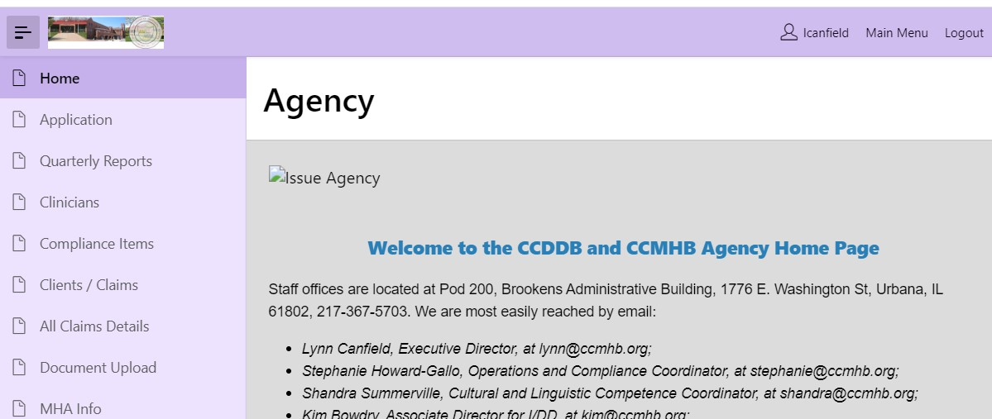
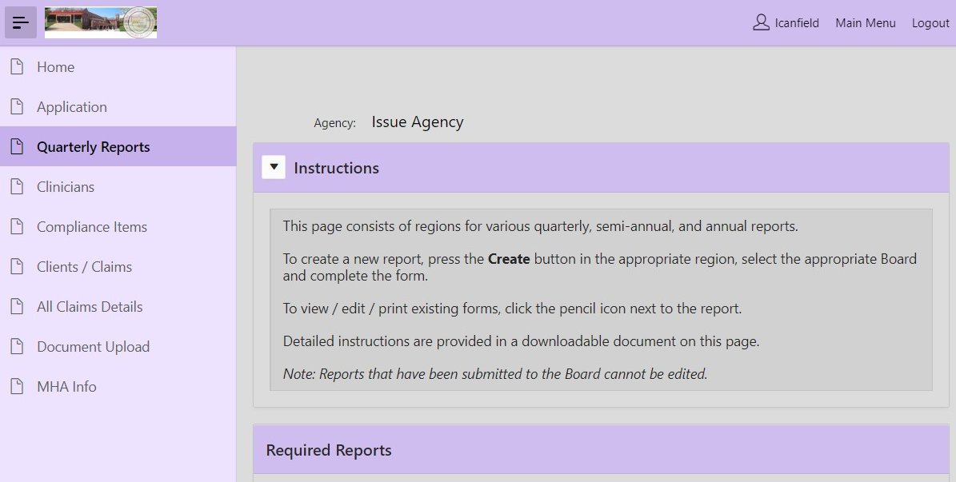

A table under the heading “Required Reports” shows which are due each quarter.

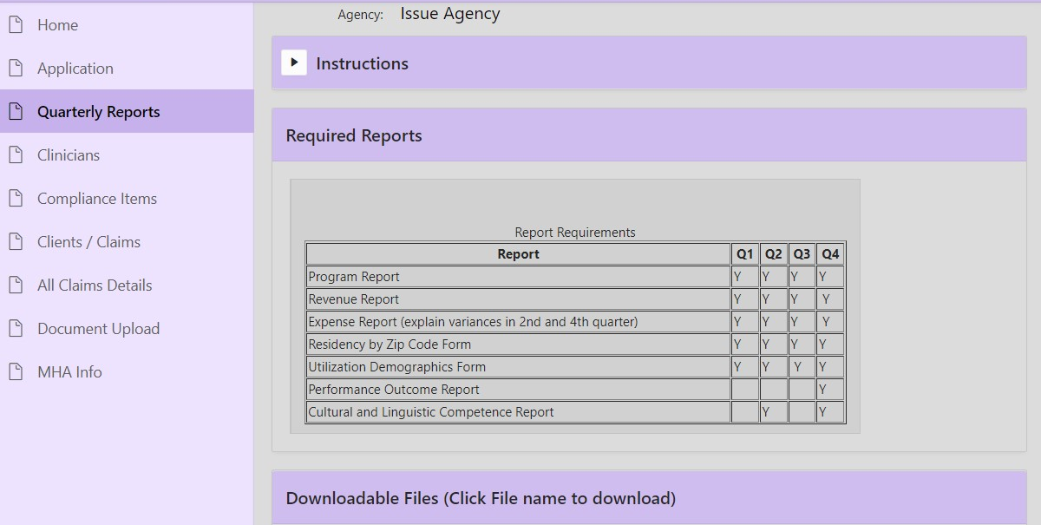
Directly below the table are “Downloadable Files” (with these instructions among them).

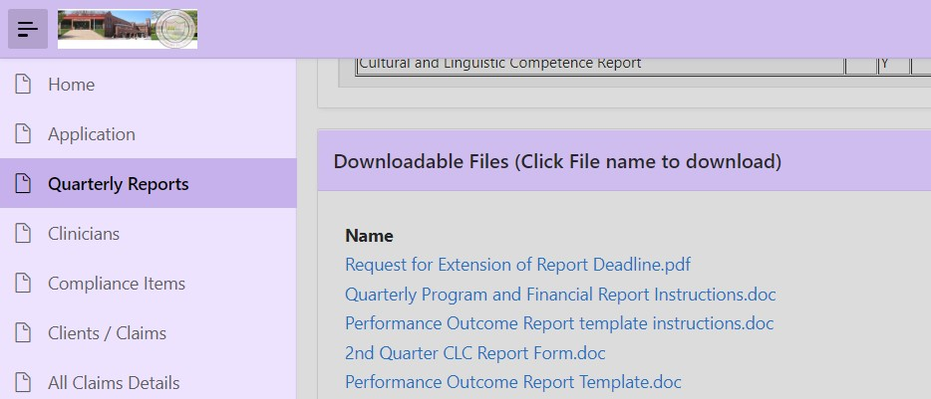

Below these is a region labeled “Report Tracking” which shows the status of required reports.

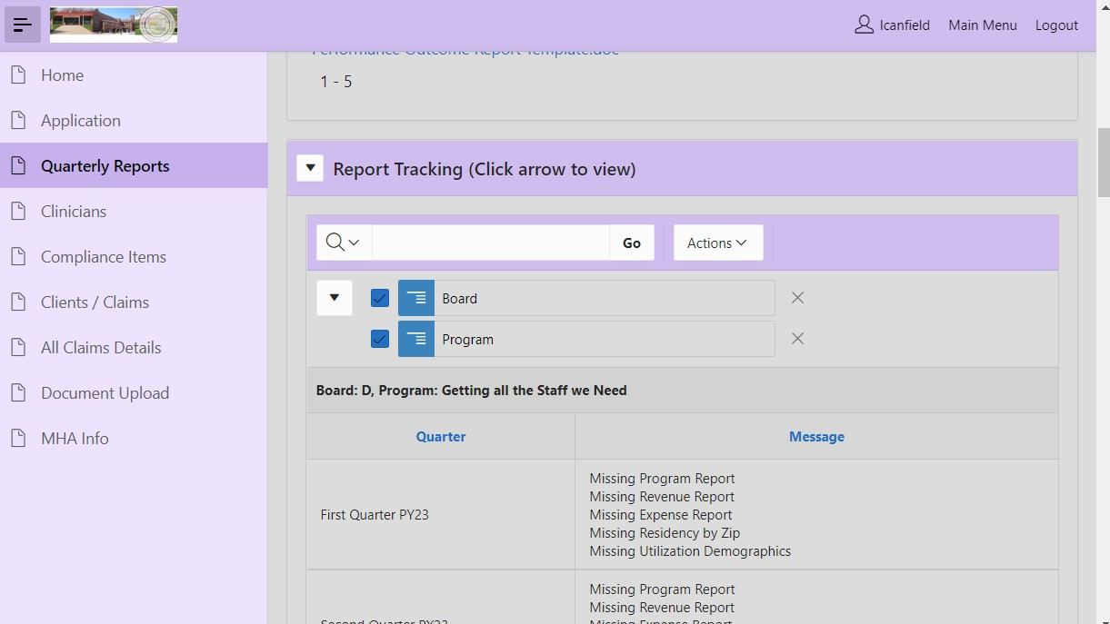
Next are “Selection Parameters”. From the Board dropdown list, select the Board/Fund which supports the program and select the appropriate Fiscal Year.

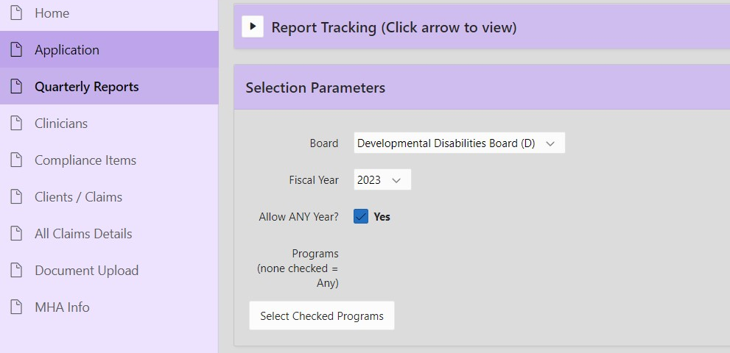

Below this section is a list of funded programs. Scroll down to “Quarterly Program Reports” and select “Create” to start work on the service activity report for each program.

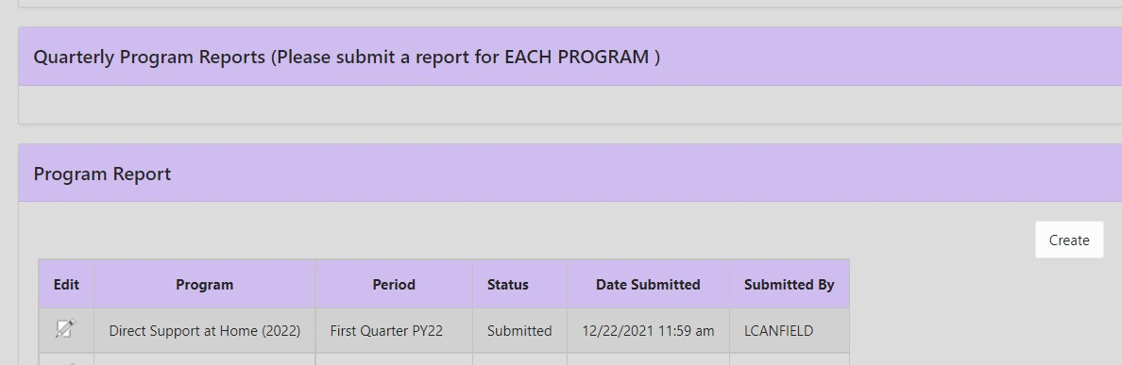
Select the desired program from the “Program” dropdown menu. Next, use the “Period” dropdown menu to select the correct period (Fiscal Year and Quarter). To finalize selections, click on “Create”.
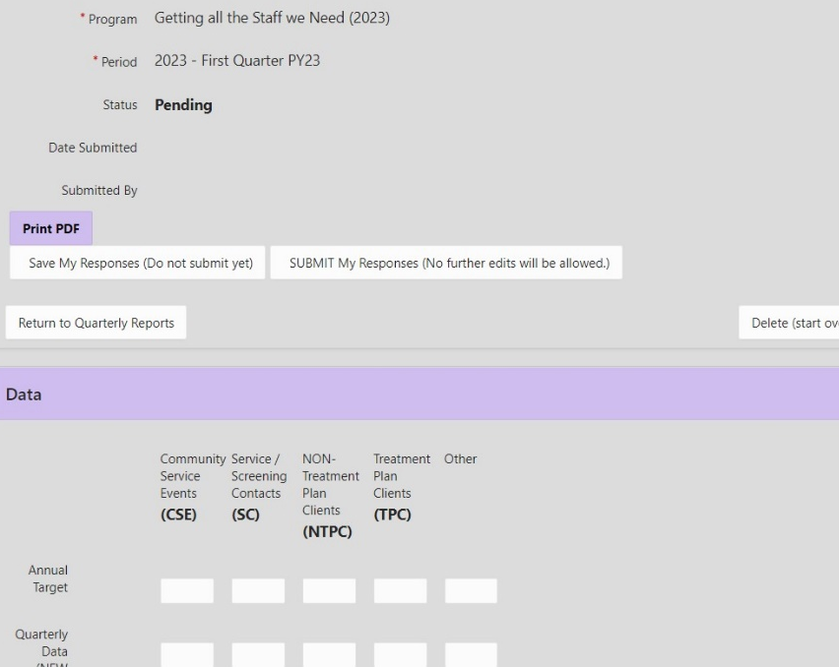
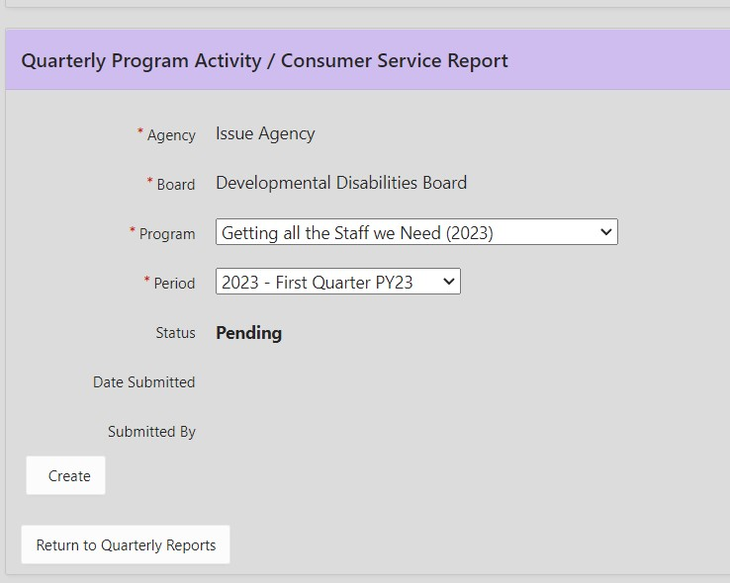

After creating the form (see below for how to complete specific forms), you may select “Save My Responses (Do not submit yet)” and return to it at another time. Save often. When all work on the form is finished, with no more edits needed, save and “SUBMIT…” the form. To work on other reports, use the “Return to Quarterly Reports” button.

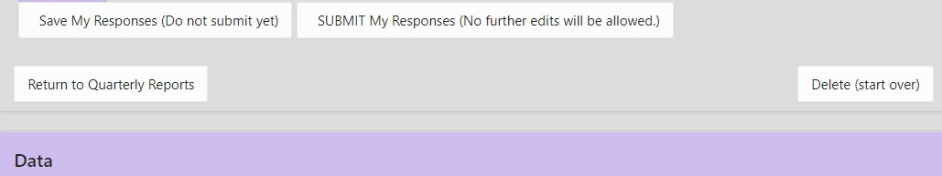

Repeat the Create, complete, Save, and SUBMIT process for each required form. Forms may be deleted prior to submission using the “Delete” button on the right side of the form. To view, edit, or print existing reports, from the “Quarterly Reports” page, click the edit/pencil icon next to the report. (Note: make sure that ‘Selection Parameters’ indicate the correct Board and fiscal year.)

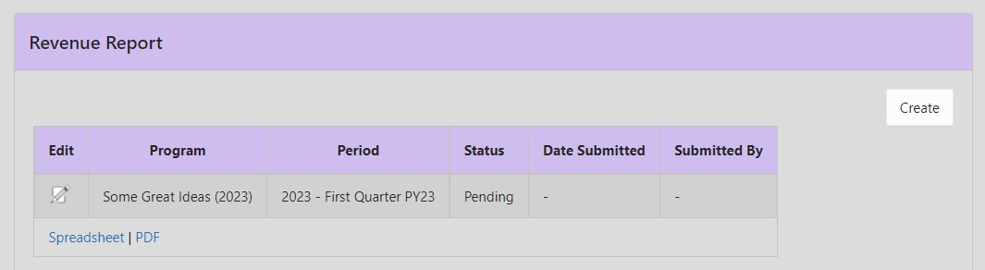

Program Reports

The Quarterly Program Activity/Consumer Service Report is accompanied by a Client Residency by Zip Code Report and a Utilization Demographic Report. Each report is only to account for only Champaign County residents, as those from outside the County are not eligible for CCDDB or CCMHB funding.

The Quarterly Program Activity/Consumer Service Report is the standard program report form, for report of community service events (CSEs), service/screening contacts (SCs), non-treatment plan clients (NTPCs), treatment plan clients (TPCs), and any activity identified as “Other” in the Program Plan. Comments are also encouraged.
To Complete the Quarterly Program Activity/Consumer Service Report:

Step 1. Annual targets for each category applicable to your program appear in the top row of the form, auto-filled from the Part II Utilization Form. (In PY24, Part II forms will no longer be in use, so these targets will need to be entered manually.)

Step 2. Fill in the actual number of CSEs/SCs/NTPCs/TPCs/Other activities completed during the report period. First quarter reports include NTPCs and TPCs carried over from the prior Program Year, reported in the boxes for Continuing NTPC and Continuing TPC. Subsequent reports are not cumulative and should only include counts of New NTPCs/TPCs and events and service contacts which occurred during the quarter. See the definitions below for further explanation.

Step 3. Use the Comments section below the table to provide any explanations/clarifications of the numbers reported or for a narrative description of program activities in support of the numbers reported in the table.

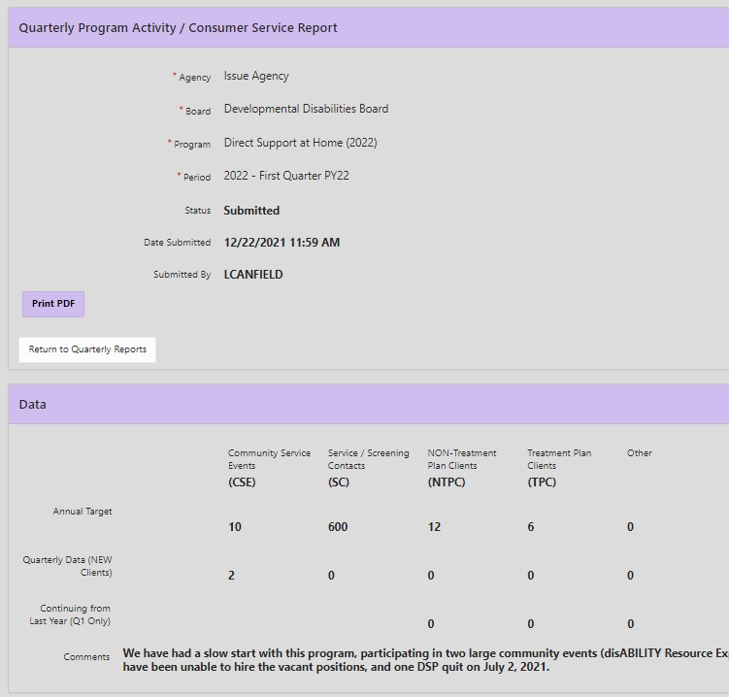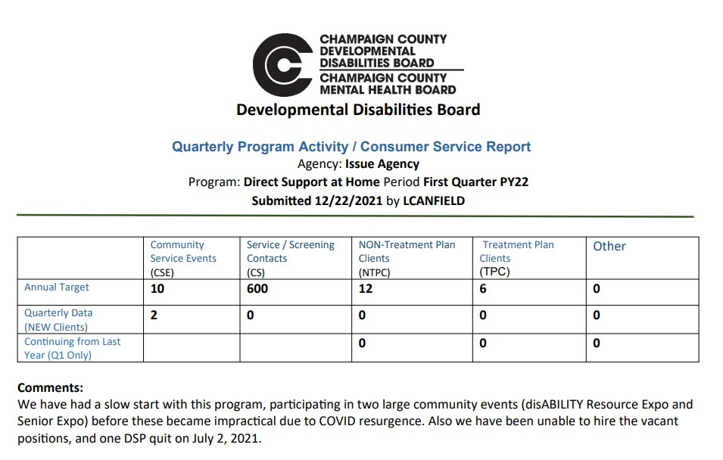

The completed form online (above, left) and the result of selecting the “Print PDF” option within the form (above, right).

Glossary of Service Category Definitions for Quarterly Service Activity Reports:

Annual Target – Projected Number of CSE, SC, TPC, or NTPC to be served, as listed in Utilization Section II of Program Plan and Program Plan Part II.

Community Service Events – Number of contacts (meetings) to promote the program or educate a targeted population: public presentations (including mass media shows and articles); consultations with community and/or caregiver groups; school class presentations; parent meetings; and small group workshops. The focus of a CSE is on activities to promote the program or educate a targeted audience.

Examples: public presentations; school class presentations; small group or workshop sessions to promote healthy lifestyles; meetings between agencies to plan community service events; interviews with reporters or the articles, programs or shows that result (do not count number of people, stations, or newspapers to which items are distributed); distribution of public service announcements, newsletters, and pamphlets. Note that attending or participating in a regularly scheduled meeting where you do not give a presentation on your program or participate in planning an event program is not a CSE.

Service Contacts/Screening Contacts – Number of successful phone calls and face-to-face contacts with consumers who may or may not have open cases in this program. This may include information and referral contacts, initial screenings/assessments, crisis services, or contacts for non-case specific consultations.

To be counted, the contact requires engagement; exclude unanswered telephone calls/correspondence. Contacts reported must also be documented. The Service/Screening Contact target number may be a total of persons receiving an assessment plus total of screening or non-case specific contacts plus total of service encounters with treatment plan clients. The preferred usage of this category is a screening contact for initial assessment.

Treatment Plan Clients – Service participants with case records and treatment/service plans. Each client should be counted only once a year, as a continuing or new client. Continuing Treatment Plan Clients are those with cases opened previously who continue to receive services during the first quarter of the current year. New Treatment Plan Clients are those whose cases were opened during the quarter for which activity is being reported.

Non-Treatment Plan Clients – Service recipients with case records but no treatment/service plans, to which substantial services are provided. Operational definitions are negotiated with each program, based on the nature of its services. Note that all clients reported must have case records.

Examples: recipients of material assistance; cases in which considerable outreach is done but where the client never commits to treatment/service; cases closed before a treatment/service plan was written because the client did not want further service; cases in which a client is seen as a service to another agency but does not receive program services beyond assessment, (e.g. a court-requested evaluation), and youth enrolled in and participating in an after school program. A new NTPC may be a person who has enrolled in a program or service that does not treat a diagnosed condition, i.e., no treatment plan required, such as a prevention-oriented service. It may also be a parent, child, or sibling of the primary client, who is participating in a program but does not have a treatment plan. Continuing and New NTPC clients are reported using the same formula as for TPCs.

Other – Applicants may use one indicator of their own invention such as contact hours, discharges, intakes, etc. “Other” will have been defined in the Utilization Section of the Part I form.

The other program reports to be completed are regarding residency and demographic data associated with the Treatment Plan Clients reported in the Service Activity Report.

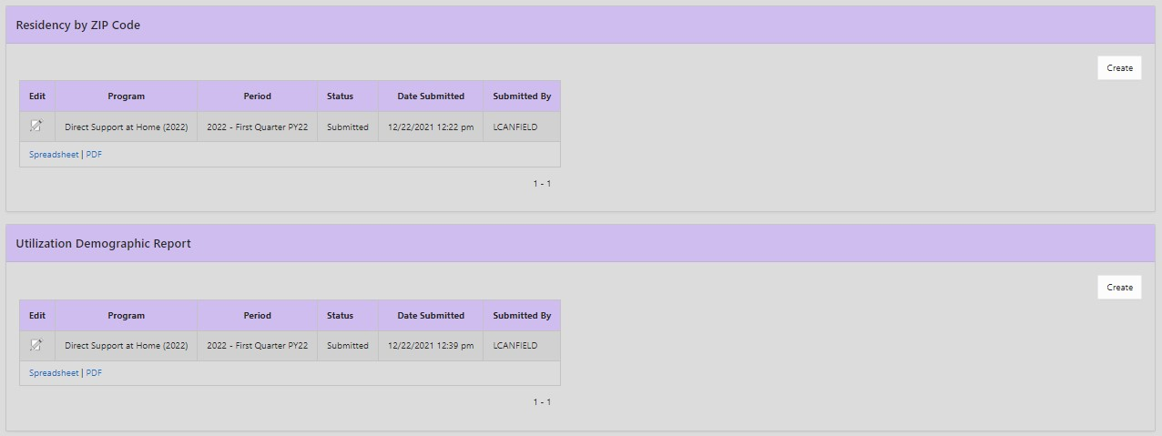

To Complete the Residency by Zip Code Report:

Step 1. In the box for each zip code, fill in the number of clients who engaged in services during the report period. For the first quarter, report on Continuing and New Clients. For the second, third and fourth quarters, report on only New Clients. If a zip code is not listed, use the “other” box to indicate the number served for other zip codes; then write that zip code and number of clients in the comments section. If the program only reports Community Service Events (CSEs) and no client data, then use the Zip Code Form to report either where CSEs were held or fill in boxes with zeros. If clients are reported in the Program Activity Report, client zip codes should be listed rather than CSE zip codes.
Step 2. If data are not available, provide an explanation in the comments section. Include only Champaign County residents, as people outside the county are not eligible.Total clients reported by zip code should match the number on the quarterly program activity report and the demographic report.

Download options are at the bottom of the report.

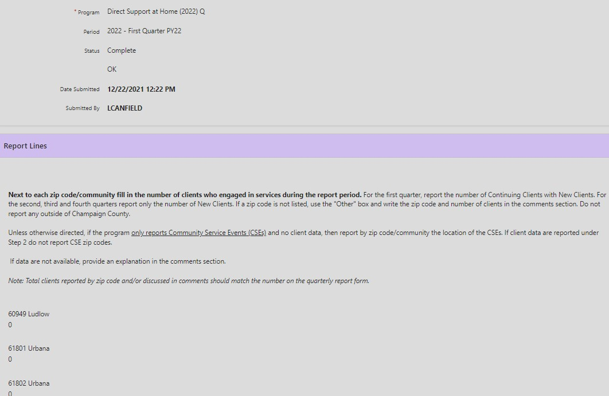

To Complete the Utilization Demographic Report:

Step 1. Next to each age group, fill in the number who engaged in services during the report period.
Step 2. Next to each race category, provide the number who engaged from the racial group.
Step 3. Provide the number of clients engaged in services who are “Of Hispanic/Latino/a Origin” and the number who are not. Indicate in the comment section if the number of those with Hispanic/Latino/a origin is a subset of a race category.
Step 4. Next to each gender category, provide the number who engaged in services. (Use “male” for trans or cis male and “female” for trans or cis female. People may choose Other. If gender is relevant to the service, describe in Comments.)
Step 5. If data are not available, provide an explanation in the comments section. Include Champaign County residents only. Number in each category should match number of clients reported in the quarterly program activity report.

Download options are at the bottom of the report.

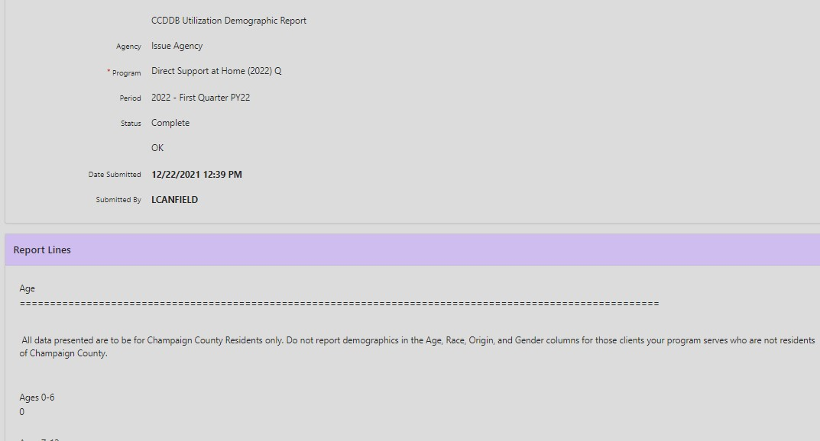

Financial Reports

The Quarterly Financial Report consists of a Revenue Report and an Expense Report. These are cumulative: all information should be reported as year-to-date (end of the relevant quarter) totals. Separate Revenue and Expense Reports are to be completed for each funded program. Refer to the Agency Plan Instructions for details on the distribution of revenue/expenditures per appropriate category. See above for how to find and create each of the Revenue and Expense Reports.

To Complete the Revenue Report:

Enter the dollar amount for each budgeted source of income. Revenues unrestricted by the donor must be allocated on a reasonable basis to all contracts, whether they are CCMHB or CCDDB funded. Each quarterly report is cumulative: provide year-to-date (July 1 to the end of the quarter being reported) amounts received.

When you Create the report for the relevant quarter, some boxes will be automatically filled in from the Revenue Form submitted as part of the application. Boxes highlighted in yellow require an entry.

Total Agency YTD Revenue - include year to date amounts from all sources of revenue received by the total agency

Total Program YTD Revenue All Sources Including CCMHB/CCDDB/Contract - include year-to-date amounts from all revenue sources which support the total program contracting with the CCMHB or CCDDB or I/DD Special Initiatives (beginning in PY24).

Total CCMHB/CCDDB/Contract YTD Revenue - include only the year-to-date revenue received from CCMHB or CCDDB or I/DD Special Initiatives (beginning in PY24) for this program.

It may be helpful to think of this array as a funnel, left to right. Each entry should be less than or equal to the one to its left.
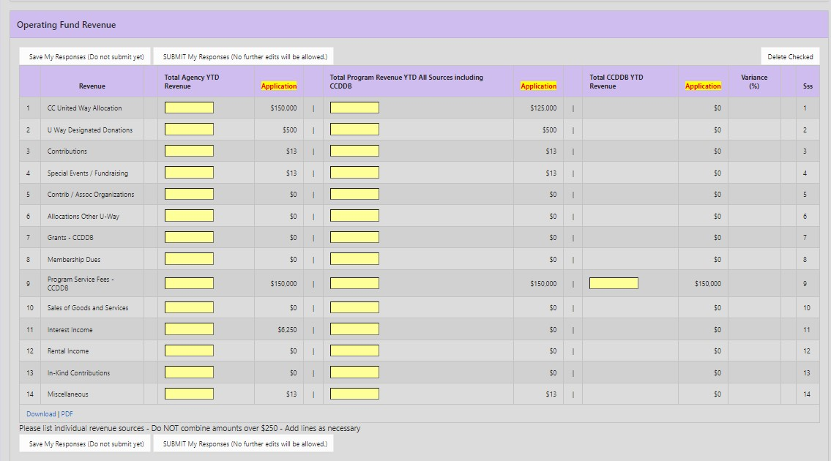

- CC United Way Allocation - Total Champaign County allocation received.
- United Way Designated Donations - United Way campaign designations received.
- Contributions - Include both contributions specifically earmarked for a particular program which are separate from general contributions and contributions that are not specific to a particular program but are allocated on a reasonable basis to all programs.
- Special Events/Fundraising - Includes total sales of goods (e.g., T-shirts) directly connected with the event received.
- Contributions by Associated Organizations - Amounts received from national, state, and local organizations and/or payments from collaborative operations with other agencies.
- Allocations from any other United Way - All contributions received from any United Way outside Champaign County.
- Grants – All grant funds received from funding sources. All revenue listed should be specified as to the source. Sources should be listed individually. Note: if new grant funding has been awarded since the contract was finalized, and if that new funding is not represented in the revenue form completed with the application or subsequently revised, please contact CCDDB/CCMHB staff to discuss updating for accurate representation.
- Membership Dues - Amounts received from organizations for dues.
- Program Service Fees – Reimbursement fees received for services provided. Sources should be listed individually. Line 9 is for Fee for Service contract payments. Use lines 9.a, 9.b, etc. to report received from other Fee for Service contracts. Note: if new fee-for-service funding has been awarded since the contract was finalized, and if that new funding is not represented in the revenue form completed with the application or subsequently revised, please contact CCDDB/CCMHB staff to discuss updating for accurate representation.
- Sales of Goods and Services - Sales of any goods where the sale is NOT directly connected with a special event or fundraising activity. Revenue received from sales of goods and services, including workshop or activity products, should be reported here.
- Interest Income - Include investment income.
- Rental Income - Revenue received from other organizations/agencies for facility rental.
- In-Kind Contributions - Please refer to the detailed explanation for allowable In-Kind Contributions listed below.
- Miscellaneous - Include bequests received.

Notes on In-Kind Contributions:

In-Kind Contributions represent the value of non-cash contributions provided by the grantee, other public agencies, and institutions, and/or private organizations and individuals. In-Kind Contributions may consist of real property and equipment, and goods and services directly benefiting and specifically identifiable to the grant program. All In-Kind Contributions shall be accepted as part of the grantee's revenue when they meet the following criteria:
- are identifiable from the grantee's accounting records, including the General Ledger;
- are necessary and reasonable for proper and efficient accomplishment of program objectives; and
- conform to the following provisions on valuation.

Valuation of In-Kind Contributions - Grantees should use the following specific procedures to determine the value on in-kind contributions from private organizations and individuals:
- Volunteer Services may be furnished by professional and technical personnel, consultants, and other skilled and unskilled labor. Each hour of volunteered services may be counted as local share if the service is an integral and necessary part of an approved program.
- Rates for Volunteer Services should be consistent with those regular rates paid for similar work in other activities of the agency. In cases where the kinds of skills required for the grant-assisted activities are not found in other activities of the grantee, rates used should be consistent with those paid for similar work in the labor market in which the grantee competes for the kind of services involved.
- Volunteers Employed by Other Organizations - When an employer other than the grantee furnished the services of an employee, these services shall be valued at the employee's regular rate of pay (exclusive of fringe benefits, and overhead costs) provided these services are in the same skill for which the employee is normally paid.
- Valuation of Donated Materials - Contributed materials could include office, maintenance, workshop or classroom supplies and food etc. Prices assessed to donated materials should be reasonable and should not exceed the cost of the materials to the donor or current market prices, whichever is less, at the time they are charged to the project.
- Valuation of Donated Equipment, Buildings and Land - The method used for claiming revenue for donated equipment, buildings and land may differ depending upon whether there is a transfer of ownership to the grantee:
- If there is a transfer of ownership to the grantee, the total value of the donated property may be claimed as revenue in the year in which ownership is transferred.
- If there is not a transfer of ownership to the grantee, the fair rental or use value may be claimed for the periods for which the property is in use. The fair rental or use value must be established by an independent appraiser, i.e., private Realtor, equipment dealer or certified appraiser.

Valuation of Other Charges - Other necessary charges incurred specifically for an indirect benefit to the grantee may be accepted as revenue provided, they are adequately supported and permissible under law. Such charges must be reasonable and properly justifiable.

Supporting Documentation - The following requirements pertain to the grantee's supporting records for in-kind contributions from private organizations and individuals:
- The number of hours of volunteer services must be supported by the same method used by the grantee for its employees.
- The basis for determining the charges for personal services, material, equipment, buildings, and land must be documented.

The completed, submitted document cannot be edited. With all cells filled in, saved and submitted, it may look like this:

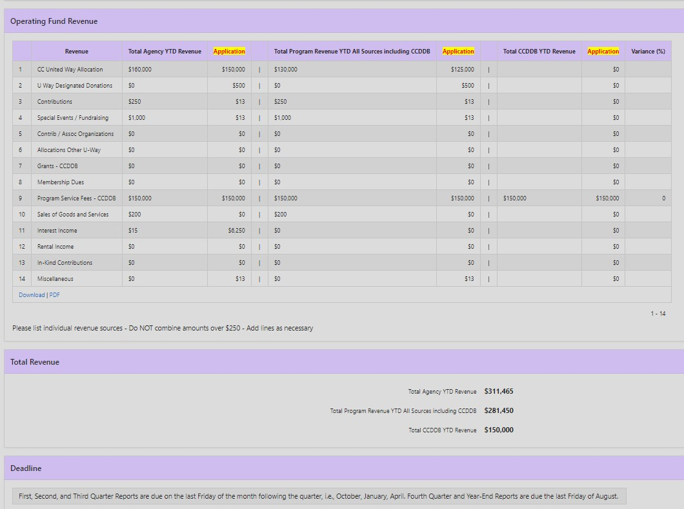

Note the summary of YTD total agency, total program, and CCDDB/CCMHB/Contract revenue at the bottom of the form.
To Complete the Expense Report:

Enter the dollar amount expended for each budgeted line item. If an expense line was not used in the Expense Form submitted as part of the application, no amount should be reported for that category without CCMHB/CCDDB approval. An individual expense form is to be completed for each program. Each quarterly report is cumulative: provide year-to-date (July 1 to the end of the period being reported) expense amounts. When you Create the report for the relevant quarter, some boxes will be automatically filled in using details from the Expense Form submitted as part of the application. Boxes highlighted in yellow require an entry.

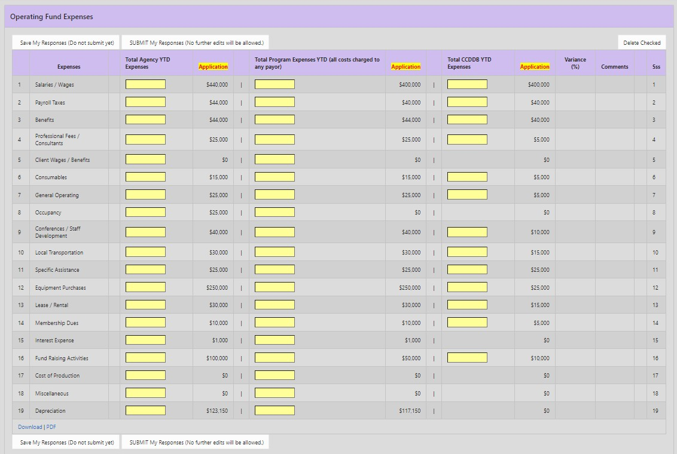

Total Agency Expenses - include year-to-date expenditures for the total agency.

Total Program Expenses YTD (all costs charged to any payor) - include YTD expenditures for the total program which is contracting with the CCMHB, CCDDB, or I/DD Special Initiatives (beginning in PY24).

Total CCMHB/CCDDB/Contract YTD Expenses -- include only YTD expenditures being paid for by this contract with the CCMHB, CCDDB, or I/DD Special Initiatives Fund.
It may be helpful to think of this array as a funnel, left to right. Each entry should be less than or equal to the one to its left.

Variances between the budgeted expense (as submitted on the application form) and actual year-to-date expense are calculated for each line item. Any which are greater than +/- 20% and greater than $100 require a written explanation in the second and fourth quarter reports. After entering all figures on the expense report, press the “Save” button. The system will automatically calculate the percent variance for each line item and will populate a comment box for any line items with a variance of +/- 20% or greater and greater than $100. In a sentence or two, provide a written explanation of the cause of the variance. Once explanations have been entered in all required comment boxes, you may then submit the expense report. (Note: Variance comments are required on second and fourth quarter expense reports ONLY.)

- Salaries/Wages - Amounts paid/incurred to regular full-time and part-time agency employees, not including consultants or other professionals engaged on a contract basis. Include the following:
- Salaries and gross wages, including overtime
- Earned leave time (vacation, holiday, personal and sick leave)
- Payroll Taxes - Examples include the following:
- Employer FICA
- Unemployment/Workman's Compensation
- Benefits - Examples include the following:
- Employee health and retirement benefits
- Accident insurance premiums
- Life insurance premiums
- Medical and hospital plan premiums
- Pension or retirement plan premiums
- Supplemental payments to pensioned employees
- Employment termination expenses
- Other employee benefits including disability insurance
- Professional Fees/Consultants - Include year to date fees paid on a contractual basis.
- Client Wages and Benefits - Enter the total wages and fringe benefits for individual clients paid/incurred year to date through agency programs, i.e., sheltered workshops.
- Consumables—Year to date expenses for:
- Office Supplies
- Medicines and Drugs
- Recreation and Crafts
- Educational Supplies
- Food and Beverages
- Kitchen Supplies
- Housekeeping Supplies
- Laundry Supplies and Linens
- Workshop Supplies
- Program Support Supplies
- General Operating Expenses - Year to date expenses for:
- Telephone, Telegraph, Internet, Webhosting
- Subscriptions/Reference Material - Include the cost of purchased publications, technical books, magazines, & pamphlets, online subscriptions.
- Postage/Shipping - Include postage, Fed Ex, UPS, trucking, and other delivery expenses along with shipping materials.
- Outside Printing - Include the cost of printing, commercial artists and supplies for plates, artwork, proofs, photographs & other costs of leaflets, films & other informational materials, digital, website, and logo design.
- Liability/Malpractice Insurance – Include the cost of all other liability, malpractice, personal injury, and other insurance not reported as property insurance or as employee benefits; include bonding expense.
- Occupancy Expense - Costs arising from an agency's occupancy and use of land, buildings, and offices. The cost of permanent improvements and items of equipment with a unit cost of more than $500 each and having a useful life of more than one year cannot be included. Include the following year to date expenses:
- Property Insurance - Enter all comprehensive hazard insurance including property liability insurance
- Electricity, Heat & Other Utilities
- Janitorial & Other Maintenance Services
- Building & Grounds Maintenance Supplies
- Equipment Maintenance
- Property Taxes
- Conferences, Staff Development, Conventions & Meetings - Include year to date expenses of conducting and/or the attendance of conferences, staff development events, conventions & meetings relating to the agency's activities.
- Local Transportation - Include the following year to date expenses:
- Vehicle Operating Cost - Vehicle insurance, license plates, gasoline, repairs, and maintenance. Do not include depreciation or lease payments.
- Other Staff Transportation - Cost for staff travel, including mileage paid for use of personal vehicles.
- Specific Assistance - Year to date costs paid/incurred of providing individual clients with special necessary needs where the items purchased became the property of the individual rather than the agency.
- Clothing
- Allowance
- Foster Parent Board Payments
- Client Legal Expense
- Necessary Appliances (e.g., wheelchairs)
- Client Transportation (e.g., public transportation)
- Equipment Purchases – Year to date expenses for equipment items with a unit cost of less than $500 or a lower maximum based on established policies of the agency. Do not include capital equipment purchases here.
- Office Equipment
- Building Equipment & Furnishings
- Recreation Equipment
- Food Service Equipment
- Education Equipment
- Lease/Rental - Year to date expenses for
- Equipment
- Vehicles
- Building Rent/Lease
- Membership Dues - Include year to date amounts for membership dues paid or payable to organizations that provide services, publications, and materials for the agency’s use.
- Interest Expense – Year to date expenses for:
- Current Operating Interest
- Construction Period Interest
- Mortgage Interest
- Equipment Interest
- Fund Raising Activities – Include year to date expenses directly connected with the event.
- Cost of Production -- Include year to date expenses directly involved with production costs.
- Miscellaneous -- Include the following year to date expenses:
- Awards and Grants - Amounts paid or committed to individuals or organizations for the support of research, fellowships, scholarships and other health or welfare programs.
- Moving/Recruiting - Cost of interviewing prospective employees and moving and expense allowance provided to new employees.
- Amortization of organization and pre-operative costs - (e.g., operation expenses incurred in preparing for rendering client care before the first client is admitted.)
- Depreciation – Total allocation of the cost of physical assets over their estimated useful lives. Provision for depreciation is intended to spread the cost of such assets over the period their use benefits the program or supporting activities of the agency.

Some expenses listed above, i.e., depreciation costs, may not be allowable as CCMHB/CCDDB expenditures. Please refer to the contract or funding guidelines for additional information.

The completed, submitted document cannot be edited. With all cells filled in, it may look like this:
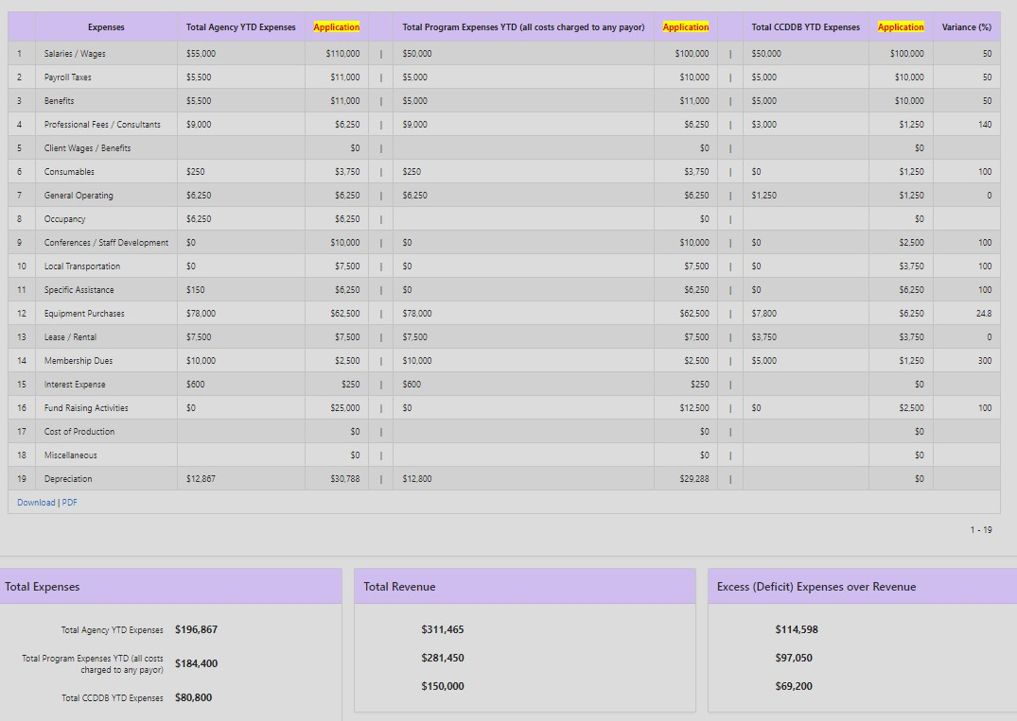

The Cultural and Linguistic Competence Plan Progress Report is completed with second quarter and fourth quarter reports, based on the actions identified in the agency’s CLC Plan. The second quarter report is a downloadable template, to be completed and uploaded back to the system. The fourth quarter report is built into the online system and requires updates on all the actions identified within the agency’s submitted CLC Plan.

To Complete the Cultural and Linguistic Competence Plan Progress Report:

FOR THE SECOND QUARTER REPORT:

Step1. Download the 2nd Quarter CLC Report Form on the Agency’s Quarterly Report Page.

Step 2. Complete the form as directed, following the instructions in the form.

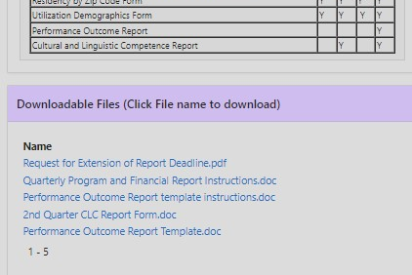

Step 3. Upload the CLC Plan Progress Report file in the designated space on the Quarterly Report page.

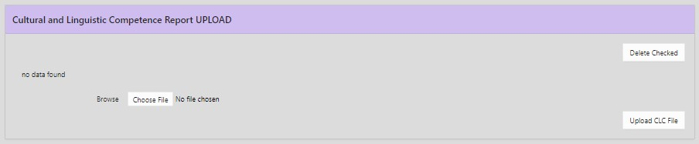

FOR THE FOURTH QUARTER REPORT:

Step1. Find the Cultural and Linguistic Competence Report Section on the Agency’s Quarterly Report Page, just above the CLC UPLOAD Option. Select “Create”.

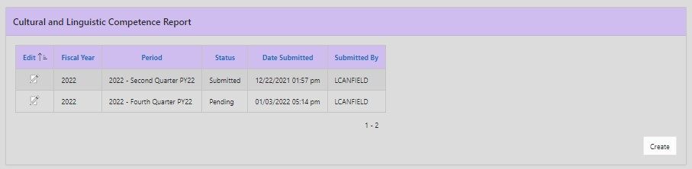

Step 2. Select the 4th Quarter from the dropdown menu and again select “Create”.

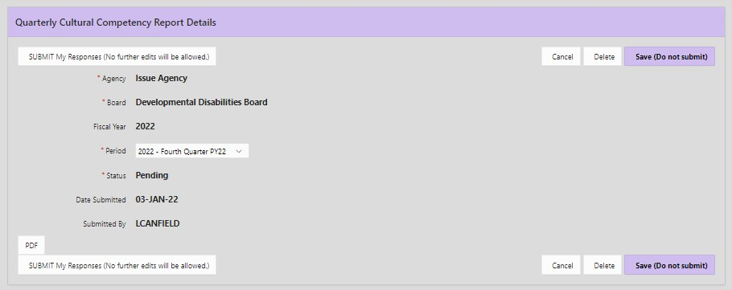

Step 3. Scroll down and to the right to find “Status” boxes for each action and organized by the relevant standard.
Fill in each Status box.

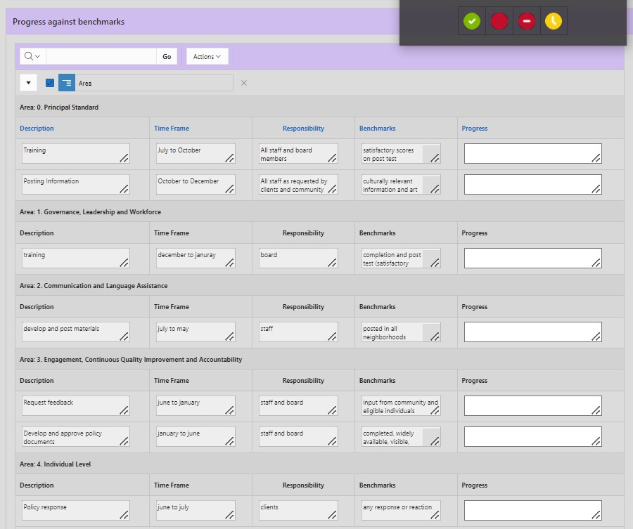

Step 4. When you are satisfied that Status comments are complete, select either of the buttons titled “SUBMIT My Responses (No further edits will be allowed.)”
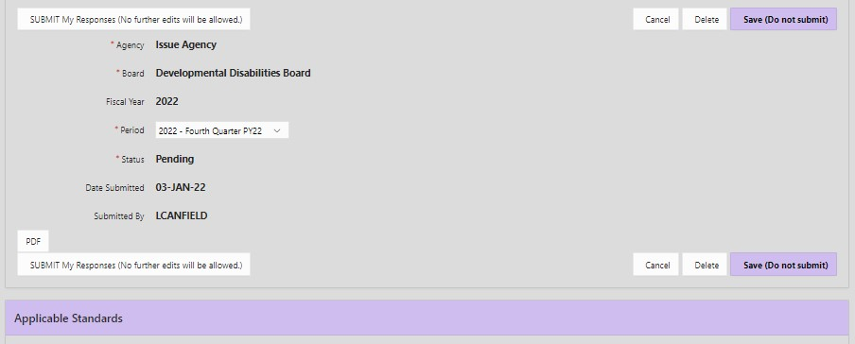

The “PDF” option creates a version of the report that looks like this:
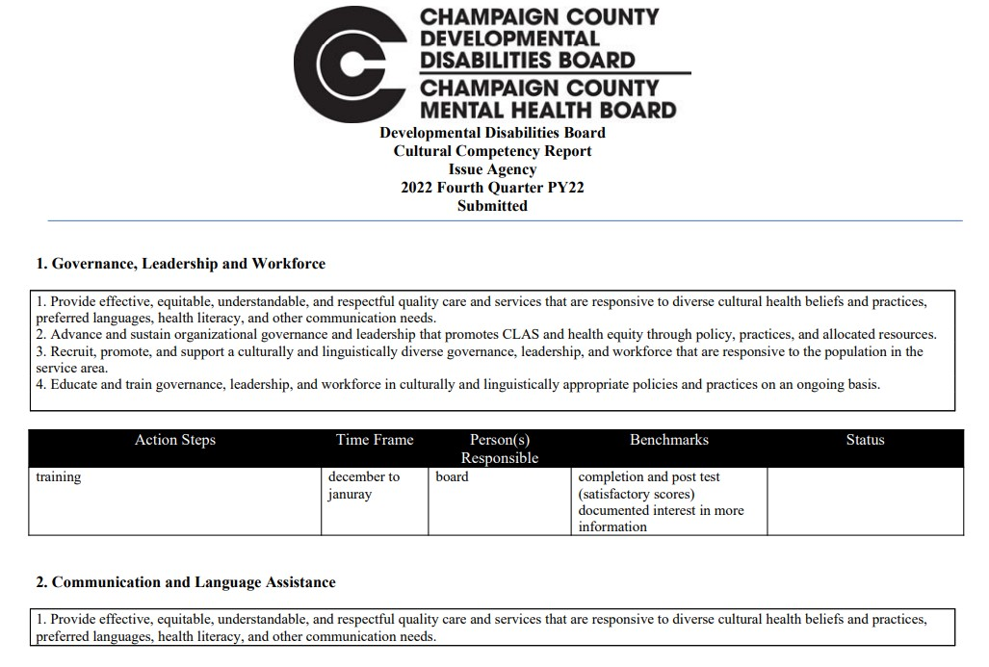
The Performance Outcome Report (POR) is an uploaded document, completed at the end of the contract year (AKA program year). The POR details performance outcomes (Access, Consumer Outcome, and Utilization measures detailed in the Program Plan) and presents results achieved by the program in relation to each of the performance measures and utilization targets. The year-end Performance Outcome Report is due with fourth quarter reports, on or before the last Friday in August.

To Complete the Annual Performance Outcome Report:
Step1. Toward the top of the Agency Quarterly Report Page, find and download the Performance Outcome Report Instructions and the Performance Outcome Report Template.
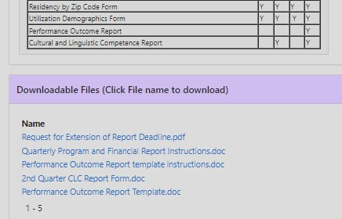

Step 2. Complete the downloaded report form by following the downloaded instructions as well as detailed instructions in the form. Note: PY23 and PY24 applications have fewer questions than prior years, so use N/A if a field is not relevant.

Step 3. To submit a Performance Outcome Report, find the designated section on the Quarterly Report page, choose the file using “Browse” and select “Upload PMO File”. If needed, use “Delete Checked” and upload the revised version.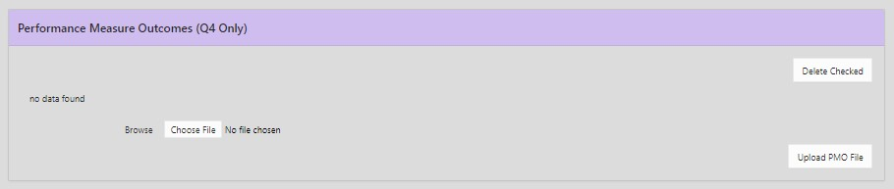

To Request an Extension of the Deadline for any Report Listed Above:
The online system will close at midnight on the date reports are due.
If you need extra time or to revise a submitted form, download the fillable pdf form. Complete the form as indicated and email it to the staff identified PRIOR to the deadline. Follow up to confirm time/date. 