Compiled Annual Performance Outcome Reports

of CCMHB Funded Programs for Contract Year 2017

Champaign Community Coalition
Summer Youth Initiative - $107,000
Although this contract did not require performance reports in CY17, as the ACCESS Initiative Sustainability Plan transitioned to the Coalition, a summary report is included.
Champaign County Children’s Advocacy Center
Children’s Advocacy Center - $37,080
Champaign County Regional Planning Commission Community Services
Youth Assessment Center - $26,000
Champaign County Regional Planning Commission Head Start
Social-Emotional Disabilities Services - $55,645 (ID/DD program)
Champaign Urbana Area Project
CU Neighborhood Champions - $19,189
TRUCE - $75,000
Community Choices
Community Living - $63,000 (ID/DD program)
Self-Determination Support - $70,000 (ID/DD program)
Community Service Center of Northern Champaign County
Resource Connection - $65,290
Courage Connection
Courage Connection - $66,948
Crisis Nursery
Beyond Blue Champaign County - $70,000
Developmental Services Center
Individual and Family Support - $387,428 (ID/DD program)
Don Moyer Boys and Girls Club
CU Change - $100,000
Youth and Family Services - $160,000
East Central Illinois Refugee Mutual Assistance Center
Family Support & Strengthening - $19,000
Family Service of Champaign County
Counseling - $20,000
Self-Help Center - $28,928
Senior Counseling & Advocacy - $142,337
First Followers
Peer Mentoring for Re-entry - $29,764
Individual Advocacy Group
CILA Expansion - $50,000 CCMHB & $50,000 CCDDB
Although this agreement does not require performance reports from the provider, a brief report is included.
Mahomet Area Youth Club
Bulldogs Learning and Succeeding Together - $15,000
MAYC Members Matter! - $12,000
Prairie Center Health Systems
Criminal Justice Substance Use Treatment - $10,300
Fresh Start - $75,000
Parenting with Love & Limits Extended Care - $300,660
Prevention - $58,247
Specialty Courts - $199,050
Youth Services - $108,150 $54,078
Promise Healthcare
Mental Health Services with Promise - $222,000
Promise Healthcare Wellness & Justice - $58,000
Rape Advocacy, Counseling & Education Services
Counseling & Crisis Services - $18,600 $7,750
Rosecrance C-U
Criminal Justice - $284,080
Crisis, Access, & Benefits - $255,440
Parenting with Love & Limits Front End - $282,663
TIMES Center Screening MI/SA - $70,000
UP Center of Champaign County
Children, Youth, & Families Program - $19,000
Urbana Neighborhood Connections
Community Study Center - $12,000

2016 Champaign Community Coalition Summer Youth Initiatives

- Champaign Schools - $20,000
- Targeted initiative for (18) middle-school boys
Leadership, academic enrichment, mentoring
- Targeted initiative for new group of (10) middle-school boys
Leadership, academic enrichment, mentoring
Contact: Orlando Thomas, thomasor@champaignschools.org

- Urbana Schools - $25,000
- Summer employment and training
Career awareness and exploration
Up to (40) students participating
Contact: Lisa Benson, lbenson@ccrpc.org; Don Owen, dowen@usd116.org

- Dream House - $4,000
  - Dream House summer educational initiative
(25) boys pre-kindergarten enrichment and reading
Contact: Tracy Dace, tracy@dreaamhouse.org

- CU Neighborhood Champions - $4,000
  - Trauma information and education for targeted neighborhoods in Champaign-Urbana
Training for up to (40) participants
Contact: Karen Simms, karen.c.simms@gmail.com

- Boys and Girls Club - $10,000
  - Subcontracts –
Racial Taboo, video production, community engagement, Coalition promotional activities, Mental Health Awareness Week, Rantoul Project?
(200) participants
Contact: Ray Pratt, RPratt@dmbgc-cu.org

- Midnight Basketball - $10,000
  - Youth-For-Christ – targeted initiative boys and girls
Leadership-recreation
Up to (200) participants
Contact: Willie Comer, williecomer@att.net

- Community Campus Connection (C³) - $2,300
  - Partnership University of Illinois
Community organizations
Campus-based recreational activities
Up to (300) community youth and campus participants
Contact: Robyn Deterding, rdeterdi@illinois.edu

- 1st String - $1,000
  - Sports-based initiative
Leadership and skill development
Up to (40) youth participants
Contact: John Cooper, cooper.john7249@comcast.net ;
Peter McFarland, mcfarlandpeter@hotmail.com

- Lifeline - $2,000
  - Summer camp activities
Garden Hills area youth
10-16 age group
(35) participants
Contact: Rev. Lekevie Johnson, pastorlcj@aol.com

- Dream Girls Academy - $2,000
  - Targeted middle-school girls
Coaching-mentoring-advocacy
Up to (75) participants
Contact: Debarah McFarland, dreamgirlsacademyil@gmail.com

- Banks Bridgewater Lewis Academy - $3,000
  - Fine arts, music academy
Up to (60) participants
Contact: Nathaniel Banks, nathlbanks@gmail.com

- Community Arts - $3,000
  - In development
Krannert, Urbana Park District, Urbana schools
Summer arts-focused project
Up to (15) participants
Contact: Sam Smith, smsmith3@illinois.edu

- Community Arts - $5,000
  - 3-week dance camp for targeted students
Krannert, Champaign schools, Champaign Park District
Up to (20) participants
Contact: Angela Smith, smithan@champaignschools.org

- Freedom School - $5,000
  - Academic enrichment reading program
Up to (20) participants
Contact: Regina Parnell, ReginaParnell@gmail.com

- Over (1100) participants

- Initiative Funding made possible by $107,000 Award from the Champaign County Mental Health Board

- Don Moyer Boys and Girls Club – Fiscal Agent
10% Administration Fee = $10,700
$96,300 allocation

CHAMPAIGN COUNTY CHILDREN'S ADVOCACY CENTER

PERFORMANCE OUTCOME REPORT PROGRAM YEAR 2016

PERFORMANCE OUTCOME MEASURES:
Consumer Access:
Service Quantity
During Program Year 2017, the Champaign County Children's Advocacy Center {CAC} continued to provide Immediate, round-the-clock access to the facility, ensuring a timely response to allegations of child sexual and serious physical abuse. CAC staff members continue to be available 24 hours per day in order to facilitate interviews and to initiate services.

During the 12-month period ending June 30, 2017, a total of 187 (at 12.5% increase from FY 2016) Champaign County children were interviewed at the Children's Advocacy Center, a number which includes 159 children interviewed as potential primary victims of sexual or serious physical abuse (treatment plan clients), plus 28 children interviewed as potential witnesses or who are siblings of the primary victims (non-treatment plan clients), for a total of 187 Champaign County children. We exceeded the annual target of 110 screening contacts for Champaign County children (the sum of primary victims plus witness/siblings).

Not counted in this number are children interviewed at the CAC who reside outside of Champaign County. On July 1, 2016 we officially began providing CAC services to Ford County children and families. This new coverage did not impact operations because we were already seeing those families on a courtesy basis-the difference now is that we receive additional funding from Department of Child and Family Services (DCFS) to support the services to these families.

In the calendar year 2016 we interviewed 213 children from all counties (Champaign and others), a 15% increase from 2015. While we expect fluctuations from year to year, we note that other Illinois CACs are seeing the same increased numbers.

Service Involvement by Other Entities
All children interviewed at the CAC are brought there (described as being "referred") at the direction of either law enforcement investigators and/or child protection investigators from the Illinois Department of Children and Family Services (DCFS). DCFS becomes involved in a case if the alleged perpetrator is a caregiver or in a position of trust or authority over the child. Most of the CAC cases are considered for prosecution in Champaign County, so the Champaign County State's Attorney's Office Is part of the Multidisciplinary Team for Coordinated Investigations. In addition to DCFS and the State's Attorney's Office, the following Champaign County law enforcement departments were involved in interviews conducted at the Children's Advocacy Center during Plan Year 2017:
Champaign Police Department
Champaign County Sheriff's Office
Federal Bureau of Investigation-local office
Fisher Police Department
Ford County Sherriff's Office
Grundy County Sherriff's Office
Gibson City Police Department
Mahomet Police Department
Paxton Police Department
Rantoul Police Department
Thomasboro Police Department
Tolono Police Department
Urbana Police Department
Villa Grove Police Department
Vermillion County Sherriff's Office
In addition, we interviewed children from cases originating out of each of the following jurisdictions:
Macon County, Ford County, and Vermilion County Sheriff's offices
Aurora Police Department
Terre Haute, Indiana Police Department
Algonquin Police Department

In the role of coordinator of the Multidisciplinary Team (MDT), the Children's Advocacy Center Executive Director coordinated and facilitated Multidisciplinary Team Case Review Meetings each month in PY 2017. A new Executive Director, Kari May, started in February 2017. During the 12-month period ended June 30, 2017, 207 Champaign County cases involving primary victims were reviewed by the MDT. Individuals representing the following agencies/organizations attended one or more MDT Case Review meetings during the reporting period:

All of the Champaign County Law Enforcement entities listed above, plus:
IL Department of Children and Family Services
Champaign County State's Attorney's Office (SAO)
Champaign County SAO Victim-Witness Advocate
Carle Clinic-Pediatrics Department Carle Hospital-Emergency Department
Carle Clinic-Social Work Department
Champaign County CAC (all three of our staff attend)
East Central Illinois Refugee Mutual Assistance Center
RACES (Rape Advocacy, Counseling & Education Services)
Stephanie Beard, Crisis Counselor
Joanna Kling, Crisis Counselor
Christine Washo, Crisis Counselor
Ann Chan, Crisis Counselor

Services:
Crisis Counseling and Family Advocacy
Entirely funded through a grant from the Illinois Criminal Justice Information Authority, the Children's Advocacy Center offers free crisis counseling services to children referred to the CAC and their non-offending family members. The Crisis Counseling services are provided by three licensed therapists under contract to the CAC, and can last up to about eight weeks, or longer if the client is on a wait list for long-term services at another local provider. A new Crisis Counselor funded through donations, Stephanie Beard, was added to the team in order to provide counseling in for those clients who reside in Rantoul and Ford County. One of the positives about our crisis counseling contract is that the young people are eligible for the service until they turn 18 years old. For fiscal year 2018 services through Beard will be funded through an expansion of the Victims of Crime Assistance Grant. So if the child has additional emotional problems years after the abuse they are eligible to start up with counseling again.

The CAC Family Advocate provides free case management services to children who live, have lived, or were the suspected victim of sexual or severe physical abuse while visiting Champaign County. The service ranges from a few brief follow-up contacts to the non-offending parent to intensive services helping families with serious needs such as homelessness, food insecurity, or child behavioral issues. She works with the family for up to two years, or until the court case concludes if there is one. We are tracking the length of time families remain in services in order to assess optimal case management service duration.

Child Forensic Interviewing
Since January of 2014 the CAC has employed a Child Forensic Interviewer. While many Champaign County investigators are trained interviewers, giving them the option to use the CAC-based interviewer has benefits for both the investigators and the children. The CAC was notified on Jun 15, 2017 that funds were awarded through an expansion of the Victims of Crime Assistance {VOCA) grant to retain the experienced Forensic Interviewer.

Case Coordination and Child Forensic Interviewing
In June 2017 the CAC also received additional VOCA funding to hire an additional staff person who will coordinate the case review (Multidisciplinary Team - MDT) meetings, coordinate MDT trainings, coordinate trainings with new members of the MDT upon hire and provide child forensic Interviews. The new MDT Coordinator will provide services at the CAC for fiscal year 2018.

Cultural Competence
In November of 2016 the Governing Board of the CAC reviewed the Cultural and Linguistic Competence Plan, and approved some changes which were reported to the CCMHB Cultural Competence Coordinator. The Board will review the Plan, and any suggested changes, annually each November, so that changes may be incorporated into the CCMHB application due early in each calendar year.

Protocol for Multidisciplinary Investigation of Child Sexual and Physical Abuse
Throughout this plan year the CAC has revised sections of the agency Protocol for Multi disciplinary Investigation of Child Sexual and Physical Abuse, a 20 page document outlining the approach and service delivery guidelines for all aspects of the center. The plan was reviewed and revised in November 2016. The plan will be updated and revised again in November of 2017 to reflect the changes to the National Children's Alliance performance standards that were released January 2017.

Consumer Outcomes:
Consumer Satisfaction Surveys
Beginning January 1, 2017 we began participation in the Outcome Measurement System designed and supported by our national accrediting body NCA. The instruments, which have been deemed valid and reliable by research professionals, are administered to the parent/caregiver at the end of the initial interview via a tablet computer (supplied by NCA) and results are uploaded to a national database. We chose to join this initiative both to increase our survey response numbers, and to be able to benchmark our results against a national sample.

Our parents and caregivers have responded quite positively, and express gratitude that we ask for their feedback. Completed surveys have been highly positive, and have also highlighted areas for improvement, mostly pointing to writing down more of our information so that parents can refer back to the documents when they are not in the midst of the crisis of child sexual abuse investigations.

Service Impact
For each case child receiving management or crisis counseling services, the CAC staff person conducting the intake completes a comprehensive needs assessment. The needs assessment serves as a pre-service measure of well-being, assists with the identification of child and family strengths, highlights areas of concern, and serves as a guide for identifying appropriate community-based services and making initial service referrals. The Family Advocate tracks the ongoing progress of each client through frequent telephone, in-person, and written contacts with the child's non-offending parent/caregiver. All client contacts are documented.

Prior to case closure, the CAC Family Advocate reviews each case to evaluate, among other things, services offered to the family, whether or not the family has accepted those services and/or has experienced any barriers or impediments to the delivery of services, any additional service referrals which might assist the family, any recommendations made by the Multidisciplinary Team (MDT), and the status of any criminal or juvenile court proceedings. If after that evaluation the Case Manager determines that the case is eligible for closure, she discusses the recommendation with the CAC Executive Director, who grants final approval for closure.

Utilization:
For Plan Year 2017
 | Community  Service Events | Service/Screening Contact Clients | Treatment Plan Clients | Non- Treatment  Plan Clients | Other Clients
Target | 12 | 110 | 100 | 10 | 0
Actual  (New) | 15 | 187 | 159 | 28 | 0
Percent of  target met | 125% | 170% | 159% | 280% | na
The client numerical targets have exceeded they annual target amount. This is a function of the numbers of children that have been brought to the center by law enforcement or DCFS, rather than anything we can influence. The CAC does not have any input into how many children are brought to the center for interviews and in 99% of cases we are able to schedule the interview within 48 hours of the date/time requested by the investigator.

Additional Program Activities:
The agency's most pressing challenge has been the delay in payments for the grant the program receives from the Department of Children and Family Services (DCFS). Vouchers were sent from DCFS to the Comptroller's office in mid-December and as of August 24, 2017, payment has still not been received from the state, despite numerous calls and attempts to apply for hardship status by Executive Director, Kari May.

A second challenge has been data management. When the former Executive Director began at the CAC in June of 2013 the agency was using paper and pencil tallies to document client numbers and demographics, services, and case dispositions. In July of 2017 the program received noticed that a grant from National Children's Alliance will fund the purchase of a database made specifically for Children Advocacy Centers which can be tailored to track the required documentation required by the 5 different grants who fund the CAC.

Respectfully Submitted,
Kari S. May
Executive Director, Children's Advocacy Center

CCRPC Youth Assessment Center
Fiscal Year July - June | JULY '16 | AUG | SEPT | OCT | NOV | DEC | JAN '17 | FEB | MAR | APR | MAY | JUNE | Total
Total # referrals processed | 46 | 50 | 75 | 79 | 56 | 52 | 40 | 74 | 87 | 38 | 61 | 44 | 702
CPD | 13 | 9 | 19 | 31 | 24 | 18 | 15 | 26 | 39 | 13 | 17 | 20 | 244
UPD | 4 | 9 | 9 | 2 | 5 | 5 | 7 | 15 | 8 | 7 | 15 | 12 | 98
RPD | 6 | 2 | 5 | 2 | 7 | 2 | 1 | 1 | 2 | 2 | 2 | 1 | 33
Sheriff | 4 | 14 | 12 | 8 | 4 | 11 | 3 | 3 | 11 | 1 | 15 | 5 | 91
Other law enforcement | 2 | 0 | 4 | 0 | 0 | 3 | 5 | 1 | 4 | 4 | 0 | 1 | 24
JDC | 13 | 2 | 5 | 18 | 4 | 3 | 1 | 5 | 5 | 5 | 10 | 2 | 73
Schools | 0 | 0 | 0 | 1 | 2 | 1 | 0 | 7 | 0 | 0 | 0 | 0 | 11
Self/ family | 1 | 4 | 5 | 1 | 0 | 0 | 0 | 0 | 0 | 1 | 0 | 3 | 15
# Brought to YAC by law enforcement | 3 | 10 | 16 | 16 | 10 | 9 | 8 | 16 | 18 | 5 | 2 | 6 | 119
# ineligible + out of county | 2 | 0 | 2 | 3 | 2 | 3 | 0 | 0 | 2 | 3 | 3 | 2 | 22
# youth re-referred due to successive offense(s) | 18 | 15 | 18 | 22 | 12 | 14 | 14 | 18 | 22 | 9 | 22 | 22 | 206
# of Intakes complete during the month | 24 | 33 | 30 | 34 | 28 | 27 | 22 | 33 | 45 | 21 | 23 | 17 | 337
Rate of Engagement | 52% | 66% | 40% | 43% | 50% | 52% | 55% | 45% | 52% | 55% | 38% | 39% | 48%
Law Enforcement Diversions
Station Adjustments | 17 | 22 | 19 | 25 | 22 | 21 | 15 | 26 | 28 | 13 | 17 | 11 | 236
Warn & Release | 7 | 8 | 6 | 8 | 7 | 6 | 4 | 5 | 14 | 4 | 9 | 3 | 81
Station Adjustments closed in the month |  |  |  |  |  |  |  | 16 | 24 | 19 | 30 | 29 | 118
Successful |  |  |  |  |  |  |  | 13 | 18 | 9 | 19 | 12 | 71
Failed |  |  |  |  |  |  |  | 2 | 2 | 5 | 6 | 4 | 19
Unengaged |  |  |  |  |  |  |  | 1 | 4 | 5 | 5 | 1 | 16
Mandatory Diversion Intervention | 17 | 21 | 18 | 24 | 20 | 21 | 19 | 26 | 29 | 11 | 15 | 3 | 224
Mediation | 9 | 3 | 2 | 4 | 6 | 4 | 4 | 6 | 5 | 6 | 6 | 0 | 55
Peer Court | 3 | 13 | 11 | 13 | 10 | 13 | 10 | 14 | 13 | 5 | 7 | 3 | 115
Reflections | 4 | 4 | 5 | 2 | 4 | 3 | 4 | 3 | 9 | 0 | 1 | 0 | 39
Drug/Alcohol Assessment | 1 | 1 | 0 | 5 | 0 | 1 | 1 | 3 | 0 | 0 | 0 | 0 | 12
other | 0 | 0 | 0 | 0 | 0 | 0 | 0 | 0 | 2 | 0 | 1 | 0 | 3
Fiscal Year July - June | JULY '16 | AUG | SEPT | OCT | NOV | DEC | JAN '17 | FEB | MAR | APR | MAY | JUNE
# youth assessed at a risk level warranting treatment referrals | 7 | 7 | 11 | 8 | 6 | 7 | 10 | 16 | 15 | 5 | 6 | 8 | 106
Recommended Service Referrals | 22 | 56 | 34 | 34 | 32 | 26 | 28 | 40 | 37 | 10 | 28 | 28 | 375
Individual Counseling / Mental Health
Kevin Elliot Counseling | 0 | 0 | 0 | 0 | 1 | 0 | 0 | 0 | 0 | 0 | 0 | 0 | 1
Pavilion | 0 | 2 | 1 | 0 | 0 | 0 | 0 | 2 | 0 | 0 | 0 | 0 | 5
Family Services | 0 | 2 | 1 | 0 | 0 | 0 | 0 | 0 | 0 | 0 | 0 | 1 | 4
Choices | 2 | 2 | 1 | 0 | 0 | 0 | 1 | 2 | 0 | 0 | 1 | 0 | 9
HopeSprings (Cunningham Children's Home) | 0 | 0 | 0 | 2 | 2 | 0 | 1 | 3 | 7 | 0 | 2 | 4 | 21
Clubs/Groups/Classes
Preparing for Success | 0 | 0 | 1 | 0 | 3 | 2 | 1 | 4 | 2 | 0 | 0 | 0 | 13
Reflections | 5 | 6 | 0 | 5 | 4 | 2 | 1 | 2 | 1 | 0 | 0 | 0 | 26
Big Brothers/Sisters | 0 | 0 | 0 | 0 | 1 | 0 | 0 | 0 | 0 | 0 | 2 | 0 | 3
Boys & Girls Club | 3 | 4 | 3 | 1 | 1 | 4 | 0 | 2 | 2 | 2 | 1 | 1 | 24
Park District | 1 | 3 | 0 | 0 | 0 | 1 | 2 | 0 | 0 | 0 | 0 | 0 | 7
FACC Anger Management | 0 | 2 | 3 | 2 | 0 | 1 | 3 | 4 | 3 | 2 | 3 | 7 | 30
Parenting with Love & Limits (PLL) | 3 | 33 | 20 | 21 | 15 | 12 | 10 | 13 | 13 | 6 | 10 | 12 | 168
Mentoring/Individual Support
No Limits 4 teens | 0 | 0 | 0 | 0 | 0 | 0 | 3 | 3 | 3 | 0 | 2 | 2 | 13
Drug/Alcohol Counseling
Prairie Center/ Seven Challenges | 1 | 0 | 1 | 0 | 0 | 1 | 4 | 0 | 0 | 0 | 0 | 1 | 8
3rd Millennium | 0 | 0 | 0 | 0 | 0 | 0 | 0 | 0 | 0 | 0 | 0 | 0 | 0
refused connection | 7 | 1 | 3 | 0 | 1 | 0 | 0 | 2 | 3 | 0 | 2 | 0 | 19
Other | 0 | 1 | 0 | 3 | 4 | 3 | 2 | 3 | 3 | 0 | 5 | 0 | 24

Annual Performance Measures Report FY2016-2017 Outcomes
For Champaign County Head Start/Early Head Start (CCHS)

The outcomes for the 2016-2017 school year were as follows:
Service Categories | Annual Targets | Annual Data
Community Service Events | 1 | 26
Service/Screening Contacts | 600 | 824
New Non-Treatment Plan Clients | 55 | 72
Continuing Treatment Plan Clients | 30 | 17
New Treatment Plan Clients | 60 | 75
Other activities | 8 | 40

Champaign County Head Start/ Early Head Start experienced a staffing change with the Social-Emotional Development Specialist (SEDS) role during 2016. After more than a decade of service Lynn Watson retired in April of 2016, creating an opening that needed to be filled. By August 2016, the Early Childhood Division Director had contracted with Elise Belknap to provide SEDS services for the students and families of CCHS. With the new hire came a new approach to providing services. Changes to strategies and supports will be identified in the narrative below.

The Head Start/Early Head Start (HS/EHS) program had 17 Continuing TPC rollover from the 2015 – 2016 school year. Those clients were in counseling, play therapy or had Individual Success Plans (ISP) in the 2015 – 2016 school year that continued on into the 2016 – 2017 school year.

The New TPC clients for this school year totaled 75. Those clients were children that had a new Support Plan (replacing the ISP) developed during a one-hour meeting by the support team including parents, teachers, site managers, family advocates, any other important stakeholders, and the SEDS. Support plans include a hypothesis for the function of the challenging behavior experienced in class and/or at home and goals related to the identified behavior. Support plans also include prevention strategies, new skills to teach, suggested teaching strategies, and new response strategies for when the child engages in the challenging behavior and for when they engage in positive behavior at home or in the classroom. New TPC clients also includes children that had social/emotional goals added to their lesson plans due to scores above the cutoff on the ASQ-SE, and new clients in counseling or play therapy services.

HS/EHS exceeded the target number of 60 New TPC’s by 15. The Social-Emotional Development Specialist received 79 referrals for children demonstrating challenging behavior in the classroom or at home. Out of the 79 referrals, four parents did not sign the consent for a social-emotional observation.
The total TPC goal for this school year was 90. HS/EHS did not meet that target because of a lower than expected continuing TPC count of 17 instead of 30.

The new NTPC goal for this school year was 55. During the 2016 – 2017 school year the SEDS supported 72 NTPC clients surpassing the goal of 55 by 17. This year’s number may seem significantly less than previous years. That is because the current SEDS interprets who qualifies as a new NTPC differently than the previous SEDS. In previous years this category included parent/teacher meetings to discuss concerns of a child, ISP team meetings, and parent training. It was logical to the current SEDS that this category includes any individual that warranted an informal consultation with teachers, parents, medical professionals, or local school district staff. This year NTPC category is determined by the number of clients who were discussed but did not require goals, treatment plan, or support plan. The meetings identified in previous years as NTPC were instead counted this year as service contacts.

The Service Contacts target this year was 600. The cumulative number of Service Contacts was 824. The services counted under this category included Social Emotional classroom observations, individual child observations, child and family focus meetings, support plan meetings, parenting consultations, parent counseling sessions, crisis interventions, play therapy, 1:1 behavior support in the classroom, teacher consultation, meetings required to complete functional behavior assessments, informal consultation contacts, meetings to support referrals, parent meetings and trainings, and the number of ASQ SE screenings completed.

Community Service Events included representing CCHS at community meetings such as, the Infant Mental Health central chapter, Champaign Community Coalition, CU Neighborhood Champion meetings, and Early Intervention LIC meetings. The goal for Service Events was 1 and SEDS participated in 26 of these events.

The Other category consists of staff trainings, social-emotional information shared through parent newsletters. Our goal was 8 for this category and HS/EHS achieved 40. This significant surpassing of the goal was due to the current SEDS providing more staff trainings than anticipated in order to support responsive relationships between children and staff an important component of preventing challenging behaviors in the classroom.

The board is well aware of the fiscal challenges of the last couple of years in the state of Illinois. For most social service agencies and school settings the needs of the community continue to increase and while funding for services has continued to decrease. Champaign County Head Start/Early Head Start very much appreciates the support of the Mental Health Board to fund services for some of the most vulnerable and marginalized members of our community.

CU Neighborhood Champions – FY 17 Outcomes Report

CU Neighborhood Champions (CUNC) had a successful year. We achieved the following outcomes:
CSE: 12 Projected 26 Held
SC: 70 Projected 118 unduplicated individuals who attended an intensive training event/activity
NTPC: 0 Projected 2 (Support to partners of fresh start participants)
TPC: 0 Projected 6 (A family and their extended network)
Other: 75 Projected 97 additional people participated in an introductory workshop or educational activity. (i.e. an Educational Presentation at the Douglas Library). These numbers do not include the 19 people who consistently attend a Trauma Care Informed Working Group Meeting monthly; and 17 people regularly attend our bi-monthly Champions Responder meetings.

In addition to the aforementioned we achieved the following outcomes:
We had four Youth-CAN Best Practices to Address Urban Violence Eight-Hour Trainings, one Youth Training, and 2 Trainings for Seniors.
In addition, we conducted nine Introduction to Trauma Informed Care Workshops, reaching more than 118 participants. These participants represented a number of community organizations: formal organizational representatives have come from Choices, Cunningham, law enforcement, city government, therapists in private practice, seniors, students and faculty of the University of Illinois, youth-service providers, child-care providers, and mental-health and human-service providers. We did not succeed in reaching substance-abuse providers, but they are part of our targeted outreach for the upcoming fiscal year.
We have developed a network of 22 community-level potential responders. Twelve of these participated in our Healing Solutions Training. Afterward, they spent time (1) developing a job description and protocols based on the content of the training. They also started applying the skills they acquired in the training in informal ways: informing neighbors, friends, and peers about trauma, providing them with resources, and serving as listening ears. They also spent time (2) discussing how to engage in the work effectively, in a way that meets the needs of those most affected by violence and who did not also suffer from adverse emotional impacts; and (3) listening to community members and identifying training and educational needs.
At community events, TRUCE sponsored block parties and Walk as One events. Champion Responders made themselves available to listen to survivors of gun violence, to listen to neighbors (especially seniors) who had experienced distress because of witnessing and experiencing community violence, and to serve as supporters for their peers. They heard people’s fears about being involved in systems, their reticence about relating to law enforcement, and their attempts to normalize their feelings of distress and the impact of trauma in their lives. The Champion Responders felt that these informal, peer-to-peer and neighbor-to-neighbor contacts were the best way they could respond to people’s needs. As a result, we did not require them to document these contacts. At this juncture, we agree that these informal contacts might stay informal, and that we will create a structure for a more formal process. This formal process would involve a family-intervention model with a three-person team of supports. In the fourth quarter, we were able to operationalize this model and respond to the needs of a family, providing them with more than 90 hours of supports including linkage to care, resources, and support for meeting their basic needs, such as housing, clothes, mental health services, child care, food.
In addition to addressing the needs of individuals informally, program participants thought that for the responder effort to succeed, we must continue to reduce stigma but also increase the community’s understanding of trauma and trauma-informed care. We held a Training for Trauma Educators that was co-sponsored by Cunningham Children’s home, which provided CEUs. Twenty-six participants represented various formal and informal organizations; 10were not agency affiliated. They completed evaluations at the end, and 86% rated the training as extremely helpful and having exceeded their expectations. All the participants agreed to apply what they had learned in their work and to conduct presentations in the community or at their places of employment. Everyone involved felt that this effort was a success and should be offered again.
We also held our inaugural Healing Solutions: Best Practices to Address Urban Violence training. Thirty-one people attended, most of them (22) participating in 20 or more hours, and 17 completing the whole program. Their comments included “This was the one of the best trainings I have attended” (from a seasoned professional) and that the training “was lifesaving” and she “wished all the adults in her life had these skills” (from a young adult graduate). The latter graduate is now in college pursuing a degree in psychology. She is a young adult with a significant trauma narrative that includes bouts of homelessness and the losing a boyfriend to gun violence. Her high school vice principal even advised her to drop out of school because she seemed “hopeless and disengaged.” She reported that the training helped her see herself as competent and led her to apply to school. She has been using the skills she acquired in her peer community, in her young adult group at church, and with her own family. Everyone involved stressed that the training should be offered again. Sixteen people expressed an interest in attending the training after hearing feedback from others, but we did not have funding to replicate the training in the spring.
Participants in our Youth CAN and Healing Solutions Training complete individualized plans at the training and are asked to provide updates on them at six-month intervals. Forty-seven participants have completed a plan at baseline, and 24 have sent us sixth-month updates.
According to the feedback we have about the individual action plans, participants have been engaged in the following activities post-training:
- Educating their family members, friends, and peers about trauma.
- Helping community groups and faith-based organizations become more aware of trauma and violence.
- Restructuring their volunteer youth, community and afterschool programs.
- Practicing better self-care.
- Finding and working with trauma therapists, and helping family members, children, or loved ones secure trauma treatment.
- In the case of home-based child-care providers, integrating proactive factors and trauma-based healing/affect regulation skills into their programs (to better meet the social, emotional, and behavioral needs of their clients).
- Advocating more effectively for trauma-informed services and supports at school and at work.
- Increasing their engagement in neighborhoods and community groups
Increasing the application of protective-factor and resiliency-building strategies at home and in their families.

Champaign Urbana Area Project TRUCE Performance Outcomes Report, FY2017

PROGRAM PERFORMANCE MEASURES
TRUCE was developed and implemented using the evidenced based Cure Violence model that seeks to:
1) Interrupt transmission of gun violence
2) Identify and change the thinking of highest potential transmitters
3) Change group norms
Most studies focus on measuring criminal justice outcomes (i.e. arrests and homicides) rather than norms of violence or changes in individual or community well-being (i.e. Mental health, trauma informed supports).
Most initiatives, with the cure violence and/or “don’t shoot,” program includes multi-agency efforts, community mobilization, and the use of street outreach workers. Fortunately in Champaign County during the FY16/17 fiscal year we implemented programs like TRUCE, CU Neighborhood Champions, and CU Fresh Start to work collaboratively with law enforcement, and in the community on reducing and deterring gun violence, as well as, to increased trauma education and responses when shooting incidences occurred.
As a result of our combined efforts there has been a reduction in shootings and homicides reported from last year this time. There was a recent story on WCIA-TV about gun violence down in C-U. See link and story except below.
http://www.illinoishomepage.net/news/local-news/gun-crimes-down-in-numbers/811567807

Gun crimes down in numbers
By: Ty Batemon
Posted: Sep 14, 2017 10:58 PM CDT
Updated: Sep 14, 2017 11:17 PM CDT

This year there been 58 acts of gun violence in Champaign-Urbana.
That's down from 74 at this time last year.
Numbers may be down but there's still work that needs to be done.
Police Chief Anthony Cobb says last month was the worst August they've had in three years.
That included three homicides.
In the forum they discussed some of the factors that have helped.
With the help of C-U Fresh Start, they've been able to reduce the number of shootings and recurring offenses.
While there have been some changes, gun violence is still a larger problem for everyone.
"It's a society issue and that's the reason why we have a focus tier model that involves all three prongs. You have law enforcement, you have the community, and social service agencies all working together to try to deal with this society issue," says Champaign Police Chief Anthony Cobb.
C-U Fresh Start and Chief Cobb say its vital to make sure the community is truly engaged in this process.
For people to have the type of community they want - they have to be proactive to get there.
As reported by TRUCE administration, in order to effect outcome measures it would take specific training and recruitment of individuals who could serve as violence interrupters a.k.a. “Peaceseekers.” Recruitment and Training took place during the first six months of the program’s reporting year (as indicated in the program plan) which would reflect in the overall performance outcomes.
Although CUAP Administration and Board is pleased with the overall outcome of what the PeaceSeekers have been able to accomplish in six months, more can and will be done in FY 2018 to stop the transmission of violence in our community.
We expect more data analysis will be reported in FY2018 now that we have begun to effectively track, manage, and analyze all program data.
Currently data is being collected by MSU and the City of Champaign Community Relations department to determine what we are doing as a community that is working in the area of violence reduction programs.

CONSUMER ACCESS
CUAP offered over 48 hours of professional training to community members who were interested in becoming a PeaceSeeker (violence interrupter) in the TRUCE program or a CU Neighborhood Champion Trauma Responder.
40 hours CU Champions “Healing Solutions” and additional 8 hours of TRUCE “Peaceful Solutions” training was offered.
Program objectives: Conduct Annual Training Session.
Program objectives: Meet Exceeded 
Program objectives: Recruit four individuals to become involved in Truce.
Program objectives: Meet Exceeded

Program Outcome: Truce now has 6 trained individuals who are involved with the program and of which four of them identify as TRUCE PeaceSeekers.
- Peaceseekers has obtained 40 hours – Jobie Taylor
- Peacseekers has obtained 32 hours – Joyce Robinson
- Peaceseekers 30 hours – Josh Payne, Kardia Shelby, Wandjell Harvey Robinson
- Peaceseekers 16 hours – Linda Turnbull
Total combined TRUCE PeaceSeekers training hours received: 118 hours

Truce PeaceSeekers collaborated with Andre Montgomey from Amehigh to provide regular visits to JDC to mentor/motivate/encourage individuals. It is estimated that the TRUCE PeaceSeeker spent approximately 12 hours speaking to the incarcerated youth over a six month period. Amehigh hours most likely exceeded those provided by Truce because of the frequency of their visits.

CUAP Executive Director also made a visit to JDC with a Peace Seeker to observe them in action, and to speak, also with the youth who suffered a gunshot wound about retaliation. 1 hour.
Total JDC Visit hours: Approx. 13 hours

CONSUMER OUTCOMES:
On February 2, 2017 CUAP participated in answering 78 questions on the on-line Violence Reduction Assessment (VRAT) survey.
The Violence Reduction Assessment Tool (VRAT) is a planning and support instrument that allows communities to assess their capacity for effective implementation and to identify concrete action steps to increase their capacity to adopt evidence-based practices.
The VRAT has been developed by Michigan State University (MSU) under a grant from the Bureau of Justice Assistance (BJA). Initially designed for Project Safe Neighborhoods (PSN) programs working to reduce violence, the VRAT have been shown to be a useful resource for abroad range of SMART Suite Justice Programs for strategic planning purposes in support of effective implementation,
The Survey has 78 questions covering 4 sections: (1) Governance and Project Management; (2) Partnerships; (3) Data and Analysis; (4) Feedback and Awareness. At the end of the survey I added your respective names to an invitation list to take the survey so forgive me if you receive another e-mail directly from the VRAT inviting you to take the survey.
CUAP is a community partner, and a member of MDT steering committee and we work in collaboration with the City of Champaign Community Relations department staff on the distribution, collection, and dissemination of community surveys. Community surveys are still being collected at CU Day event in August.
Once this information becomes available we will be able to share with CCMHB and other community partners of its findings.
Expected Outcomes:
Public Education and Mobilization events: 4 community events: Reached over 490 people/Moblized 91 individuals through planning and peace marches/rallies.
Program objectives: Hosts community building activities, educate the community about the impact of violent crime, and to change community norms.
Program objectives: Meet Exceeded  Ongoing 

Shooting Responses: 5
Program objectives: To interrupt the transmission of violence.
Program objectives: Meet Exceeded Ongoing

TRUCE PeaceSeekers held their first public event on February 18, 2017. The objective of the Peace Summit was to have an open dialogue with the audience about the causes of, problems with, and possible solutions of gun violence. There were 39 participants in attendance, and 17 surveys collected.
We were able to hear from many individuals from our targeted audience young (African American Males) who believed the problem of increased gun violence was mainly tied to lack of opportunities, jobs, capital, education, constructive recreation, and simple pettiness.
In March, 2017 the Peaceseekers were able to reach over 71 individuals directly during our Peace Walk and Rally and we came into contact with at least 150 others as we marched and passed out information bags to residents and passerbys. We made stops in Beardsley, Douglass, and Martin Luther King Parks.
In April 2017 the PeaceSeekers participated in the Silver/Vawter Peace Walk and Neighborhood clean-up. Over 100 people attended the walk, helped to clean-up the neighborhood, and promise to work to bring positive change back to that area in the future. During the event CUAP staff and the PeaceSeekers was able to increase the knowledge of many in attendance about the serious impact gun violence has on communities and families.
In June 2017, and, after weeks of planning with numerous community members the PeaceSeekers held the “Tremont Street Block Party,” which unfortunately was held one day after a deadly shooting in the Douglass Park area. Needless to say this tragedy had a huge impact on turnout for the event. The community partners felt the event still was a success with nearly 130 people attending including eight resource tables set up complete with candy and information packets. The children sure felt it was a hit, with the bouncy fun house, and all the candy and give-aways were gone from the tables.
Utilization/Production Data Narrative
SC’s Annual Target: 40 Actual: 56
Program objectives: Meet Exceeded

CSE’s Annual Target: 24 Actual: 44
Program objectives: Meet Exceeded

Other: Annual Target: 36 Actual: 32
Program objectives: Meet Exceeded 

Community Choices
Performance Measure Outcomes, FY 2017: Community Living Program

Community Transitional Support
(Goal: 15 individuals)
- Number individuals served: 18
  - Number individuals living independently in the community: 15
  - Number individuals with guardians: 3
  - Number individuals with payees: 10

- Individual Plans and Assessments:
  - Number of individuals completing person-centered plans: 10 (Plans are still being developed for several participants in the Planning phase. Several other participants left the program before their plan for the year was due to be renewed, and several others remain in consultation and receive services as needed and thus do not have a formal plan)
  - Assessments:
    - Number of “Personal Outcome Measures” completed: 14
      - Individuals increasing their score in at least one area: 6 (please note that not all individuals completing the POM were doing so for the second time, making score comparison impossible)
      - Based anecdotal analysis of POM results for individuals participating in the program throughout the phases, program staff found that individuals reported on their POMS increased satisfaction in domains relating to their personal goals from the program. This continues to be an area that staff will use to evaluate program validity.
- Planning Phase Outcomes
  - Individuals served in the Planning phase: 4
  - Individuals completing the planning phase: 3
    - Goals met by individuals in the planning phase: One individual moved into a house with roommates, one individual began informal meetings with a potential roommate
    - New Community Activities engaged in: Two individuals began walking together regularly

- Move-Out Phase Outcomes
  - Individuals served in the Move-Out phase: 8
  - Individual completing the Move-Out phase: 6
    - Examples of goals met by individuals in the Move-Out phase: Moving into new and more ideal living situation, Navigation to local businesses and a family members home using a white cane and public transport, preparation of food [eggs, stuffed shells, enchilada casserole, bacon, mac and cheese], advocating to landlord for needed repairs, writing a formal letter including standard mailing conventions, updating a resume, planning, saving, and financing the purchase of a vehicle, voting in the presidential election, saving toward moving expenses and security deposit
    - Examples of new Community Activities engaged in: two individuals began having lunch together occasionally, two individuals started a movie club, one individual began playing video games with roommates, one individual began visiting preferred community locations on his own
- Reach-Out Phase Outcomes
  - Individuals served in the Reach-Out Phase: 8
  - Individuals completing the Reach-Out Phase: 2
    - Examples of goals met by individuals in the Reach-Out Phase: Fixing up a bicycle and riding for transportation, completed home-repair projects, responding to and handled a security breach by an employer, preparation of food [home-made BBQ sauce, spaghetti, applying for and completing a financial aid audit, voting in the presidential election, accessing programs for low income residents (YMCA scholarship, low cost internet service, etc.)
    - Examples of new Community Activities engaged in: Three individuals started an informal lunch club, one individual joined a gym, another individual began attending a regular work-out group, one individual began attending a movie group
Life-Skills Training
- Number of Life Skills Classes Offered: 5
  - Topics – Men’s Group 2x, Women’s Group 2x, Intro to Technology 1x
    - Skills learned by participants: Coping skills, understanding and using peer support, friendship building skills and strategies, use of personal technology devices (smart phones and tablets), how to access and use email on personal devices, how to access and use text messages on personal devices, email, phone, and texting etiquette, how to identify and respond safe and unsafe communication using technology, how to use an app to plan routes and use the MTD
    - A curriculum for how to cook health vegetable dishes was also developed to be taught later
  - Number of total participants: 21
- Number of Personal Support Workers with increased skills: 11 PSWs increased their skills and ability to provide support to individuals with disabilities
  - Examples of skills gained: How to fade back support, how to support with job development and coaching, communication tools and strategies (PECS, checklists, visual supports, etc.), how to coach financial decisions and budgeting in a person-centered way

Accomplishments Beyond our Deliverables
- Home-Based Service Facilitation (Funded by State of Illinois)
- Number of individuals served: 33
- Number of visits with individuals and families: 46
- Number of individual goals met: 33
  - Examples of goals met: getting a volunteer job, cooking healthy meals, living within a budget, exercising regularly, joining a community group, using coping skills to control anger, learning parenting skills to care for son
  - Examples of natural supports built: friendship formed with a coworker, neighbor, and church member, regularly attending events at Parkland College, becoming a regular at the YMCA, gaining closer relationships with past acquaintances
  - Development of new HBS Service Facilitation options for upcoming shift in the organization of state-funded services
    - Staff worked to create a menu of services that individuals and families can choose to purchase with their HBS waiver funds to better meet their needs and budgets
    - Staff worked to keep abreast of changes to the develop new tools and methods for using state funds in progressive and person-centered ways

Performance Measure Outcomes, FY 2017: Self-Determination

Building Community
- Social Events held: 48
  - Average attendance per event: 12 individuals
  - Number of individuals attending for the 1st time: 7
    - Examples Types/Locations of Events: Series events in an effort to help participants feel like and be accepted as a “regular” (Urbana Food Truck Rally, Monthly Trivia Team at Jupiter’s Pizza, Neighborhood Nights Live Music Events); Dining Groups (Fiesta Café, Red Robin, Siam Terrace, Potbelly’s, etc.); Trip to Indiana Beach; U of I Hockey Game; Marching Illini Concert; Bowling
- Co-op Clubs: 4
  - Number of Individuals Participating in Co-Op Clubs: 15
Examples of Clubs being supported:
    - Wii Club: Members play Wii Games and enjoy snacks together at the organizers home
    - Area 51 Club: Members meet at an area café every 2 weeks to discuss “Fantastical Things” and lives/minds of the club members
    - Cooking Club: Members meet monthly at the organizers home to jointly prepare dinner, eat together, and watch a movie
    - Just for Fun Society: Members meet monthly or bi-monthly to do fun things around the community such as going to a movie, bowling, or playing Putt-Putt golf.
Examples of Relationships Built through these events: Individuals have contacted each other for company outside of the structure provided by Community Choices; One member threw a holiday party for his club members and their families; One group has been able to continue meeting without the support of the Community Choices facilitator
- Togethering Participants: 6
  - Examples of Connections/Relationships Built: One individual joined and became a regular speech-giving member in the area Toastmasters International Club, one person joined the CU Poetry Group, three individuals participated in the Ladies Geeking Out Meet-Up group at Titan Games, One individual joined a local Pokemon Go group, two individuals joined the 1 People CU organization and trained to volunteer at their free summer arts camp for middle schoolers
Self-Advocacy
- “Step Up to Leadership” Class Offerings: 1
  - Number of participants: 7
- Self-Advocacy Projects initiated: 1
  - The Leadership Class participants conceived of initiated a project where adult self-advocates with disabilities become mentors to secondary-school aged individuals also with disabilities
  - On-going partnership and collaboration with CU 1 to 1 Mentoring Established
  - Members trained and meeting regularly with dedicated mentees at Jefferson Middle School: 3
  - Members regularly meeting as a group and one on one with staff for guidance and support in their mentorship efforts
- State-wide Events Attended: 2 (Speak Up – Speak Out, Going Home Rally)
  - Number of participants: 6
- Additional Opportunities created for the execution of leadership skills by individuals with disabilities: Presentation on adult services and the experience of living with a disability was developed collaboratively with one individual and presented to multiple U of I courses; One individual with a disability joined the Community Choices Board of Directors; two individuals with a disability took a leadership role in developing relationships and connections to their mentee’s families, one individual continue to co-develop and execute the leadership course
Family Support and Education
- Family Informational and Networking meetings: 8
  - Topics covered: The Host-Home CILA Model, Additional Day Program services in the Champaign Area, How to help families create a person-centered approach to meetings and interactions with adults with disabilities, Understanding Employment 1st, Community Input on Home-based Support needs and organizational policies, HBCS Rule Changes
    - Average Attendance: 28
    - New Attendees: 16
- Family Gatherings: 4
- Family Members Engaging in Advocacy: 10
  - Focus: Creating Housing Options – a workgroup met 6 times to develop systems to work toward supportive housing options in our community, these ideas were communicated to state leaders in supportive housing (Lore Baker and CSH Leadership)
Accomplishments beyond our deliverables:
- Individuals are made aware of additional community social events monthly and encouraged to participate without direct staff support.
- 7 inclusive, public, co-sponsored events with community groups were and executed. (Funded by the Illinois Council of Developmental Disabilities “A Life Like Any Other” grant).

PERFORMANCE MEASURE OUTCOMES FOR PY17
Community Service Center of Northern Champaign County

Consumer Access/Production Report

The number of households served, the various client contacts, and overall service levels are some of the indicators we use to track performance in terms of consumer access and outcomes. The information and referral (I&R) contacts have decreased by 3% after a 14% increase the last year. This seems to be a normal year to year fluctuation rather than an indicator of changing needs. We are referring to 211 infrequently –21 times compared to 8 times the previous year, only when the information sought is not readily available to our staff. The number of non-treatment plan households increased by 3% after a 9% decrease. We are still seeing fewer new clients and more continuing clients. The number of people in need of basic services is slightly higher, but those remaining are also receiving services less often. This is reflected by the fact that our overall client contact count has decreased by 3%.

We also track the number of client contacts by other agencies using our facilities. The number of contacts by other CCMHB funded agencies increased significantly; 463 in PY17 and 274 in PY16. The primary reason is an increase in clients seen by Prairie Center staff in the past year. The current CCMHB/DD funded agencies that use our facility are: Prairie Center, Family Service, Courage Connection, the Regional Planning Commission, and the Refugee Center. Prairie Center along with Courage Connection and the Refugee Center now have regular hours here. Choices CCS has also used our offices occasionally. However, our overall count of contacts by other agencies has decreased by 15%, mainly due to not having four different temp employment agencies that used our facilities in the previous year. Community Health Partnership of Illinois is currently using two offices. The Partnership provides health services to agricultural workers, primarily Latino. The portion of Latino families accessing our services has increased a bit from 21% to 25%. This number does vary somewhat by how many migrant workers access our services each year.

The requests for food assistance have increased by another 1% after a 3% increase last year. This is consistent with continued reports showing increased demand at most food pantries. However in the past two years, two more small pantries are operating in Rantoul and that does take some of the burden off our pantry. Also, the economic condition seems to have improved somewhat locally. In the last year we had four temp employment agencies using our community room to pre-screen potential employees for the local factories. They stopped using our facilities in March of 2016 and some have located within the factories they serve. In PY13 we gathered data on the frequency of use of our services. 78% of our consumers received direct services six or less times in the fiscal year. That number was the same for PY14. In PY 15, we had 79% receiving services six or fewer times. In PY16, we had 75% of households receiving services six or less times. This past year that number rose to 81%, so although we served more households, they did not need services as often (see first paragraph). We continue to provide more resources for those that use our services more than six times per year by connecting them with other needed services including mental health related programs. We also regularly give out flyers informing new clients of other services available at our offices, stressing access to mental health and substance abuse programs.

We have a public phone and copy/fax service which consumers use to contact other services and submit needed information via fax. That service is very popular with our consumers but the demand decreased from 1,421 faxes sent and copies made in PY16, to 819 in PY17, a 42% decrease (after a 4% increase the previous year). We don’t have a viable explanation as to why that happened. This past year we added a free Notary Public service that was used by 46 clients. We continually strive to provide various forms of access to services for our consumers and are now providing limited computer access so people can download various forms and check their LINK accounts. In PY16 we helped 32 different individuals with this service. This past year the number increased to 48. We did set up a small table in our lobby with a lap top to help with this. All these efforts enhance access for our consumers to other needed services and hopefully lessen the stress for those struggling with meeting basic needs and related problems.

The percentage of unmet needs/services (based on information & referral contacts) has decreased; 5.5% in PY17 down from 7.3% in PY16. The main areas of unmet needs continue to be basic needs such as food, utilities, and housing, as well as more specialized areas such as baby needs (diapers, formula, etc.) and holiday assistance. The needs that decreased were for housing and food.

The need for our services continues to stay at a high level, including the need for services from other agencies that use our facility. We are glad to see new agencies and services being provided here. Currently we are housing the Police Social Worker from the Regional Planning Commission and funded by a new grant from CCMHB. Access to services is enhanced due to collaboration between providers and this funding body. We continue to meet local demand by employing a 66% time intake worker (partially funded by CCMHB) which helps a great deal. Through the continued support from the CCMHB we are able to function as the hub for mental health and social services for residents of northern Champaign County.

Courage Connection Performance Outcome Report – FY17

CONSUMER ACCESS
Performance Outcome Measure(s):

Individuals who are interested in accessing services with our domestic violence programs do so through walk-in or by contacting our 24/7 domestic violence hotline. Hotline advocates are available to victims, or to anyone calling on their behalf, for crisis intervention, safety planning, and information/referrals. Through our hotline we have access to over 200 languages through interpreter services, and can receive/make calls through services for the hard-of-hearing. Trained personnel staff the shelter 24/7 so that services are always available to victims of domestic violence. All staff have completed the state-mandated 40-hour domestic violence training prior to working with victims. The training curriculum is developed by the Illinois Coalition Against Domestic Violence (ICADV) and the Illinois Certified Domestic Violence Professionals.

Staff regularly engage in cultural competency review at the team level, and policies and practices are adjusted and improved as needed based on consumer feedback.

Services do not have a maximum length, with the exception of residential services. Emergency shelter is a maximum of 30 days, and transitional shelter is a maximum of one year. In both cases, there is the ability to extend in order to ensure discharge to a safe location. There are no limits to how often an individual or family can utilize either shelter so long as they continue to meet eligibility criteria.

For emergency shelter, access is immediate so long as there is bed availability. Transitional shelter beds are available for anyone to move into from the emergency shelter, again depending on bed availability.

The length of time from referral to assessment to engagement in counseling services is as follows:
- 100% of individuals who are seeking counseling services will be able to contact the 24/7 domestic violence hotline and speak with a client advocate immediately. This is made possible by policy that ensures the hotline is accessible by staff at all times, and with practices to ensure back-up staff in the case of primary staff being occupied with assisting a client.

100% of individuals who contacted our hotline for any reason were able to speak to an advocate immediately. The hotline is directed as the primary responsibility of all who work within our domestic violence program. In the rare cases of our phone lines going down, the hotline is forwarded to the National Domestic Violence Hotline.

- 85% of individuals who are eligible for services will be contacted by a Counselor to set up an intake assessment within 72 hours.

84.49% of individuals who were eligible for services were contacted by a Counselor within 72 hours, most within the same day. It should also be noted that for several months, we were down to one Counselor, and it was during this period that we had lower-than-typical percentages. 100% were contacted were services (although a small percentage were incidents with a disconnected number, no voice mail, or other barrier to establishing contact).

3) 60% of individuals who complete an intake assessment will engage in at least two follow up counseling appointments.

80% of individuals who completed an intake assessment engaged in at least two follow up appointments. It should be noted that we could not filter this report for Champaign County only clients: as the vast majority of our clients are from Champaign County (90%+), and the percentage is significantly over the goal, we feel confident in this report that the goal was met.

CONSUMER OUTCOMES
Performance Outcome Measure(s):

For ensuring survivors achieve an improved sense of safety and self-empowerment, we will measure the degree to which residential clients, both emergency and transitional, discharge into improved, safer environments. Based on exit data, we will measure “Reason for Leaving”, using the categories “Completed program”, “Left for housing opportunity before completing program”, and “Needs could not be met by project” as positive indicators of an improved, safer environment. (The latter category because in each case this is marked it represents a referral to a living environment that better suits the client’s immediate and/or most pressing needs. Other categories include negative or questionable discharges such as rule violations or unknown destinations.) We expect 60% positive discharge indicators, with no more than 15% of discharges to be “Unknown” or “Unassigned”.

61% of discharges met the categories of positive discharge indicators.

37% of discharges were “Unknown” or “Unassigned”, which represents almost the entire balance of clients who did not discharge under the positive indicators. The goal of 15% was a “stretch goal” that we intended to use to bring up the number of positive departures, working on an assumption that many of “Unknown” or “Unassigned” events were preventable. The year’s data suggests they are not.

The dynamics that lead to unknown departure locations are almost always examples like a client returning to live with an abuser and (incorrectly) assuming our staff will be unhappy with this, so they do not tell us they are leaving out of shame, or fear, or concern they will be disappointing staff. Indeed, those who flee domestic violence often return to abusers, and need to leave on average 7 times before they leave permanently. (An excellent resource that summarizes why this is can be found at: http://womensfreedomcenter.net/get-informed/barriers-to-leaving/) Courage Connection’s role is to provide a safe space that people can feel they return to, and to ensure that no matter where they leave to, they have learned more ways to keep themselves safe (so that they can return when/if the abuse continues).

The 15% goal continued into the FY18 application and subsequent contract. This goal will almost certainly be revised in the FY19 application, should data at that time show the trend continues, so as to focus simply on positive discharges.

To measure a survivor’s skills and confidence to move to a more positive situation (or a more rapid removal from a dangerous one), we will use survey responses generated by IDHS and the Illinois Coalition Against Domestic Violence (ICADV) as recorded in the InfoNet reporting system. Survey questions asked are in accordance with IDHS and ICADV standards, and vary slightly depending on the service (e.g. Legal Advocacy or Counseling). We endeavor to ensure that 75% of eligible surveys will be administered, when not including Legal Advocacy. (We do collect surveys for Legal Advocacy, but the often singular nature of this service, often provided exclusively in court, makes administering the survey particularly challenging, and often irrelevant given the brief nature of the service.) Surveys are not administered to small children who do not have the capacity to answer these questions. For most services, the survey is administered at or near the end of the service. For more ongoing services, such as Counseling, the survey is administered at least yearly.
We expect 90% of survey responses to be positive, reflecting an improved understanding of safety planning, community resources, legal rights, and the effects of abuse, as well as an improved sense of safety and knowledge that abuse is not their fault. As any particular service drops below 90%, we will review service provision accordingly to explore potential improvements or to identify reasonable explanations for the lower score.

The following yes/no questions were asked to clients receiving services in FY17 (percentages are for Champaign County residents):
- I know more ways to plan for my safety – 90% of clients surveyed reported “Yes”
- I know more about community resources – 83%
- I feel safer from abuse by getting out of the abusive environment while in shelter – 96%
- I feel more hopeful about my future – 94%
- I have a better understanding of the effects of abuse on my life – 100%
- I have a better understanding of the effects of abuse on my children’s lives – 100%
- I have an increased understanding of my legal rights as a domestic violence victim – 94%
- I know I can report violations of my order of protection – 98%
- [children only] The abuse in my family is not my fault – 100%
- [children only] I know two things to do when I don’t feel safe – 100%
- OVERALL – 92% “Yes” responses

All the survey categories, save for one, met the 90% target. The one that did not (“I know more about community resources.”) is likely a representation of the large, complex, and challenging to access panoply of services, made more intimidating by the myriad of needs any one client often has. This target, however, is monitored monthly by staff, and has already been targeted as an area requiring improvement.

UTILIZATION
Performance Outcome Measures:

Continuing Treatment Plan Client (CTPC): A residential client who was in shelter for at least the past 3 days, or a non-residential client who received at least 3 services in the preceding quarter, on the last day of the FY.

Target: 20
FY17 actual: 61
Analysis: This category can vary significantly, depending on shelter use.

Treatment Plan Client (TPC): A residential client who has opened a new case in the quarter and has been in shelter for at least 3 days, or a non-residential client who has opened a new case in the quarter and has received at least 3 services in the quarter. “New” means the client has not been previously engaged as a client in the operating FY.

Target: 320
FY17 actual: 351
Analysis: Target matched actual.

Continuing Non Treatment Plan Client (CNTPC): A residential client who was in shelter for less than 3 days on the first day of the operating FY and had less than 3 non-residential services on the first day of the operating year, or a non-residential client who has received less than 3 services on the first day of the operating year.

Target: 5
FY17 actual: 1
Analysis: This category can vary significantly, depending on shelter use.

Non-Treatment Plan Client (NTPC): A residential client who has opened a new case in the operating quarter and has been in shelter for less than 3 days in the operating quarter and had less than 3 non-residential services during the operating quarter, or a non-residential client who has opened a new case in the operating quarter and has received less than 3 services in the quarter. “New” means the client has not been previously engaged as a client in the operating FY.

Target: 45
FY17 Actual: 120
Analysis: The doubling of our Court Advocate staff in FY17 (from 2 to 4) functionally resulted in a doubling of clients able to be served. The nature of Court Advocacy – which is very often a one-time service – no doubt contributed to the larger number here, as NTPC are, as a rule, clients of Court Advocacy.

Service Contacts (SC): The number of phone contacts received via our 24/7 domestic violence hotline, or calls initiated/returned in response to a referral, that do NOT involve a current or former client. [NOTE: This would be all InfoNet categories under “Hotline Information” except “Hotline - has client ID” and “Hotline - Information & Referral (not a DV victim)”.

Target: 600
FY17 actual: 619 / 590*
Analysis: Target matched actual. *While completing the annual report, it was noticed that in Quarter 1, the two categories listed above that should not be counted were not removed from the hotline total for that quarter. Q1 listed 140 contacts, but should have been 111. All other quarters were reported correctly.

Community Service Events (CSE): The number of contacts that promote the program and serve to inform the public about domestic violence, including public presentations, consultations with community groups and/or caregivers, and school class presentations, as well as any media in which our staff engage for the same purpose.

Target: 150
FY17 actual: 201
Analysis: Actual exceeded target. Additional staff members in FY17, plus renewed focus on CSEs as a mission of the agency, plus increased documentation of CSEs from Executive Director, all contributed to exceeding target.

CCMHB PERFORMANCE OUTCOME REPORT 7/1/16 to 6/30/17
Crisis Nursery – Beyond Blue - A Perinatal Depression Program for Champaign County

PERFORMANCE OUTCOME MEASURES
Consumer Access
Crisis Nursery Family Specialists, working in the Beyond Blue program, have made numerous connections with agencies and service providers in the rural and Champaign/Urbana communities during fiscal year 2017. Staff members spoke at several community and agency events about the Beyond Blue program and distributed brochures and program materials at social service agencies throughout the community. Presentations about the program were also made at WIC offices and to Carle and PCMC’s social workers and nurses. Community members and agencies were also invited for tours of Crisis Nursery, where information about Beyond Blue was shared. These activities supported the robust partnerships we have with many community agencies, enabling us to better serve our clients.

From the above community connections, the Beyond Blue program received 123 referrals from:
- Carle Social Work – 10
- Crisis Nursery Safe Children program – 58
- DCFS - 1
- Parent Wonders – 1
- Private Practice Counselors (LCPCs, LCSWs, LMFTs) – 1
- Regional Planning Commission - 2
- Self or Friend Referrals – 15
- WIC (Champaign and Rantoul offices) – 35

Of these above referrals, we were able to successfully and fully engage 33 clients from the following referral sources:

- Parent Wonders - 1
- Private Practice Counselors (LCPCs, LCSWs, LMFTs) – 1
- Carle Social Work - 4
- Safe Children program at Crisis Nursery – 8
- Self-referral or referral from former client – 9
- WIC (Champaign and Rantoul Offices) – 10

If families could not be accommodated into the Beyond Blue program, referrals were made to Crisis Nursery’s Strong Families program, as well as to other local community agencies and programs including: counseling offered by Presence Covenant Medical Center’s Community Resource Center, Family Service, Promise Healthcare, Rosecrance, the GOALS Project, CU Early, and Developmental Services Center. Referrals may also fail to engage, for reasons such as: the client deciding they do not want to participate, client becomes unreachable, client moves out of county, or the client finds the programming does not fit into their schedule. Even if clients choose not to engage with Crisis Nursery, staff members always provide information on other resources.

Within the Beyond Blue program, families were referred to many resources in the community depending on need. The 75 referrals made for clients this fiscal year included:

Community Agency | Number of Referrals Made
Carle Breastfeeding Clinic | 1
Care for You | 1
CARS Clinic | 1
CCRS | 2
Courage Connection | 3
CU Cares | 1
Champaign Urbana Tenant Union | 2
Child and Family Connections | 4
Crisis Line | 2
Crisis Nursery | 7
Crosspoint Human Services | 2
DCFS | 1
DHS | 1
Early Intervention | 1
Emergency Family Shelter | 2
Empty Tomb | 3
Family Advocacy Center | 1
Family Service | 2
First Baptist Church Cleaning Mission | 1
Fraternal Order of Police (Car Seat Referral) | 2
GOALS | 1
Head Start | 1
Hope Center Food Pantry | 1
Illinois Worknet | 3
Illini Christian Ministries | 1
Land of Lincoln | 2
PCMC Community Resource Center | 3
Public Library | 2
Promise Healthcare | 3
Private Practice Counselors (LCPCs, LCSWs, LMFTs) | 7
Regional Planning Commission | 2
Refugee Center | 1
Rosecrance | 2
Salt and Light | 4
SOFFT | 1
Urbana Adult Education ESL | 1

Beyond Blue Family Specialists provided 382 home visits to families in Fiscal Year 2017. Of these visits, 176 were in rural areas and 206 were in Champaign-Urbana. This service is vital in helping to decrease isolation for the mothers. By seeing clients in their daily living environment, home visits also help the Family Specialists identify additional strengths and family needs. This enables them to tailor their services and provide individualized support to the families. In addition, we also provide developmental screenings (43 in FY17) and connections to community resources (75 in FY17) in the comfort of the family’s home.

The Family Specialists began monthly consultation with Lisa Haake, PhD, LCPC in FY17. These supervision meetings are reflective in nature and allow the Family Specialists to gain new perspectives and therapeutic approaches in order to best support Beyond Blue clients.

Groups continue to be one of the most impactful ways we work with clients in the Beyond Blue program. Based on the evidenced-based intervention Parents Interacting With Infants, our Infant Parent-Child Interaction groups provide Family Specialists with the opportunity to model and support positive parenting interactions Throughout FY17, we held 33 successful Infant Parent-Child Interaction Groups. In an effort to make the group more accessible for our rural clients, we attempted multiple groups at Cornerstone Baptist Church in Savoy. However, these groups failed repeatedly to attract clients. In response, we scheduled additional Infant Parent-Child Interaction Groups to be held at Crisis Nursery, which were well attended by both rural and CU-based clients. While marketed to our Beyond Blue clients, our Infant Parent-Child Interaction Groups are open to any community member with a child under the age of 1. We believe this strategy benefits Beyond Blue mothers, as they can witness non-depressive mothers model positive interactions with their infant.

We also offer a Beyond Blue Support Group, which provides the space for our Beyond Blue clients to connect with their peers, share their experiences, and expand their support network. In FY17, we offered 33 Beyond Blue support groups. Again, efforts were taken to offer some of these groups in rural areas to improve access for rural clients. However, only 5 of these groups were successful in attracting attendees (all in Savoy). In response, we scheduled additional Beyond Blue Support Groups to be held at Crisis Nursery, which were well attended by both rural and CU-based clients. In addition, we invited Beyond Blue clients to attend our general Parenting Support Group, which is open to all Crisis Nursery clients (and funded through other means). Our General Parenting Support Group held sessions throughout the year at Crisis Nursery, and we had Beyond Blue clients attend 31 of those sessions.

For both our Infant Parent-Child Interaction Groups and Support Groups, we spoke with clients throughout the year to see how we can improve client access, particularly for rural clients. Overwhelming, client feedback echoed that they preferred groups based at Crisis Nursery. With the Nursery’s recent expansion, we theorize that our updated playrooms are more of a draw for clients with older children than the remote locations we used for our external groups (typically churches). These groups also have higher attendance, so clients may prefer them so they can interact with more of their peers.

Since Crisis Nursery is open 24/7, critical telephone referrals are received and responded to immediately by a Crisis Advocate. Crisis Advocates screen for risk and make appropriate emergency referrals as needed. Typically, Family Specialists are able to follow up with families wishing to engage in Beyond Blue services within 1 business day.

A Cultural and Linguistic Competence Plan has been submitted. Crisis Nursery has positively demonstrated diversity and cultural competence by ensuring that all staff receive a copy of the plan and explanation of how it is implemented. Our agency has continued to develop collaborations with diverse organizations to assist us in building culturally sensitive services. In April 2017, all staff participated in a Cultural and Linguistic Competency in-service.

PERFORMANCE OUTCOME MEASURES
Consumer Outcomes
Crisis Nursery and the other five Illinois crisis nurseries use a program outcome survey developed by ARCH, a national resource center for crisis and respite care. This survey is used to measure the impact our programming has on the stress levels of our clients, how our services have impacted their parenting skills, and to what degree they feel our services reduce the risk of harm to children. Of our Beyond Blue clients who completed the survey in FY17:

- 95% showed a decrease in their level of stress after using services,

- 95% felt there was an improvement in their parenting skills, and

- 90% believed that our services reduced the risk of harm to children.

Family Specialists routinely make post-discharge contacts with clients six months after discharge to determine if services were effective or if follow-up services are needed. Some clients report a continuation of symptoms, which prompts additional services through Crisis Nursery’s Strong Families program and other referrals. More positively, others report they are doing well and that they feel more supported in their everyday lives. Below are a couple of their individual reports:

- The Nursery hears regularly from Lindsay, a mother of two who went through the Beyond Blue program with both births. Lindsay found great comfort and many helpful tips by engaging in our support group. She engaged fully in home visiting and enjoyed the developmental screenings we did for her children. Last summer she moved out of state. She has stayed in touch, sending a card to the Nursery at Christmas and regular emails updating us on her family’s new life. She even sought out the Crisis Nursery in her new city, knowing it to be a worthy service. This spring she traveled back to CU to visit several moms she grew close to during support group. It was wonderful to be able to give her a tour of Crisis Nursery’s expansion during her visit. We really were part of her family while she lived in the area, but she has also learned how to reach out and create new relationships in her new home.

- Melanie is a Beyond Blue mom whose child turned one early in the year. During her time in the program, she struggled with dual diagnoses of post-partum depression and borderline personality disorder, in addition to other health concerns. She reported that she found the program helpful. She enjoyed attending the Beyond Blue Support Groups and receiving home visits, and she found that a regular respite scheduled at Crisis Nursery was beneficial as she managed her various therapy and doctor appointments. Since her youngest aged out of the program, she received a diagnosis of a chronic, progressive illness. While heartbroken about the diagnosis, she was simultaneously relieved to learn the cause of some of her health concerns. Melanie continues to utilize Crisis Nursery’s Safe Children program as she manages her conditions, and she keeps in touch with her Family Specialist when she needs advice about other resources.
The following objectives were met during support groups, home visits, Parent-Child Interactions groups and admissions into Safe Children program:

- Mothers gained information about the effects of perinatal depression on the baby.

- Mothers had a decrease in depressive symptoms.

- Mothers developed a greater understanding of their child’s developmental needs and an ability to meet those in positive and growth-producing interactions.

- Mothers learned to reduce their stress and seek resources which would prevent them from becoming overwhelmed.

- Mothers improved their capacity to engage fully in a reciprocal relationship with their babies resulting in optimal development of the baby, more successful and satisfying parenting, and a greater security for both.

One of the assessments used to screen mothers into the Beyond Blue program is the Edinburgh Postnatal Depression Scale (EPDS), which is a ten question survey that screens for recent symptoms of depression. This is also used quarterly with clients to monitor the progress of their symptoms. Although a useful tool, it’s important to note that the EPDS does have limitations in terms of gauging overall client success. The survey assesses clients’ feelings, but these feelings can be impacted by external factors. For example, one client we worked with had scores that were steadily decreasing (signifying an improvement in symptoms) until her family suffered a loss of income. As a result, her scores increased as she worried about how her family would make ends meet that month. Since EPDS is a self-report tool, we have also seen scores increase as the client develops rapport with her Family Specialist. This could result in the client answering the questions more honestly because she is more comfortable, leading to a higher, but more honest, score than what was collected at her initial intake. In FY17, of mothers who were screened multiple times, 54% saw an improvement in symptoms throughout the course of their service engagement. Another 29% saw that their symptoms stayed stable and did not worsen.

One of the best ways we gauge success in the Beyond Blue program is through the testimonies of our clients. Here is one account provided by a Family Specialist:

Amelia came into the Beyond Blue program with what she described as “nonexistent confidence.” She moved to Urbana with her husband, who was pursuing an advanced degree at the University, but Amelia missed her family, friends, and job back home. She and her partner argued frequently, and with limited support in the community, she felt isolated and small. After the birth of her daughter, her WIC caseworker referred her to Crisis Nursery’s Beyond Blue program. Amelia engaged fully – and blossomed. She attended regular Infant Parent-Child Interaction Groups, made friends at our Beyond Blue Support Group, and with the support of her Family Specialist, sought additional counseling and medication. Today, she attends weekly community events, from story-time to volunteering activities. She has friends in the community, and she knows she is worthy of respect. She supports her child’s emotional and developmental growth, and she’s taking steps for her own as well, moving towards a more independent and empowered life. – Jessica McCann, Family Specialist.

Other signs of success may be more individual to each participant. In addition to the bigger changes we see, such as increased participation in home visits and groups or making and reaching personal goals, we also look for some of the more subtle indicators of decreased depression. We see shifts in overall energy levels and motivation. We see mothers have more patience with their babies and older children. We also see moms smile more and have more positive interactions with their children. As the fathers become more educated about perinatal depression and as they begin to learn new skills, we also see improved interactions with them and their families. All of these wonderful, difficult to quantify factors result in stronger family bonds and healthier relationships within the family.

The Ages and Stages Questionnaire (ASQ) is utilized in Beyond Blue programming for multiple reasons. First and foremost, it is important to monitor the developmental and social/emotional progress of the infant due to the fact that the development of infants whose mothers are suffering from perinatal depression has been shown to be affected negatively in some cases. The ASQ is also used as a tool to promote interactions between the parent/child dyads and for educating parents on the development of their infant. 42 ASQs were completed on infants in the Beyond Blue program this fiscal year, and four prompted referrals to Child and Family Connections for further assessment.

PERFORMANCE OUTCOME MEASURES
Utilization
Utilization in the Beyond Blue program during fiscal year 2017 was as follows:
- 33 Clients total were served, comprised of 28 New Treatment Clients and 5 continuing. Of these, 17 were rural-based and 16 Champaign-Urbana-based. Treatment Plan Clients were the mothers determined to be eligible for the program.

- 83 new and 17 continuing Non-Treatment Clients were served. Non-Treatment Plan clients include the following: 35 babies of the mothers participating in the program; other family members.

- 1,275 service contacts were completed. Service contacts include screenings, home visits and telephone contacts with Treatment Plan Clients; screenings, home visits and telephone contacts with Non Treatment Plan mothers; contacts with other family members of Treatment Plan clients; referral contacts for both Treatment Plan Clients and Non Treatment Plan Clients.

- 317 community service events included 33 Beyond Blue support groups, 33 Infant Parent-Child Interaction groups, media events, newsletters, plus numerous speaking engagements and brochure drops at agencies and events including WIC, DSC, LAN, Human Services Council, Parent Wonders, Presence Covenant Medical Center, Rosecrance, Carle Foundation Hospital, Disability Resource Fair, Autism Walk, Buddy Walk, Growing Families Expo, Young Lives, Latino Partnership, La Linea, Parkland Social Work class, University of Illinois School of Social Work, Playing it Safe Fair, Jettie Rhodes Day, Urbana School District, Rantoul High School, Disability Resource Expo, Sistering CU, and community churches, among others.
- 4,268.75 hours combined crisis care and respite care hours were utilized by clients.
Developmental Services Center
CCMHB Performance Measurement Outcomes FY 17:

Individual and Family Support:
- Measure: Within 30 days of receipt of requisite eligibility documentation, an individual’s request for Individual and Family Support services will be presented to the Admissions Committee for consideration.
FY 17 Target: 90%
FY 17 Outcome: 100%
- Measure: All individuals who request community activities will participate in one a minimum of two times per month.
FY17 Target: 90%
FY17 Outcome: 100%
- Measure: Individuals/guardians will participate in the choice of their IFS Service Provider.
FY 17 Target: 100%
FY 17 Outcome: 100%
- Measure: Individuals receiving support will be satisfied with services received.
FY 17 Target: 90%
FY 17 Outcome: 100%
- Target to conduct five service/screening contacts was met with nine service contacts being completed.
- Target to attend two Community Service Events was met with attendance at four events during the fiscal year.

Don Moyer Boys & Girls Club – CU Change Program
Performance Outcome Report
July 1, 2016 – June 30, 2017

Don Moyer Boys & Girls Club’s CU Change Program served a total of 56 youth during FY17.
To assure consumer access to CU Change, the organization has developed partnership with and received referrals from local school districts, Police Departments, the Youth Assessment Center, Human Service, Juvenile Probation as well as community organizations to build awareness of the program and its services.

For the FY17 year, of the 56 received referrals:
- 6 of 56 were received from RPC READY School
- 4 of 56 were received from the Youth Assessment Center
- 1 of 56 were received from the Champaign Police Department
- 1 of 56 were received from the Urbana Police Department
- 5 of 56 were received from CrossPoint Human Services
- 37 of 56 were received from Parent Referrals

Although access to CU Change is on a first come, first serve basis, priority is given to youth who are referred and have had involvement with the Juvenile Justice System, behavioral or emotional issues impacting school placement, truancy, and family or community related issues. If program capacity has been reached, priority youth will be placed at the top of the waiting list in the order in which their referrals were received. Of the youth served with the aforementioned issues:
- 5 of 56 had documented juvenile justice system involvement (i.e. Probation, Juvenile Station Adjustments)
- 22 of 56 had documented behavioral issues (i.e. Perpetrator of bullying, gang involved)
- 16 of 56 had documented emotional issues (i.e. Victim of trauma/family violence)
- 5 of 56 had documented truancy issues- (i.e. Youth not involved in positive activities, homeless)
- 23 of the 56 had documented family/community related issues (i.e. No or low income)
- 13 of the 56 had documented social services issues.

A total of 13 youth enrolled had alternative placements. 8 of those 13 (61%) youth transited back into their home school during their time in the C-U Change program.
- (53%) of youth enrolled with alternative placement were enrolled at the READY School Program,
- (15%) of youth enrolled with alternative placement were enrolled at the Novak Academy,
- (15%) of those youth enrolled with alternative placement were enrolled at the Circle Academy in Urbana, IL,
- (8%) of those youth enrolled with alternative placement were enrolled at the Pavilion foundation School,
- (8%) of those youth enrolled with alternative placement was not currently enrolled in school because of expulsion.

Community Service Contacts and Events:
There were a total of 144 Community Service Contacts which included presenting the CU Change program to public agencies, school presentations and/or school staff meetings, and community events.
- 52 of these contacts included meetings between agencies – 36%
Agencies met with included Youth Assessment Center, Champaign County Probation, Champaign and Urbana Police, The Center for Family Solutions, University of Illinois, Urbana Champaign (UIUC) Local community and organizations to discuss partnerships, referral opportunities, and progress meetings.
- 50 of these contacts included public presentations 35%
Presentations were presented at Career Fairs, Community events and Family Informational Fairs throughout Champaign County.
- 9 of these contacts included high school administration presentations 6%
Presentations included counseling and school resource department presentations, open houses, etc.
- 33 of these contacts included school staff meetings 23%
Meetings included disciplinary hearings, progress reviews.

Service Contacts:
There was a total of 1411 Service Contacts. Service contacts represent the following: school staff meetings, case management, counseling and progress reporting. Off-Site contacts represent quarterly progress meetings, counseling sessions, and program action planning.
- 364 represent programming (26%)
- 960 represent case management/progress reporting/mentorship (68%)
- 86 represent counseling sessions (i.e., UIUC Counseling Department, Human Services organizations, etc.) (6%)

Non Treatment Plan Clients:
There was a total of 54 NTPC this year. Parent/guardians involvement is integral to the success of CU Change participants. Parent/Guardians were engaged in a variety of specialized programs, activities as well as, youth progress meetings.
- 30 of these represent quarterly and end of the year progress reviews
- 24 of these represent family engagement activities

Treatment Plan Clients:
The C-U Change served a total of 56 youth for year FY17. C-U Change staff, school staff and referral sources worked to encourage program participation and engagement of all youth.

Program Outcomes

- Expose youth enrolled in the program to positive youth development programs and activities.
Outcome: 100% of all youth enrolled in the program will participate in Project Learn, Positive Action, and Smart Leaders during their time in the program.
- 56 youth participated in Project Learn, Positive Action and Smart Leaders during their time in the program.
Outcome: 100% of all youth will be matched with a mentor
- 56 of 56 youth were matched with a mentor and caring adult.
Outcome: 80% of all youth will meet with their mentor at least once per week
- 45 of 56 youth met with their mentor at least once per week
Outcome: 50% of all youth who successfully complete the program will serve as mentors to new participants in the program
- 2 youth completed the program. Both graduates are currently employed and residing in the local Champaign area with plans of college in the near future. The graduates, will serve as mentors to the returning new C-U Change youth.
Outcome: 70% of all youth will participate in an average of one (1) service to community activity per month.
- 56 youth participated in an average of one service to community activity per month.
- Provide Case management that will assist youth to successfully address behavior issues
Outcome: 70% of all participants will show a decrease in School suspension
- 11 of 17 have shown a decrease in school suspension. The remaining 39 youth have no records of suspensions.
Outcome: 60% of all youth will show satisfactory classroom behavior
- 12 of the 56 youth had documented discipline reports for the year. 8 of 12 youth have a decreased amount of discipline reports for the year since enrollment in the C-U Change program. The remaining 48 of youth served for the year have no records of discipline reports while enrolled in the program.
Outcome: 60% of all participants will show improved compliance with probation and Court Services.

- 3 of 56 youth served were on probation. 1 of the 3 youth did not violate their probation while enrolled in the C-U Change program. The remaining enrolled youth have no records of involvement with probation and Court Services.
Outcome: 60% of all participants will show decreased interaction with the Juvenile Justice System.
- 9 youth enrolled in the program this year on a Juvenile Station Adjustment. 8 of those 9 youth have completed their station adjustment or are on track to complete station adjustment.
- Create opportunities for positive interaction, feedback and involvement for parent/guardian of youth enrolled in the C-U Change program
Outcome: 100% of all youth and families will participate in the intake and orientation process.
- 56 of 56 youth and families participated in the intake and orientation process.
Outcome: 70% of all parent/guardians will participate in at least one school progress meeting during each school year
- 39 of 56 parent/guardians have participated in at least one school progress meeting during each school year. Meetings included a review of change member’s grades, attendance and behavior reports and actions plans.
Outcome: 70% of all parent/guardians will participate in quarterly progress reviews, planning sessions, and family engagement activities.
- 39 of 56 parent/guardians participated in quarterly progress reviews, planning sessions, and family engagement activities.
Outcome: 60% of all parent/guardians will participate in the annual C-U Change Achievement Ceremony
- 24 parent/guardians participated in the annual C-U Change Achievement Ceremony. 24 of the 40 active C-U Change youth enrolled at the time of the ceremony were present along with other club members, staff, and community supporters.
- Improve educational achievement and progress of youth enrolled in the program.
Outcome: 100% of all participants will participate in Educational Assistance Programming including (Tutoring/Homework help, Career Launch, Money Matters and Goals for Graduation.)
- 56 of 56 enrolled youth participated in Educational Assistance Programming including (Tutoring/Homework help, Career Launch, Money Matters and Goals for Graduation.)
Outcome: 75% of all participants will demonstrate improvement in school attendance
- 26 of the 56 youth had documented absences. Of that 26,
21 of those youth improved school attendance.
Outcome: 70% of all participants will demonstrate improvement in Grade Point Average
- 30 of the 56 youth served show improvement in overall GPA.
Outcome: 75% of all participants will show annual progress towards high school graduation.
- Of the 56 youth served for the year 55 have grade promoted and or graduated since enrollment in the program.
Outcome: 100% of all participants who complete the program will develop a documented plan for the future.
- There were 2 graduating seniors. Both youth graduated high school at Centennial High in Champaign, IL and are currently employed with plans of college in the near future.

Don Moyer Boys & Girls Club – Youth & Family Services
Performance Outcome Report
July 1, 2016 – June 30, 2017

Don Moyer Boys & Girls Club’s Youth & Family Services were available to youth, families and child serving organizations in Champaign County. Specifically, DMBGC provided direct services to the following groups:

- Youth between the ages of 10 and 18 who have or are: experiencing social, emotional and behavioral challenges; have a history of trauma; involved with the juvenile justice, mental health or child welfare system
- Parents and caregivers of youth who are: experiencing social, emotional, and behavioral challenges; have a history of trauma; involved with the juvenile justice, mental health or child welfare system
- Child-serving systems, social service agencies, family support organizations, faith-based organizations, civic/social groups and other community-based entities interested in improving outcomes for youth with emotional and behavioral challenges.

Youth and caregivers/parents in our target population are often triggered because they feel isolated, hopeless and stigmatized by the systems that serve them. They find it difficult to navigate these systems due to their lack of knowledge and understanding of how the system works. These services are designed to be responsive to youth and parents/caregivers with significant trauma history due to the disproportionate rate of poverty, use of special education services, involvement in child welfare or juvenile justice systems, and mental and physical health difficulties found in Champaign County.

An important component to assisting are target population on their journey to wellness and recovery is access to peer-to-peer support and culturally responsive services. Our goal this fiscal year was to help them become more resilient, responsible, resourceful, and restored.

We accomplished this goal by providing the following services:

- Youth Advocacy Services: Individual coaching/mentoring to youth to assist with goal setting and problem-solving of specific and immediate challenges at home, school or community environments. This support is necessary to help manage, reduce stress associated with balancing adolescence, social/emotional challenges and system involvement. Example Activities include helping youth plan out activities to be involved at school, home and in the community; providing support to youth around managing friendships; educating youth about high-risk behaviors; support with addressing peer pressure. These services were provided both face to face (in the consumer’s home or in a community setting) and via phone.

- Parent Peer Support Partner: Direct supports provided to a parent/caregiver to link with community resources; support navigating the multiple systems in which the family is involved. This support is necessary to ensure that parent/ caregiver relates to another peer with lived experience. A Parent Peer Support Partner supports the parent/caregiver in decision making in a safe and non-judgmental and unbiased relationship. The Peer Supporter links the parent/caregiver to community services and works collaboratively with all the systems the caregiver/parent is involved in. Example activities include meeting with parent/caregiver to provide system-specific information regarding valuable community resources; reviewing common documentation, language, policies and procedures with a youth/caregiver entering a new system such as juvenile justice; teaching youth and caregiver, tips/tools for self-advocacy in the school system.

- Consultation/Engagement Training: Consultation, training and collaboration with community partners to support them in developing and sustaining family and youth-guided policies and practices within their organization activities and goals. Community partners include all child serving systems, social service agencies, family support organizations, faith-based organizations, civic/social groups, and other community-based entities that have a vested interest in improving outcomes for youth and families.

- Public Education Open workshops/ groups for parents/caregivers to provide support and education on social and emotional challenges that impact youth and families involved in multiple systems. The workshops/groups are preventative in nature and designed to offer families with needed information, support, and resources.

- Assessments: DMBGC offers several free, innovative programs to youth and families in the community to raise awareness, reduce stigma and promote overall health and wellness. Assessments for youth and caregivers/parents to identify areas where they are excelling and areas in which increased support is needed.

Outcomes:

All DMBGC Youth & Family Services accomplished the following shared goals and intended outcomes for youth/families and community organizations in Champaign County and surrounding rural areas:

- Provide positive peer to peer support
- 71 consumers received positive peer to peer support through direct youth & family services

- Promote self-care and health seeking behaviors
- 100% of P3 and Youth Kickback group topics promoted self-care and heath seeking behavior. Topics included: recognizing mental illness, family goal setting, family boding, cultivating relationships with healthy boundaries, coping technique, and understanding the 5 love languages.

- Improve access to community resources
- All consumers who received Linkage and Engagement services were connected to community resources based on the families’ individual needs.
- Various community resources were shared with attendees at all Community Service Events held this year

- Reduce stigma associated with mental health treatment and multiple system involvement
- All Youth & Family services are designed to reduce the stigma

- Educate families about consumer rights and feedback process
- 100% of youth and caregivers receiving Youth & Family services were educated about consumer rights and feedback processes as it relates to their specific system involvement

- Reduce disparities in services and outcomes for youth/families involved in mental health care
- All Youth & Family services are designed to reduce disparities in services and outcomes for youth/families enrolled.

- Support community partners in developing and promoting family-driven and youth-guided practices
- We partnered with various schools (Champaign, Rantoul, Mahomet, Urbana, and Circle Academy), Illinois Choices, LAN, and Champaign Community Coalition during this program year.

Utilization:

- Community Service Events (Workshops/Open Groups)

Anticipated: 60

Actual: 34

Throughout the program year we hosted 11 P3 groups which are designed for caregivers, 9 Youth Kickback groups with a variety of topics and 1 youth leadership camp. In addition to this we hosted 12 community wide events during Children’s Mental Health Awareness week. We also hosted 1 Family Fall Festival where youth and their parents learned about Seasonal Affective Disorder and learned how to identify symptoms of healthy options to cope.

- Service Contacts (Youth Advocacy, Peer Support, Consultation/Engagement Training, Public Education, Assessments)

Anticipated: 100

Actual: 71

As the program year got underway, we found it more beneficial to solely focus on tracking the number of assessments provided to the individuals who received direct services through our Youth Advocacy and Parent Peer Support. Therefore, service contacts reported in the actual number represent our initial point of contact with youth and caregivers where assessments were given. Continuing consumers were given new assessments at the start of the program year. They are reflected in the 1st quarter continuing numbers. We implemented a new peer support model during the program year which required unanticipated training and implementation time. This lead to limited enrollment of new individuals to serve. Consultations/trainings were not conducted this year due to the need to the prioritization of revamping our direct services to youth and families.

- NTPC (Linkage and Engagement)

Anticipated: 20

Actual: 12

There was a slow start to the number of individuals who requested linkage and engagement services the first two quarters of the program year. During the third quarter, the YFPSA website was relaunched and numbers increased. During the 4th quarter we had an increase of 16 consumers for linkage and engagement services after the May 5, 2017 relaunch of the website. Unfortunately, we were not able to collect demographic information from these consumers and could not report them in our actual numbers. Next program year we will have mechanisms in place to collect the necessary information needed to accurately report this information.

East Central Illinois Refugee Mutual Assistance Center - Year End Recap FY17

In our proposal for FY17, the Refugee Center proposed for our grant 75 “Community Service Events” and 28 hours of workshops. For FY17 there were 97 events occurred. These ranged from citizenship classes, discussion groups, festivals, other cultural events, to community education. We provided 8 hours of Health and Nutrition workshops for children. We also provided workshops on immigration and citizenship, Self-protection, Family workshops on WIC and Public Benefits, Employment, Rules of the Road, Cultural Harmony, and even Mental Health issues like Stress.

Support activities were well attended. The newsletter published four articles on Mental Health issues Feeling Stressed, Understanding American Politics, Know your Community, and Medicare Alert.

Linkage with Child Advocacy Center, Crisis Nursery, Courage Connection, DCFS, Family Service, Heartland Alliance (Anti-Trafficking Consortium), local hospitals, police, and the courts continue. Home visits were made to Vietnamese, Spanish, Iraqi, Russian, Chinese, Afghan, and African homes. Case notes, encounter forms, newsletters, attendance lists, and mailing list provide documentation of services.

CCMHB FY 2017 PERFORMANCE OUTCOME REPORT
Family Service of Champaign County

Family Counseling

Overview
The Counseling program provides services to any individual in Champaign County. We have a subcontract for service provision with Choices Inc. We also have memorandums of understanding with Champaign County Drug Court and the Youth Assessment Center, ensuring that children and adolescents with mental illness, substance abuse and developmental disabilities issues, and eligible adults as defined by DHS/DMH are given priority service. Over 90% of the program’s clients requesting services are low-income and/or do not have insurance.

Family Service continues to be one of the few agencies in Champaign County without a religious orientation offering both short-term and long-term services on a sliding fee scale. In general, there are no limits to the number of sessions available to a client. The program adheres to the mental health guidelines for standard practices and promotes client driven therapy.

Services usually begin with either a referral from an outside source or direct request from a client. After an intake interview has been conducted, the case is assigned to a therapist. The therapist makes every effort to schedule an initial session with a client within 1-2 days following the intake interview. In the initial therapy sessions, depending on the client’s needs and situation, an assessment is completed and client and therapist begin to develop a treatment plan. Once goals are established, they are reviewed every three months (more often, if necessary) to determine progress and/or need for continuing therapy. Client and therapist together decide what the treatment goals will be and how progress is being made.

Therapy sessions are conducted primarily at the Family Service office. Family Service offers individual, couple, and family therapy. The program addresses issues such as anger management, abuse (which may include adult and/or child abuse), child behavioral issues, family discord, co-dependent behavior, grief, and substance abuse. Therapists are ever aware and sensitive to the client’s needs and issues and in order to address those needs they use creative techniques and approaches. In issues such as substance abuse and parenting there is a strong educational component. Clients may be given homework assignments; children and adults may be asked to complete projects together or express feelings through artwork or written documents.

This fiscal year the counselors and program director completed training provided from the Illinois Department of Children and Family Services (DCFS) regarding Trauma-Informed Evidence Based Practices. These trainings began in July 2016, are internet based and are at no cost to Family Service. All counseling staff will be credentialed providers of Trauma-Informed Evidenced Based Practices after their documents are reviewed and approved by DCFS.

Performance Outcome Measures

Rural Residents
This program tries to ensure that rural residents and the various professionals who work with rural residents are aware of the Counseling program at Family Service. While the program’s limited staff and funding do not allow us to extend service to locations outside of our Champaign facility, we offer evening hours on Mondays and Thursdays so that the service is more accessible to those who may have further to travel. Personal visits were made to area libraries and community centers to post flyers that described our counseling services to increase awareness and usage of our services by the rural Champaign County population. Communities visited included: Mahomet, Foosland, Fisher, Dewey, Ludlow, Rantoul, Thomasboro, Seymour, Ivesdale, Sadorous, Pesotum, Tolono, Homer, Philo, Ogden, Champaign and Urbana. In communities that did not have a library or community center a flyer was placed at the Post Office.

Consumer Access
The Counseling program provides access for consumers in an expedient manner and operates on a child and family centered strength based model. Although therapists do not currently provide therapy off site (other than occasional exceptions for Drug Court clients), therapists do coordinate services with other community service providers in an effort to ensure a “single integrated treatment plan across systems”. Family Service provides access for children of low-income families by offering a sliding fee scale and works with at-risk children to improve behaviors and assist children and families in improving the quality of family interactions. These interventions are part of a larger community system designed to strengthen families.

Family Service is located at a major intersection on a bus route, making it accessible for those individuals using public transportation. It is also within walking distance of downtown Champaign and other community resources that are often used by our clients.

The fee for Drug Court clients is reduced or waived if requested by a representative of the assessment team or Judge Ford. This allows access to service for this population who may have no insurance or income to pay for counseling. In FY 17, Family Service counselors served seven Drug Court clients and fees were waived for all seven of these individuals.

The Counseling program continues to experience very slow growth in client and service numbers. No staffing changes occurred during FY17. There was no waiting list to receive counseling services. At this time we are not a Medicaid approved provider and receive an average of three requests per week for counseling services that we refer to Medicaid approved providers.

In FY17 we had a DCFS fee for service contract as well as a contract with Choices (a DCFS managed care provider) and received a total of two referrals in FY 17 related to both of these contracts. We did provide services to one youth as a result of referrals from the Youth Assessment Center. The Program Director regularly attends the Drug Court Assessment team meetings and courtroom proceedings. The program director’s attendance at community meetings with the Human Services Council and Choices Provider Council are helpful with networking and marketing of the program. The counseling program is also promoted at Health and Wellness Fairs such as the Disability Expo, the Parkland Wellness Fair and the National Depression Screening Day at Parkland.

Consumer Outcomes
The goal is to improve the client's level of functioning. Depending on the client and the presenting problem, this may include reducing stress, depression or anxiety; reducing relationship conflicts; improving parenting or communication skills, or ending an abusive relationship.

Success in achieving service outcome goals is determined in several ways: 1) by analyzing treatment goal completion after a client has terminated services; 2) by comparing the standardized Global Assessment of Functioning (GAF) scores to assess clients' progress; 3) by gathering information from the clients prior to the beginning of each session on their current functioning through the Outcome Rating Scale (ORS) (Note: clients retain the right to refuse to complete the ORS form and we do not ask clients under 18 to complete this form); and 4) by client’s self-report to the therapist.

When clients complete therapy, goals are rated on a scale of 1 to 10. One equals no progress and ten is successful completion. Thirty-eight (38) counseling cases were closed during FY17. Five of the cases were closed before a treatment plan could be developed. Of the clients with developed treatment plan and goals, seventy-two percent (72%) had substantially completed 80% or more of their treatment plan goals at the time their case was closed.

The GAF scores at the beginning of therapy averaged 63. The definition of this score is some mild symptoms (e.g. depressed mood and mild insomnia) or some difficulty in social, occupational, or school functioning but generally functioning pretty well, and has some meaningful interpersonal relationships. At the close of therapy, the GAF scores averaged 70. The same definition applies but the GAF range under this definition is 61-70. This improvement in GAF scores still indicates an improvement in overall functioning for these clients.

The ORS is a brief, four-item, self-report instrument designed to assess change in three areas of client functioning widely considered valid indicators of progress in treatment: individual (or symptomatic) functioning, interpersonal relationships and social role performance (work adjustment, quality of life). Overall well-being is also rated by the client with a scoring range of 0 – 10 for each of the four items and a total potential value of 40. Counseling staff reported that many of the adult clients refuse to participate in the completion of the ORS form as they feel it takes up therapy time or they just don’t see the purpose of it during session. This is not disputed with the client. Clients under age 18 are not asked to complete this form. Six of the thirty-eight closed cases were minors. The ORS score at the beginning of therapy for those who completed the ORS averaged 12.83/40. However, these clients chose not to complete any subsequent ORS so it was not possible to measure progress with this tool. Three cases closed were couples for whom the ORS is difficult to apply. Three cases were one time mental health assessments for probation.

Client's verbal input is solicited throughout the counseling process to ensure that their needs are being met. This is accomplished during the sessions with the therapists who discuss the needs of the client during the psychosocial evaluation and the treatment planning process. This is our most valuable therapeutic evaluation of client progress. Clients discuss with the therapist the results of their efforts between sessions towards achieving their goals. Furthermore, the counseling policy is to review and update the treatment plan every three months, thus allowing for periodic opportunities to further discuss clients’ needs. Every client whose case is closed receives a client satisfaction survey to complete. Of the 38 cases closed, 35 satisfaction surveys were sent out. The three individuals who obtained mental health assessments were not sent satisfaction surveys since they did not receive therapy. Six surveys were returned. Five of the six surveys strongly agreed that their therapist was skilled, professional and ethical. Only one of the six surveys indicated dissatisfaction primarily due to the fact that a female counselor would have been preferred. This individual had wanted afternoon appointments and only a male therapist was available to meet with her. Some of the comments included “Therapist had a low affect which was very positive since I and my grandchild are both verbal. I appreciate how he helped.”; “Therapist is very easy to communicate with. My trust is with him to do what is needed.”; “Enjoyed meeting with the therapist – soft voice, caring – recommend her very highly.”

Utilization/Production Data Narrative
In FY17 the program served 49 unduplicated clients who were residents of Champaign County. This was 82% of the FY17 target of 60 clients to be served. We saw substantial increase in billable hours in FY 17 because of an increase in ongoing weekly appointments and an increase in the number of Champaign County Drug Court clients (7 Drug Court clients for FY17). The no show rate for the counseling program is quite low (8.2%). We believe there continues to be a number of reasons that the program has challenges in increasing the number of clients served. One challenge is very limited resources to advertise the program. We try to take advantage of every no-cost or low-cost opportunity to promote the service and to do outreach to potential clients and referral sources, but still find that many in the community are not aware of our program or that we do not have a waiting list for services. Please refer to earlier discussion under the headings Rural Residents and Consumer Access with regards to our intensive outreach efforts in FY17. Another reason is that our program primarily serves individuals who do not have Medicaid or other insurance and are therefore self-pay. Even with our sliding fee scale, we see that some individuals still find it difficult to pay for services. In response, we have increased the number of fee reductions and fee waivers that we grant in order to assure greater access to and utilization of our services. Program staff continues to make a concentrated effort to increase program utilization.

SELF-HELP CENTER

The Mission and purpose of the Family Service Self-Help Center
The Self-Help Center (SHC) provides information on and services to self-help and support groups. The program is a resource for self-help groups and professionals who provide support to individuals and families facing problems of isolation or circumstances of critical proportions. These groups are able to help people develop coping skills, acquire a network of supportive persons with a shared life experience or condition, reduce isolation and help enhance a sense of well-being. The groups thus enable individuals and families to function with a greater degree of self-determination and independence.

The Self-Help Center enriches the lives of the individuals who reside in Champaign County, Illinois through the education, promotion, and establishment of support groups and by fostering relationships between community organizations, support groups and individuals. A self-help group is a voluntary gathering of people who share a common problem, condition or history. By coming together, members share support and ideas on how to cope and live more productive and fulfilling lives. Groups are usually free of charge, on-going, and open to new members.

Self-help or mutual assistance groups are playing an increasingly important role in the health care system. They complement traditional services by effectively helping people deal with problems, stress, hardship, pain, and personal development. In self-help groups, people take responsibility for each other and themselves. They find that participating with others dealing with similar issues is non-stigmatizing and effective. Today, millions of Americans are turning to support groups to help them cope with some of life’s most difficult problems. Ranging from tiny gatherings to national networks, often operating on shoestring budgets, meeting in rooms donated by churches or community centers, support groups have managed to survive and flourish. They are proving to be extremely effective in helping people cope with their problems. Proving themselves to be “an idea whose time has come,” support groups are now burgeoning around the country at a fast-increasing rate. People seeking the help they offer want answers to some important questions: “What Makes A Good Group?”, “How can a group help me?”, “How Do I Find the Right Group?” and “How do I locate a group for my particular condition?”. The SHC assists individuals with answering those important questions.

Consumer Access
Those seeking the services of the SHC are not required to meet any eligibility requirements. Because all information provided is confidential and anonymous the demographics for persons served are not available. However, we did collect and report below some demographic information on those who attended our biennial conference in April 2017. Consumers are able to access services via the internet through the Family Service webpage and the SHC Facebook page. The speed of consumer access is generally within 24 hours if a call or email is received during business hours. Internet access is immediate. A log is kept to record the date of all phone calls and responses given.
The information on support groups is accessible to rural residents via the Internet and by phone or email. The phone number for the Self-Help Center is published in the Sunday News-Gazette Community calendar. During FY17 personal visits were made to area libraries and community centers in the following communities to distribute support group information: Mahomet, Foosland, Fisher, Dewey, Ludlow, Rantoul, Thomasboro, Seymour, Ivesdale, Sadorous, Pesotum, Tolono, Homer, Philo, Ogden, Champaign and Urbana. In the smaller rural communities where no library or community center exists, flyers were posted in their post offices with information about the Self-Help Center. A needs assessment conducted a number of years ago indicated 36% of participants in area self-help groups resided in a rural area of Champaign County (including Rantoul). Rural libraries and churches are also on the Self-Help Center mailing list for directory and other SHC meeting notices. Six hundred newsletters were distributed each quarter in FY17. The area hospitals and medical clinic social services departments also received SHC information on a regular basis. The Center also distributes information at community fairs such as at Parkland College, City of Champaign Employee Fair, Jettie Rhodes Neighborhood Day, Garden Hills Spring Fling and the Disability Expo where residents from across the county are in attendance.
We maintain and distribute eleven Specialized Lists with current information on the self-help and support groups related to the following topical categories:
Addictions
Bereavement
Caregivers
Disabilities
Health
Mental Health
Other (Crime Victims, Employment, Neighborhood Associations, Public Speaking, Veterans, Women’s Issues)
Parenting (including Separation/Divorce)
Physical and Emotional Abuse
Sexual Orientation
Youth/Students

We are always soliciting community members’ input as to any new groups that may be forming in our area so that these can be added to our database and the SHC website. We do not endorse any specific groups. Rather, it is up to the individual seeking information to determine if a group is the right match for his or her needs.
A hard copy Support Group Directory, containing an exhaustive list of all known support groups in our area, is printed every other year. The 16th edition was updated and published in the spring of FY17. The on-line version of the directory is updated on an on-going basis. The eleven hard-copy Specialized Lists are also updated on a regular basis. These lists are available in hospitals, agency lobbies, public libraries throughout Champaign County, counseling offices, health and wellness fairs and in some churches. A lending library of training materials for group leaders is located at Family Service for individuals to borrow.
The SHC provides consultation services and educational packets for individuals wanting to start a group or improve existing group functioning on an ongoing basis. Consultation is by phone or in face-to-face meetings at a location convenient to the individual. We provide 1-3 workshops per year for self-help group skill development at Family Service or another community location. To enhance public awareness about self-help groups we participate in approximately 5-7 community fairs/forums for the public or professionals. The Self-Helper newsletter for group leaders, members and other community professionals is published quarterly. Every other year the Self-Help Center holds a biennial conference. The day-long conference was held this past spring on April 7, 2017 at the Hawthorne Suites in Champaign.

Outcome Goals: (responses to goal achievement are in italics)
Due to confidentiality and anonymity issues, limited information is collected on the information and referral calls except for the subject or nature of the call. Information is not available for pre and post service outcomes for persons who access information from our publications and on the internet. Post service measures are in effect for the workshops, classes and conferences which measure acquisition of skills, knowledge, satisfaction, networking opportunities and implementation. The benchmark figure established since 2005 was a good or excellent rating by the participants on the post event evaluations. This goal has been met 98% for the biennial conference measurements. A copy of the evaluation summary from the Self-Help Center Biennial Conference is attached with this report for review. The conference was held in April at the Hawthorne Suites in Champaign. Seventy individuals attended the conference. Attendees also had the opportunity to earn 6 CEU’s from attending the conference.

The following demographic information was collected from individuals who registered for the conference:
Gender:
Female – 62 Male – 8
Ethnicity:
Caucasian – 59
African American – 6
Hispanic – 1
Other (Indian) – 1
No Answer - 3
Residence:
Champaign County – 53 Other Counties – 15 No Answer - 2
Not everyone who registered completed the information that was requested since it was voluntary. Addresses were required only for those who were receiving CEU’s.

Through the Self-Help Center, individuals and families will be made aware of the existence of self-help groups and will be provided information and/or referral to a group(s) appropriate to address their needs (when one is available).
The Self-Help Center completed 331 weighted community service events (CSEs) this year, which was 51 units more than the goal of 280 weighted events. These “events” include updating and maintaining the website; community events/presentations; consultations for groups in formation and existing groups; updating the Support Group Directory; publication and distribution of the quarterly Self-Helper Newsletter; updating and distribution of 11 Specialized Lists; planning meetings for the Center’s Biennial Conference (conference held in April 2017) and attending planning meetings with various community organizations.

The Center responded to 271 information and referral calls and 1295 emails relating to self-help. There were 12,469 visits to the Self-Help Center website.

Through the Self-Help Center, individuals wanting to start a group and group leaders experiencing difficulties will be able to effectively start and lead groups and group visibility will increase.

A total of 45 group consultations were provided during FY17. One facilitator workshop was held during FY17. Fifteen of the consultations were with existing groups. Twelve of the consultations were with groups in formation (post-election anxiety group, Victims/relatives of gun/crime violence, Ehlers Danlos Syndrome patients, teens who have lost parents, men as caregivers). Organizations including United Way, Children’s Home & Aid, Champaign County Regional Planning Commission, the Epilepsy Foundation, Harbor Lights Hospice, the Rosecrance Crisis team, the University of Illinois Social Work program and PACE, Inc .consulted with the Self-Help Center.

Through the Self-Help Center, professionals will be able to locate Self-Help groups to which they can refer their clients and will know how to work effectively with groups.
Web Counts = 12,469(Note: We cannot distinguish lay vs. professional counts)
I&R calls and emails= 1566
11 Specialized Lists = Distribution to professionals and lay persons
Support Group Directories = all hardcopies of the 15th edition have been distributed – 16th edition printed in spring 2017. On-line version was maintained and available throughout FY17.

Continue to develop collaborative training approaches for self-help group leaders and professionals working with support groups.
Attended planning meetings with the following: Disability Resource Expo; Self-Help Advisory Council; Birth to Six Council; Human Services Council; Alliance for the Promotion of Acceptance, Inclusion and Respect; Champaign/Urbana Mental Health Public Education Committee; Senior Task Force; Self-Help Biennial Conference Planning Committee and Caregiver Support Team.
Attended 10 community events that provided the opportunity to inform others about the SHC.
Five public presentations were given in addition to the Biennial Conference: United Garden Hills Neighborhood Association; Family Service Board of Directors; Depression Screening Event at Parkland College; Ann Casey’s University of Illinois Social Work 501 class; and the Anxiety Screening Event at Parkland College.

The Self-Help Center Biennial conference was titled “Meaningful Communication for Meaningful Connection”. Dr. Elaine Shpungin, director of the UIUC Psychological Services Center, was the keynote speaker. Six break-out sessions were also conducted: Verbal Judo – presenter Dr. Michael Schlosser; Communicating and connecting for Mental Health – presenters Nancy Carter & Debra Medlyn; Communicating and Connecting for Restorative Justice – presenter Joseph Omo-Osagie; Communicating and connecting for Spiritual Growth – panel discussion led by Vera Duncanson; Communicating and connecting with Technology and the Internet – presenter Avigail Laird and Christopher Smith; and Communication and connecting in Intimate Relationships – presenter Dr. Mikhail Lyubansky.

Six CEU’s were available for attendees to receive. Seventy people attended the event. Fifty-three individuals identified themselves as Champaign County residents. Twelve additional Illinois counties (including Cook) were identified.

To implement culturally sensitive practices and outreach approaches as possible.
All of the topics presented at the conference incorporated some discussion that included cultural competency/sensitivity topics.

Utilization/Production Data Narrative
In FY 17 the program exceeded the expected level of service in the contract program plan. The Self-Help Center completed 331 weighted community service events this year (118% of target). The goal was 280 weighted events. See page 4 above for additional detail on FY17 community service events.

Measurement of outcome goals is tracked by the following: volume statistics from the Self-Help Center website; counts on the number of Support Group Directories distributed; counts of the number of community fairs and events for the public that the Center participates in; and counts of phone calls/emails made to the Self-Help Center. Status of groups in formation is tracked in terms of number of groups in formation and groups that actually formed with the assistance of the Self-Help Center. Number of consultations to existing groups and newly forming groups are recorded and distribution of informational packets sent to group leaders is recorded. Follow-up on the consultations and feedback on the information packets is also conducted. Attendance records are kept for workshops, classes and public presentations as well as the biennial conference. Follow-up evaluations are conducted to monitor the benefits of the training opportunities. Distribution of support group information to professionals is tracked by: volume statistics from the Self-Help Center website; counts of Support Group Directories distributed; counts of community events; and counts of phone calls/emails to the Self-Help Center. Measurement of Consumer Satisfaction is measured from the participant evaluations of each workshop and class provided.

Self-Help Center Conference Evaluation Summary, Friday, April 7, 2017
At the Self-Help Center we are always trying to improve our programs and services. Please help us evaluate this conference and provide suggestions for future conferences by filling out this form. You can drop it in the evaluation box at the registration table, fax to 352-9512 or mail it to the Self-Help Center of Family Service, 405 S. State St., Champaign, IL 61820. Thank you!

There were 57 completed evaluations turned in.

- How did you hear about the conference?
8 Conference Brochure
8 Newsletter
10 Continuing Education Institute of Illinois e-blast
___ Radio (Which station?)
___ TV
18 Friend/Professional
5 Self Help Center or Family Service Website
2 Other (specify) __Kim Simpson’s nursing class____

- I am (check all that apply)
4 a self-help group member
8 a self-help group facilitator/leader
42 a professional
1 a minister or pastoral staff
8 an interested lay person
8 a family member or caregiver
6 an undergraduate or graduate student
__other (please indicate) ______________________________

- Please evaluate the following, using the scale across each item. Additional comment space is included below.
 | Excellent | Good | Fair | Poor
Conference Facility/Location
Hawthorne Suites | 40 | 14 | ___ | ___
Parking | 42 | 8 | 6 | 1
Registration | 44 | 13 | __ | ___
Exhibits | 36 | 18 | 3 | __
Refreshments/Lunch | 37 | 19 | _ | ___
Resource packets  /Program Info | 38 | 18 | __ | __
Volunteer Assistance | 39 | 15 | __ | __
Comments:
Rooms were a bit hard to get around in- tight fit!
Lunch was delicious but the line was so long and I was at the end, so barely got time to eat before 1:00.
Nice, easy location! Much appreciated- no stairs!
Difficult to find where to park.
Larger soup bowls- really good soup!
Gluten-free options for lunch.

- Please evaluate the speakers/sessions you attended.
a. MORNING KEYNOTE – Dr. Elaine Shpungin –
“Listening Underneath: Three Keys for Tuning Conflict into Connection”

Subject Level: _Too Elementary 54 Just Right _0 Too Advanced
Presentation: _50 Effective 0 Somewhat Effective _0 Not Effective

Comments:
*A lot of good information was given.
*Excellent practical strategies for life.
*Very interesting. Good Job!
*Fantastic! I will begin today to change by relationships by listening and valuing the other person’s feelings.
*Loved it!
*Excellent! Well organized with memorable personal examples that illustrated her points well.
*Very useful
*Dr. Elaine was informative and engaging! Good information and reminders.
*This was fantastic!
*Elaine was an excellent speaker- fresh and useful information.
*Best presentation!
*Loved it!
*Loved her! Totally enjoyed her ability to connect! She was able to make information relevant in all walks of life.
*Loved it. Information was very useful. I was able to connect as I am currently experiencing similar situation with my son. Information presented was wonderful as you can use it in all aspects of your life.
*Great information!

b. AFTERNOON WRAP-UP/CLOSING
Presentation:
37 Effective 15 Somewhat Effective 0 Not Effective

Comments:
*Interactive- Great!
*Thanks for having people share.
*Nice to share back
*I couldn’t hear what a lot of people at my table were saying. (too loud)
*We needed a little more time at the end to discuss within our groups (tables).
*Great review. Sounds like some great information in the other sessions. Wish I could have heard them all.
*I enjoyed this session and it was well worth attending.
*Could have been shorter.

- My overall reaction to the conference:

36 Excellent 18 Good 1 Fair 0 Poor

Comments:
*Well organized.
*Great topics for connection.
*Dr. Elaine Shpungin was excellent and I learned a lot from her.
*Dr. Elaine and her husband Mikhail were really fun! Wonderful presenters
*Mowrer Award winners/stories were very interesting.
*Well organized and executed.
*Lots of food for thought.
*Thank you!
*Loved the restorative conversations!
*Well organized, great topics strong presentations, and wonderful turn out!
*Thank you for organization of this educational event that supports the professional development and networking across services agencies and community providers.
*Excellent! The sessions meshed really well. I enjoyed getting a husband and wife perspective!
*This was my first time attending the conference and I enjoyed each break-out session.
*Very constructive and encouraging.
*Well done!
*Verbal Judo was very good!
*Repeat some concurrent sessions.
*Good job putting everything together!
*Very professional
*Information was great!
*I truly enjoyed the conference!

6. Is there anything you didn’t like or would have liked to see done differently? If so, what?

Comments
*More lines for lunch.
*Some sessions did not seem to have an agenda.
*Name tags should have agency/title or degree.
*No- it was very well planned. I know it is a lot of work- thank you!
*Maybe some way for us all to network- ice-breakers, group work, etc.?
*I don’t think the Mowrer Awards were appropriate.
*It was a tad cold in the White Oaks II room.
*The descriptions on the break-out sessions didn’t seem to accurately describe the workshops. While both presentations were ok neither was what I expected.
*Too much noise overflow from adjoining rooms-during the break-out sessions.
*It would be nice to have write-ups stating what the break-out sessions are based on or about. (Loralea’s note- this information was available on the website.)
*I would like smaller work groups to learn and practice techniques.
*More organized- At times I felt like people did not know what they were supposed to do.
*Smaller groups and more time with presenters to practice some of the skills that were presented.
*It was a little cold.
*I think it would have been more effective for people to get lunch first and then we could have eaten while watching the Mowrer Awards presentation.
*Too little time to eat! I had to eat in 15 minutes! I never got to see the exhibits.

7. Please indicate topics you would be interested in for future workshops/conferences:
*Please bring Elaine back!
*More conferences with Dr. Mikhail and Dr. Elaine!
*Recovery
*Mindfulness
*Self-Care
*Spiritual health
*DBT
*LGBTQ
*Health
*SBIRT (?)
*Challenge conversation on reasons of race issues that divides God’s people. All created equal to enjoy life and earth that is so beautiful.
*Trauma-informed practice
*Grassroots movements
*Identity politics
*Role Play
*What’s up and coming in connection in technology? How is HRE helping/hindering communication? How could we incorporate technology into our groups?
*Technology- practical applications for 12-step groups.
*CONCRETE ideas for social media outreach.
*Examples of social media and tech would have been helpful.
*A whole workshop on restorative justice/changes in the court system and safe policing.
*More in-depth communication styles for the mental health population.
*Marketing for non-profits
*Survival techniques for non-profits
*Autism
*General health improvement
*Networking
*More information on NVC (nonviolent communication)
*Conflict in the workplace
*Non-Violent Communication
*Spiritual topics-helps me cope with life’s challenges

8. Is it ok to use what you wrote down in our marketing materials (like our website and brochures?) No responses received

- Yes
- No, thank you
Senior Resource Center—Senior Counseling and Advocacy

CONSUMER ACCESS
The Counseling and Advocacy program serves Champaign County seniors 60 years of age and older, those caring for seniors, seniors caring for adult children with disabilities, grandparents and others raising related children, and adults with disabilities ages 18-59. The program specifically targets seniors age 75 and older, living in poverty, living in rural areas, living alone, and/or those who are minorities. The following demographics show that, in most cases, the Senior Resource Center at Family Service served this population in numbers that are higher than the Champaign County average.

Fiscal Year 2017
Targeted Consumer Population | Percent of County Population (2010 Census) | Percent of Counseling and Advocacy Clients
75 years of age or older | 33% | 40%
Low Income | 5% | 72%
Rural* | 29% | 16%
Living Alone | 22% | 57%
Minority | 20% | 34%
*(those who live outside of Champaign, Urbana, Rantoul and Savoy)

The following outcomes, targets and progress address Treatment Plan clients during FY2017:

FY2017 Outcomes
Intended Outcomes | Target | Progress
PEARLS clients will improve their PHQ9 scores by 40% or more. | 70% | see below
Brief Solution Focused Therapy clients will show improvement on their anxiety/depression or social isolation assessment after 6 months of intervention. | 70% | 73%
Other clients assessed as experiencing depression or anxiety will have improved assessment scores after six months of intervention | 60% | 70%
Clients with social isolation indicated on their assessment will decrease their level of social isolation after 6 months of intervention. | 70% | 71%
Clients will report increased feelings of empowerment and satisfaction with their personal life situation. | 85% | 88%
Clients will report increased access to resources to address the needs and problems associated with aging. | 80% | 85%
Clients will have unmet needs identified at opening met at closing. | 80% | 87%

Results exceeded targets for most outcomes.

During FY2017, 32 clients were referred to the PEARLS program and 22 accepted screening. The Senior Resource Center continues to sustain the number of clients referred to the program, screened for the program and implementing the program. Of the clients implementing the PEARLS program this year, 20% discontinued the program during implementation, 40% are still in the program and 40% have completed the program but did not improve their PHQ 9 scores by 40% or more. All of the clients completing the program were suffering from illness or injury. The categories most affecting their PHQ9 (depression assessment) scores were those reporting physical difficulties (interrupted sleep, changes in appetite, loss of energy, etc.). In many cases, items reporting emotional well-being remained the same or improved. Implementation of the program and continued supportive counseling can help the senior cope with his/her changing health.

A Client Satisfaction Feedback Form is distributed annually to all clients receiving service during the year. On the 2017 Client Satisfaction Feedback Form, of those responding to the item, “The caseworker who helped me made me feel less alone,” 85% responded positively. On the same feedback form, of those responding to the item, “The caseworker who helped me made my situation feel safer,” 87% responded positively.

During FY2017, Treatment Plan Clients in Senior Counseling received more than 195 hours of supportive counseling on issues related to aging.

Part II: Utilization/Production Data 2017
Service Category | Community Service Events  (CSE) | Service/ Screening Contacts | Non-Treatment Plan Clients (NTPC) | Treatment Plan Clients (TPC) | Other (Caregiver)
Annual Target | N/A | 9,200 | 1,275 | 320 | 200
End of Year Data | N/A | 12,908 | 1,287 | 389 | 194

During the third quarter, the Caregiver Advisor broke her leg and was out of work or working partial days for most of the quarter. She was unable to travel/drive for most of that time. Time sensitive issues and emergencies were covered by the Counseling and Advocacy manager or assigned staff members.

Counseling and Advocacy caseworkers continue to receive in-service training and clinical supervision on therapeutic techniques and community resources. These trainings increase the caseworkers’ knowledge base and intervention tools. It also helps expand the inventory of resources available to them when assisting seniors.

In addition to our stated deliverables, we were privileged this year to work with the Building Evaluation Capacity project. We learned new ways to look at our data and to measure outcomes and program success. In the FY 18 fiscal year, we will be collecting data on several new outcomes as a result of this project. This will give us time to refine our outcomes and data collection procedures prior to the FY 19 grant application process at which point goals and measurements will be updated to reflect the new outcomes. Among those may be:
- Increase number of clients in rural areas using Counseling and Advocacy services through a written rural outreach plan
- Clients have access to knowledgeable experts in information and referral.
- Clients have decreased rates in subclinical anxiety or depression over time.
- Clients with perceived clinical anxiety or depression receive appropriate referral to mental health services.
- Clients are better able to verbalize service choices after options counseling.
- County age, gender, race, and ethnicity groups are served in numbers proportional to county demographics.

Performance Outcome Report
FirstFollowers-Peer Mentoring Program-FY 2017

Consumer Access
Performance Outcome Measures
1. Drop-In Center Operations-We have run our drop-in center two days a week throughout the year, apart from eight days when we had to close due to construction at our facility. We have served a total of 65 new clients in our drop-in center during the year. This is less than our target of 100. Our numbers were negatively impacted by the construction at our site which forced us to relocate to Urbana for eight weeks. Also, we need to market our services more effectively particularly through networks of other agencies such as the Reentry Council and the Champaign Coalition.
2. Promotion of our services- We promoted our services at public events which included Reentry Fairs, five public forums organized by FirstFollowers, Juneteenth celebration, Back to School Explosion, the Expungement and Sealing Summit and Champaign-Urbana Days. We also made public presentations at the Urbana City Council and the Champaign Human Relations Commission. In social media we upgraded our Facebook page and now have more than 100 followers. We sent two dozen promotional letters to individuals currently incarcerated inside IDOC facilities. We received referrals from Rep. Carol Ammons’ office, Champaign County Reentry Program, Ann’s House, IDOC, Champaign County Drug Court and Probation Services. We also held informational meetings with Courage Connection, C-U At Home, U of I Human Resources Department, Express Temporary Services, Restoration Urban Ministries, Dream House, Education Justice Project, Muslim American Society, Central Illinois Mosque, and Stone Creek Church.

Consumer Outcomes
Narratives
1. Anti-Stigma- We trained three peer mentors in outreach to employers. These individuals then implemented an outreach program which combined personal visits to employers with telephone and email contacts. We contacted 79 employers in all, including fifteen with whom we had personal meetings. Through this work and our drop-in center contacts we also compiled a list of twenty- six employers who have employed individuals with felony convictions. Our employer network has led to full-time employment for eight individuals with felony convictions.
2. Outreach-We implemented part-time contracts for eight peer mentors. We enhanced their capacity for outreach work through a series of capacity building workshops on conducting needs assessments. These mentors reached out to more than 300 people in the community, conducting a needs assessment for people returning home from incarceration and soliciting recommendations for measures authorities could take to improve outcomes for those living in the community with felony convictions. After completing the needs assessment, peer mentors presented the results of their study to audiences in the community, including church congregations, law students, U of I classes as well as at a conference at Northeastern Illinois University. We have added more than 50 new people with felony convictions to our FirstFollowers database. No candidates surfaced with an interest and the requisite qualifications to complete a certificate of rehabilitation. We did, however, provide support for five individuals going through the expungement and sealing process as well as assistance for three people entering university programs of study.
3. Support Groups-The anticipated demand for support groups for substance abuse did not materialize. However, our needs assessment revealed a demand for a support group around developing transitional housing opportunities for people returning to the community. We conducted three support group sessions and developed guidelines and a plan of action for implementing a transitional house.

Summary of measured outcomes:

Quantitative Assessments:
Number of part-time jobs created: 8
Number of employer interviews conducted: 15 in person, 64 by phone or email
Number of individuals with felony convictions interviewed: 108
Number of people with felony convictions added to data base: 52
Number of support groups and average attendance: 3 with average attendance of 6
Number of certificates of rehabilitation granted: 0
Number of Participants with behavioral health histories participating in support groups: 6
Qualitative Assessments
We did not use evaluation forms for qualitative assessment but rather conducted facilitated evaluation sessions which were summarized in written reports. These sessions evaluated the outreach work as overwhelmingly positive for the individuals and the agency. Every participant had suggestions for improving our outreach and anti-stigma work.

Data collection systems:
1. We keep a daily log of visitors and prepare intake forms and case notes for all those who come to the drop-in center seeking direct assistance. We also log telephone calls requesting service which we receive after hours.
2. We circulate sign-up sheets at all events. We evaluate these events through small group discussions rather than written forms.
3. We keep a record of community events attended via our reports to our board.
4. We have a database of all employer contacts as well as a database of employers with a history of hiring individuals with felony convictions.
5. We have developed a list of landlords willing to provide accommodation to individuals with felony convictions.
6. We follow up with our NTPCs via email, phone calls and text messages.

Unexpected or Unintended Results
In our outreach to employers we found few parties that responded positively to our efforts. Only a handful agreed to in-person meetings and those were often perfunctory. We have thus concentrated on a few employers where we have had some success. We have also re-doubled our efforts at assisting our clients to gain access to employment at the University of Illinois and/or continue with their studies at Parkland or the U of I. In addition, we have formed a steering committee to explore the possibility of running a workforce development course which would link participants to job opportunities in the building trades. Our steering committee includes representatives from the City of Champaign, the University of Illinois Human Resources Department, College of Education at U of I, and the Village of Rantoul.

Individual Advocacy Group
FY17 Champaign County CILA Updates

IAG supports seven adults living in two homes sponsored by the Champaign County Board. Three men live in the Royal Oak home. There is currently one opening in that home. Four ladies live in the Englewood home.
The staffing ratio is 2:3 at the men’s home during prime time and 1:3 all other times. The women’s home has a 1:4 staffing ratio. On many occasions there is a 2:4 staff ratio to accompany the ladies on community integration experiences.
Our individuals are offered other community Day Programs or a Flexible Day Experience at IAG. This Flexible Day Experience includes customized programming based on individual’s interests and goals. This Program can be expanded with Community referrals.
This past year has been challenging to recruit local professional support for this Program due to restrictions in funding.
Mahomet Area Youth Club - B.L.A.S.T. Program

Consumer Access
MAYC’s B.L.A.S.T. Programming for students K-12 includes enrichment activities, academic help, and cultural and community-based programming. MAYC partnered with Mahomet Seymour Schools District in this endeavor for several reasons: it allows the use of district facilities, providing a safe and structured environment, children participate in activities in their own school community limiting the need for transportation, additional contact with teachers, school staff, social workers, and guidance counselors, specialized learning spaces (including computer labs, gyms, music and art rooms), access to a variety of caring community volunteers, and most importantly, an inclusive environment that brings students from all economic backgrounds together.
Bulldogs Learning and Succeeding Together (B.L.A.S.T.) makes consumer access a priority. Outreach to eligible participants (all MS students in first grade - senior year) is accomplished through several avenues. The MAYC/B.L.A.S.T. program is discussed at Back-to-school nights at the various schools. Also, all students receive the sign-up form via the district Skyward communication tool. The program is also promoted on the school website, the MAYC/B.L.A.S.T website, and the MAYC Facebook page.
B.L.A.S.T. is promoted at the clubhouse, and all MAYC parents are contacted to encourage participation. Teachers and staff also encourage participation from the target population. The B.L.A.S.T. registration information is sent out via email and paper registrations as well for the families that do not have internet access. The majority of the families sign up online, but families can call-in to gain access to the program. To register, families must remit payment and request a class. MAYC members and students who qualify for free and reduced lunch are giving priority with 25% of the class held open for socio-economic disadvantaged students. Those students that qualify for free and reduced lunch are given priority and a scholarship in order for them to participate in the program.
In terms of actual participation, we have been able to meet and/or exceed the poverty rate in Mahomet when registrations are finalized. 21% of the students in the program qualified for free and reduced lunch last year, and those youth received scholarships to participate in the program. We have not yet had to turn away a student from participating in the B.L.A.S.T. program, and enrichment programming is always found for students wanting to participate. Once enrolled, the trend is for students to continue attendance at upcoming sessions of B.L.A.S.T., allowing participation to be ongoing. All B.L.A.S.T. information is tracked with B.L.A.S.T. registration packets, attendance by class, and target population in spreadsheet documents.

Consumer Outcomes(s)
The B.L.A.S.T. enrichment classes offer students a chance to experience new activities in arts, culture, life skills, and recreation. B.L.A.S.T. Enrichment Classes are offered in 6 week sessions, 60 – 90 minutes after school Monday – Thursday and are offered four (4) times throughout the school year (2 per semester). Classes cost ~$50 each per student. During non-session times, students have the opportunity to participate in the schools after school program. Enrichment classes are age-appropriate and from multiple disciplines. Programs thus far have included cooking classes, Code studio, Zumba, Crafty Kids, Being Creative with Literacy, History’s Mysteries, Music, Wacky Science, Glass Art, Veterinary Medicine, Club MATH-tastic, Tae Kwan Do, and many others.
The B.L.A.S.T. program completes a parent survey at the end of each set of enrichment classes to make sure the classes are meeting the needs of the youth. In addition, the survey tracks attendance, engagement, and social interactions. Results are as follows:
- 62% of children were more interested in attending school on B.L.A.S.T. days.
- 68% of youth were more engaged in learning because of B.L.A.S.T.
- 82% of children made new friends at B.L.A.S.T.
- 76% responded that there was enough variety in enrichment opportunities
- 92% stated that the B.L.A.S.T. instructor was respectful, fun, and knowledgeable.

Youth that are more engaged at school, attend classes more often, and have friends are more than likely to perform better across the board. The attendance, engagement, and socialization keys that are noted above demonstrate that this program that just completed its 4th year is making an impact with students and their overall trajectory.
MAYC also tracks enrollment closely to ensure that we are impacting a significant number of students. In 2017, we reached 865 students across multiple semesters, and provided scholarships to 21% of the students who enrolled in the classes. The scholarship rate exceeds the poverty rate in Mahomet, and the scholarship students are the core of who we want to reach at the club.
Although every student in the district is eligible to participate in the B.L.A.S.T. afterschool and enrichment programming for a fee, our target population includes students from disadvantaged backgrounds, families with financial hardship, and those who are eligible for free and reduced price lunches. We provided $30,000 dollars in scholarships and fee waivers for low income families in the district to insure that the target population has an opportunity to participate in an inclusive quality after school enrichment program and related activities. Students from diverse backgrounds and depressed economic conditions are provided the same opportunities as all other youth in the district.

Utilization Outcomes
MAYC continues to track demographic information including age, race, gender, income, family size, residency, and zip code information through the collection of membership applications. Decisions regarding reduced fees or scholarship eligibility are aided by this information
The majority of MAYC members are primarily categorized as non-treatment plan clients. In working more closely with mental health providers, social workers, school administrators and in attempting to refer individuals to service providers, MAYC anticipates that the number of treatment plan clients may increase.
The 2017 targets and results are as follows
 | 2017 Target | 2017 Actual
Continuing TPC | 1 | 0
New TPC | 2 | 2
Total TPC | 3 | 2
Continuing NTPC | 200 | 451
New NTPC | 97 | 414
Total NTPC | 297 | 865
Service Contacts | 150 | 2595
Community Service Events | 110 | 600

We experienced another great turnout in 2017 for our B.L.A.S.T. programming. Since each course is a distinct offering on different topic, we show a significant increase in Total NTPC. Service contacts are also now based on the total number of NTPC that are contacted three times for each B.L.A.S.T course. It includes the enrollment review, an in-progress update, and the survey when the course is completed.
Community service events are based on the total number of courses that are offered. We offer 50 different courses for 6 weeks each, and there are two courses per week. As a result, we offer 600 events per year. Each course day is now an event based on how we are tracking student contacts.

Mahomet Area Youth Club - Members Matter

Consumer Access
MAYC tracks demographics for members and that information includes age, gender, race, school, city of residence and zip codes. Parents and or guardians are asked to provide information about household size, head of household, and annual household income. Financial reporting is mandatory only when a family requests a reduction in fees or when applying for the MAYC Scholarship Program.
Membership in MAYC is based on recruitment efforts by staff attending school functions, talking with teachers/school social workers, word of mouth, referrals from social workers or other agencies, past members, and information posted on the MAYC website and social media sites. In some instances, referrals from station adjusted youth and or juveniles required to complete community service work has resulted in MAYC membership and younger family members joining the club.
MAYC membership is from September 1 to August 31 of every year and all members/families are required to complete a membership application. Membership is $20 per year per child. Daily rates are based on a sliding scale that is the same as what is used for the free and reduced lunch program. Daily rates range from $10 per day to free based on the sliding scale mentioned above. Teens must pay the yearly membership fee, but they are not assessed any daily registration fee. 57 of the 100 youth in our summer programs are on scholarship, have fees fully paid by another organization, or not charged a daily fee due to age. At the Jr. High, our after-school program is a drop-in program that is free to all students.
All families interested in enrolling their child at MAYC are encouraged to come and view the club and facilities – unannounced – whenever the club is open. A MAYC staff member provides a tour of the facility and is available to answer any questions about the organization or services available. Parents are asked if they would like to be added to email list which provides periodic updates on MAYC activities and requests additional input from parents/guardians about MAYC policies and procedures. We also survey parents after each school’s out session and additionally in the middle of the summer session to collect feedback and further conversations with parents about the club and what is needed.
MAYC’s program activities are planned on a monthly basis, and activities integrate members, family, and staff requests and feedback. All members are commended for good behavior and outstanding conduct and members may be recognized by an award of a “special privilege”, which was a Bears Training Camp visit this year for our top youth.
MAYC continues to partner with other agencies to provide a selection of activities for the members and collaborations include working with local area churches, Champaign County Forest Preserve, 4H of Champaign County, University Of Illinois, Parkland College, Don Moyer Boys and Girls Club, Champaign County United Way along with other organizations.

Consumer Outcomes
The Members Matter program does track outcomes, and we have a 94% passing grade rate within the Jr. High after school program, and 75% of the students in the program have held their math or reading graded steady or improved their grades during their time in the program.
The MAYC Members Matter! Program provides activities in five value areas. Membership at MAYC, participation at the club, and interaction with staff is designed to:
1. Teach members to be self-sufficient in school and in age-appropriate life skills
2. Discuss and seek out educational or vocational opportunities
3. Develop skills to make appropriate behavioral decisions
4. Learn and share information about the importance of community service
5. Expand parental involvement through the MAYC Parents’ Club
MAYC members are introduced to conversations about homework assignments, behavioral expectations, and involvement with community service projects. When a referral to MAYC is made by a social service agency, mental health agency, school, law enforcement or court related agency, the orientation process and initial family/member interview is appropriately modified to assist families with additional information regarding additional resources and referrals.
Educational and/or vocational information is presented to members via programming activities, MAYC community service projects, and participation in some grant application and presentations. MAYC parents may also seek additional assistance and services from MAYC staff in developing resumes, seeking job placement with local businesses and employment services to develop positive work force skills. MAYC also shares information received about job fairs, parenting techniques, special community meetings additional resources, and will request feedback on MAYC issues via an email contact list aptly entitled "MAYC Parents' Club".
MAYC provides information to and reminders for all members, families and volunteers about the "rules" and behavioral expectations when at the club. MAYC continues to utilize and promote a standard discipline structure at the club and school. Each location has posted expectations and outcomes with core issues. MAYC members are held accountable for negative behavior against themselves, other members, staff, volunteers, and or the general public. If a MAYC member is found to be in violation of a club rule, staff and other members will speak to the individual to determine the cause and depth of the problem, and MAYC administrative staff will speak with members to emphasize better decision making skills, consider the “consequence of choice”, and to make any apologies. For older members, they are provided with an opportunity to discuss the disciplinary action that will be taken and the level of discipline equates to the infraction. Discipline can range from a time-out to being sent home from the club.
Utilization
MAYC continues to track demographic information including age, race, gender, income, family size, residency, and zip code information through the collection of membership applications. Decisions regarding reduced fees or scholarship eligibility are informed by this information
The majority of MAYC members are primarily categorized as non-treatment plan clients. In working more closely with mental health providers, social workers, school administrators and in attempting to refer individuals to service providers, MAYC anticipates that the number of treatment plan clients may increase.
The 2017 targets and results are as follows:
 | 2017 Target | 2017 Actual
Continuing TPC | 2 | 0
New TPC | 2 | 3
Total TPC | 4 | 3
Continuing NTPC | 90 | 78
New NTPC | 20 | 79
Total NTPC | 110 | 160
Service Contacts | 175 | 2463
Community Service Events | 75 | 206
We experienced a record number of youth at the club this summer. Many of them were first time attendees of the club. Those helped boost our summer numbers and the total NTPC numbers above. We did not have as many returning Jr. High program participants as expected. Some students age out and move on to high school and others find new activities after 6th or 7th grade. Also, we did have some students in our program move out of district this year, and that number appeared higher than usual.
We began tracking service contacts differently counting each homework contact during the week and each program day participated in by youth during the summer as a contact. This quickly accelerated the service contact numbers beyond the target. Our community service events are now based on the number of days where we service youth. Each day that we service youth has become an event. That was calculated differently in previous submissions.

Performance Outcome Report
Prairie Center Health Systems, Inc.
Criminal Justice Substance Use Treatment
FY17

PROGRAM PERFORMANCE MEASURES

Consumer Access
Access Outcome Measures:
- Inmates who are offered brief intervention services while incarcerated.
- Inmates who engage in brief intervention, case management, or counseling services while incarcerated.

Access Outcomes Results for FY17:
- There were 175 Inmates who were offered brief intervention services while incarcerated.
- There were 120 Inmates who engaged in brief intervention, case management, or counseling services while incarcerated.

Consumer Outcomes
Consumer Outcome Measures:
- % of inmates who engage with case manager following their release.

Consumer Outcome Results:
- 11%- Twelve out of 111 inmates who were identified as being screened while incarcerated in Champaign County Correctional Center engaged with case manager while in jail or immediately following release from jail. Some inmates received assessments while in jail and were recommended for residential or drug court. The case manager continued to provide them with case management services while their status for residential and drug court were pending. 9 out of 12 were admitted to treatment and engaged in services.

Based on Client Survey (Mental Health Statistics Improvement Program—MHSIP):
- 98% of consumers with positive general satisfaction with PCHS services;
- 98% of clients satisfied with their treatment outcomes;
- 96% of clients with positive feelings about the quality and appropriateness of treatment.
- 97% of clients satisfied with access to services

Results in all categories remain well above national averages in each area. It is noted that these results are for all substance abuse treatment programs at Prairie Center Health Systems, as clients move between various levels of care and facilities while receiving treatment.

Comments: During this fiscal year there was no staff turnover compared to FY 16 when there were three changes (Clinical Director, Clinical Coordinator, Jail Services Case Manager). Jail Services Case Manager Kathy Mayberry who was hired February 11, 2016 has done an excellent job of improving the results of the program with her outreach efforts both in the jail and after an inmate has been released. The case manager collects demographic data from inmates who agree to complete a GAIN Short Screen so that she can contact them via telephone or by mail to follow up with them once they are released. Compared to FY16 when there was only one inmate who followed up with treatment upon release in FY17 9 inmates completed an assessment and was admitted to treatment. Those 9 inmates were accepted in to Prairie Center’s residential program, Drug Court Program (Specialty Courts Program), or outpatient treatment services.

As was stated in the previous performance outcome report without any incentives or sanctions, it is extremely difficult to engage inmates in services both while incarcerated and post-release. Kathy has continued efforts to create a better continuum of care between the agencies involved in providing substance abuse and mental health services for the Champaign County Correctional Center by staffing inmates with Rosecrance and other agencies that send staff to the jail to offer services. She documents referrals to Rosecrance, Cognition Works, and other local agencies on the back of the GAIN Short Screen. Each agency has a representative at the jail where they consult and make referrals to collateral agencies. There is not enough space at the jail to offer treatment services currently. Prairie Center continues to work with the Reentry Council to find ways to better engage persons who are screened while in the jail. CEO Gail Raney and one other staff attend Reentry Council meetings periodically. This clinical director feels that the decision to add an additional component involving case management outreach via phone call and letter to attempt to engage clients post release is starting to pay off. The case manager also continues to engage current active Prairie Center clients while they are incarcerated for continuity of their treatment services and to increase the likelihood that they will continue treatment services upon release from jail.

UTILIZATION OUTCOME MEASURES

CCMHB GRANT PROGRAM | FY17 Actual | FY17 Target
1. Community Service Events | 0 | 0
2. Screening Contacts | 9 | 3
3. Non-Treatment Plan Clients | 111 | 150
4. Total Treatment Plan Clients | 9 | 2
5. Other | 266.25 | 150

Performance Outcome Report
Prairie Center Health Systems, Inc.
C-U Fresh Start
FY17

PROGRAM PERFORMANCE MEASURES

Consumer Access
Access Outcome Measures:
- 85% of eligible, interested offenders will be contacted within 2 working days of the call-in by the case manager.
- 50% of the identified offenders will develop a strengths-based individualized service plan with the case manager and engage in case management services.

Access Outcomes Results for FY17:
- 90% of eligible, interested offenders were contacted within 2 working days of the call-in.
- 71% of the identified offenders developed a strengths-based individualized service plan with the case manager and engage in case management services.

Consumer Outcomes
Consumer Outcome Measures:
- % of those who participate that will be connected to at least one identified community service resource

Consumer Outcome Results:
- 100%- All 12 of the participants who developed an individualized service plan and engaged in case management services was successfully linked to at least one identified community resource. Examples of resources that participants were connected to include, but are not limited to employment, housing, education, mental health, transportation, and legal services. More details in comments section below.

Based on Client Survey (Mental Health Statistics Improvement Program—MHSIP):
- 98% of consumers with positive general satisfaction with PCHS services;
- 98% of clients satisfied with their treatment outcomes;
- 96% of clients with positive feelings about the quality and appropriateness of treatment.
- 97% of clients satisfied with access to services.

Results in all categories remain well above national averages in each area. It is noted that these results are for all substance abuse treatment programs at Prairie Center Health Systems, as clients move between various levels of care and facilities while receiving treatment.

Comments:
During FY17 which was the pilot year of the C-U Fresh Start Initiative there were several internal meetings to ensure proper program development and coordination with the Champaign Community Coalition and the Steering Committee (now known as the MDT Committee). Recruitment and interviewing for the case manager position also took place during the 1st quarter. Donte Lotts was hired as the case manager (Community Liaison).
Throughout the fiscal year the CEO, Clinical Director, and Case Manager have all attended a variety of meetings to facilitate communication and coordination between Prairie Center and the community including, the Champaign Police Department, Urbana Police Department, The Reentry Council, First Followers, Peoria's version of the "Don't Shoot" model, City of Champaign Community Relations Department and Deputy City Manager, the faith community, neighborhood associations, and others providing "natural supports" within the local community.
Donte Lotts worked with the other members of the Fresh Start Steering Team to learn more about Fresh Start, spending time with local law enforcement in “ride-alongs” and at their internal meetings to discuss ways to work together to help those who will participate in the Fresh Start Initiative. Ongoing-training for the case manager included familiarizing himself with community and other resources specifically targeted to individuals with criminal records who may have difficulty finding employment, housing, and education as a result of their involvement with the criminal justice system. Donte has also visited the Peoria team to learn more about their program and its implementation. Along with Carol Bradford, Clinical Director, and Gail Raney, CEO, he has created strong collaborations with others involved in the Fresh Start Initiative, has helped to get the word out about the Fresh Start Initiative, and has been integral in the planning of both "Call-ins."
The case manager continued to work on building relationships with the young men in the program and establishing rapport with their natural support systems such as friends and family members to help externally motivate the young men to participate in the program. The case manager has engaged in advocacy and support by attending court hearings, probation/parole meetings, and appointments with the participants. He has helped them navigate the legal system, complete job applications, secure clothing for job interviews (in-kind donation), prepped them for interviews, and enrolled in college courses and/or GED programs.
Two call-ins were held during FY 17. The first call-in was held on October 6, 2016 and the second call-in was held on March 9, 2017. Since the call-ins some valuable lessons have been learned resulting in subcommittees being formed to address some gaps in the program as it relates to needs of the participants. The MDT committed is still working on these issues which include securing more employment resources, obtaining proper clothing for work, discrimination in housing due to felony records, and addressing mental health and trauma issues. There are some barriers to completing the needs assessment (ANSA) in a timely manner due to work schedules, lack of properly working telephone/no telephone, and appointments rescheduled due to participant conflicting commitments. The case manager developed and keeps a weekly tracking sheet to record his attempts to engage individuals. He makes calls to the numbers provided including those of family members/friends of participants, sends letters, makes visits to the address provided by the individual at the time of the call-in and contacts probation and parole officers to let them know he is having difficulty connecting. Oftentimes the probation officer will invite the case manager to the individual's next appointment so that they can connect. With this population the intensive case management outreach is so important because these are people who have in many cases been living chaotic transient lifestyles so their contact information changes constantly. The case manager has put in a lot of time and effort to engage the 2nd cohort and to keep the 1st cohort engaged. All of this is documented in case notes and on tracking sheets.
The case manager continues to establish rapport and build relationships with all participants. The case manager has also worked hard to connect with the participants families to establish rapport and gain trust so that these support systems can provide encouragement and support to the young men as they pursue education and employment. Some family members and friends have taken advantage of the information shared regarding resources in the community. The case manager continues to support some participants by attending probation meetings and court hearings with them. He provides transportation for two participants to attend substance abuse treatment and purchased bus passes or tokens for other participants to use for work and school. The case manager has also helped individuals with securing clothing needed for interviews.

Not all of the participants in the program have fared well, especially in the 2nd cohort. There were 3 participants who signed up at the call in but never engaged due to being arrested for parole violations (none of them complete the ANSA or a service plan due to their arrests) and 1 voluntarily left the program once he completed parole. One participant was arrested but later released due to mistaken identity. He re-engaged in the program upon his release. As a result of the hard work of the case manager one participant successfully completed parole, several participants are furthering their education, and some have jobs, several have proper identification and/or birth certificates/social security cards. Some participants attended the re-entry job fair enrolling in a job training program that resulted in him being hired. Participants submitted applications to over 18 different employers. Consistency in attending court and keeping probation and parole appointments have improved for most of the participants. This is a key factor in reducing recidivism rates for jail and prison. One family has benefited as well by receiving help from the case manager in securing stable housing. This family is currently on the wait list for Section 8 housing as well.

Overall it has been a very busy year with the ups and downs expected in a pilot year. The great teamwork, communication, and commitment to making this program a success has helped both invested community members and participants stay invested in the program. Prairie Center looks forward working the Champaign Community Coalition and the rest of the community to address the gun violence in our communities.

UTILIZATION OUTCOME MEASURES

CCMHB GRANT PROGRAM | FY17 Actual | FY17 Target
- Community Service Events | 175 | 50
2. Screening Contacts | 11 | 12
3. Non-Treatment Plan Clients | 6 | 13
4. Total Treatment Plan Clients | 13 | 12
5. Other | 59 | 50

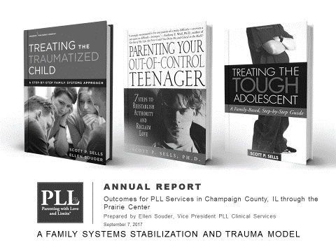
The covers of three books, "Treating the Traumatized Child," "Parenting Your Out-of-Control Teenager," and "Treating the Tough Adolescent" over the heading "PLL Annual Report: Outcomes for PLL Services in Champaign County, IL through the Prairie Center... A Family Systems Stabilization and Trauma Model"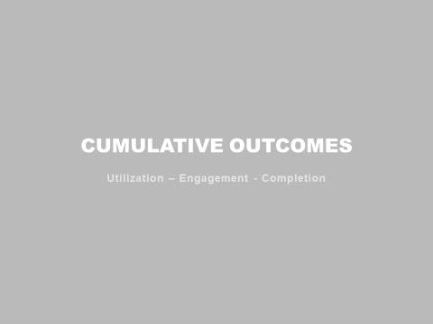
Title page which reads, “Cumulative Outcomes: Utilization - Engagement - Completion”
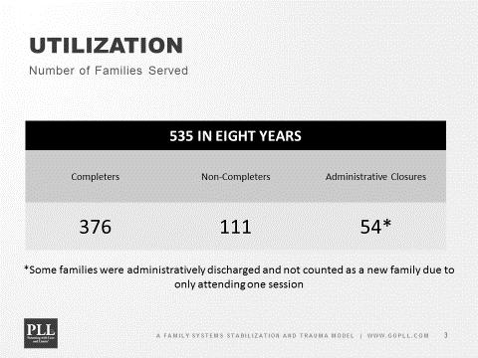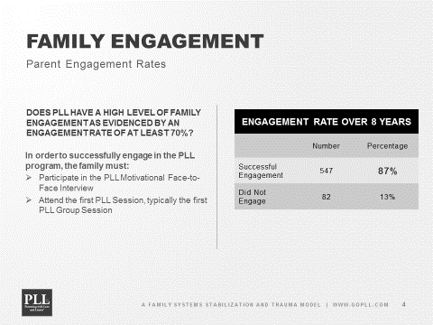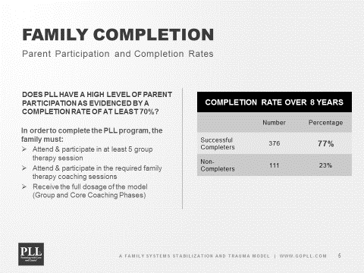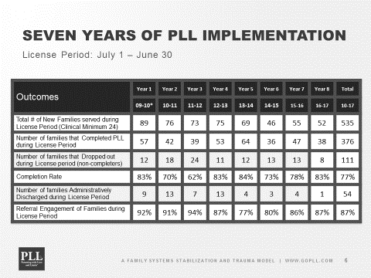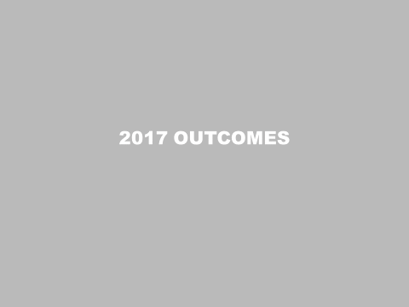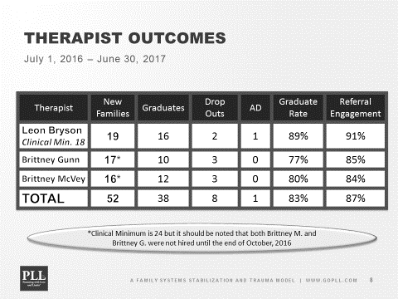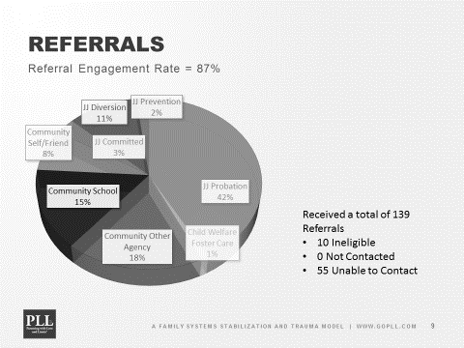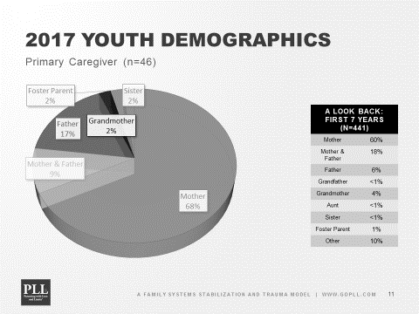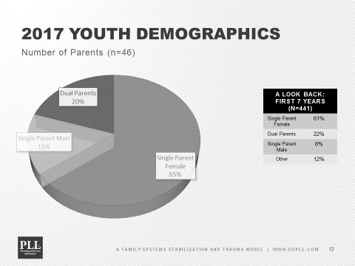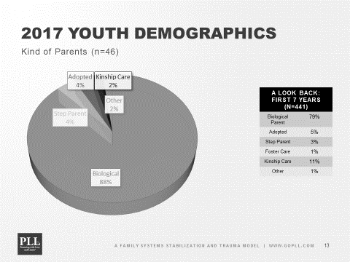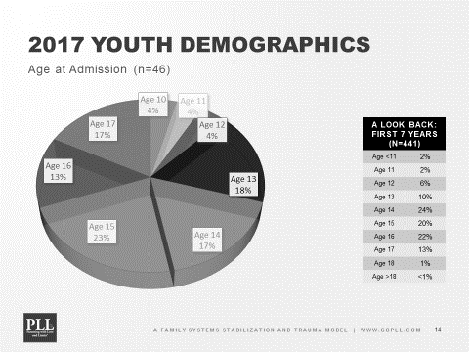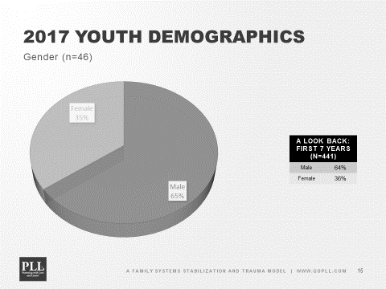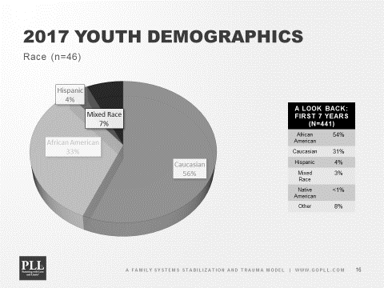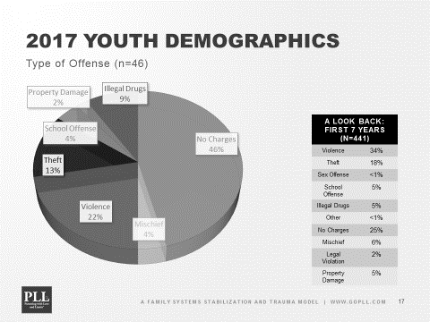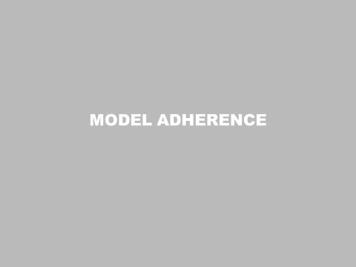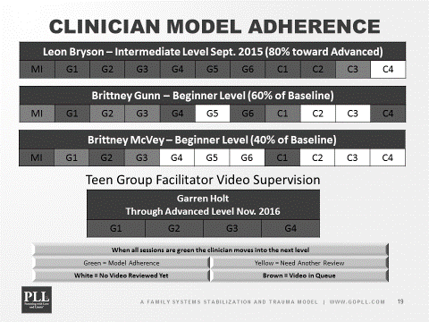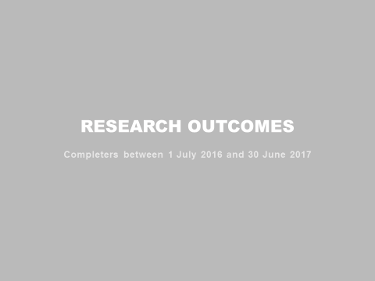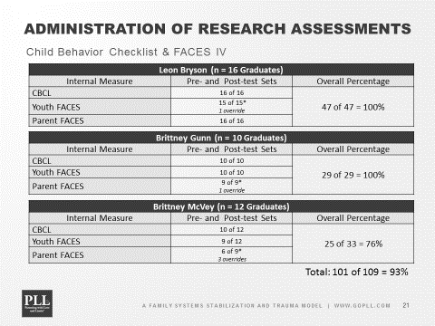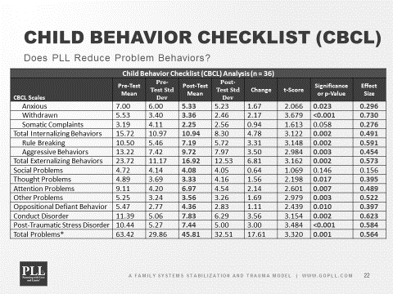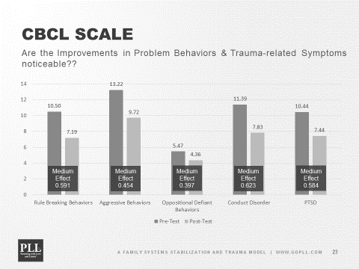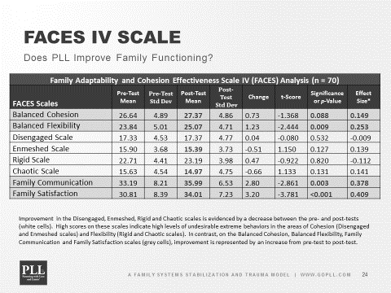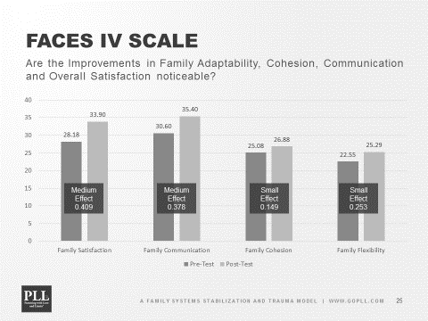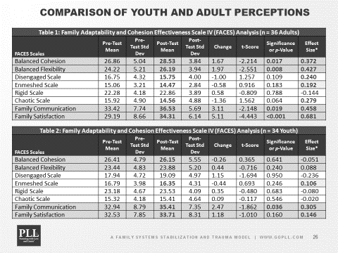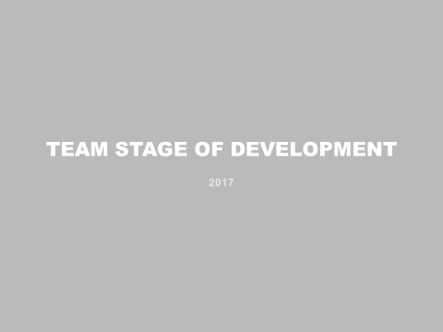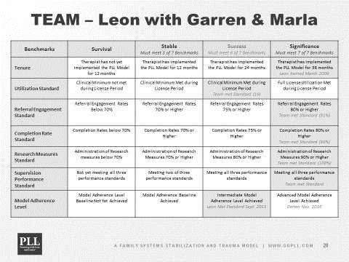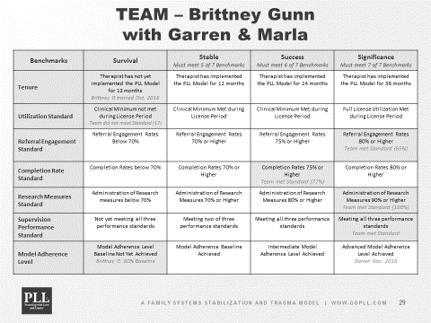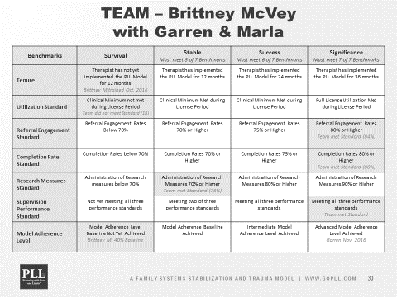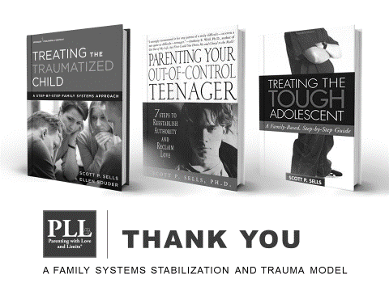

Prairie Center Health Systems - PREVENTION DEPARTMENT
FY17 Consumer Outcome Report

The following is a consumer summary for the Prevention Department of Prairie Center, which includes consumer outcome measurement and consumer satisfaction/feedback.

Consumer Outcome
The Prevention Department utilizes the Mendez Foundation’s “Too Good” programs, which has been supported as an evidence-based curriculum by the Substance Abuse and Mental Health Services Administration, the US Department of Human Services and meets Illinois School State Standards in the areas of health and science. Too Good for Drugs and Too Good for Violence are evidence-based, skill building programs designed to mitigate risk factors and build the basis for a safe, supportive, and respectful learning environment. The Too Good for Drugs curriculum features 10 sessions per grade and focuses on life skills and alcohol, tobacco and other drug education. The Too Good for Violence curriculum features 9 sessions per grade and focuses on conflict resolution, anger management, respect for self and others, and effective communication skills. Pre/Post Tests are utilized as a knowledge-based outcome measurement tool for students participating in the Too Good curriculums. Results for the 2016-2017 school year include:

- Franklin Middle School (6th, 7th, 8th grades): The average Too Good for Drugs Pre-Test score was 72% and the average Post-Test score was 84%, for an increase of 12%. A 10% increase has been noted for students’ Pre-Test scores from in 6th grade to students’ Pre-Test scores in 8th grade, which documents retention in knowledge as the curriculum is presented each year.
- Urbana Middle School (6th, 7th, 8th grades): The average Too Good for Drugs Pre-Test score was 76% and the average Post-Test score was 89%, for an increase of 13%. A 16% increase has been noted for students’ Pre-Test scores in 6th grade to students’ scores in 8th grade, which documents retention in knowledge as the curriculum is presented each year.
- Edison Middle School (6th,7th, 8th grades): The average Too Good for Drugs Pre-Test score was 85% and the average Post-Test score was 93%, for an increase of 8%. A 5% increase has been noted for students’ Pre-Test scores in 6th grade to students’ Pre-Test scores in 8th grade, which documents retention in knowledge as the curriculum is presented each year. FY 17 was the second year for implementation for services at this site.
- Jefferson Middle School (6th, 7th, 8th grades): The average Too Good for Drugs Pre-Test score was 74% and the average Post-Test score was 86%, for an increase of 14%. A 15% increase has been noted for students’ Pre-Test scores in 6th grade to students’ scores in 8th grade, which documents retention in knowledge as the curriculum is presented each year.
- Ludlow Elementary School (5th,6th, 7th, and 8th): Both Too Good for Drugs and Too Good for Violence curriculums were presented at this site in FY 17. The average Pre-Test score for Too Good for Drugs was 64% and the average Post-Test scores was 80%, for an increase of 16%. The average Pre-Test score for Too Good for Violence was 45% and the average Post-Test score was 63%.

Consumer Satisfaction

Teacher evaluations are distributed to all school personnel Prairie Center staff is involved with, through classroom/afterschool presentations. Overall teacher feedback indicated “curriculums are age appropriate, interactive and effective with knowledge increase of students” and “Prairie Center staff being knowledgeable, dependable and presenting the material with an effective style”. Evaluations also reflect “students implementing the skills learned through the programs and a change of behavior in the school setting”. Teachers have also provided feedback regarding the student-parent homework and activities available through the Too Good curriculum’s as a reinforcement tool for parents to continue to have discussions relating to drugs and violence.

Performance Outcome Report (Specialty Courts)
Prairie Center Health Systems, Inc.
Drug Court
FY17

PROGRAM PERFORMANCE MEASURES

Consumer Access
Access Outcome Measures:
- Consumers who received assessment within three business days of sentencing to Drug Court.
- Clients who began treatment within three business days of assessment (excluding clients court-ordered to remain incarcerated).
- Individuals with potential barriers who received Case Management services.
- Number of Drug Court graduates.

Access Outcomes Results for FY17:
- 42% (19/45) of consumers who were sentenced to Drug Court received an assessment within three business days of sentencing or were already open clients. 73% (21/29) of the consumers who were not assessed within three business days were in jail and were assessed on the day of their release. 28% (8/29) of the consumers who were not assessed within three business days were not assessed due to staff shortage (case manager on medical leave/vacant cm position), awaiting start of medication assisted treatment (MAT), holiday (agency closed), or client no showed/cancelled 1st scheduled appointment (individual or group treatment). If consumers who were court ordered to stay in jail are included with those completed within three business days or already open, then 89% (40/45) of consumers were assessed within three business days and only 11% (5/45) did not meet that outcome measure.
- 53% (24/45) of new Drug Court clients began treatment within three business days of assessment or were already open clients. 73% (21/29) of the consumers who did not begin treatment within three business days were in jail and began treatment on the day of their release. 10% (3/29) of the consumers was a no call/no show. If those consumers who began treatment on the day of their release are included, then 85% (38/45) of consumers began treatment within three business days and only 16% (7/45) did not meet that outcome measure.
- 100% of individuals with identified potential barriers to treatment received Case Management services.
- There were 14 Drug Court graduates in FY17.

Comments: In addition to consumers’ court ordered to remain incarcerated there were consumers who were on a residential waitlist and were court ordered to remain in jail until a residential bed opened up. There was one consumer who was pregnant and awaiting residential placement in a special residential facility out of county. There was one incarcerated consumer who started treatment 2 months after the initial assessment while awaiting a new trial. That consumer was eventually given time served and released for treatment to Prairie Center’s residential facility. Assessment completion dates were impacted by numerous factors including but not limited to staff turnover at Prairie Center (detailed in comments section below), Prairie Center Case Manager Alexis Armbruster start date August 1, 2017 (no case manager during the month of July 2016), changes in Champaign County Drug Court sentencing criteria (resulting in an increased volume of consumers to assess), and continued loss of the assessment services provided by the TASC Program due to state budget impasse and cuts. As of June 30, 2017 TASC has not been restored by the state.

Consumer Outcomes
Consumer Outcome Measures Part I:
- Number of Drug Court Graduates

Consumer Outcome Results for FY17:
- Number of Drug Court Graduates: 14 total graduates in FY17

Consumer Outcome Measures Part II: based on Survey (Mental Health Statistics Improvement Program—MHSIP):
- % of consumers with positive general satisfaction with PCHS services;
- % of clients satisfied with their treatment outcomes;
- % of clients with positive feelings about the quality and appropriateness of treatment.
- % of clients satisfied with access to services.

Consumer Outcome Results for FY17: based on Survey (Mental Health Statistics Improvement Program—MHSIP):
- 98% of consumers with positive general satisfaction with PCHS services;
- 98% of clients satisfied with their treatment outcomes;
- 96% of clients with positive feelings about the quality and appropriateness of treatment.
- 97% of clients reports positive perceptions about access to services.
The results in FY16 remain well above national averages in each area.

Results in all categories remain well above national averages in each area. It is noted that these results are for all substance abuse treatment programs at Prairie Center Health Systems, as clients may move between various programs, levels of care, and facilities while receiving treatment.

Percent of graduates who do not experience recidivism:
- 63.91% of clients who graduated did not experience recidivism

Drug Court Recidivism Rate:
Since March of 1999, 751 offenders were sentenced to Drug Court (March 1999 through June 30, 2017). From 6/5/2000 through May 27, 2017, a total of 266 offenders graduated from the Champaign County Drug Court program. These figures (266/751) represent a 31.42% graduation rate. Of the 266 graduates, the gender breakdown is 106 females and 160 males. The race breakdown of the 266 graduates notes 134 African-Americans (50.38%), 127 Caucasians (47.72%), 2 Hispanics (1.20%), one Hispanic/AA (.38%) and one Asian (.38%). As for the age range of those sentenced to Drug Court, two were 18 at the time of sentencing and one individual was 60. The median age is 34 and the average age at the time of sentencing is 35.39. As for the education background of those in Drug Court, 114 earned a high school education and 25 earned a GED. Accordingly, 139 of 266 graduates earned a high school education or equivalent (139/266, or 52.26%). Most offenders received Drug Court following a class 4 conviction (139/266 or 52.26%) and the majority received a probation sentence of 30 months (189/266 or 71.05%).

Information provided by Drug Court Coordinator Amber Edmonds from June 30, 2017 data analysis by Champaign County Drug Court. Since 1999, the probation department has tracked Drug Court participants for 5 years post-graduation. The review of the data for recidivism notes that 96 graduates either committed an additional offense (misdemeanor or felony), or had their probation revoked. The rate of recidivism amounts to 36.09% (96/266), or 63.91% success rate (170/266). The largest rate of recidivism occurs prior to the end of the first year following graduation. The data indicates that in the first year, the recidivism rate is very high with 34 of the 96 individuals recidivating. These figures (34/96) represent over 1/3 of the total recidivism rate (35.42%); including the next category of those recidivating with the 1-2 year span in the equation, 58 (34 +24) participants recidivated. This figure (58/96) representing 60.42% of all cases that recidivated within the second year following graduation. In the 2-3 year span following graduation, 14 individuals recidivated, representing 14.58% of total cases. In year 3-4, 11 individuals recidivated (11.46%) and in the 4-5 year span (13.54%).

Of the 96 graduates who recidivated within the 5-year review period, 38 of the 96 individuals were sentenced to the Illinois Department of Corrections (39.58%). Of the 38 individuals committed to IDOC, 26 (68.42%) were male and 12 (31.58%) were female.

Comments: Specialty Courts (Drug Court) experienced staff turnover-Assessment Clinician Don McCall resigned effective October 21, 2016. Addictions Counselor Dan Giers was trained to complete assessments and given clearance by the jail to access to inmates to complete assessments on site. Clinical Coordinator Brandon Underwood resigned effective June 16, 2017. Drug Court staff are currently reporting directly to the Clinical Director, Carol Bradford. Alexis Armbruster started her employment as Drug Court Case Manager on August 1, 2016. In addition to staff turnover at Prairie Center, the Champaign County Drug Court Team also experienced turnover at collateral agencies and probation. The Drug Court program continued to be impacted on ability to get clients assessed and in treatment within 3 business days due to the continued loss of the TASC Program to complete court ordered initial assessments with clients. The Champaign County Drug Court also changed its criteria determining eligibility of participants which initially led to an increase in the number of participants referred to Prairie Center needing assessments at the jail. Prior to the change the number of assessments needing to be completed was 1-2 a week, after the change there were as many as 5 to 6 requests per week. Due to the high volume of people sentenced to drug court with severe opioid addictions some were referred to residential treatment in Springfield and Rockford Illinois respectively who didn’t return to Prairie Center for aftercare. The Judge entered a Petition to Revoke for some clients who were unable to complete residential treatment due to sexually acting out, disobeying the rules, or failing drug tests. This also reduced the graduation numbers for Champaign County drug court participants.

UTILIZATION OUTCOME MEASURES

CCMHB GRANT PROGRAM | FY17 Actual | FY16 Target
1. Community Service Events | 6 | 6
2. Screening Contacts | 6495 | 4500
3. Non-Treatment Plan Clients | 0 | 0
4. Total Treatment Plan Clients | 96 | 95
5. Other | 16751 | 25094

Performance Outcome Report
Prairie Center Health Systems, Inc.
Youth Services
FY17

PROGRAM PERFORMANCE MEASURES

Consumer Access
Access Outcome Measures:
- Clients who received screening within five school days of referral.
- Clients who began treatment within five school days of assessment.
- Clients with potential barriers to treatment who receive case management services.

Access Outcomes Results for FY16:
- 48% of consumers who were referred to Youth Services received screening within five school days of referral.
- 77% of Youth Services clients began services within five school days of assessed need. 19% did not engage in recommended treatment.
- 100% of Youth Services clients received case management services.

It is noted that youth clients were offered immediate services, but that individual situations kept youth from participating in services immediately. Some of these include the following scenarios:
- Youth detained at Juvenile Detention Center following referral
- Youth expelled/suspended from school and unable to locate
- Youth who moved out of area during time following referral
- Youth sentenced to Illinois Department of Corrections following referral
- Youth rescheduling or failing to attend scheduled appointments for screenings, assessments, and individual or group counseling sessions.

Consumer Outcomes

Consumer Outcome Measures:
I) Mental Health Statistics Improvement Program (I) client surveys
II) DSM-5 Level 1 Cross-Cutting Symptom Measure

Consumer Outcome Measures Part I: based on Survey (Mental Health Statistics Improvement Program—MHSIP):
- % of consumers with positive general satisfaction with PCHS services;
- % of clients satisfied with their treatment outcomes;
- % of clients with positive feelings about the quality and appropriateness of treatment.
- % of clients satisfied with access to services.

Consumer Outcome Results for FY17: based on Survey (Mental Health Statistics Improvement Program—MHSIP):
- 98% of consumers with positive general satisfaction with PCHS services;
- 98% of clients satisfied with their treatment outcomes;
- 96% of clients with positive feelings about the quality and appropriateness of treatment.
- 97% of clients reports positive perceptions about access to services.
The results in FY16 remain well above national averages in each area.

Results in all categories remain well above national averages in each area. It is noted that these results are for all substance abuse treatment programs at Prairie Center Health Systems, as clients may move between various programs, levels of care, and facilities while receiving treatment.

Consumer Outcome Measures Part II: based on the DSM-5 Level 1 Cross-Cutting Symptom Measure
(Approved by World Health Organization and SAMHSA)
For FY17 client outcomes will be collected at intake (baseline) and at time of planned discharge using the DSM-5 Level 1 Cross-Cutting Symptom Measure, which is a self-rated measure that assesses domains that are important across psychiatric diagnoses. It is intended to help clinicians identify additional areas of inquiry that may have significant impact on the child’s treatment and prognosis. These patient assessment measures were developed to be administered at the initial patient interview and to monitor treatment progress. This child-rated version of the measure consists of 25 questions that assess 12 psychiatric domains, including depression, anger, irritability, mania, anxiety, somatic symptoms, inattention, suicidal ideation/attempt, psychosis, sleep disturbance, repetitive thoughts and behaviors, and substance use. Each item asks the child, age 11–17, to rate how much (or how often) he or she has been bothered by the specific symptom during the past 2 weeks. The measure was found to be clinically useful and had good test-retest reliability in the DSM-5 Field Trials conducted in pediatric clinical samples across the United States.

The FY17 consumer outcome data results will be based on improvement in symptom presentation with data being collected at intake and at time of planned discharge using the DSM-5 Level 1 Cross-Cutting Symptom Measure. There is no existing trend data for percentages. Due to a history of complex trauma and multiple other barriers including stigma, lack of transportation, lack of positive social connections, exposure to family and/or community violence, risk-taking behaviors, mental health issues, and physical health concerns this is a difficult population to engage and keep in treatment. Therefore, the initial target for FY17 will be set at a conservative number.

1) 50% of treatment plan clients will show symptom improvement in 60% of the 12 domains.

*Note: After utilizing the measure with the first few clients it was determined that scoring only the overall improvement in symptomology would reduce the error rate and that scoring for each of the 12 domains yielded no significant information that would change the course of treatment. Therefore the measure scores were not broken down by the 12 domains.

Consumer Outcomes Results:

1) 59% of treatment plan clients showed symptom improvement overall. 22% remained the same, 14% declined, and approximately 5% didn’t complete the series of due to unplanned discharges and not being available at the time of discharge to complete the measure. A copy of the completed measure is kept in the client’s hard copy treatment file. The youth counselor also keeps an outlook spreadsheet to track scores.

Comments:

The Youth Program was impacted by staff turnover for FY17. Leslie Salmon, Clinical Coordinator took over the day to day management of the youth team on July 1, 2016. Jillian Mershon resigned July 29, 2016 to relocate with her fiancé to Chicago. Dan Giers and Natalie Hall helped manage the youth caseload until the vacancies could be filled. Parisha Carter was hired as Case Manager on August 1, 2016. Kanitra Keaton was hired as a Clinical Counselor on August 2, 2016. Parisha Carter resigned July 21, 2017. As expected all of these transitions along with the usual barriers to engaging youth in services greatly impacted the youth program caseload numbers as well as the ability to complete screenings within 5 school days of referral and to start treatment services within 5 school days of assessment.

Since the return of the Clinical Director from medical leave, meetings have been held during the quarter with the youth team to provide more information, training, and support on providing substance abuse services to teens, understanding how to code billing, and clarification on what can and can't be billed, and clarification on what data needs to be tracked for the funding source. In addition, the youth team received training on the ANASAZI database utilized by Prairie Center staff to bill and document treatment services. The youth team started entering progress notes into the system in March. This will also aid in the tracking data being more accurate as well as billing services. The youth team is working hard to increase billable hours by doing more outreach to engage the youth clients in treatment services, transporting clients to and from services, making home visits (when appropriate), and providing incentives (pizza parties, gift cards, and journals). The case manager also consults with the probation officers to keep them informed on clients’ participation and progress as well as to elicit their help in getting clients to follow through on attending individual and group therapy.

While the entire FY17 has been a struggle for the youth program, 4th quarter has been even more difficult. The MSW intern Claire Luce’s internship ended in May. She had been helping to complete screenings, assessments and carried a small caseload. In addition, due to performance issues the youth case manager resigned leaving a staff vacancy. Also as the school year came to a close there was a decrease in referrals from the public schools. It is also difficult to get clients to treatment once the weather warms up. A new case manager, Alysia Fenton will start on September 5, 2017. Prior to submitting an application for FY19 a determination will be made as to whether or not to continue the current staffing patter of one case manager and one counselor or to go back to having two counselors.

Both the Clinical Director and the Clinical Coordinator have reached out to collaterals in the community in an attempt to expand the youth program. These include the Urbana Neighborhood Connections, the Don Moyer Boys and Girls Club, Mahomet School District, Rantoul School District, Gerber School, Cunningham Children's Home (various programs), and Youth Assessment Center (to the new coordinator). The youth staff also started a youth group at the probation office on June 06, 2017 so that youth that would normally be seen at school would be seen at the probation office over the summer. Historically, during the summer some youth don't come to individual or group appointments as scheduled. So the probation group was an effort to at least continue services with some of the youth over the summer break.

The decision was made to also expand the program by offering early intervention services for those youth who do not meet the criteria for a substance abuse diagnosis but still may be at high risk of substance use and abuse due to trauma, school problems, family problems, and being related to and/or living in the home with someone abusing drugs and/or alcohol. Schools will be back in session in late August and early September so the hope is that these services can begin to be implemented within a 2-3 weeks after classes begin.

The youth program continues to deal with the same barriers encountered in working with this adolescent population include the following:
- Lack of consequences for youth suspended by schools who were required to only complete an assessment, then were allowed to return to school, but not required to continue with treatment/follow treatment recommendations.
- High percentage of youth referred who have trauma-related issues.
- High percentage of youth referred who have mental health disorders, learning disabilities, and/or emotional disabilities.
- High percentage of youth referred who are involved in the Juvenile Justice system.
- Lack of family involvement in/support of treatment.
Efforts will continue to expand and build on the program by offering both early intervention services and continuing individual and group treatment services. The plan is to run multiple groups under both types of services, as well as continue to offer outreach to youth with an increased effort to provide psycho-educational services to the family members of youth involved in services.

UTILIZATION OUTCOME MEASURES

CCMHB GRANT PROGRAM | FY17 Actual | FY17 Target
- Community Service Events | 35.25 | 30
2. Screening Contacts | 97 | 100
3. Non-Treatment Plan Clients | 55 | 50
3. Total Treatment Plan Clients | 79 | 90
4. Other | 855 | 1100

Promise Healthcare Mental Health Services FY17
Performance Goals and Measures
Consumer access is measured in time it takes for patient to establish care.
Goal #1: 90% of patients internally referred for counseling will complete a Mental
Health Assessment within three weeks of referral. In FY17 80% of the patients referred
to counseling received a Mental Health Assessment with 3 weeks of referral. 393 of the
492 individual referred to counseling received an assessment within the 3 week period
while 99 received an assessment from 4-8 weeks after referral. The Counseling team has
seen a significant increase in the amount of referrals both internally and externally. This
has increased the wait time to see a counselor.
Goal #2: 90% of patients internally referred to a psychiatrist will be scheduled within 30
days of referral. All patients internally referred to psychiatry were scheduled within 30
days of referral. Having three psychiatrists supports strong access to care for our
patients.
Consumer outcomes are measured for adults and children through the Global
Assessment of Functioning (GAF) scale or the Children’s Global Assessment of
Functioning (C-GAF) at the start and cessation of treatment. Based on the CBT approach,
intermittent evaluation of progress i.e. Depression Scale, Anxiety Scale, GAF, and goal
achievement will be assess at regular intervals.
Goal #1: 95% of clients enrolled in counseling will have a GAF scale completed at the
start of treatment.
100% of all counseling clients received a GAF scores at the start of treatment.
Goal #2: 90% of ongoing counseling clients will have a repeat GAF scale completed
every 6 months or at case closure.
90% of ongoing counseling client received GAF scores every 6 months.
Increase GAF = 43
Decrease GAF = 3
Same GAF = 43

Promise Healthcare Wellness and Justice FY17
Performance Goals and Measures

Wellness and Justice targeted outcomes proposed included
- Help patients resolve over 600 issues (assists). This will be a count of the issues a patient needs support and assistance addressing to move towards wellness. Simple cases may need help with just one or two issues while more complicated patients will have a much higher score.
- Reduce the percentage of mental health visits where patients do not have coverage to under 15% through outreach and enrollment efforts and help 2000 people enroll in coverage (all programs, includes non-Promise patients as well). Fewer than 8% of
Promise Healthcare psychiatrist and counselor patient visits did not include health care coverage.

CSE is community service events and unique collaborators.
SC is screening contacts.
NTPC are total unique patients assisted.
TPC are patients that receive multiple assists, case management and a subset of NTPC.
Other is estimate of 600 new people enrolled in Medicaid or marketplace insurance coverage this quarter.

Building Evaluation Capacity for Wellness and Justice
Promise Healthcare greatly benefited from our Wellness and Justice program being one of the four programs selected to work on building evaluation capacity with the
University of Illinois consultants.

From October 2016 to June 2017 they assisted us with the program in several ways.

1. Promise worked with consultant to streamline CCMHB reporting and to begin to collect data that could shape and improve programing.
2. Wellness and Justice patient resources were digitized to stay up to date, for accessibility for more staff, and efficient access from any exam room.
3. Promise began to look at value of services provided by collecting information on patient experience and execution.

Improving Evaluation Capacity Required Changes to Electronic Medical Record System
• Some were ones that Promise could make for just our health center (below)--which we will begin using in CCMHB FY18.
• Others required EMR upgrades from software company like allowing to pull data from both the health record and practice management

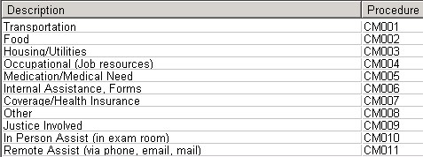

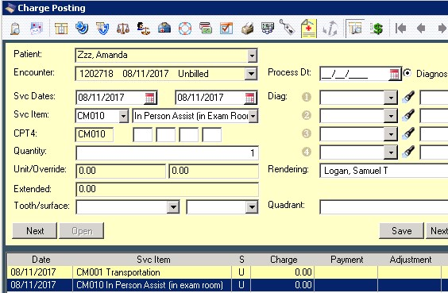
U of I Consultants asked important questions

• What will the reporting output look like? Looked at excel columns and rows with eye to potential data analysis
• How many assists are in person versus over the phone and why?
• Have you asked patients if they used the resources provided? If not why not? If they have what did they think?

Below is performance evaluation information from the University of Illinois consultant report on evaluation work for the Wellness and Justice Program.

Gather information on patient experiences with using the resources provided. Most commonly, the need(s) of the patient are not actually met during the meeting with the coordinator; instead, they are provided with information, a referral, paperwork, or other instructions on how to address their concern. Therefore, even if patients are very pleased (or displeased) with the service right afterwards, the question remains of whether they use the resource and whether it fully addresses the initial concern. In order to investigate this question, we conducted a call-back study over the course of a month and a half. Patients were called back within 2 weeks of their appointment and asked a series of questions. These questions included whether they had followed-up on the resources and information provided, why they hadn’t if not, and how well they addressed the need if they did follow up. Results from this study are presented below.

Study Results
- Types of Assists. From 3/21/17 to 5/9/17, 39 encounters specific to the Wellness and Justice program were recorded. These included 41 assists, as one encounter involved more than one client concern. This data was collected during a time of staff turnover at the Wellness and Justice program, so this number should not be treated as an assessment of typical patient flow. Due to this small sample size, all findings should be viewed as preliminary and exploratory. The most common assist category was housing/utilities. This included help with power bills, help with reprieve from eviction, and assistance with mold removal. Eight assists dealt with transportation, such as getting a handicap parking placard, referral to medical transportation charities, and assistance with getting a bus pass. In another eight assists, the coordinators provided a referral to an agency for a medical need (e.g., Rosecrance for counseling, Family Services, smoking quit line, Empty Tomb for medication assistance). Three assists were related to food availability, and were primarily referrals to Empty Tomb or provision of food baskets available at the health center. Only one assist related to job resources (workers comp billing). Six assists were categorized as “other”, which included a patient who needed a phone and was referred to Safelink, instructions for how to use the Vial of Life (a medication storage system so first responders can find necessary medication in the case of an emergency), a referral to Courage Connection for domestic violence concerns, and a referral to Empty Tomb for clothing. The most common agencies that coordinators connected patients with were Ameren (to file a hardship with to keep utilities on), Empty Tomb, and Land of Lincoln.

Table 1. Types of assists
Assist Category | Count | Percent
Total | 41
Housing/Utilitie | 15 | 36.6
Transportation | 8 | 19.5
Referral for medical need | 8 | 19.5
Food | 3 | 7.3
Job resources | 1 | 2.4
Other | 6 | 14.6

- Patient follow-up. Twenty-four patients were reached for follow-up conversation. Out of these, 15 had followed up with the resources or referral they were given; 3 did not need to follow up, and 6 had not followed up yet. For those who had not followed up with the resources or referral, two indicated that the issue resolved itself, one was very upset about a different life issue so had not followed up, one forgot and planned to call in the future, and one hadn’t felt like going but still planned to go.

Table 2. Have you followed up with the resources or referral provided?
Answer | Count | Percent
Yes | 15 | 62.5
No | 6 | 25
N/A because follow-up  Not needed | 3 | 12.5

Of those who did follow up or did not need to, half indicated that the resources provided had resolved the issue completely or mostly. Five people reported that it resolved the issue somewhat; four indicated that it did not resolve the issue at all. Reasons for dissatisfaction included being unhappy with the types/quantity of food they received from Empty Tomb, being unable to request transportation services without already having an appointment, and still waiting for an appointment with an agency. In one case, the service they were referred to was no longer available.

Table 3. How well did the resources or referral resolve the issue?
Answer | Count | Percent
Completely | 7 | 38.9
Mostly | 2 | 11.1
Somewhat | 5 | 27.8
Not at all | 4 | 22.2

Conclusions
Overall, the majority of patients used the resources or referral provided, and found that they resolved the issue completely, mostly, or somewhat. When this did not occur, the data indicates opportunities for the Wellness and Justice services to be strengthened.

A quarter of patients had not followed up with the resources or referral they were given. While this is not a surprising given the complexity of patient’s lives, there is room for improvement in terms of connecting patients with resources. To the extent possible, coordinators should aim to connect patients with referral agencies while they are still in the room with them. This may entail completing paperwork with patients or making a phone call while they are in the room. While no patients indicated that transportation or access to a phone was a barrier to accessing a resource, these and other possible barriers should still be discussed with patients while the coordinator is meeting with them.

Job resources were rarely discussed with patients. While this may reflect a lack of need in this area, it is also possible that patients are not being referred to coordinators for this issue because the doctors do not know that the coordinators can help with this issue or because patients are not aware of the coordinator’s services. If providing resources on finding and keeping employment is a goal of the Wellness and Justice program, they should strengthen their resources in this area and make sure that the doctors and nurses are aware of this aspect of their services so they can communicate this to patients.

The majority of encounters focused on only one problem. It is possible that these patients had other needs that could have been explored if they were aware of the other resources available. Wellness and Justice coordinators should be encouraged to ask patients about any other areas of their life where they may have concerns, and may want to run through each category (housing/utilities, transportation, medical needs, food, job resources) with patients.

In a few cases, a patient reached out to an agency and found that it did not meet their needs. Patients should be encouraged to reach back out to the Wellness and Justice coordinators when this happens, so that they can provide alternative options or help a patient navigate the system.

Rape Advocacy, Counseling & Education Services (RACES)

FY 17 Performance Outcome Measures-Counseling

FY17 was a year of re-building for RACES. The agency all but suspended operations at the end of FY16; only the Hotline and Medical Advocacy continued during a period of stabilization over the second half of calendar year 2016. Beginning in January 2017, the agency brought on a new Executive Director, stabilized operations, resumed suspended grant funding, and began the search for two additional staff members. Once fully staffed, the agency returned to offering a full array of services for survivors of sexual violence ages three and above, and their significant others.

RACES provides services in three major program areas: prevention education, counseling, and advocacy. Advocacy includes crisis intervention, both on the hotline and in-person, medical advocacy with survivors at the emergency room, court/legal advocacy with the criminal justice system, and what one of our funders calls “other advocacy”. Other Advocacy includes helping the victim and significant others with any difficulties associated with their victimization. Some examples include filing for Crime Victim’s Compensation, exercising rights under VESA (Victim Economic Security Act), getting locks changed, interfacing with university and colleges regarding Title IX rights and processes, and helping victims access follow-up medical care.

The CCMHB-funded Counselor—Cynthia Degnan—started work on May 8, and spent her first week with the agency at the 40-Hour Training in Crisis Intervention required of all staff and volunteers statewide who work with survivors of sexual assault. She began taking appointments beginning Monday, May 15, and has been building a solid caseload since then.

Consumer Access to Counseling:
During Program Year 2017, RACES continued to provide immediate, round-the-clock access to trained advocates, ensuring a timely response the needs of those affected by sexual violence. Many of our counseling clients first interact with the agency via the 24-hour Hotline. The Hotline has a toll-free number to insure access for those outside of the area.

In order to serve clients for whom English is not the preferred language, we subscribe to the Language Line which offers remote language interpretation services in 240 languages; we also partner when appropriate with local language interpreters accessed through the East Central Illinois Refugee Mutual Assistance Center and several University of Illinois resources.

In addition, many of our counseling clients are referred by other Champaign County entities. Over the last six weeks of FY17, clients were referred to us for counseling by the following agencies or entities:

University of Illinois Counseling Center
Parkland College Advising Office
Rosecrance
Courage Connection
Carle Foundation Hospital
Community Service Center of Champaign County

Access for Rural Residents
To insure that rural residents can access needed counseling services, we can help pay for transportation to and from the RACES office. Also, we are exploring options for offering counseling in Rantoul for Northern Champaign County individuals or families who find it easier to seek counseling closer to home.

Services: Individual Counseling
During the period May 15-June 30, 2017, our counselor saw eleven (11) unduplicated Champaign County residents for counseling services. Some had just one session, while others had multiple sessions. Our counselor uses an evidence-based, trauma-informed approach insuring that the service will be appropriate for the needs of our survivors.

We contract with an experienced, licensed counselor for clinical supervision of the counseling program.

Services: Group Counseling
In the past, RACES has offered group counseling for female high school students and adult women, often organized around an art therapeutic approach. Because of the reduction in services, the agency did not offer any group services during FY17.

We do anticipate offering group therapeutic services during the upcoming plan year, including some specialty groups for adult sexual assault survivors such as yoga for survivors, art group for survivors, writing group for survivors, and hopefully equine-assisted therapy for survivors. All groups will be co-led by a RACES counselor and the subject matter teacher/coach. If there is interest, we may offer some of these groups to young people as well, perhaps in association with the Children’s Advocacy Center. All of these group services will be funded by VOCA.

Cultural Competence
It is clear that due to the agency’s FY16 crisis and reduction in staff and services there has been a great loss in institutional memory. For instance, none of the current board members are familiar with the agency’s Cultural and Linguistic Competence (CLC) Plan or even knew of its existence; a board-level understanding is crucial to assuring that cultural competence undergirds and suffuses throughout all agency activities and communications.

Immediate changes were instituted: Board members have all received a copy of the current plan, and will receive a CLC training at the October Board meeting after new board members are seated. All staff (both current and new) receive a copy of the plan during the first week of orientation, and all participate in regular ongoing CLC trainings or workshops.

A training on “Working with People on the Autism Spectrum” was held a RACES on June 2, 2017; staff from RACES, CAC, CCMHB, and victim advocates from Champaign County State’s Attorney’s Office attended. Presenters were from The Autism Project at UIUC.

All staff and volunteers must complete the required 40-Hour Crisis Intervention Training which includes 4 hours on privilege and oppression. Volunteers also receive quarterly supervision and trainings on a variety of subjects, including cultural and linguistic competency. A recent offering was about transgendered individuals and sexual violence.

In addition to the above, the Executive Director has made an appointment with CCMHB’s Cultural Competence Specialist for a top-to-bottom individualized assessment of our CLC plan and approaches.

Anti-Stigma Efforts
Victims of sexual violence face huge obstacles stemming from the stigma society holds against them. Victim-blaming by others, and self-blame by survivors both contribute to shame and ongoing pain.

In order to help combat this serious problem, we use a multi-faceted approach. For self-blame, all of our advocates, counselors and other staff reinforce that only the perpetrator is to blame for the attack. Other messaging includes “we believe you”, “you are not alone”, “it was not your fault”. We try to reinforce these concepts in both community settings such as recruiting fairs and in television and other media interviews.

Policies and Protocols
The agency—especially the Executive Director—has spent considerable time this spring creating or revising agency policies, procedures, rules and protocols for in order to provide a safer and more responsive environment. Examples include: Unusual Incident Policy, Protocol for Dealing with Clients Threatening Suicide, Homicide or Self-Harm; Policy on Clients Bringing Pets into the Office; and Client/Program Records Retention.

The agency is also about to institute a new, expanded and updated Employee Handbook.

Looking Ahead
For the upcoming FY18 Plan Year, RACES has requested that CCMHB dollars be redirected towards our Sexual Violence Prevention Education programming.

Our Associate Director, Jaya Kolisetty, heads up that program area and has been reaching out to schools in order to schedule presentations in the classroom again this fall. Although the agency has always endeavored to present the most up-to-date programs, through our state-wide coalition we will be participating in a CDC-sponsored national initiative to provide evidence-informed curricula and to evaluate programmatic impact from a public health perspective.

This approach will dovetail nicely with our work with the CCMHB Evaluation Project. This past spring we worked with the consultants on describing and measuring outcomes for our Advocacy services; this plan year we intend to explore with the consultants how to evaluate our Prevention Education.

We also plan to partner fall semester with UI students taking a class called “Trauma, Diversity, and Resilience”. They will create content for printed materials and may design and present a workshop on a topic related to the class subject material. If they do create such a workshop, we will be sure to invite our colleagues from other social services agencies, as we learn better when staff working with other populations are in attendance and contributing to the discussions.

Respectfully Submitted,

Adelaide Aimé, MSW, LCSW
Executive Director
Rape Advocacy, Counseling & Education Services
Rosecrance C-U
CCMHB FY 17
Criminal Justice Year-End Summary
Consumer Access
Participants in Drug Court have no delay in accessing services. The assigned staff is experienced in working with the court systems and the populations served through the Problem Solving Courts. They are able to engage clients in a prompt and efficient manner and are experienced in managing resistance and barriers that may be present.
For those not in the Problem Solving Courts, every effort is made to engage them within five working days. Screenings and mental health assessments are completed at the jail if indicated. Often our services include providing assistance with transportation to ensure that the consumer is able to attend appointments with doctors and court services personnel. In order to improve access and deliver services where the consumer is, case management services may occur in the participant’s home or other community settings.
Walk-in screenings and/or assessments are available five days a week to improve access to services. Assessments are either completed that day or the individual is referred to the appropriate program within the agency to complete the assessment process.
FY 17 Outcomes: Referrals in the jail continued to be seen promptly as staff are on-site daily. Referrals to substance abuse services were often able to be scheduled within the days of receipt of the referral.

Consumer Outcomes

FY 17 Outcomes: To calculate recidivism again this year we took all clients admitted into the three programs (Community, Jail and Problem Solving Courts) and researched their offense data from the date of their admission. Celeste Blodgett was able to pull the following data:
- 93% did not recidivate
- 12 cases were still pending
- 5 cases found NGRI/Unfit
- Of the 23 that did recidivate, 9 were criminal misdemeanor and 14 were criminal felony

Utilization/Production Data Narrative: Reference Data contained in Part II

In FY 17 TPC’s will continue to represent the community based clients engaged in services, the clients receiving substance use services and those in drug court. Projected Continuing TPCs is 50 and New TPCs is 150 for a total of 200 TPCs.
FY 17 Outcomes: 60 Continuing TPCs and 287 New for a total of 347.

In FY 17 NTPCs will represent the individuals in the jail served by the case manager. Projected Continuing NTPCs is 80; New NTPCs is 390 for a total of 470 NTPCs

FY 17 Outcomes: Continuing NTPCs was 45, well below the projected number and New NTPCs was 189. Less than ½ of the original projected number. This decrease was due to

The ability to meet the projected NTPCs was impacted by two factors:
1. The case manager in the jail has had to focus more of her time with consultations on cases that don’t necessarily end up being a new screening. Part of this consultative role requires that the case manager spend a significant amount of time researching information on referrals in two electronic health record systems within Rosecrance, the jail’s data system and the circuit clerk. Many people receive informational fliers but it has been very difficult to actually screen high numbers of individuals with just one case manager. With a second case manager approved for the FY 18 funding cycle, we expect these numbers to go back up again.

2. There was a significant increase in new trainings required of staff due to the merger with Rosecrance over the past year. Staff had to learn a completely new electronic health record system; had to re-do paperwork so that records were in compliance with Rosecrance protocols and we had to restructure our intake and screening process along with tracking our identified needs. Staff is fully trained now on all of the new systems.

FY 17 Crisis/Access/Benefits
Year End Summary

Consumer Access:
Rosecrance C/U strives to promptly respond to consumers in need of services.
- The Access Department seeks to answer at least 95% of incoming calls live. In FY 17 93% of the incoming calls were answered live.
- The Crisis Team goal for face to face assessments is to respond within 30 minutes or less at least 90% of the time. In FY 17 74% crisis face to face assessments were responded to within 30 minutes and 100 % of Crisis Line calls were responded to in 15 minutes or less.
- We continue to offer walk-in times 5 days a week allowing consumers the opportunity for “same day” screenings and/or mental health assessment rather than waiting for a specific appointment that could be scheduled weeks out. The goal is to complete 95% of screening and/or assessments on the same day people walk in assuming the person is eligible and chooses to complete them. In FY 17 100% of walk-ins were screened on the same day.
- There are many factors outside of the Benefits Case Managers’ control that could affect the success of someone obtaining entitlements. In FY 17 183 people received assistance from the Access and CCHC Benefits Case Manager of which 79 were initiated at the county jail.
Consumer Outcomes

Utilization/Production Data Narrative:

- In FY 17 Non-TPC’s (NTPC’s) will continue to represent the number of mental health assessments and screenings completed by Access Clinicians for those who are Champaign Co. residents. Due to the downward trends of this number our target will be 350. The total NTPCs for FY 17 was 749.

- In FY 17 Service Contacts will continue to represent the number of crisis line calls and we project this number to be 4,400. The actual number of Crisis Line Calls was 3,977. In FY 17 Community Service Events will continue to reflect the number of educational presentations, community events or requests for consultations attended by the Crisis Line Coordinator. Additional staff may join the Coordinator to assist with meeting specific requests. The target for FY 17 is 30. The actual number achieved in FY 17 was 36; 22 by the Crisis Line Coordinator and 14 by the Crisis Team Leader and Supervisor.

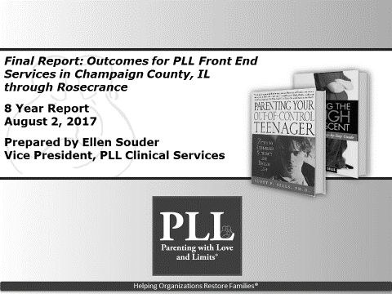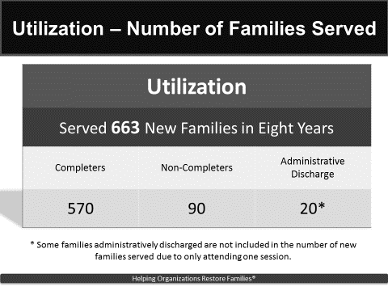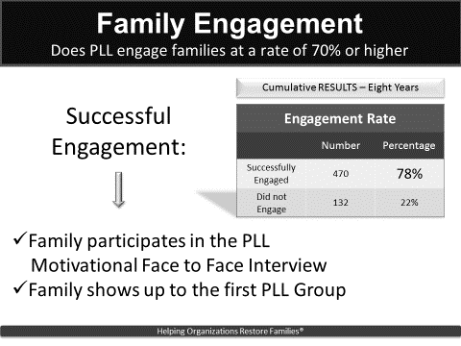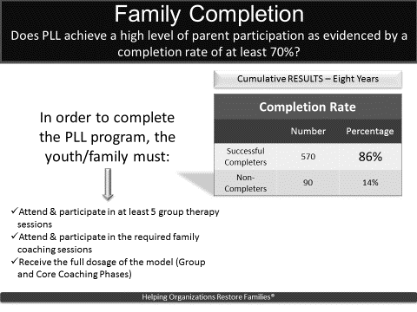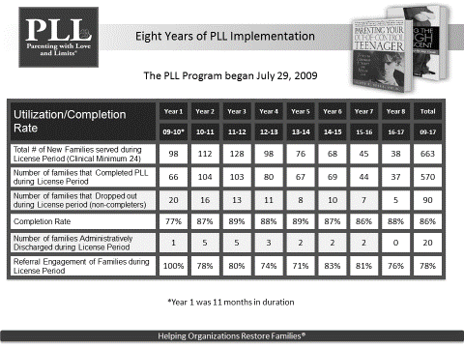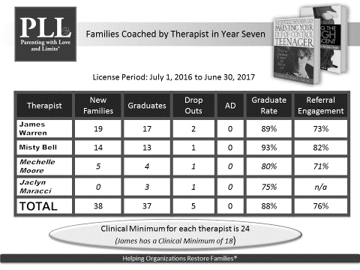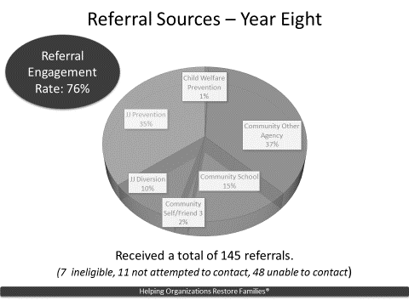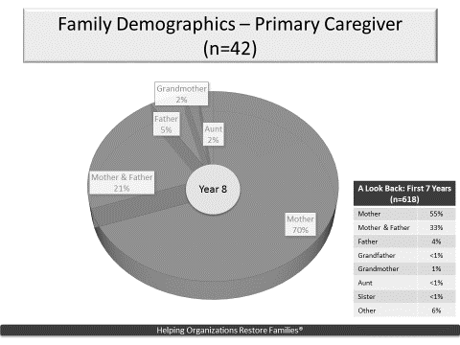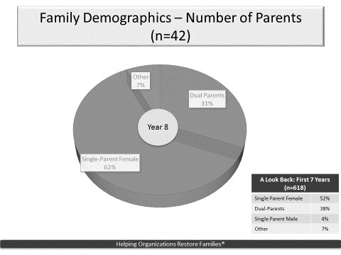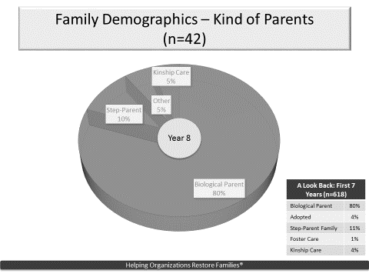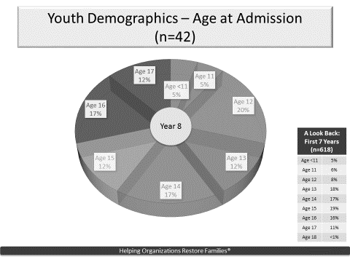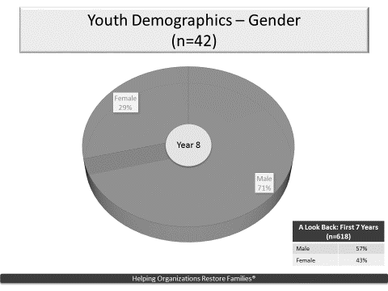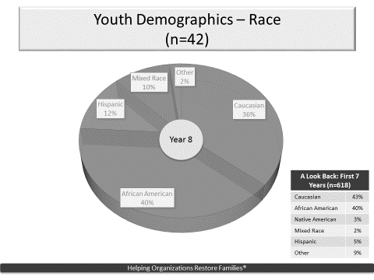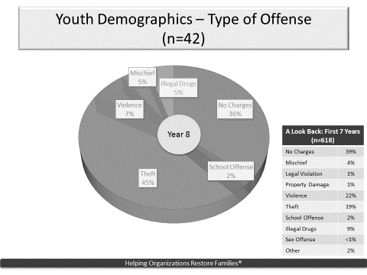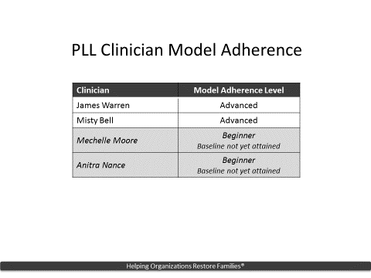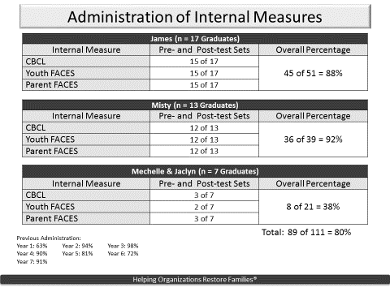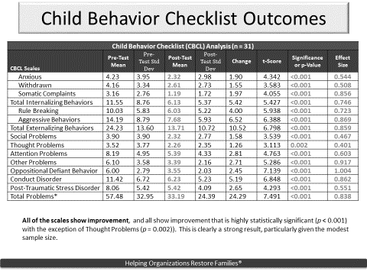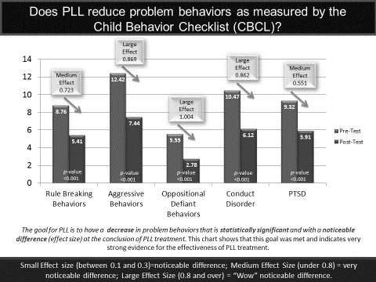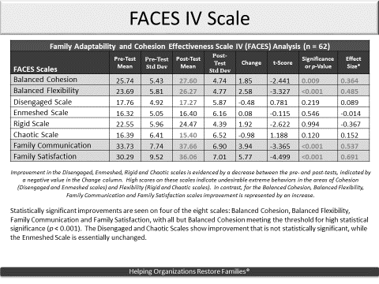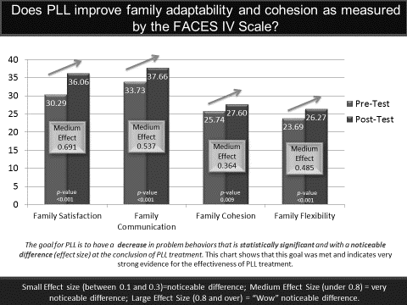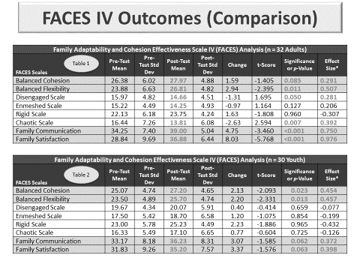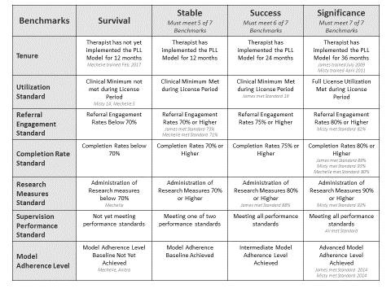

Rosecrance Champaign Urbana
TIMES Center
FY17 Year-End Report

Consumer Access:
The TIMES Center operates 7 days a week, but is closed from 9 – 5 on the weekdays. IOP groups could be offered during the time the building is closed. Groups in the early evening could also be an option. This change in operation was a result of funding cuts from the State of Illinois and a recognized need that more residential treatment supports need to be available on site. Calls and referrals for open beds can be made to TIMES between 8:00 a.m. and midnight. In accordance with local and state requirements, a verification of identification and legal status is completed before admission to the TIMES Center.

Rosecrance C/U participates in the Council of Service Providers to the Homeless as well as the Urbana Champaign Continuum of Care. We coordinate and promote our services through these networks, as well as through a positive relationship with other social service agencies, churches and the media. Local churches and community providers often make referrals to TIMES Center. We continue to work with law enforcement and other community partners to meet the needs of homeless individuals engaged in the criminal justice system. In FY17, we are proposing to address this with offering IOP services on site.

FY17 Outcomes:

TIMES Center, which is now called the Men’s Transitional Housing Program (MTHP), operates 7 days a week, with staff presence from 8:00 a.m. to 11:00 p.m. Sunday through Thursday and 8:00 a.m. to midnight on Friday and Saturday. We serve up to 20 men at a time, with referrals and inquiries coming in regularly. Referrals come to us through the Centralized Intake For Homeless system, which serves Champaign County.

At intake, every participant is administered screenings for mental health and substance abuse issues, as well as a criminogenic screening. Results from these screening tools are used to help determine appropriate services for assisting the men in moving toward a greater level of self-sufficiency. Each man is assigned to a case manager or recovery specialist who works with them on addressing barriers to self-sufficiency.

We did not hold formal treatment groups during FY17, but we met with the residents as a group at least quarterly in order to discuss issues. Additionally, informal counseling is provided at least weekly on-site by case managers and recovery specialists. While we had considered offering Intensive Outpatient Program (IOP) services on-site at the MTHP, these services are offered through Rosecrance so there is not the need to offer them on-site. When a resident is identified as having substance use and dual diagnosis issues, staff make referrals to those and other treatment services through Rosecrance, as well as through other local providers.

The MTHP is represented regularly at the Council of Service Providers to the Homeless and the Urbana Champaign Continuum of Care meetings.

Consumer Outcomes
The Case Manager or Recovery Specialist complete mental health, substance abuse, and criminogenic screenings on all new admissions. The goal is to conduct screenings on 90% of admissions. The screenings identify further recommendations for services and resources to meet the client’s needs and to develop a treatment plan. The goal is for 100% of residents who are identified as needing treatment will be referred to the appropriate services provided by Rosecrance C/U or another community provider.

TIMES Center will continue to share data, as appropriate, with the Criminal Justice Data Project in an effort to measure recidivism across all criminal justice related programs.

FY17 Outcomes:

- 100% of admissions received mental health, substance abuse, and criminogenic screenings in FY17.
- 100% of admissions had an individualized service plan completed.
- 100% of admissions identified as needing treatment were offered assistance in accessing these services.
- While no data was shared with the Criminal Justice Project, of the 60 men served during FY17, 41 (68%) have had some form of criminal involvement in their history, and 12 (20%) had legal involvement at the time of their admission to the MTHP.

Utilization/Production Data Narrative

TPC’s will represent the number of unduplicated residents being served. Since there is a 20 bed capacity and openings for new residents can occur infrequently, we are projecting to serve 50 TPC’s in one year.

NTPC’s will reflect the number of unduplicated individuals from the waitlist that we attempted to bring into the program but were unsuccessful in doing so. The target number is 50.

Service Contacts will represent the same data we are required to report to DHS on a quarterly basis called Supportive Services. Staff track the number of interactions they have with the residents based on a list of 20+ supportive services categories as defined by DHS. The list of services tracked and their definition is available for review. Based on FY 17 first quarter data, we project a total of 6,000 service contacts in the year.

Each resident will complete an initial Self-sufficiency assessment in collaboration with his case manager/recovery specialist. Every six months and at discharge, another assessment will be completed to track progress toward goals. Sixty percent (60%) of the residents discharged from the program after at least one year of services will demonstrate improved scores on at least three of the five outcome scales.

Further evidence of positive outcomes is noted by a dramatic increase in our measure of success rates. Success rates are calculated by noting those who leave TIMES voluntarily and/or with identified permanent housing.

FY17 Outcomes

- During FY17, the number of unduplicated clients (TPCs) served was 60.
- Of the 42 men who discharged during the year, 34 (81%) were positive discharges.
- The number of NTPCs served was 72
- The number or Service Contacts provided was 6282.
- A Self-Sufficiency Matrix was completed on 100% of the men beginning in November, 2016. Of the residents discharged from the program during FY17 after at least one year of services, 50% demonstrated improved scores on at least three of the outcome scales, while 67% demonstrated improved scores on at least two of the outcome scales.
UP Center of Champaign County
Children, Youth, and Families End of the Year Report 2016-2017
Performance Measure Outcomes

This brief report provides an overview of the 2016-2017 evaluation procedures, results, and future directions for the Uniting Pride (UP) Center’s Children, Youth, and Families programming.

Evaluation Procedure: 2016-2017
In the grant application for the fiscal year of 2016-2017, it was stated the UP Center would have youth participating in support groups complete a pre/post-test measure of their psychological distress, sense of belonging, perceptions of support, and demographics. However, none of this information was tracked (see ‘Limitations’ section below for more information). The only information that was tracked over the course of the year was demographics for the youth attending the support group.

Evaluation Findings: 2016-2017
During the fiscal year 2016-2017, demographic information was collected for 11 youth that are covered under the CCMHB grant. See Table One.
TABLE ONE
Gender Identity
Male | 5
Female | 3
Trans | 5
Non-binary | 3
Sexual Orientation
Pansexual | 1
Bisexual | 2
Polysexual | 1
Asexual | 3
Gay | 2
Lesbian | 1
Queer | 1
Questioning | 1
Straight
Prefer not to say
Race/Ethnicity
Hispanic/Latino
White | 10
Black/African-American
Asian
2 or more Races | 1
Geographic region
Champaign (61820) | 1
Champaign (61821) | 3
Champaign (61822) | 1
Urbana (61801) | 1
Philo (61864)
Mansfield (61854)
Olney (62839)
Danville (61832)
Mahomet (61953) | 2
Fisher (61843)
Farmer City (61842)
Rantoul (61866)
Homer (61849) | 1
Pesotum (61863) | 1
Sidney (61877) | 1
* Note: client are allowed to choose more than one demographic, hence the disparity between the actual number of youth and the demographics reported.

Limitations to 2015-2016 Evaluation
There has been a large turnover in staff during the 2016-2017 fiscal year, including four different Youth Coordinators. As a result, some agreements made under the FY17 contract, such as tracking performance measures, have not been fulfilled. While the current Board and Youth Coordinator profusely apologize, we understand that it does not make up for the breach of obligations. Here forward, we will meet to the agreed upon activities for FY18 (see ‘Ongoing Changes’ section for more information).

Ongoing Changes
Under new supervision, the Children, Youth, and Families programming has already started tracking psychological distress and demographic information for youth attending the youth group for FY18. New or reoccurring youth attending group within the first three weeks of Quarter 1 were asked to complete the Depression, Anxiety, Suicide, and Stress Scale (DASS-21). New youth attending after the first three weeks of Quarter 1 will take the DASS-21 during the Quarter 2 follow up. This policy was put in place to keep time between follow-ups approximately the same for all youth. Youth will complete the DASS-21 quarterly. At subsequent quarters for FY18, youth attending group will also complete additional surveys and questions help us understand the effectiveness of and to make improvements to our Children, Youth, and Families programming.

Conclusion
The UP Center provides a unique and necessary service to Champaign County. In the past years, there have been improvements in well-being to youth who attended our Children, Youth, and Families programming. While we do not have the data to support this pattering for FY17, we will for FY18. The demographic form for 2016-2017 is attached.

UP Center Youth Mental Health Inventory Cover Sheet Demographic Information
For each category below, check all that apply.

Gender |  |  |  |  |  |  |  |  | Sexual Orientation
Male | Female |  | Trans | Other |  |  | Prefer Not Say |  | Bisexual | Gay |  |  | Lesbian |  | Pansexual |  | Queer |  |  | Questioning |  | Straight Ally | Other |  |  | Prefer Not Say
Race / Ethnicity
Hispanic or Latino |  |  |  |  |  | White |  |  |  |  |  | Black or African American |  |  |  |  |  | Native Hawaiian or Other Pacific Islander
Asian |  |  |  |  |  | American Indian or Alaska Native |  |  |  |  |  | Two or More Races |  |  |  |  |  | Other |  |  |  |  |  |  | Prefer Not Say
City
Champaign  61820  61821  61822 |  | Fisher  61843 |  |  | Homer  61849 |  |  | Mahomet  61853 |  |  | Ogden  61859 |  |  | Pesotum  61863 |  | Philo  61864 |  |  | Rantoul  61866 |  | Saint Joseph  61873
Savoy  61874 |  | Sidney  61877 |  |  | Thomasboro  61878 |  |  | Tolono  61880 |  |  | Urbana  61801  61802 |  |  | Danville  61832  61834 |  | Decatur  62521  62522  62523  62526 |  |  | Other |  | Prefer Not Say

Guarantee of Confidentiality Statement
The information you choose to provide will not be shared with anyone

Staff Use Only
Date:_________________ Intake/Follow-up (include quarter #):________________________

ID #:__________________ Group Name:__________________________
Agency: Urbana Neighborhood Connections Center
Program: Community Study Center
Date: 2017 - 4th Quarter Performance Outcome Report

Consumer Access: Performance Outcome Measures
UNCC makes an effort to identify all demographic of Non Treatment Plan Clients. The following information accounts for estimated numbers of clients to be served along with actual number served during this grant year
Estimated: Actual # Served
Unduplicated Clients Served
100 131
AREA OF RESIDENCE
City of Champaign 32
City of Urbana 193
Village of Mahomet 2
RACE/ETHNICITY
Black/African American 197 White (Non-Hispanic) 12
Multi-Racial 13
Asian /Pacific Islander 5
CLIENT INCOME LEVELS
Less than 50% Median Family Income 156
51-79% of Median Family Income 45
At or above 80% Median Fam Income 26
Not Known 0
SEX
Male 110 Female 117
AGE
0-6 53
7-12 137
13-18 37
Consumer Outcomes: Performance Outcome Measures

Urbana Neighborhood Connections Center's 2017 desired program measurement outcomes for the Community Study Center Program were:
1. Engage targeted youth in structured out of school time educational, social development and
recreational activities.
2. Reduced and/or minimal criminal activities by youth in targeted neighborhoods.
3. Expose targeted high school students to various college and career related activities
4. Implementation and accomplishment of 2 of the Cultural Competency Plan goals and objectives.
Results
1. Maintained and/or increased the number of hours spent investing in academic, recreational, and social-emotional skill development for 150 unduplicated youth during afterschool, school out days, weekends and summer activities.
2. Introduced and/or re-engaged program participants to new and/or familiar physical fitness and cultural arts activities (daily walks, team building activities, group dancing, etc.) designed to promote acceptable behaviors, attitudes and confidence needed to maintain positive and healthy lifestyles at home, school and on community.
3. Introduced or re-engaged program youth to juvenile delinquent indicators and prevention approaches and other awareness resources used to reduce and/or minimal criminal activities while participating in family, school and or community activities.
4. Engaged staff in activities such as staff meetings, movies/videos and other media types whereby their knowledge, awareness and skill performance were enhanced as related to Cultural Competency planning and implementation of activities and supports while engaging the youth and families who participate in UNCC’s program.
Collection Methods used to record the above results included:
1. Individual Registration Forms
2. Daily Attendance Records
3. Consultation with parents and school personnel.
4. Self-reports from program youth re: juvenile delinquent behaviors and/or a lack of involvement in the juvenile legal system.
5. Participation & Satisfaction Surveys for select program participants
5. Graduation diploma, verification of employment and/or college admission letter.

Utilization/Production Data Narrative: Performance Outcome Measures
UNCC Community Study Center program offered community based academic support, tutoring, Reading/literacy/Math instruction, social/emotional development, prevention, intervention, and career opportunities for Non Treatment Plan Clients (NTPC).
UNCC counted multiple programs (afterschool activities, school out days, college and career readiness/twice-monthly weekends and summer) and/or activities within one category called the Community Study Center (CSC).
UNCC only reported the number of Unduplicated NTPC's receiving multiple programs within the Community Study Center that were represented in the Utilization/Production.

